# xpedx.com Next generation

# *Customer and User Profile*

**Authors: Sterling Commerce**

**Date Created:** 05/14/10

**Last Updated:** 05/14/10

**File Name:** C:\Documents and Settings\bfurman\My Documents\Temp\Methodology v1.1\Project Management\TEMPLATE - DOCUMENT - Use Case Definition.docCustomer and User Profile Low level design

Document Revision History

This chart tracks the changes introduced by the revisions to the document as the project progresses through the stages of the System Development Life Cycle (SDLC).

| Version | **Date** | **Description (Changes Made)** | **Author(s)** |
| --- | --- | --- | --- |
| 1.0 | 05/14/2010 | Initial Draft | Sterling |
|  |  |  |  |
|  |  |  |  |
|  |  |  |  |
|  |  |  |  |

Related or Reference Documents

| Document Name | Description | Owner | Location |
| --- | --- | --- | --- |
| SCI_Xpedx Solution Definition Document v1.0 | Solution Definition document | Sterling Commerce |  |
|  |  |  |  |
|  |  |  |  |
|  |  |  |  |

TABLE OF CONTENTS

1. Introduction 4

1.1 Document Purpose 4

1.2 Document Audience 4

2 UOM List 5

2.1 Overview 5

2.1.1 Sequence Flow 6

2.1.2 Input XML 6

2.1.3 Output XML 6

3 Classes and Services 6

4 Unit test cases 13

# Introduction

## Document Purpose

This document develops helps developers to code/maintain UOM list functionality.

## Document Audience

This document is intended for developers/architects/support to understand the data and flow in Web Channel related to viewing and managing Customer and User Profiles.

# Customer and User Profile

## Overview

The Customer profile involves the following,

1. Customer General Information.
2. Customer Maintenance Information.
3. Viewing Business and Order/Order Line Rules.
4. Viewing Customer Locations.
5. Location Administration

The User Profile involves

1. User Administration.

## Customer Profile Description

1. The Customer information is maintained in the YFS_Customer table in extended columns.
2. On UI, the Customer Information is broken down into several screens,
   1. General Info
   2. Customer Maintenance
   3. Business Administration with Order/Order Line Rules
   4. Locations List
   5. Location Administration.
3. General Info Screen-
4. Customer Maintenance –
   1. The action xpedxCustomerMaintenance tied with Action class com.sterlingcommerce.xpedx.webchannel.profile.org.XPEDXGetCustomerMaintenanceAction is used to fetch data related to customer Maintenance.
   2. The action updateCustMaintenanceInfo with Action class com.sterlingcommerce.xpedx.webchannel.profile.org.XPEDXManageCustMaintenanceInfo & method manageCustMaintenanceInfo is used to update the Customer Maintenance Data.
   3. Layout – The customer Maintenance JSP is currently inset within the Corporate Info Tab under Organization Profile
   4. Screenshots –

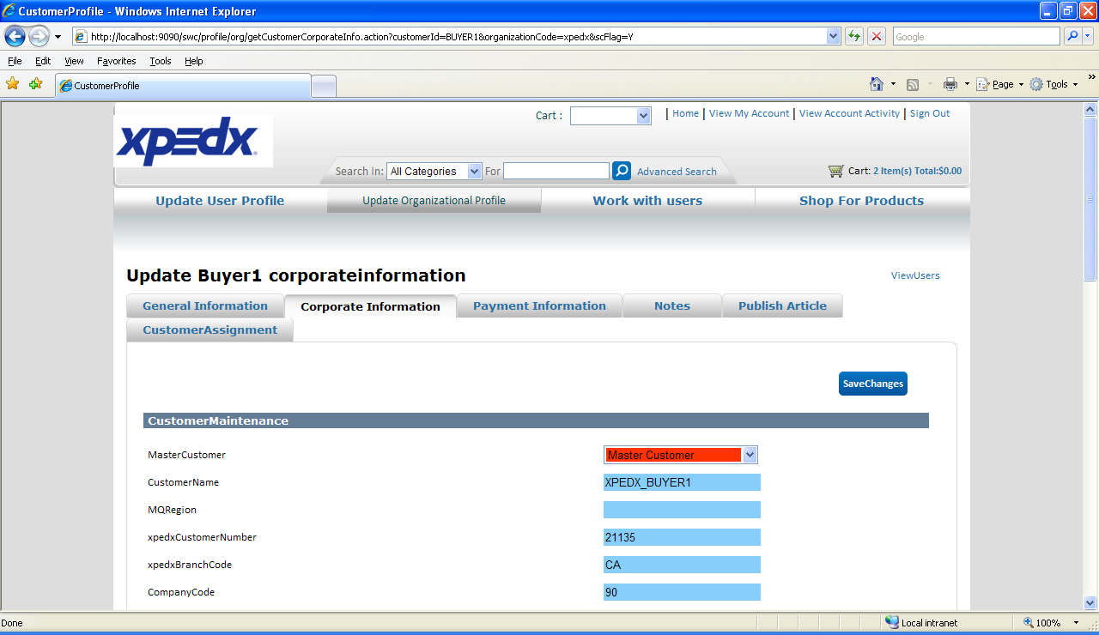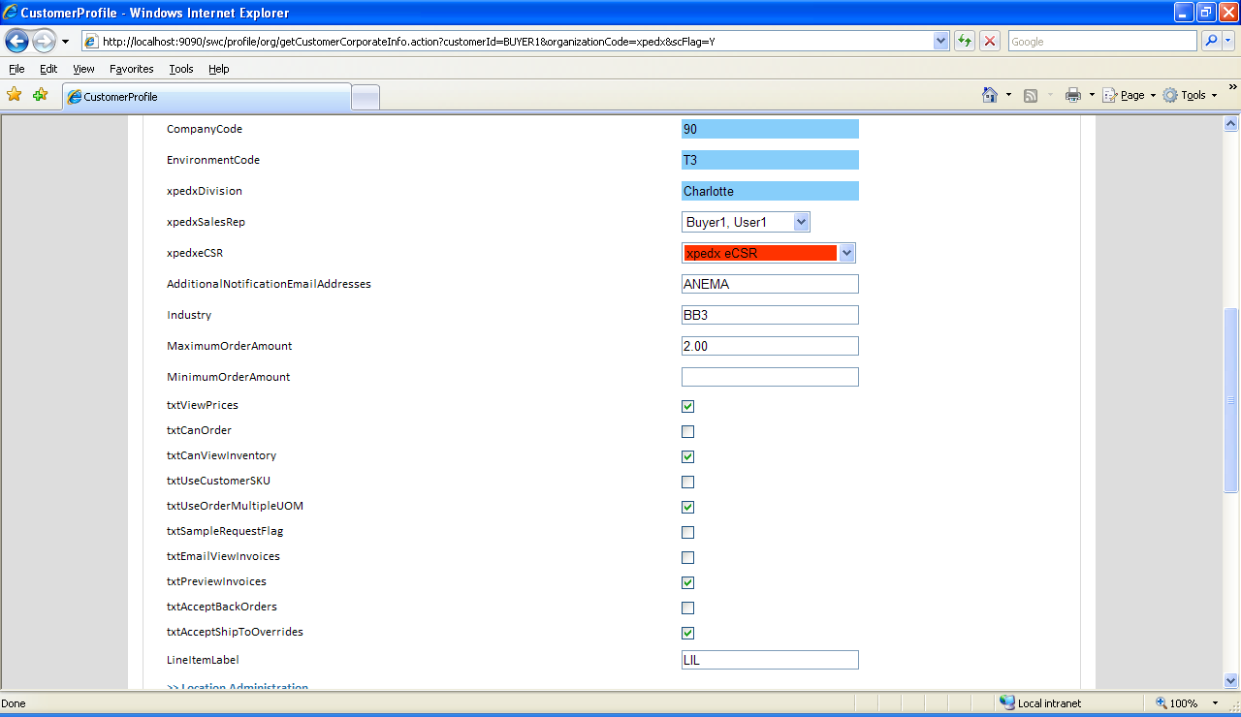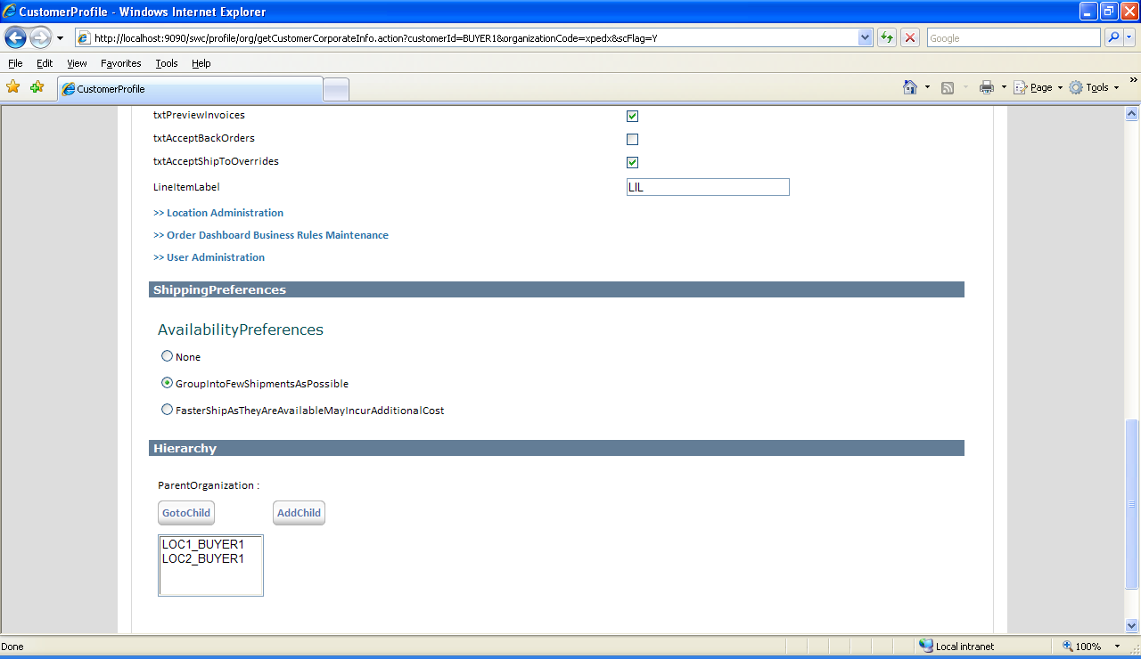

* 1. The following fields were created as part of Customer Maintenance.

|  |  |  |  |
| --- | --- | --- | --- |
| **Sl No** | **Field** | **Description** |  |
| 1 | Master Customer | Provides information on Customer’s Master Customer | Readonly, dropdown - ? |
| 2 | Customer Name |  | Readonly |
| 3 | MQRegion |  | Readonly |
| 4 | Xpedx Customer Number |  | Readonly |
| 5 | Xpedx Branch Code |  | Readonly |
| 6. | Company Code |  | Readonly |
| 7. | Environment Code |  | Readonly |
| 8. | Xpedx Division |  | Readonly |
| 9. | Xpedx Sales Rep |  | Readonly, drop down |
| 10. | Additional Notification Email Addresses |  | Readonly |
| 11. | Industry |  |  |
| 12. | Maximum Order Amount |  |  |
| 13. | Minimum Order Amount |  |  |
| 14. | View Prices |  |  |
| 15. | Can Order |  |  |
| 16. | Can View Inventory |  |  |
| 17. | User Customer SKU |  |  |
| 18. | Use Order Multiple UOM |  |  |
| 19. | Sample Request Flag |  |  |
| 20. | Email / View Invoices |  |  |
| 21. | Preview Invoices |  |  |
| 22. | Accept Back Orders |  |  |
| 23. | Accept ShipTo Overrides |  |  |
| 24. | Line Item Label |  |  |

## Input XML

<UOMList CustomerID=*""* ItemID=*""* OrganizationCode=*""*/>

## Output XML

<UOMList>

<UOM UnitOfMeasure=*""* ConversionFactor=*""* />

<UOM UnitOfMeasure=*""* ConversionFactor=*""* />

<UOM UnitOfMeasure=*""* ConversionFactor=*""* />

</UOMList>

# Classes and Services

A new service called ‘XPXUOMListAPI’ is defined to fetch the valid UOMs. This will be defined in the master Config. This service uses the following class to retrieve the UOMs.

package com.xpedx.nextgen.uom.api;

import java.rmi.RemoteException;

import java.util.HashMap;

import java.util.Iterator;

import java.util.Properties;

import java.util.Set;

import org.w3c.dom.Document;

import org.w3c.dom.Element;

import org.w3c.dom.NamedNodeMap;

import org.w3c.dom.Node;

import org.w3c.dom.NodeList;

import com.sterlingcommerce.baseutil.SCXmlUtil;

import com.yantra.interop.japi.YIFApi;

import com.yantra.interop.japi.YIFClientCreationException;

import com.yantra.interop.japi.YIFClientFactory;

import com.yantra.interop.japi.YIFCustomApi;

import com.yantra.yfc.dom.YFCDocument;

import com.yantra.yfc.dom.YFCElement;

import com.yantra.yfc.log.YFCLogCategory;

import com.yantra.yfs.japi.YFSEnvironment;

import com.yantra.yfs.japi.YFSException;

public class **XPXUOMListAPI** implements YIFCustomApi {

/** API object. */

private static YIFApi api = null;

private static YFCLogCategory log;

private String lowestConvUOM = "";

private int currentConversion;

private String ExtnIsCustUOMExcl = "";

public void setProperties(Properties params) throws Exception {

// this.props = props;

}

static {

try {

log = YFCLogCategory.instance(XPXUOMListAPI.class);

api = YIFClientFactory.getInstance().getApi();

} catch (YIFClientCreationException e1) {

log.info(e1.getMessage());

}

}

public Document getXpedxUOMList(YFSEnvironment env, Document inXML)

throws YFSException, YIFClientCreationException, RemoteException {

log.beginTimer("XPXUOMListAPI:getUOMList started...");

HashMap<String, String> htBaseUOMConv = new HashMap<String, String>();

String LegacyCustomerNumber = "";

String companyCode = "";

String useOrderMulUOMFlag = "";

String orderMultiple = "";

String customerDivision = "";

Element documentElement = inXML.getDocumentElement();

String itemID = documentElement.getAttribute("ItemID");

String customerID = documentElement.getAttribute("CustomerID");

String storeFrontId = documentElement.getAttribute("OrganizationCode");

String[] customerIDTokens = customerID.split("\\-");

if (customerIDTokens != null && customerIDTokens.length > 1) {

LegacyCustomerNumber = customerIDTokens[1];

}

HashMap<String, String> customerDetails = getCustomerDetails(env, inXML);

companyCode = customerDetails.get("companyCode");

customerDivision = customerDetails.get("customerDivision");

useOrderMulUOMFlag = customerDetails.get("useOrderMulUOMFlag");

YFCDocument inputDocument = YFCDocument.createDocument("Item");

YFCElement inputElement = inputDocument.getDocumentElement();

inputElement.setAttribute("ItemID", itemID);

inputElement.setAttribute("OrganizationCode", storeFrontId);

env.setApiTemplate("getItemList", SCXmlUtil.createFromString(""

+ "<ItemList><Item><AlternateUOMList><AlternateUOM />"

+ "</AlternateUOMList><Extn><XPXItemExtnList><XPXItemExtn/>"

+ "</XPXItemExtnList><XPXItemcustXrefList><XPXItemcustXref />"

+ "</XPXItemcustXrefList></Extn></Item></ItemList>"));

api = YIFClientFactory.getInstance().getApi();

Document outputListDocument = api.invoke(env, "getItemList",

inputDocument.getDocument());

Element outputListElement = outputListDocument.getDocumentElement();

NodeList itemListNodes = outputListElement.getChildNodes();

int length = itemListNodes.getLength();

for (int i = 0; i < length; i++) {

Node itemNode = itemListNodes.item(i);

NodeList itemNodeChildren = itemNode.getChildNodes();

int length1 = itemNodeChildren.getLength();

for (int j = 0; j < length1; j++) {

Node itemNodeChild = itemNodeChildren.item(j);

if (itemNodeChild != null

&& itemNodeChild.getNodeName().equals("Extn")) {

NodeList extnChildList = itemNodeChild.getChildNodes();

int length2 = extnChildList.getLength();

for (int k = 0; k < length2; k++) {

Node extnChild = extnChildList.item(k);

if (extnChild != null

&& extnChild.getNodeName().equals( "XPXItemExtnList")) {

orderMultiple = getOrderMultipleValue(extnChild,

companyCode, customerDivision);

} else if (extnChild != null

&& extnChild.getNodeName().equals(

"XPXItemcustXrefList")) {

handleXpxItemcustXrefList(extnChild,

LegacyCustomerNumber, customerDivision,

useOrderMulUOMFlag, orderMultiple,

htBaseUOMConv);

if (ExtnIsCustUOMExcl != null

&& ExtnIsCustUOMExcl.equals("Y")) {

return getOutputDocument(htBaseUOMConv, "");

}

}

}

} else if (itemNodeChild != null

&& itemNodeChild.getNodeName().equals(

"AlternateUOMList")) {

handleAternateUOMs(itemNodeChild, htBaseUOMConv);

}

}

}

env.clearApiTemplate("getItemList");

Document document = getOutputDocument(htBaseUOMConv, lowestConvUOM);

log.endTimer("XPXUOMListAPI:getUOMList ended...");

return document;

}

private void handleXpxItemcustXrefList(Node extnChild,

String legacyCustomerNumber, String customerDivision,

String useOrderMulUOMFlag, String orderMultiple,

HashMap<String, String> htBaseUOMConv) {

NodeList XpxItemcustXrefList = extnChild.getChildNodes();

int length3 = XpxItemcustXrefList.getLength();

for (int m = 0; m < length3; m++) {

Node XpxItemcustXref = XpxItemcustXrefList.item(m);

NamedNodeMap XpxItemcustXrefAttributes = XpxItemcustXref

.getAttributes();

if (!isCustomerMatching(XpxItemcustXrefAttributes,

legacyCustomerNumber, customerDivision)) {

continue;

}

Node ExtnIsCustUOMExclNode = XpxItemcustXrefAttributes

.getNamedItem("ExtnIsCustUOMExcl");

if (ExtnIsCustUOMExclNode != null) {

ExtnIsCustUOMExcl = ExtnIsCustUOMExclNode.getTextContent();

}

Node customerUnitNode = XpxItemcustXrefAttributes

.getNamedItem("CustomerUnit");

String customerUnit = customerUnitNode.getTextContent();

Node ConvFactorNode = XpxItemcustXrefAttributes

.getNamedItem("ConvFactor");

String ConvFactor = ConvFactorNode.getTextContent();

if (ExtnIsCustUOMExcl != null && ExtnIsCustUOMExcl.equals("Y")) {

htBaseUOMConv.clear();

htBaseUOMConv.put(customerUnit, ConvFactor);

return;

}

if (useOrderMulUOMFlag.equals("Y")) {

int conversion = getConversion(ConvFactor, orderMultiple);

if (conversion != -1 && customerUnit != null

&& customerUnit.length() > 0) {

if (currentConversion == 0

|| (currentConversion != 0 && conversion < currentConversion)) {

lowestConvUOM = customerUnit;

currentConversion = conversion;

}

}

}

htBaseUOMConv.put(customerUnit, ConvFactor);

}

}

private void handleAternateUOMs(Node itemNodeChild,

HashMap<String, String> htBaseUOMConv) {

NodeList AternateUOMList = itemNodeChild.getChildNodes();

int length2 = AternateUOMList.getLength();

for (int k = 0; k < length2; k++) {

Node AlternateUOM = AternateUOMList.item(k);

NamedNodeMap namedNodeMap = AlternateUOM.getAttributes();

Node IsOrderingUOMNode = namedNodeMap.getNamedItem("IsOrderingUOM");

String IsOrderingUOM = IsOrderingUOMNode.getTextContent();

if (IsOrderingUOM != null && IsOrderingUOM.equals("Y")) {

Node unitOfMeasureNode = namedNodeMap

.getNamedItem("UnitOfMeasure");

String unitOfMeasure = unitOfMeasureNode.getTextContent();

Node quantityNode = namedNodeMap.getNamedItem("Quantity");

String quantity = quantityNode.getTextContent();

htBaseUOMConv.put(unitOfMeasure, quantity);

}

}

}

private boolean isCustomerMatching(NamedNodeMap xpxItemcustXrefAttributes,

String LegacyCustomerNumber, String customerDivision) {

Node CustomerNumberNode = xpxItemcustXrefAttributes

.getNamedItem("CustomerNumber");

String customerNumber = CustomerNumberNode.getTextContent();

Node customerBranchNode = xpxItemcustXrefAttributes

.getNamedItem("CustomerBranch");

String customerBranch = customerBranchNode.getTextContent();

if ((customerNumber.equals(LegacyCustomerNumber) && customerBranch

.equals(customerDivision))) {

return true;

}

return false;

}

private Document getOutputDocument(HashMap<String, String> htBaseUOMConv,

String lowestConvUOM) {

YFCDocument inputDocument = YFCDocument.createDocument("UOMList");

YFCElement documentElement = inputDocument.getDocumentElement();

if (lowestConvUOM != null && lowestConvUOM.length() > 0) {

YFCElement uOMElement = documentElement.createChild("UOM");

uOMElement.setAttribute("UnitOfMeasure", lowestConvUOM);

uOMElement.setAttribute("Conversion", htBaseUOMConv

.get(lowestConvUOM));

}

Set<String> set = htBaseUOMConv.keySet();

Iterator<String> iterator = set.iterator();

while (iterator.hasNext()) {

YFCElement uOMElement = documentElement.createChild("UOM");

String UnitOfMeasure = (String) iterator.next();

String Conversion = htBaseUOMConv.get(UnitOfMeasure);

if (!UnitOfMeasure.equals(lowestConvUOM)) {

uOMElement.setAttribute("UnitOfMeasure", UnitOfMeasure);

uOMElement.setAttribute("Conversion", Conversion);

}

}

return inputDocument.getDocument();

}

private int getConversion(String convFactor, String orderMultiple) {

if (convFactor != null && convFactor.length() > 0

&& orderMultiple != null && orderMultiple.length() > 0) {

double convFactorD = Double.parseDouble(convFactor);

double orderMultipleD = Double.parseDouble(orderMultiple);

double factor = (convFactorD / orderMultipleD);

if (Math.abs(factor) == factor) {

return (int) Math.abs(factor);

}

}

return -1;

}

private String getOrderMultipleValue(Node extnChild, String companyCode,

String customerDiv) {

String orderMultiple = "";

NodeList XpxItemExtnList = extnChild.getChildNodes();

int length3 = XpxItemExtnList.getLength();

for (int m = 0; m < length3; m++) {

Node XpxItemExtn = XpxItemExtnList.item(m);

NamedNodeMap XpxItemExtnAttributes = XpxItemExtn.getAttributes();

Node companyCodeNode = XpxItemExtnAttributes

.getNamedItem("CompanyCode");

String companyCodeL = companyCodeNode.getTextContent();

Node XPXDivisionNode = XpxItemExtnAttributes

.getNamedItem("XPXDivision");

String XPXDivision = XPXDivisionNode.getTextContent();

if (companyCodeL.equals(companyCode)

&& XPXDivision.equals(customerDiv)) {

Node orderMultipleNode = XpxItemExtnAttributes

.getNamedItem("OrderMultiple");

orderMultiple = orderMultipleNode.getTextContent();

}

}

return orderMultiple;

}

private HashMap<String, String> getCustomerDetails(YFSEnvironment env,

Document inXML) throws YIFClientCreationException, YFSException,

RemoteException {

HashMap<String, String> customerDetails = new HashMap<String, String>();

Element documentElement = inXML.getDocumentElement();

String customerID = documentElement.getAttribute("CustomerID");

String storeFrontId = documentElement.getAttribute("OrganizationCode");

YFCDocument inputDocument = YFCDocument.createDocument("Customer");

YFCElement inputElement = inputDocument.getDocumentElement();

inputElement.setAttribute("CustomerID", customerID);

inputElement.setAttribute("OrganizationCode", storeFrontId);

env.setApiTemplate("getCustomerList", SCXmlUtil.createFromString(""

+ "<CustomerList><Customer><Extn>"

+ "</Extn></Customer></CustomerList>"));

api = YIFClientFactory.getInstance().getApi();

Document outputListDocument = api.invoke(env, "getCustomerList",

inputDocument.getDocument());

Element outputListElement = outputListDocument.getDocumentElement();

NodeList wNodeList = outputListElement.getChildNodes();

int length = wNodeList.getLength();

for (int i = 0; i < length; i++) {

Node customerNode = wNodeList.item(i);

NodeList customerChildNodes = customerNode.getChildNodes();

int length1 = customerChildNodes.getLength();

for (int j = 0; j < length1; j++) {

Node customerChildNode = customerChildNodes.item(j);

String companyCode = "";

String customerDivision = "";

String useOrderMulUOMFlag = "";

if (customerChildNode.getNodeName().equals("Extn")) {

NamedNodeMap extnAttributes = customerChildNode

.getAttributes();

Node ExtnCompanyCodeNode = extnAttributes

.getNamedItem("ExtnCompanyCode");

if (ExtnCompanyCodeNode != null) {

companyCode = ExtnCompanyCodeNode.getTextContent();

if (companyCode != null

&& companyCode.trim().length() > 0) {

customerDetails.put("companyCode", companyCode);

}

}

Node ExtnCustomerDivisionNode = extnAttributes

.getNamedItem("ExtnCustomerDivision");

if (ExtnCustomerDivisionNode != null) {

customerDivision = ExtnCustomerDivisionNode

.getTextContent();

if (customerDivision != null

&& customerDivision.trim().length() > 0) {

customerDetails.put("customerDivision",

customerDivision);

}

}

Node ExtnUseOrderMulUOMFlagNode = extnAttributes

.getNamedItem("ExtnUseOrderMulUOMFlag");

if (ExtnUseOrderMulUOMFlagNode != null) {

useOrderMulUOMFlag = ExtnUseOrderMulUOMFlagNode

.getTextContent();

if (useOrderMulUOMFlag != null

&& useOrderMulUOMFlag.trim().length() > 0) {

customerDetails.put("useOrderMulUOMFlag",

useOrderMulUOMFlag);

}

}

}

}

}

env.clearApiTemplate("getItemList");

return customerDetails;

}

}

For web channel, a utility is provided in **XPEDXOrderUtils** to which will call this service to get the list of UOMs. Here is the utility method. Here.

public static HashMap<String, String> **getXpedxUOMList**(

String customerID, String ItemID, String StoreFrontID) {

HashMap<String, String> wUOMsAndConFactors = new HashMap<String, String>();

YFSEnvironment env=null;

try {

YFCDocument inputDocument = YFCDocument.createDocument("UOMList");

YFCElement documentElement = inputDocument.getDocumentElement();

documentElement.setAttribute("ItemID", ItemID);

documentElement.setAttribute("CustomerID", customerID);

documentElement.setAttribute("OrganizationCode", StoreFrontID);

IWCContext context = WCContextHelper

.getWCContext(ServletActionContext.getRequest());

SCUIContext wSCUIContext = context.getSCUIContext();

env = (YFSEnvironment) wSCUIContext

.getTransactionContext(true)

.getTransactionObject(

SCUITransactionContextFactory.YFC_TRANSACTION_OBJECT);

YIFApi api = YIFClientFactory.getInstance().getApi();

env.setApiTemplate("XPXUOMListAPI", SCXmlUtil.createFromString(""

+ "<UOMList><UOM>"

+ "</UOM></UOMList>"));

Document outputListDocument =api.executeFlow(env, "XPXUOMListAPI", inputDocument.getDocument());

Element wElement = outputListDocument.getDocumentElement();

NodeList wNodeList = wElement.getChildNodes();

if (wNodeList != null) {

int length = wNodeList.getLength();

for (int i = 0; i < length; i++) {

Node wNode = wNodeList.item(i);

if (wNode != null) {

NamedNodeMap nodeAttributes = wNode.getAttributes();

if (nodeAttributes != null) {

Node UnitOfMeasure = nodeAttributes

.getNamedItem("UnitOfMeasure");

Node Conversion = nodeAttributes

.getNamedItem("Conversion");

if (UnitOfMeasure != null && Conversion != null) {

wUOMsAndConFactors.put(UnitOfMeasure

.getTextContent(), Conversion

.getTextContent());

}

}

}

}

}

} catch (Exception ex) {

log.error(ex.getMessage());

}

env.clearApiTemplate("XPXUOMListAPI");

return wUOMsAndConFactors;

}

# Unit test cases

1. Checked customer’s preferred UOM, then only system retrieves only preferred UOMs
2. Checked by giving CustomerID in the format of <Customer Div>-<Legacy Customer Number>-Suffix and tested it whether system is honors customer division, legacy number while retrieving UOM list.
3. Checked by enabling Order Multiple flag for unit of measure and its lowest conversion factor. Verified that this unit of measure is on the top of the retrieval list.
4. Checked whether alternate UOMs for that item are retrieved successfully.
5. Checked whether web channel utility is successfully able to retrieve the list of UOMs