# SCATTLogo_2cxpedxLogo

# xpedx.com Next generation

# *Hand Off Document*

**Author: Arun Sekhar**

**Date Created:** 04/08/2011

**Last Updated:** 04/08/2011

**File Name :** C:\Documents and Settings\bfurman\My Documents\Temp\Methodology v1.1\Project Management\TEMPLATE - DOCUMENT - Use Case Definition.docHand Off Document

**Table of Contents**

[1. Data Migration 3](#_Toc290040890)

[2. Email Templates 5](#_Toc290040891)

Data Migration

1. User Profile Migration
   1. Internal User
   2. External User
2. Customer Profile Migration
3. Customer Specific Data Migration
4. Division Profile Migration
5. My Items List

Services Used for each of the above migration Items:

|  |  |
| --- | --- |
| Data Migration Item | Service Name |
| User Profile Migration | XPXIntAndExtUserProfileMigration |
| Customer Profile Migration | XPXTriggerCustomerProfileMigration |
| Customer Specific Data Migration | XPXTriggerCustSpecificMigration |
| Division Profile Migration | XPXTriggerDivisionProfileMigration |
| My Items List | XPXMyItemsListMigration |

Please refer to the MC doc for the config details (Index: *53.Changes done for Data Migration 15/03/2011*)

Latest / Important email communication on data migration items

  

Input XMLs for each of the data migration items:

User Profile Migration: 

Customer Specific: 

Customer Profile: 

Division Profile: 

My Items List: 

Latest Files for all the migration feeds: 

XSL’s used:

1. Internal User

XPXInternalUserProfileMigration - InternalUserProfileMigration.xsl

1. External:

TriggerManageCustomerAPI - ExternalUserProfileMigration.xsl

XPXExternalUserProfileMigration - manageCustomerAssignment.xsl

1. Customer Specific:

XPXCustomerSpecificDataMigration - CustomerSpecificDataMigration.xsl

1. Division Profile:

XPXDivisionProfileMigration - DivisionProfileMigration\_Existing\_Node.xsl

Property File changes:

*customer\_overrides.properties* for all 4 environments are updated with the File Paths for the File-IO.

Email Templates

1. Order Confirmation
2. B2B Order Confirmation
3. B2B Internal Order Confirmation
4. Password Reset
5. Password Change Customer Notification
6. Manager Order Approval
7. Order Approved
8. eMail Template
9. Refer A Friend
10. New Shipping Location
11. Return Request
12. Sample Request
13. Buyer Added
14. Buyer Removed
15. Email Change

**The ones which are integrated by me so far are the following:**

1. Order Confirmation
2. B2B Order Confirmation
3. Buyer Added
4. Buyer Removed
5. Email Change

Please find below the config changes

*Order Confirmation* & *Order Confirmation:*

**Component #1: [Service-Modification] XPXSendUserUpdateEmailService**

**Description:** Modified this service to add the condition component – “Is B2B?” and added two email components ‘B2B Order’ and ‘Order’ respectively to the *True* and *False* flows of it.

**Service Name:** XPXSendUserUpdateEmailService

**Service Group Name:** XPXCustomerProfileRule

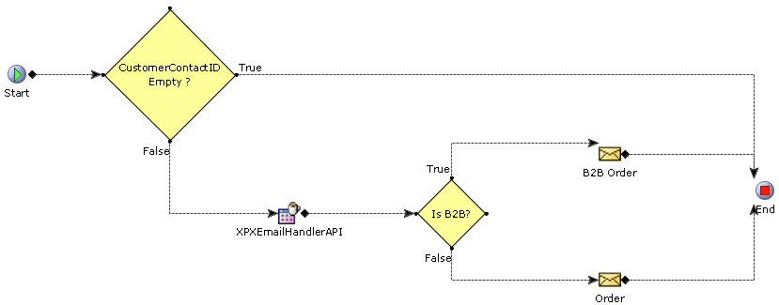

**Properties: Condition**

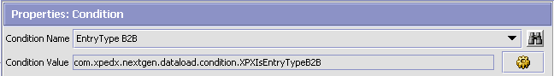

**Properties: E-mail Sender (B2BOrder)**

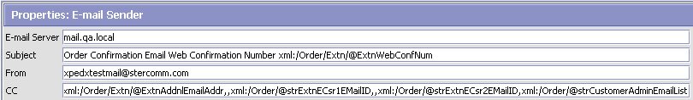

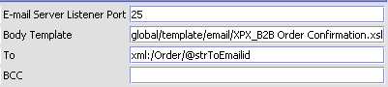

**E-mail Server**: mail.qa.local

**E-mail Server Listener Port**: 25

**Subject**: Order Confirmation Email Web Confirmation Number xml:/Order/Extn/@ExtnWebConfNum

**Body Template**: global/template/email/XPX\_B2B Order Confirmation.xsl

**From**: [xpedxtestmail@stercomm.com](mailto:xpedxtestmail@stercomm.com)

**To**: xml:/Order/@strToEmailid

**CC**: xml:/Order/Extn/@ExtnAddnlEmailAddr,,xml:/Order/@strExtnECsr1EMailID,,xml:/Order/@strExtnECsr2EMailID,xml:/Order/@strCustomerAdminEmailList

**Properties: E-mail Sender (Order)**



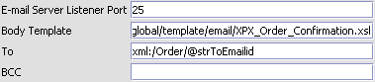

**E-mail Server**: mail.qa.local

**E-mail Server Listener Port**: 25

**Subject**: Order Confirmation Email Web Confirmation Number xml:/Order/Extn/@ExtnWebConfNum

**Body Template**: global/template/email/XPX\_Order\_Confirmation.xsl

**From**: [xpedxtestmail@stercomm.com](mailto:xpedxtestmail@stercomm.com)

**To**: xml:/Order/@strToEmailid

**CC**: xml:/Order/Extn/@ExtnAddnlEmailAddr,,xml:/Order/@strExtnECsr1EMailID,,xml:/Order/@strExtnECsr2EMailID,xml:/Order/@strCustomerAdminEmailList

*Buyer Added*, *Buyer Removed* & *Email Change:*

**Service Name:** XPXSendOrderConfirmationEmailService

**Service Group Name:** XPXOrderPlacement

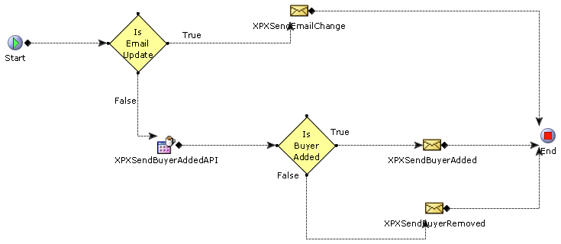

**Properties: E-mail Sender (XPXSendBuyerAdded)**

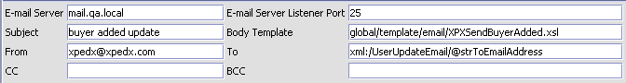

**E-mail Server**: mail.qa.local

**E-mail Server Listener Port**: 25

**Subject**: buyer added update

**Body Template**: global/template/email/XPXSendBuyerAdded.xsl

**From**: [xpedx@xpedx.com](mailto:xpedx@xpedx.com)

**To**: xml:/UserUpdateEmail/@strToEmailAddress

**Properties: E-mail Sender (XPXSendBuyerRemoved)**

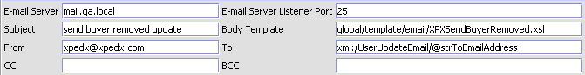

**E-mail Server**: mail.qa.local

**E-mail Server Listener Port**: 25

**Subject**: send buyer removed update

**Body Template**: global/template/email/XPXSendBuyerRemoved.xsl

**From**: [xpedx@xpedx.com](mailto:xpedx@xpedx.com)

**To**: xml:/UserUpdateEmail/@strToEmailAddress

**Properties: E-mail Sender (XPXSendEmailChange)**

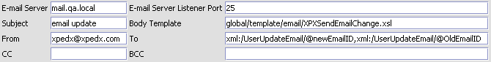

**E-mail Server**: mail.qa.local

**E-mail Server Listener Port**: 25

**Subject**: send buyer removed update

**Body Template**: global/template/email/XPXSendEmailChange.xsl

**From**: [xpedx@xpedx.com](mailto:xpedx@xpedx.com)

**To**: xml:/UserUpdateEmail/@newEmailID,xml:/UserUpdateEmail/@OldEmailID

Latest / Important email communication on data migration items



Property File changes:

*customer\_overrides.properties* for all 4 environments are updated with the paths to the images root folder.

This is for picking up the Brand logo image corresponding to the storefront.