SJR

H index
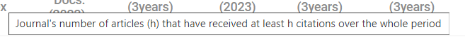
Total Docs 2023
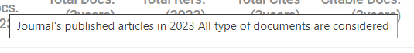
Total Docs. (3years)

Total Refs. (2023)
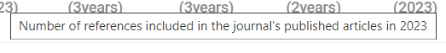

Total Cites (3years)
Citable Docs. (3years)

Cites / Doc. (2years)

Ref. / Doc. (2023)
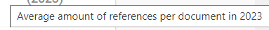

Significado de Quartiles:

Quartile is a journal rank assigned by journal databases based on three major parameters – impact factor (IF), citation, and indexing of any particular journal. There are four journal rank types: Q1, Q2, Q3, and Q4. Q index means the journal's rank, i.e., the four rankings to which the journal belongs.

Componentes de la valoración de los Quartiles

The impact factor (IF) or journal impact factor (JIF) of an academic journal is a scientometric index calculated by Clarivate that reflects the yearly mean number of citations of articles published in the last two years in a given journal, as indexed by Clarivate's Web of Science.
As a journal-level metric, it is frequently used as a proxy for the relative importance of a journal within its field; journals with higher impact factor values are given the status of being more important, or carry more prestige in their respective fields, than those with lower values.
While frequently used by universities and funding bodies to decide on promotion and research proposals, it has been criticised for distorting good scientific practices.[1][2][3]

In general, an impact factor of 10 or higher is considered remarkable, while 3 is good, and the average score is less than 1. The very prestigious journal Nature had an impact factor of 69.504 in the year 2021.

