A COMPARATIVE STUDY OF DWT AND DCT BASED IMAGE WATERMARKING TECHNIQUES

SUBMITTED BY

PRATIK SENGUPTA

EXAMINATION ROLL NUMBER: M1TCS12-17
CLASS ROLL NUMBER: 001111003018
REGISTRATION NUMBER: 92373 of 2004-05

A THESIS SUBMITTED TO
THE FACULTY OF ENGINEERING & TECHNOLOGY OF JADAVPUR UNIVERSITY
IN PARTIAL FULFILLMENT OF THE REQUIREMENTS FOR THE DEGREE OF
MASTER OF ENGINEERING
IN
SOFTWARE ENGINEERING

UNDER THE SUPERVISION
OF
DR. BIBHAS CHANDRA DHARA
ASSISTANT PROFESSOR
DEPARTMENT OF INFORMATION TECHNOLOGY
JADAVPUR UNIVERSITY
2014

DEPARTMENT OF INFORMATION TECHNOLOGY
FACULTY OF ENGINEERING & TECHNOLOGY

JADAVPUR UNIVERSITY

CERTIFICATE OF SUBMISSION

I hereby recommend the thesis, entitled “A Comparative Study of DWT and DCT based Image Watermarking Techniques”, prepared under my guidance by Pratik Sengupta, be accepted in partial fulfilment of the requirements for the degree of Master of Engineering in Software Engineering of Jadavpur University.

-----------------------------------
Dr.Bibhas Chandra Dhara,
Assistant Professor,
Department of Information Technology,
Jadavpur University

Countersigned:

--------------------------------------

Head of the Department,
Department of Information Technology,
Jadavpur University

JADAVPUR UNIVERSITY

DEPARTMENT OF INFORMATION TECHNOLOGY
FACULTY OF ENGINEERING & TECHNOLOGY

CERTIFICATE OF APPROVAL

The thesis at instance is hereby approved as a creditable study of an Engineering subject carried out and presented in a manner satisfactory to warrant its acceptance as a prerequisite to the degree for which it has been submitted. It is understood that by this approval the undersigned do not necessarily endorse or approve any statement made, opinion expressed or conclusion drawn therein, but approve this thesis for the purpose for which it is submitted.

Examiners:

............................................... ......................................... .........
(Signature of the examiner) (Signature of the supervisor)

JADAVPUR UNIVERSITY
FACULTY OF ENGINEERING AND TECHNOLOGY

Declaration of Originality and Compliance of Academic Ethics

I hereby declare that this thesis contains literature survey and original research work by the undersigned candidate, as a part of my Master of Software Engineering studies.

All information in this document have been obtained and presented in accordance with academic rules and ethical conduct.

I also declare that, as required by these rules and conduct, I have fully cited and referenced all material and results that are not original to this work.

Signature with Date

.............................................
Name : Pratik Sengupta
Roll Number : 001111003018
Thesis Title : A Comparative Study of DWT AND DCT Based Image Watermarking Techniques
ACKNOWLEDGEMENT

It has been a long journey by writing this thesis and the related work. I would like to thank a lot of people who gave me unending support and inspiration from the first day till the finishing of the thesis.

With my most sincere respect and gratitude, I would like to thank Dr. Bibhas Chandra Dhara, my guide, for the interesting subject he issued for this work and for his overwhelming support throughout the duration of this project. I would like to thank him for his valuable suggestions, guidance and encouragement which have helped me immensely in understanding the subject. His motivation always gave me the required inputs and momentum to continue my work, without which the project work would not have taken its current shape. His valuable suggestions and numerous discussions have always inspired new ways of thinking. I am highly grateful and I feel deeply honoured that I have got this opportunity to work with him.

I would like to thank all faculty members of the Department of Information Technology for their continuous support.

I would also like to thank my family, all my classmates and friends in Jadavpur University for the constant support and help they provided me all the time.

Regards,

Location: _______________________
Date: Pratik Sengupta
M.E. in Software Engineering
Class Roll No: 001111003018
Exam Roll No: M1TCS12-17
Registration No: 92373 of 2004-05
ABSTRACT

Image watermarking with both insensible detection
and high robustness capabilities is still a challenging problem for
copyright protection up to now. Many proposed methods are already there which are more efficient against certain type of attacks. This paper compares between two major Frequency Transform Watermarking approaches - Discrete Cosine Transform and Discrete Wavelet Transform based Watermarking in colored still image
which are inherently collusion attack resistant.

Our DCT based Watermarking scheme for comparision is
based on averaging of middle frequency coefficients of block
DCT coefficients of an image which introduces high redundancy and can sustain malicious
attacks. Experimental results show the robustness of the
proposed scheme against the JPEG compression and other
common image manipulations.

Whereas, the DWT based scheme is based on hiding the watermark data in blocks of the block segmented image by embedding
the watermark data in the low pass wavelet coefficients of

each block. Due to low computational complexity of the
proposed approach, this algorithm can be implemented in
real time. Experimental results demonstrate the imperceptibility of the proposed method and its high robustness
against various attacks such as filtering, JPEG compression, cropping, noise addition and geometric distortions.

Finally we compare the results from the two schemes.
Chapter 1

Introduction

Nowadays, digital images can be copied and stored easily and without loss in fidelity. Therefore, it is important to use some kind of property rights protection system. With digital multimedia distribution over World Wide Web, authentications are more threatened than ever due to the possibility of unlimited copying. So, watermarking techniques are proposed for copyright protection or authentication of digital media. Many watermarking methods for images have been proposed [1]- [4].

More and more researchers are joining this area and number of publications is increasing exponentially. Most of the work is based on ideas known from spread spectrum communication [5] which is additive embedding a pseudo- noise watermark pattern and watermark recovery by correlation [6]. Cox et al suggested using the DCT domain [6], which has been extensively studied because this is the transform used in JPEG compression. Further advantage of using DCT domain includes the fact that frequency transform is widely used in image and video compression and DCT
coefficients affected by compression are well known.

This paper proposes an efficient use of middle-band coefficients exchange to hide the watermark data. This paper uses the idea of Middle Band Coefficient Exchange which was discussed by Koch and Zhao [8] and further explained by Johnson and Katezenbeisser [9]. Later Hsu and Wu also used
the DCT based algorithm to implement the middle band embedding [10]. Further one more efficient collusion attack resistant scheme has been presented based on middle-band coefficients exchange [7]. Collusion attack is the severe problem for some applications of watermarking like fingerprinting which involve high financial implications. So while designing a watermark scheme we are taking this attack as a prime. [11]- [12] Our main motivation behind selecting middle-band
coefficients exchange scheme as a base is that this scheme has proven its robustness against those attacks which any how do not affect the perceptual quality of an image such as JPEG compression.
Section 2 discusses the background studies. Chapter 3 describes the proposed method and Chapter 4 discusses the results.

Background

The term "digital watermark" was first coined in 1992 by Andrew Tirkel and Charles Osborne. Watermarks are identification marks produced during the paper making process. The first watermarks appeared in Italy during the 13th century, but their use rapidly spread across Europe. They were used as a means to identify the papermaker or the trade guild that manufactured the paper. The marks often were created by a wire sewn onto the paper mold. Watermarks continue to be used today as manufacturer's marks and to prevent forgery.

The information to be embedded in a signal is called a digital watermark, although in some contexts the phrase digital watermark means the difference between the watermarked signal and the cover signal. The signal where the watermark is to be embedded is called the host signal. A watermarking system is usually divided into three distinct steps, embedding, attack, and detection. In embedding, an algorithm accepts the host and the data to be embedded, and produces a watermarked signal.

Then the watermarked digital signal is transmitted or stored, usually transmitted to another person. If this person makes a modification, this is called an attack. While the modification may not be malicious, the term attack arises from copyright protection application, where third parties may attempt to remove the digital watermark through modification. There are many possible modifications, for example, lossy compression of the data (in which resolution is diminished), cropping an image or video, or intentionally adding noise.

Detection (often called extraction) is an algorithm which is applied to the attacked signal to attempt to extract the watermark from it. If the signal was unmodified during transmission, then the watermark still is present and it may be extracted. In robust digital watermarking applications, the extraction algorithm should be able to produce the watermark correctly, even if the modifications were strong. In fragile digital watermarking, the extraction algorithm should fail if any change is made to the signal.

Research Objective

Contributions

Our research work has the following contributions:

• We proposed a new scheme which applies Discrete Dosine Transform and Discrete Wavelet Transform and a hybrid approach to watermark an image. The scheme is robust against JPEG compression, cropping, rotation and other image attacks (see Chapter 4 for detail).

• We have experimented on these image watermarking schemes to test and
show its performance.

• We compare our proposed schemes with the existing scheme in different
aspects and discuss the advantages and the disadvantages of that.

The Structure of this Thesis

This Thesis is organized as 5 chapters. The next chapter introduces the issues
related to multimedia security and different image watermarking
techniques, and a survey on current watermark techniques. The proposed image watermarking schemes
are described in chapter 3 and the experimental results in Chapter 4 are followed
by. Finally, a conclusion is given in chapter 5.

Chapter 2

Literature Survey

Over the past few years, there has been tremendous growth in computer networks
and more specifically, the World Wide Web. This phenomenon, coupled with the
exponential increase of computer performance, has facilitated the distribution of
multimedia data such as images. Publishers, artists, and photographers, however, may be
unwilling to distribute pictures over the Internet due to a lack of security; images can be
easily duplicated and distributed without the owner’s consent. Digital watermarks have
been proposed as a way to tackle this tough issue. This digital signature could discourage
copyright violation, and may help determine the authenticity and ownership of an image.

In general, a digital watermark is a code that is embedded inside an image. It acts
as a digital signature, giving the image a sense of ownership or authenticity. Ideal
properties of a digital watermark have been stated in many articles and papers [13-15].

These properties include:

- A digital watermark should be perceptually invisible to prevent obstruction of the

- original image.

- A digital watermark should be statistically invisible so it cannot be detected or erased.
Watermark extraction should be fairly simple. Otherwise, the detection process
requires too much time or computation.

- Watermark detection should be accurate. False positives, the detection of a non-
marked image, and false negatives, the non-detection of a marked image, should be
few.

- Numerous watermarks can be produced. Otherwise, only a limited number of images
may be marked.

- Watermarks should be robust to filtering, additive noise, compression, and other
forms of image manipulation.

- The watermark should be able to determine the true owner of the image.

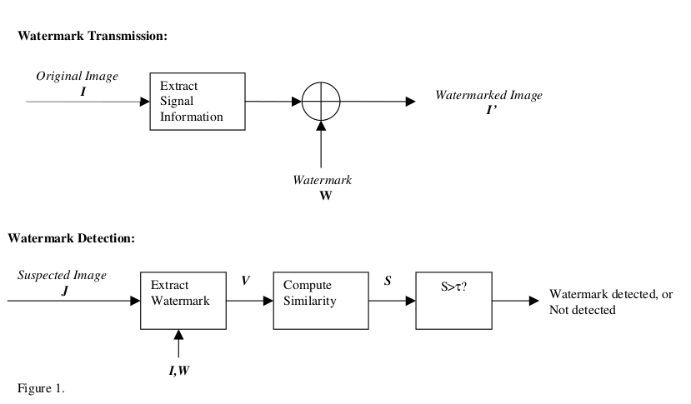

Figure 1 shows a general watermarking scheme. For transmission, the watermark
W is generated as a pseudo-random sequence to ensure statistical invisibility. Signal
information, such as DCT coefficients, are extracted from the original image I and
embedded into the information. The watermarked image I’ is formed with no visible
differences between I and I’.
For watermark detection, a suspected image J is taken and its signal information is
obtained. A suspected watermark V is extracted based on knowledge of the original
image I and the watermark W. A similarity measure S is performed on V and W.
Popular measures include the cross-correlation and correlation coefficient. Finally, S is
compared to a threshold τ. If S is larger than the threshold, then the watermark W is
detected. Otherwise, no watermark is detected.

Security in Multimedia Communications

Steganography
Steganography is the science of hiding information. Whereas the goal of cryptography is to make data unreadable by a third party, the goal of steganography is to hide the data from a third party.

There are a large number of steganographic methods that most of us are familiar with, ranging from invisible ink and microdots to secreting a hidden message in the second letter of each word of a large body of text and spread spectrum radio communication. With computers and networks, there are many other ways of hiding information, such as:

Covert channels (e.g., Loki and some distributed denial-of-service tools use the Internet Control Message Protocol, or ICMP, as the communications channel between the "bad guy" and a compromised system)

Hidden text within Web pages

Hiding files in "plain sight" (e.g., what better place to "hide" a file than with an important sounding name in the c:\winnt\system32 directory?)

Null ciphers (e.g., using the first letter of each word to form a hidden message in an otherwise innocuous text)

Steganography today, however, is significantly more sophisticated than the examples above suggest, allowing a user to hide large amounts of information within image and audio files. These forms of steganography often are used in conjunction with cryptography so that the information is doubly protected; first it is encrypted and then hidden so that an adversary has to first find the information (an often difficult task in and of itself) and then decrypt it.

Digital Watermarking

Image Watermarking

Fidelity

Robustness

Statistical Imperceptibility

Low Error Probability

Real-time Detector Complexity

Reviews on Image Watermarking Techniques

Spatial Domain Watermarks

Modification of the Less-Significant-Bit
(LSB)
: It is a simple approach to superimpose the watermark logo on the Least Significant Bit of the host image. It involves replacing n LSB of host image with data of the message to hide.

Statistical Approximation: It deals with the modification of some
statistics of the image to keep information. A simple
example would be the increase and decrease of
brightness of certain pixels of the image. The pixel
selection is determined by a pseudorandom number
generator. In this way, the statistic of the difference
between two pixels from the image taken randomly is
altered.

Texture Block Encoding: It consist on selecting and copying a portion
of the image determined by texture (herbs, asphalt, etc)
in other area of the image with similar characteristics.
In this way two zones with identical textures can be
obtained from the image. To detect these regions in a
watermarked image it will suffice to calculate the
image self-correlation to detect the position, and
subtract the image itself but shifted to the position
indicated by the self-correlation. After this process,
zones where the difference is 0 can be appreciated. The
geometrical form described by the profile of the copied
zone may be the watermark (industry name,
geometrical figure, etc). If the entire image suffers a
uniform transformation, both regions will be affected
in the same way and it will be possible to detect these
two equal parts. However, this method requires a
visual inspection to detect possible zones to copy, and
the visual impact that the process produces.

Frequency Domain Watermarks

These schemes hide information in
frequencies domain of the images, changing the value
of the spectral coefficients. Most of these approaches
are inspired in coding and compression methods (DCT,
DFT and DWT).

Discrete Cosine Transform

A discrete cosine transform (DCT) expresses a finite sequence of data points in terms of a sum of cosine functions oscillating at different frequencies. The most common variant of discrete cosine transform is the type-II DCT, which is often called simply "the DCT", its inverse, the type-III DCT, is correspondingly often called simply "the inverse DCT" or "the IDCT".

Discrete Wavelet Transform

Discrete Fourier Transform

Chapter 3

Discrete Cosine Transform based schemes:

Discrete Wavelet Transform based schemes:

In [15] a novel method is presented for audio watermarking.
In this method the host signal in transform domains is modified with respect to the binary watermark signal (0 or 1).
The embedding processes used in this method can be summarized as follows:

• Windowing the host signal.

• Applying the wavelet transform to each frame.

• Embedding the watermark bit of 1 or 0 to a number
of wavelet coefficients, W(i), of each frame based on
the following equations:

W'(i) = W(i).α For embedding 1 (1)
W'(i) = W(i)/α For embedding 0 (2)

where α is the strength factor.

• Inverse wavelet transforming the resulted coefficients of each frame.

In the detection process, the embedded data is detected
by the following process:

• Windowing the original and received signal and Applying the wavelet transform to each frame of them.

• Calculating a compare vector by dividing the wavelet
coefficients of the received signal to the original one.

• Detecting the embedded bit by comparing the vector
which is calculated in the second step with a threshold level. If the majority of the vector components is
larger than the threshold level, the embedded bit
would be 1, otherwise 0 is detected
It is proved in [16] that as the embedding process is
symmetrical, the best threshold value is (α + 1/α). 1/2

Watermark embedding

The embedding processes used in this method can be
summarized as:

• Segmenting the original image to small non-
overlapping blocks and then applying the wavelet

transforming to each block.

• In each block, the wavelet coefficients in the last
lowpass scale are modified for embedding 1 or 0
based on (1) and (2).

• Applying the inverse wavelet transform to the obtained wavelet coefficients.

Watermark detection

The detection process can be described as follows:

• Block segmenting of the received and the original
image and applying the wavelet transform to each
block for the both images.

• Calculating the comparing matrix by dividing the
wavelet coefficients of the received image to the
original one.

• Detecting the embedded bit by comparing the matrix
which is calculated in the second step with a threshold level. If the majority of the matrix components is
larger than the threshold level, the embedded bit
would be 1, otherwise 0 is detected.

We use the threshold level of (α + 1/α). 1/2 , same as [16].

Hybrid Watermarking Schemes

Chapter 4

Experimental Results

Results of DWT Watermarking scheme:

In this section we perform several experiments to test the
proposed algorithms and evaluated its performance against
various kinds of attacks. Throughout our experiments we
choose the strength factor of α = 1.05. These factors are selected to
maximize the robustness of this approach, while the modifications introduced by the watermarking process are imperceptible.
We use Normalized Cross Correlation (NCC) to measure the performance
of the watermarking scheme against attacks.
A set of four
common images were tested for our experiments
. The images are illustrated in Figure
2a.

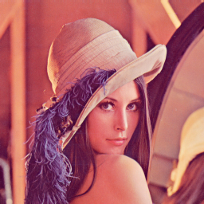 | 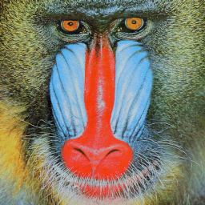
Figure 2a | Figure 2b

The Logo used for watermarking is shown here. It is a 32x32 pixel logo. |   Figure 2c
Logo scaled to 400% |   Figure 2d

They are all 512×512 standard images including: Goldhill, Baboon, Barbara and Boat.

Their watermarked versions are shown in Figures 2b and 2c. As we see the imperceptibility of the watermarked images are satisfied, the mean PSNR (peak-signal-to-noise-ratio) of
the watermarked images are ____dB, ____dB, ____dB
and ____dB respectively.

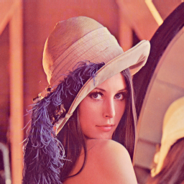 | 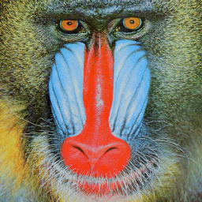
Figure 2c (After Watermarking) | Figure 2d (After Watermarking)
[NCC: 0.972288501863403 mse=1405.107421875, psnr=16.65370833107823, psnrMax=15.944261967833853, snr=12.622343221005396 ber: 0.029296875] | [NCC: 0.9399009203342764 mse=2997.5625, psnr=13.363121138435986, psnrMax=12.653674775191606, snr=9.331756028363149 ber: 0.0625]

In the second experiment, we test the robustness of theis watermarking methods against JPEG compression
attacks. Figure 2e shows the resulted NCC for different images. As we see, the DWT method is highly robust against JPEG attacks.

JPEG Compression/Metrics | NCC | MSE | PSNR | PSNR Max | SNR | BER
100% | 1.0 | 0.0 | Infinity | Infinity | Infinity | 0.0
90% | 1.0 | 0.0 | Infinity | Infinity | Infinity | 0.0
80% | 0.98 | 889.9 | 18.64 | 17.93 | 14.61 | 0.02
70% | 0.97 | 1686.13 | 15.86 | 15.15 | 11.83 | 0.04
60% | 0.96 | 2154.5 | 14.8 | 14.09 | 10.77 | 0.04
50% | 0.93 | 3372.26 | 12.85 | 12.14 | 8.82 | 0.07
40% | 0.89 | 5292.57 | 10.89 | 10.18 | 6.86 | 0.11
30% | 0.85 | 7306.56 | 9.49 | 8.78 | 5.46 | 0.15
20% | 0.76 | 0866.16 | 7.77 | 7.06 | 3.74 | 0.23
10% | 0.61 | 18594.25 | 5.44 | 4.73 | 1.41 | 0.39

JPEG Compression Level | JPEG Compressed Image | Extracted Watermark
100% | 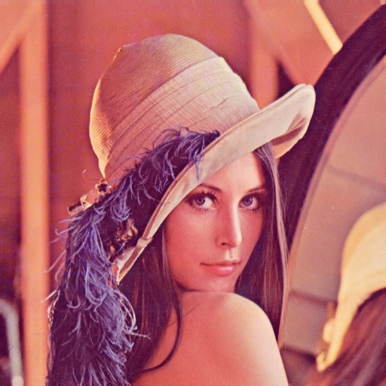
90% | 
80% |  | 
70% |  | 
60% | 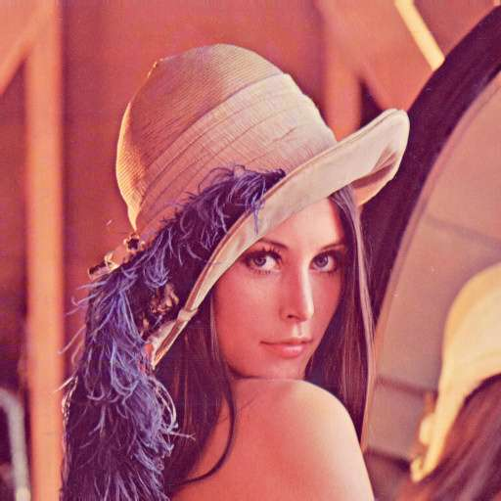 | 
50% |  | 
40% |  | 
30% | 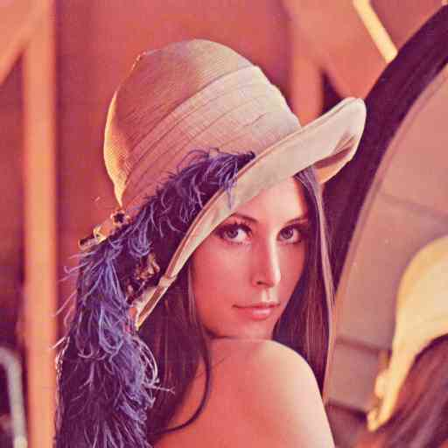 | 
20% |  | 
10% |  | 

In the third experiment, the watermarks are tested against
additive white Gaussian noise attack with different noise
levels. The NCC results are shown in Figure 2f. Again, we
see that the proposed watermarking schemes are robust
against even high variance noise attack.

Robustness against rotation is the concept of the fourth
experiment. Using template matching the rotation attack can
be compensated by identifying the rotation angle and then
rotating the image back. Therefore, the introduced distortion only comes from the interpolation due to
image rotation. The NCC results are shown in Table 1. As
we see even for large rotation angles our watermarking

methods are still robust.

Tests on Robustness

Experiment with Lossy Compression

Tests on Fidelity

Chapter 5

Conclusion

Bibliography

[1] | F.Hartung, and M. Kutter, “Multimedia Watermarking techniques”,  Proceddings of IEEE, Vol. 87, No 7, July 1999, pp. 1079-1107.
[2] | M. Arnold, M. Schmucker, and S.D. Wolthusen, “Techniques and  application of Digital Watermarking and Content Protection”,  Eds.Northwood ,Artech House, 2003.
[3] | Saraju P. Mohanty , "Digital Watermarking: A Tutorial Review",  URL: http://www.csee.usf.edu/~smohanty/research/Reports/WMSurvey1999  Mohanty.pdf http://citeseer.ist.psu.edu/mohanty99digital.htm
[4] | W. Bender, D. Gruhl, N. Morimoto, and A. Lu. "Techniques for data  hiding". IBM Systems Journal, Vol. 35.(3/4), 1996, pp. 313-336.
[5] | P.G.Flikkema, “Spread Spectrum techniques for wireless  communication”, IEEE Signal Processing 14, pp. 26-36, May 1997.
[6] | I.J. Cox, J.Kilian, T.Leighton and T. Shamoon, “Secure Spread  Spectrum watermarking for Multimedia,” IEEE Tras. on Image  Processing , Vol. 6,No12, 1997, pp. 1673-1687.
[7] | Vikas Saxena, J.P. Gupta, “Collusion Attack Resistant Watermarking  Scheme for Images Using DCT” , (To be appear in the Proceedings of  IEEE 15th Signal Processing and Communication Applications  Conference, 11-13 June 2007, Turkey)
[8] | Z. Zhao, and E. koch, “Embedding Robust Labels Into Images For  Copyright Protection”, Proc. of International  Congress on  Intellectual Property Rights for Specialised Information, Knowledge  and New Technologies", Vienna, Austria, August 21-25,1995, pp. 242-  251.
[9] | N. Johnson, ,and S. Katezenbeisser, “A Survey of Steganographic  Techniques”, Eds.Northwood, MA:ArtecHouse,43, 1999.
[10] | C.T.Hsu, and J.L.Wu., “Hidden Singatures in Images”, Proc. IEEE  International Conf. on Image Processing, ICIP-96, Vol.3, pp.223-226.
[11] | Network Technology research Center, Nanyang Technological  University, Singapore, http://www.ntu.edu.sg/ntrc/research.htm
[12] | Collusion-resistant watermarking and fingerprinting,  US Patent Issued on June 13, 2006  http://www.patentstorm.us/patents/7062653.html
[13] | I. Cox, J. Kilian, F. Leighton, and T. Shamoon, “Secure Spread Spectrum  Watermarking for Multimedia,” IEEE Transactions on Image Processing, vol. 6,  no. 12, pp. 1673-1687, Dec. 1997.
[14] | M. Swanson, B. Zhu, and A. Tewfik, “Transparent Robust Image Watermarking,”  Proc. IEEE Int. Conf. on Image Processing, Sept. 1996, vol. III, pp. 211-214.
[15] | I. Pitas, “A Method for Signature Casting on Digital Images,” Proc. IEEE Int. Conf.  on Image Processing, Sept. 1996, vol. III, pp. 215-218.
[16] | M. A. Akhaee, S. GhaemMaghami, and N. Khademi, "A  Novel Technique for Audio Signals Watermarking in the Wavelet  and Walsh Transform Domains," in International Symposium on  Intelligent Signal Processing and Communication Systems  (ISPACS), Japan, Dec, 2006.

