# Homework: Heaps and Priority Queues

This document defines the **homework assignments** for the ["Data Structures" course @ Software University](https://softuni.bg/trainings/1147/Data-Structures-June-2015).

## Implement Decrease Key

Extend your Binary Heap to support the DecreaseKey(T element) operation, that changes the priority of a given key. In a Min Binary Heap this should increase the priority of a given key, moving it higher in the tree structure, e.g. decreasing the price of a given product, increases its priority for the customers.

## A* Algorithm

You are given a skeleton. Your task is to implement the A* algorithm in order to find the shortest path from a starting point "P" (Start) to a goal point "*" (Goal) on a given grid of squares. Player is only allowed to walk up, right, down or left. The AStar class should return the path as IEnumerable<Node>, each entry corresponding to the next cell in the shortest path.

You can read more about the A* here: <http://web.mit.edu/eranki/www/tutorials/search/>

Or here: <http://www.redblobgames.com/pathfinding/a-star/introduction.html>

|  |  |  |
| --- | --- | --- |
| **Maze** | **Output Nodes** | **Path** |
| -----  -*---  WWWW-  ---P- | { "3 3", "3 4", "2 4", "1 4", "1 3", "1 2", "1 1" } | -----  -@@@@  WWWW@  ---@@ |

If there is no path to the goal, return IEnumerable<Node> containing only the start node.

|  |  |  |
| --- | --- | --- |
| **Maze** | **Output Nodes** | **Path** |
| -----  -*---  WWWWW  ---P- | { "3 3" } | -----  -----  WWWWW  ---@- |

### Hints: H Cost

First of all, implement the method GetH(). **H** is the approximation of the distance from the current node to the goal. Use **Manhattan distance** (total number of squares moved horizontally and vertically to reach the target, ignoring diagonal movement, and ignoring any obstacles that may be in the way)

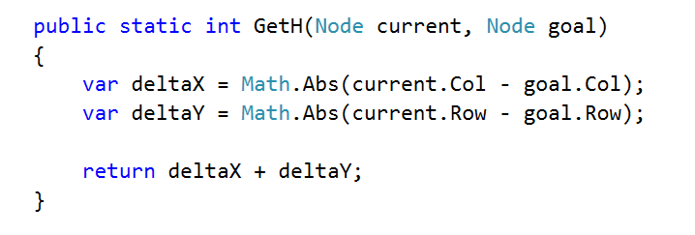

### Hints: A* Pseudocode

We need some way to store to cost to a given node and the node that we are coming from.

* OPEN = priority queue containing START
* PARENT = dictionary storing the node from which we have reached a node (following a path)
* COST = dictionary storing cost from the start to a node (following a path)
* PARENT[START] = null
* COST[START] = 0
* **Keep in mind that defining the structure at instance-level would be beneficial if someone is trying to find the shortest path in the same maze.**
* while OPEN is not empty:
  + current = remove highest priority item from OPEN
  + if current is the goal 🡪 break
  + for each neighbor of current (up, right, down, left):
    - new cost = COST[current] + 1
    - if neighbor is not in COST or new cost < COST[neighbor]
      * COST[neighbor] = new cost
      * neighbor.F = new cost + HCost(neighbor, goal)
      * OPEN 🡨 neighbor
      * PARENT[neighbor] = current

You can reconstruct the path following PARENT[goal] to the starting node. If there is no path to the goal PARENT[goal] won't be in the dictionary.

# Hierarchy – Data Structures Exam

A **Hierarchy** is a data structure that stores elements in a hierarchical order. See the example:

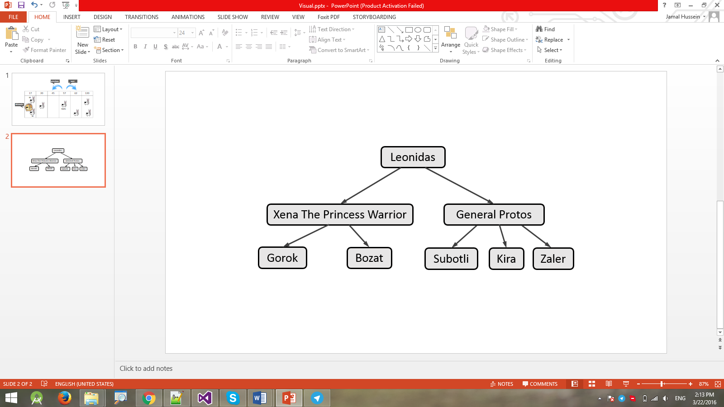

It supports the following operations:

* **Add(element, child)** - adds **child** to the hierarchy as a child of **element**.
  + Throws an exception if **element** does not exist in the hierarchy.
  + Throws an exception if **child** already exists (duplicates are not allowed).
* **Remove(element)** - removes the element from the hierarchy.
  + If it has children, they become children of the element's parent.
  + If element is root node, throws an exception.
* **Count** - returns the count of all elements in the hierarchy
* **Contains(element)** - determines whether the element is present in the hierarchy.
* **Get-Parent(element)** - returns the parent of the element.
  + Throws an exception if **element** does not exist in the hierarchy.
  + Returns the **dafault value for the type** (e.g. **int** → **0**, **string** → **null**, etc.) if element has no parent.
* **Get-Children(element)** - returns a collection of all direct children of the element in order of their addition.
  + Throws an exception if **element** does not exist in the hierarchy.
* **Get-Common-Elements(Hierarchy other)** - returns a collection of all elements that are present in both hierarchies (order does not matter). **\*Keep in mind that nested for-loops give higher algorithm complexity (n^2), it would be unpleasant if there were no common elements.**
* **For-Each()** - enumerates over all elements in the hierarchy by levels.
  + In the image above, the elements would be enumerated as such - **Leonidas** -> **Xena the Princess Warrior** -> **General Protos** -> **Gorok** -> **Bozat** -> **Subotli** -> **Kira** -> **Zaler**.

### Input and Output

You are given a **Visual Studio C# project skeleton** (unfinished project) / **IntelliJ Java project** holding the interface IHierarchy, the unfinished class Hierarchy and **tests** covering its **functionality** and its **performance**.

Your task is to **finish this class** to make the tests run correctly.

* You are **not allowed to change the tests**.
* You are **not allowed to change the interface**.

### Interface IHierarchy

The interface IHierarchy in C# looks like the code below:

|  |
| --- |
| public interface IHierarchy<T> : IEnumerable<T>  {  int Count { get; }  void Add(T element, T child);  void Remove(T element);  IEnumerable<T> GetChildren(T element);  T GetParent(T element);  bool Contains(T element);  IEnumerable<T> GetCommonElements(IHierarchy<T> other);  } |

The interface IHierarchy in Java looks like the code below:

|  |
| --- |
| **public interface** IHierarchy<T> **extends** Iterable<T> {  **int** getCount();  **void** add(T element, T child);  **void** remove(T element);  Iterable<T> getChildren(T element);  T getParent(T element);  **boolean** contains(T element);  Iterable<T> getCommonElements(IHierarchy<T> other); } |

### Submissions

Submit an archive (.zip) of the source code + external libraries.

# Scoring

Each implemented method brings you a specific amount of points, some of the points are awarded for correct behavior, others for performance. You need to cover all tests in a given group in order to receive points. Bellow is a breakdown of all points by methods:

|  |  |  |  |
| --- | --- | --- | --- |
| Method | Correct Behaviour | Performance | Total |
| Add | 3 | 8 | 11 |
| Remove | 4 | 12 | 16 |
| Contains | 3 | 10 | 13 |
| Get Parent | 3 | 11 | 14 |
| Get Children | 3 | 11 | 14 |
| Get Common Elements | 4 | 12 | 16 |
| For Each | 4 | 12 | 16 |
| Overall: | 24 | 76 | 100 |