* + Details of tools and frameworks used
    - **Postman** (version >= 9.31.0)
    - **NodeJs** (version >=10.0)
    - Below 2 NodeJs dependencies to be installed
      * newman
      * newman-reporter-htmlextra
  + Assumptions made while developing the test cases
    - The application is an online booking solution for hotels/lodge/B&B. API’s are exposed to various 3rd parties systems to manage their booking.
      * Following 4 API’s are in scope of testing
        + Create-Booking
        + Get-Booking
        + Update-Booking
        + Delete-Booking
    - Tests to be create around different **CRUD** operations for these API’s.
      * **C**reate, **R**ead, **U**pdate & **D**elete
    - High level test cases as below
      * Happy path scenario
        + Create booking - Post operation
        + Retrieve/Get booking - Get operation
        + Update booking - Put operation
        + Delete booking - Delete operation
      * Scenarios to be added to check different validation messages in case of corrupt input for all the API’s

**How to run the project**

2 ways to run the project, 1st via postman and 2nd via command prompt/terminal

1. Run project via Postman
   1. Import **RESTFUL-BOOKER.postman_environment.json** in the **environment** section and **Restful-Broker.postman_collection.json** in the **collections** section of the postman

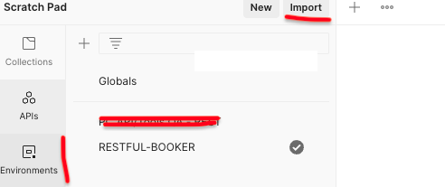 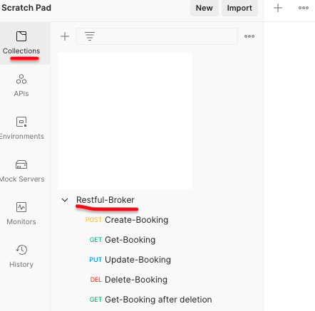

* 1. Run the collection from view more actions
  2. Click on Run button

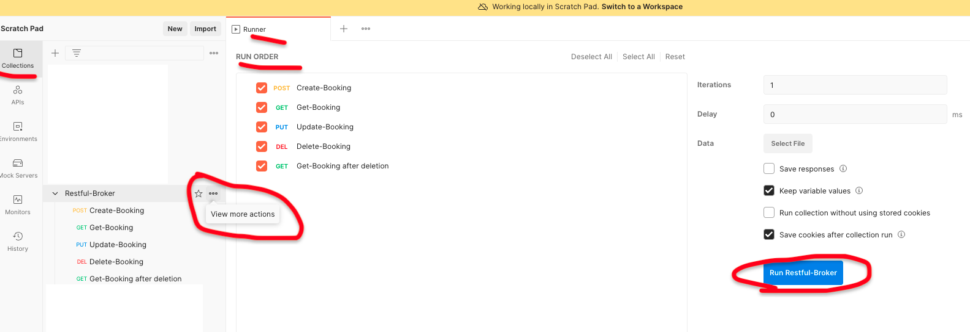

* 1. View the summary/Run Again or Export the results

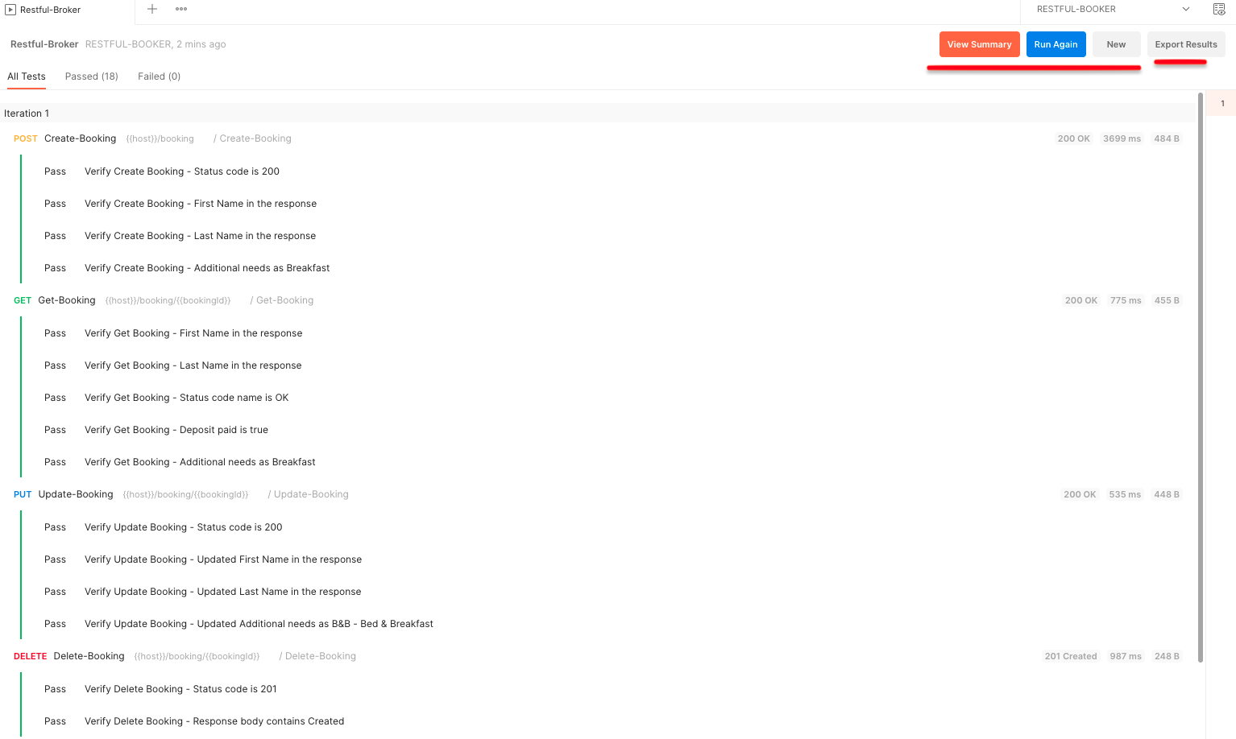

1. Run project via command prompt and terminal
   1. Create a folder in your machine. For eg:- <<NewmanCollection>> as per this example and copy **RESTFUL-BOOKER.postman_environment.json** and **Restful-Broker.postman_collection.json** in this folder.
   2. Open terminal/command prompt and ensure that you are in this folder

* 1. Execute the below command from the terminal

***newman run Restful-Broker.postman_collection.json -e RESTFUL-BOOKER.postman_environment.json -r htmlextra***



* 1. After command is executed html results file is generated in a new folder named newman

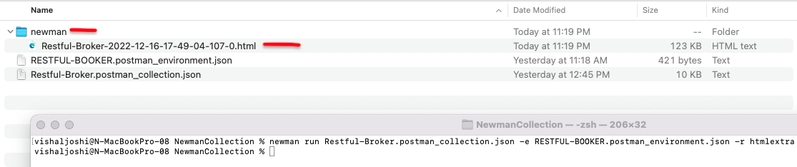

* 1. View the results in HTML format

