BMC Software UI assignment

**Tools/technologies used**

* Java - version "1.8.0_202"
* Apache Maven 3.8.6
* Eclipse - Version: Oxygen.2 Release (4.7.2)
* Eclipse should have TestNG & Cucumber plugin configured
* Below dependencies defined in Project Maven POM.xml
  + Gherkin
  + JUnit
  + Selenium
  + cucumber-html
  + log4j

**How to run the project**

* Download the project and import it in any Java editor VIZ. eclipse, intellij etc.
* Configure the project and ensure that there are no errors.
* Build/compile the project.
* Navigate to file **GoogleRunnerTest** under **src\test\java\com\googlesearch\testrunner** path. Right click on it and run as **JUnit** Test.

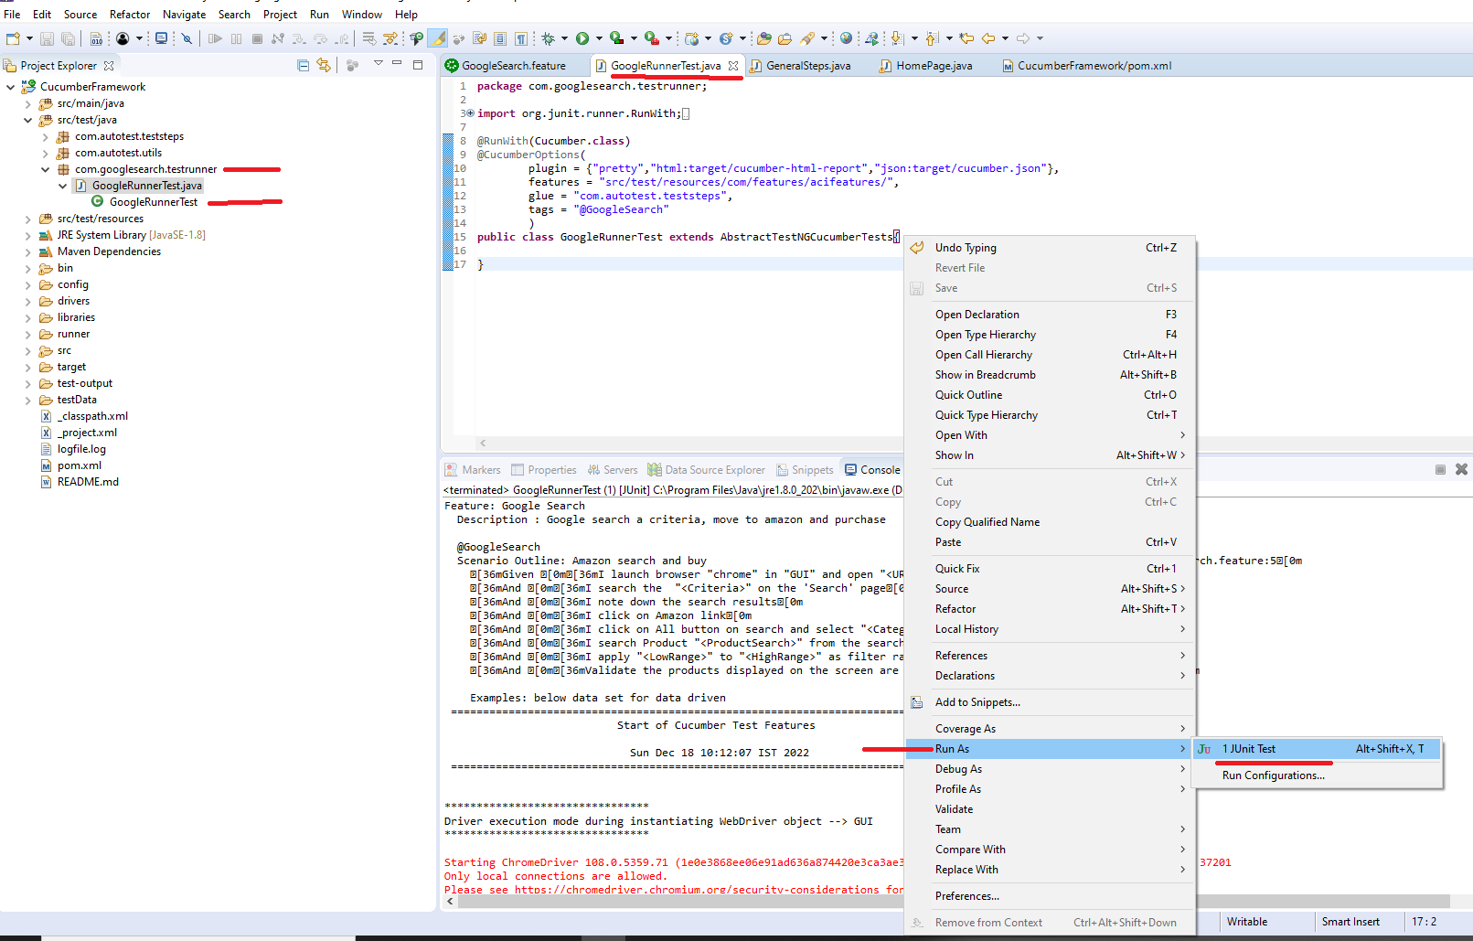

* Results are generated under **\target\cucumber-html-report** folder. Refer to **index.html** for the results.
* Results file is displayed as below.

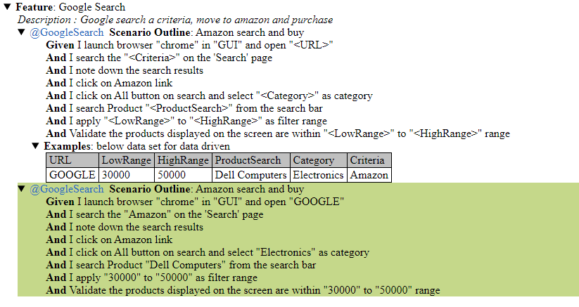

**Search Results** and validation of product amount (**>= 30000 and <=50000**) are displayed in the **console logs**.

Input data is picked from the scenario outline in the feature file

