EVOLUTIONARY PATTERNS IN LATE QUATERNARY CALIFORNIA CONDORS

Valerie J. Syverson¹ and Donald R. Prothero^{1,2}
- Division of Geological and Planetary Sciences, California Institute of Technology, Pasadena, CA 91125 USA: valeriej@caltech.edu
- Department of Geology, Occidental College, Los Angeles, CA 90041 USA: prothero@oxy.edu

KEY WORDS: condor, Pleistocene, La Brea tar pits, Holocene, extinctions, dwarfing

ABSTRACT
Pleistocene fossils related to the living California condor (Gymnogyps californianus) have been found in several locations in western North America. Different authors have either assigned these to the species G. amplus or considered them a chronological subspecies of G. californianus. We examined the morphology of the genus Gymnogyps from the late Pleistocene to the present, using specimens from the asphalt deposits of Rancho La Brea (RLB) and modern skeletons, a total of about 80 specimens. The limb bones (using seven variables on each element) and skulls (using 13 variables) were quantitatively compared using bivariate and multivariate techniques. No significant size or shape change through time was apparent in RLB samples ranging from the late Pleistocene (35,000 radiocarbon years b.p.) to the early Holocene (9000 radiocarbon years b.p.), suggesting evolutionary stasis in the face of the climatic changes of the last glacial-interglacial cycle. Proximal limb elements and skulls showed patterns of variation consistent with a species distinction between the RLB specimens and modern G. californianus. This confirms Fisher’s (1944) contention that the RLB species is G. amplus Miller 1911, and not referable to the modern species. A set of specimens from a 9000 year old Indian midden in Oregon as well as the presence of Gymnogyps in early Holocene Pit 10 at RLB suggest that the modern and ancient Gymnogyps may have coexisted with each other as well as with humans, and not died out or become dwarfed with the extinction of the rest of the Pleistocene megafauna, as suggested by some authors.

Introduction
The Rancho La Brea (RLB) fossil asphalt pits of Los Angeles, California, are one of the foremost late Pleistocene fossil localities in the world (Akersten et al., 1983; Stock & Harris, 1992). These deposits have been radiocarbon dated from 35 ka to 9 ka, or from the late Pleistocene to the early Holocene (Marcus & Berger, 1984). Fossils from these deposits provide a fairly complete longitudinal picture of the fauna during this period, spanning the end of the Tioga glacial maximum in California and the beginning of the Holocene interglacial period. A recent survey of both modern and RLB fossil golden eagles, Aquila chrysaëtos, indicates no overall trends in body size over the period from 35 ka to the present (Molina & Prothero, submitted). In this study, we measured a set of modern and RLB bones from the California condor, genus Gymnogyps, in order to look for morphological trends over time related to the environmental changes due to glacial-interglacial cycles.
An additional question is raised in the literature regarding the validity of the species distinction between Gymnogyps californianus, the modern California condor, and G. amplus, a Pleistocene species. The type specimen for the latter is a single broken tarsometatarsus (UCMP 9834) from the Pleistocene of Samwel Cave near Shasta Lake (Fig. 1). Fossils from this deposit yield radiocarbon ages between 16 and 20 ka (Feranec et al., 2007). UCMP 9834 was figured and described by Miller (1911) who regarded the robustness of the specimen as an indication of species distinct from the living California condor. However, Miller compared it to only 14 RLB condor tarsometatarsi, since they were just beginning to be discovered. The type specimen is of limited diagnostic use, so taxonomic opinion is divided on the identity of the RLB specimens. Based on a number of cranial characters, Fisher (1944, 1947) argued that the RLB condor could be referred to G. amplus as a distinct, valid species. But Emslie (1988, p. 220) argued that the G. amplus was not a distinct species, but at best a temporal subspecies of G. californianus. This follows the general opinion of many avian paleontologists (Howard, 1947; Wetmore, 1959; Brodkorb, 1964; Jollie, 1976-1977; Rea & Hargrave, 1984). We attempted to resolve this disagreement by applying statistical techniques to our morphological data set.

Methods
Nearly every available unbroken adult specimen of the bones listed in Table 1 were measured in the collections of the George C. Page Museum, the Natural History Museum of Los Angeles County, the Santa Barbara Natural History Museum, and the Museum of Paleontology and Museum of Vertebrate Zoology at the University of California, Berkeley. Seven dimensions were measured on limb bones, 11 on crania, and two on maxilla. Measurements were made with dial calipers, accurate to the nearest 0.1 mm, following the landmarks and protocols used by Fisher (1944) and Bochenski & Campbell (2006), and then entered into Excel spreadsheets. Statistical analyses were performed using Excel and SYSTAT software.

Abbreviations
LACM, Natural History Museum of Los Angeles County; LACMHC, Hancock Collection, George C. Page Museum, Natural History Museum of Los Angeles County; SBNHM, Santa Barbara Natural History Museum; UCMP, University of California Museum of Paleontology; UCMVZ, University of California Museum of Vertebrate Zoology; CMC, carpometacarpus; TBT, tibiotarsus; TMT, tarsometatarsus.

SYSTEMATIC PALEONTOLOGY

Order Ciconiiformes Bonaparte, 1854
Family Vulturidae (Illiger, 1811)
Genus Gymnogyps Lesson, 1842

Gymnogyps amplus Miller, 1911

Type specimen: UCMP 9834, a right tarsometatarsus with the proximal end broken (Fig. 1), from Samwel Cave, Shasta County, California.
Plesiotypes: LACMHC B2832, B2703, and B3781, cranium, rostrum, and mandible, from La Brea tar pits, Los Angeles County, California (fide Fisher, 1944)
Revised specific diagnosis: distinguished from G. californianus by general larger size and greater robustness, especially in the proximal limb elements (humerus and femur). Distinct columnar swelling above the foramen magnum. Robust, widely spread occipital processes with wide, blunt ends (Fig. 2). Frontoparietal suture further forward, much wider occipital, and a larger ratio of occipital width to cranial length than G. californianus.
Discussion: Miller (1911, p. 390) erected the species G. amplus based on a broken (proximal end missing) right tarsometatarsus, UCMP 9834 (Fig. 1) from the late Pleistocene (16-20 ka, fide Feranec et al., 2007) deposits of Samwel Cave in Shasta County, California. He diagnosed this species as distinct from G. californianus (the living California condor) based on its much broader, more robust proportions, and “foot set inward on the shaft so that the median line of the shaft falls outside the center of the foot.” Based on 14 specimens of tarsometatarsi that had become available from the recently discovered Rancho La Brea deposits, Miller (1911) regarded the type specimen of G. amplus as distinct from the RLB condors, as well as from the living species. As he noted, “in this splendid series [of RLB condor TMTs], there is no individual which approaches in breadth of shank the dimensions displayed in the specimens here described.” Miller (1911) regarded the type of G. amplus as outside the range of variation of any fossil or living condor described up to that time. On the other hand, Miller (1911) considered the RLB condor specimens to be within the range of variation of living G. californianus.
Fisher (1944, 1947) examined a much larger sample of RLB condors, including 107 crania, and numerous other bones, and revised Miller’s (1911) taxonomy. He noted that the type specimen of G. amplus, UCMP 9834, was no longer distinctively robust, but was similar to some other RLB condor TMTs (Fig. 1). Our own measurements confirmed this (Fig. 3). Although the type of G. amplus is one of the most robust specimens of Gymnogyps TMTs known, it falls within the range of variation of RLB specimens. Some RLB TMT specimens, such as LACMHC B2832, B2703, and B3781, are comparable in proportions (Fig. 1). In addition, the clusters of RLB TMTs overlap with those of G. californianus, so the two species cannot be distinguished based on this particular bone.
For this reason, Fisher (1944) redefined G. amplus (based entirely on RLB specimens, including plesiotype skull elements LACMHC B5415, B6513, and B7591) to include a suite of characters that distinguished RLB condors from the living species. He noted that there were many differences in the skull, mostly related to greater size and robustness. He observed that the frontoparietal suture was further forward in the RLB condor skulls, and that there was a columnar swelling above the foramen magnum. The RLB skulls also had a deeper temporal fossa and temporal muscle attachment. In addition to these and some other less striking differences, the most obvious distinction occurred in the robustness and spread of the occipital process, which are terminated with a wide, blunt end. This is in contrast to the shorter, more pointed occipital processes of G. californianus (Fig. 2), which do not flare as widely. Our own measurements of these processes (see below) confirm how distinct they are in shape and size. As noted by Fisher (1944, p. 290), the RLB skulls had a much wider occipital width, and a larger ratio of occipital width to cranial length, which did not overlap with that of the living species. Fisher’s (1944) paper was chiefly focused on skulls, but he commented “it is hoped that the entire skeleton of the Pleistocene species may be studied statistically since large series of most bony elements are available. At that time it may be possible to add substantially to the differentiation between the two species” (Fisher, 1944, p. 290). Fisher (1947) later examined and measured most of the postcranial elements in the RLB sample, but failed to find any distinctions between G. amplus and G. californianus in his measurements. Finally, Miller (1957) re-examined his type specimen of G. amplus and again argued that it was more robust than any RLB condor TMT.
Since Fisher’s (1944, 1947) and Miller’s (1911) papers, however, most avian paleontologists have regarded G. amplus as a larger, more robust temporal subspecies of G. californianus (Howard, 1930, 1947; Wetmore, 1959; Brodkorb, 1964; Jollie, 1976-1977; Rea & Hargrave, 1984). Emslie (1988, p. 220) restudied the problem, and argued that the differences were simply due to the larger size of the RLB specimens, and thus the RLB specimens were not a distinct species. Emslie commented that many of the qualitative differences noted by Fisher (1944) could be seen in G. californianus, and thus the two species could only be distinguished by size. In this regard, Emslie (1988, Tables 2, 3, and 4) argued that the RLB and modern species overlap in most dimensions, so the distinction is not valid. However, he measured only 32 CMCs and TMTs of RLB condors, and expressed his results as means and ranges of variation, without publishing any bivariate plots that would visually show whether the two clusters of morphology could be distinguished.
In our own measurements, it is apparent that RLB and modern condors do overlap in most measurements of the TMT and other distal limb elements, such as the tibiotarsus. Skull dimensions and proximal limb elements and skulls, however, showed patterns of variation consistent with a species distinction between the RLB specimens and modern G. californianus. In Fig. 4A, all cross-sectional areas of the femur display noticeable segregation between the RLB and modern specimens; the same is true to slightly lesser extent in the humeri (Fig. 4B). This is marked even more strongly in several skull dimensions (Fig. 5A, B, C), specifically the ratio of skull length to temporal width (Fig. 5A), ratio of skull length to height of the cranial vault, ratio of the width between the occipital protrusions versus that between the opisthotic protrusions (Fig. 5B), and the relative length of the occipital protrusions (Fig. 5C). This last feature was noted by Fisher (1944) as one of the distinctions between the RLB specimens (G. amplus, fide Fisher) and G. californianus.
These data distinctions are apparent not only in bivariate plots such as those in Figures 4 and 5, but also in statistical analysis of the dataset. Each measurement of extant G. californianus was compared to the comparable measurement of RLB specimens (Table 2). Nearly all samples had significantly unequal variances, as established by the F-test, and were normally distributed, as established by a chi-squared test. Thus, we performed t-tests on the samples assuming unequal variances. In nearly every dimension, the RLB specimens were significantly larger than the comparable modern condor specimens (at the 95% confidence level). Thus, the distinction is not only established by visual inspection and bivariate plots, but also by statistical analysis.
Surprisingly, Fisher (1947) did not find these distinctions in his data set of postcranial bones. This may be due to the fact that he measured a smaller number of specimens (typically only a dozen). He also displayed his results as simple tables of means and standard deviations. In data such as those in Fig. 4A and 4B, there is a slight overlap in individual variables between humeri and femora of G. amplus and G. californianus, but it is clear from visual inspection of bivariate plots and from statistical analysis (Table 2) that the clusters are distinct, with only a few outlying points that fall inside the cluster of the other species. Indeed, if one looks closely at the data in Fisher’s (1947, Table 2) humerus sample or his femur sample (Fisher, 1947, Table 11), it is clear that the means are strikingly different between G. amplus and G. californianus. If we had his original data available and could analyze them ourselves, they would prove to be statistically non-overlapping. But Fisher did not notice these differences because the distal limb elements do not show the distinction between species as well as the proximal elements do. Thus, it appears that Fisher (1947) did not use the appropriate methods for discriminating two populations that are subtly separated in proportions.

Sexual dimorphism
In analyzing size changes through time of any fossil species, it is important to account for possible differences in size due to sexual dimorphism. Living G. californianus shows only the slightest sexual dimorphism, with males averaging slightly larger than females (Koford, 1953; Snyder & Snyder, 2000, 2005). To confirm this, we examined the distribution of sexed specimens in the samples of living condors. Although we measured every available specimen in the UCMVZ, SBNHM, and LACM collections, and had as many as 62 femora and 29 humeri in our sample (Table 1), only a handful of the bones had the gender of the bird recorded. Nonetheless, the size of the sexes is completely overlapping in our largest sample of sexed bones (7 males, 3 females), as shown in Figure 6. The largest specimens were indeed males, but they overlapped completely with the females, and some of the smallest were also males (not surprising, considering there were twice as many male specimens). Thus, there is no reason to expect that sexual size dimorphism is a factor when discussing size changes through time.

Discussion

Morphological stasis through time

The late Pleistocene was a time of dramatic global climatic change. From the peak interglacial at 125 ka, the planet went through a steady decline into the early Wisconsinan glacial stage, also known as oxygen isotope stage 3 in the marine record. The last glacial maximum spans the interval from 24-14 ka, with the peak cooling at 20 ka. Between 14-10 ka, the planet then went through a glacial-interglacial transition, with a rapid pulse of warming and cooling during the Younger Dryas event between 12.8 ka and 11.5 ka, which marked the transition into the Holocene interglacial (the last 10,000 years).
Although southern California did not experience the climatic extremes of icecaps or tundra vegetations, nevertheless the climatic changes in the region were dramatic. Analysis of wood specimens (Ward et al., 2005) demonstrated that C3 plant primary productivity was greatly reduced during the last glacial maximum. Analyses of plant fossils (Warter, 1976) and mollusks (Lamb, 1989) show that the Pleistocene climate was cooler, milder and wetter than today. Stable isotope biogeochemistry on bones (Coltrain et al., 2004) suggest a drying trend during the last glacial maximum, followed by dramatic changes in carbon and nitrogen isotopes as the Holocene approached.
Heusser (1998) analyzed the pollen preserved in deep-sea cores offshore from RLB, and was able to obtain a more detailed record of climatic and vegetational change. Between 40 and 24 ka, southern California made the transition from oak and chaparral vegetation to pine-juniper-cypress woodlands. At the glacial maximum (24-14 ka), the region was covered in junipers and closed-cone pines, with a brief return to oak-chaparral at 15 ka. During the glacial-interglacial transition (14-10 ka), the oak-chaparral was mixed with alders. Since 10 ka, the region has been dominated by the modern oak woodland-chaparral vegetation.

Given these dramatic changes in climate and vegetation over the past 40,000 years, one would expect to see significant changes in size and/or shape in the condor population that soared above and scavenged this landscape. However, in the RLB specimens we measured, no significant (Table 3) size or shape change through time was apparent in any element for samples ranging from 35,000-9,000 ka, suggesting evolutionary stasis in the face of the climatic changes of the last glacial-interglacial cycle (Figure 7) This is consistent with the recent study showing a similar lack of change in golden eagles from the RLB asphalts (Molina & Prothero, submitted), or the lack of notable size changes in the RLB turkey (Bochenski & Campbell, 2006).

Such stasis in the face of climatic changes, especially significant drying and vegetational change, are in stark contrast to the traditional model of bird evolution as exemplified by the Galapagos finch (Weiner, 1995; Grant and Weiner, 1999; Grant & Grant, 2007). If such disparate birds as turkeys, eagles, and condors show stasis despite the climatic changes of the past 40,000 years, perhaps the Galapagos finch model of immediate response to climate change is not universally applicable to birds, or to mammals, either (Prothero & Heaton, 1996; Prothero, 1999; Barnosky, 2005; Prothero et al., submitted). The widespread stasis of many different groups of animals in response to climatic and vegetational change suggests that we may need to rethink just how sensitive organisms are to climate, and reassess the importance of climate in driving evolution.
Potential temporal overlap with humans

There is a partial skeleton tagged as Gymnogyps californianus (UCMVZ 13377) which bears a written note indicating that it was not a museum-prepared skeleton like all the others in the collection, but instead was found in a midden at an archaeological dig at The Dalles, Oregon, associated with ancient Native Americans. As there are three humeri present, this box clearly holds the remains of more than one animal. For the purposes of the present study, however, the interesting aspect of the specimen lies in its measurements. The skull of UCMVZ 13377 falls well outside the range of sizes observed for Gymnogyps californianus, and indeed at the large end of the spectrum of RLB specimens.
There is no reason to assume these fossils are from a single individual, and indeed the assemblage of bones certainly contains at least one element from a second condor, if not more. However, since the bird to which skull UCMVZ 13377 belonged presumably lived (and died) at the same time as the people depositing the midden, this unique specimen indicates likely coexistence of the late Pleistocene California condor with humans.
A Indian midden, known as Five Mile Rapids, not far from The Dalles (Simons, 1983), yields condor bones that were mostly referred to G. californianus by Miller (1957), although his concept of G. amplus is different from that of Fisher (1944, 1947) or as used in this paper. This midden ranges in age from 9785 ± 220 radiocarbon years at the base to 7875 ± 100 radiocarbon years at the top (Simons, 1983). We are not sure whether the UCMVZ specimens mentioned above are from this midden, since the locality information is vague on the specimens, but it seems very unlikely that there are two such major condor-bearing Indian midden localities next to The Dalles. We surmise that the collections made for the UCMVZ were made before the locality was formally described as the Five Mile Rapids midden. If so, then Miller’s identification of these condors as G. californianus should be amended to G. amplus.
The idea that large Pleistocene condors survived into the early Holocene is supported by the solitary specimen of Gymnogyps amplus (LACM G2465, a very robust TMT) found in Pit 10 at Rancho La Brea. It is the only condor specimen in Pit 10, and there are none that suggest the less robust modern species. Pit 10 was the location where "La Brea Woman", the only human fossil found in the RLB deposits, was unearthed; it is also the youngest of the RLB excavations so far, with a radiocarbon age of 9,000 years.
If both of these occurrences of G. amplus in the early Holocene are valid, this has implications for studies that argue that that large condors vanished, or became dwarfed, in response to the Holocene changes in climate and the loss of their megafaunal prey. For example, Emslie (1987) showed that condors vanished from the Grand Canyon region in synchrony with the loss of the megafauna about 10 ka. However, these occurrences in California and Oregon show that a similar extinction did not occur in California or Oregon. Chamberlain et al. (2005) and Fox-Dobbs et al. (2006) looked at the isotopic values of a number of large Pleistocene vultures, and concluded that Gymnogyps survived into the Holocene when their megafaunal prey vanished by shifting to a diet of marine food items, especially marine mammal carcasses. The isotopic evidence for diet is strong, but our data show that the dwarfing of G. amplus to give rise to G. californianus did not occur immediately upon the extinction of the Pleistocene megafauna, but apparently took place some time in the early Holocene, younger than 9000 years ago, and possibly as recent at 7000 years ago. Early Holocene localities with condors are very rare, so we do not have the data yet to determine whether G. amplus and G. californianus actually co-existed in the early Holocene (a splitting speciation event) or the lineage reduced in size some time after the early Holocene (anagenesis). Either way, it is clear that the size reduction did not happen immediately after the megafaunal extinction. The location and timing of the speciation event, however, would be difficult to determine without a larger set of Holocene samples. The earliest historical G. californianus on record is dated to 1797 (Chamberlain et al., 2005), which leaves a gap of more than 6500 years during the putative time of speciation.

Acknowledgements
We thank K. Campbell, J. Harris and C. Shaw for access to the Page Museum specimens, K. Campbell for access to the LACM specimens, P. Collins for access to the SBNHM materials, P. Holroyd for access to the UMCP collections, and C. Cicero and R. Bowie for access to the UCMVZ collections. We thank K. Campbell, J. Harris, S. Emslie, T. Stidham, and xx for helpful reviews of the manuscript.
Cited literature

Akersten, W.A., C.A. Shaw, & G.T. Jefferson. 1983. Rancho La Brea: status and future.- Paleobiology 9:211-217.
Barnosky, A.D. 2005. Effect of Quaternary climate change on speciation in mammals.- Journal of Mammalian Evolution 12:247-264.
Bochenski, Z.M., & K.E. Campbell Jr. 2006. The extinct California turkey, Meleagris californica, from Rancho La Brea: comparative osteology and systematics: Contributions in Science, Natural History Museum of Los Angeles County, 509:1-92.
Brodkorb, P. 1964. Catalogue of fossil birds: Part 2(Anseriformes through Galliformes).- Bulletin of the Florida State Museum, Biological Sciences 8:195-335.
Chamberlain, C.P., J.R. Waldbauer, K. Fox-Dobbs, S.D. Newsome, P.L. Koch, D.R. Smith, M.E. Church, S.D. Chamberlain, K.J. Sorenson, & R. Risenbrough. 2005. Pleistocene to recent dietary shifts in California condors.- Proceedings of the National Academy of Sciences 102:16707-16711.
Coltrain, J.B., J.M. Harris, T.E. Cerling, J.R. Ehleringer, M. Dearing, J. Ward, & J. Allen. 2004. Rancho La Brea stable isotope biogeochemistry and its implications for the palaeoecology of the late Pleistocene, coastal southern California.- Palaeogeography, Palaeoclimatology, Palaeoecology, 205:199-219.
Emslie, S.D. 1987. Age and diet of fossil California condors in Grand Canyon, Arizona.- Science 237:768-770.
Emslie, S.D. 1988. The fossil history and phylogenetic relationships of condors (Ciconiiformes: Vulturidae) in the New World.- Journal of Vertebrate Paleontology 8:212-228.
Feranec, R.S., E.A. Hadly, J.L. Blois, A.D. Barnosky, & A. Payton. 2007. Radiocarbon dates from the Pleistocene fossil deposits of Samwel Cave, Shasta County, California, USA.- Radiocarbon 49:117-121.
Fisher, H.I. 1944. The skulls of cathartid vultures.- Condor 46: 272-296.
Fisher, H.I. 1947. The skeletons of Recent and fossil Gymnogyps.- Pacific Science 1:227-236.
Fox-Dobbs, K., T.A. Stidham, G.J. Bowen, S.D. Emslie, & P.L. Koch. 2006. Dietary controls on extinction versus survival among avian megafauna in the late Pleistocene.- Geology 34:685-688.
Grant, P.R. ,& J. Weiner. 1999. The Ecology and Evolution of Darwin’s Finches.- Princeton, NJ, Princeton University Press.
Grant, P.R., & B.R. Grant 2007. How and Why Species Multiply: The Radiation of Darwin’s Finches.- Princeton, NJ, Princeton University Press.
Howard, H. 1930. A census of the Pleistocene birds of Rancho La Brea from the collections of the Los Angeles Museum.- The Condor, 32: 81-88.
Howard, H. 1947. A preliminary survey of trends in avian evolution from Pleistocene to recent time.- The Condor 49:10-13.
Jollie, M. 1976-1977. A contribution to the morphology and phylogeny of the Falconiformes.- Evolutionary Theory 1:285-298, 2:115-300, 3:1-142.
Koford, C.B. 1953. The California Condor.- National Audubon Society Research Report 4: 1-154.
Lamb, R.V. 1989. The nonmarine mollusks of Pit 91, Rancho La Brea, southern California, and their paleoecologic and biogeographic implications.- Unpublished master’s thesis, California State University Northridge, Northridge, CA: 1-365.
Marcus L. F., & R. Berger. 1984. The significance of radiocarbon dates for Rancho La Brea. In: P. S. Martin & R. G. Klein, Eds., Quaternary Extinctions: A Prehistoric Revolution.- Chicago, University of Chicago Press: 159–188.
Miller, L. 1911. Avivfauna from the Pleistocene cave deposits of California.- University of California Publication, Bulletin of the Department of Geological Sciences 6:385-400.
Miller, L. 1957. Bird remains from Oregon Indian middens.- Condor 59:59-63.
Prothero, D.R. 1999. Does climatic change drive mammalian evolution?- GSA Today 9(9):1-5.
Prothero, D.R., & T.H. Heaton. 1996. Faunal stability during the early Oligocene climatic crash.- Palaeogeography, Palaeoclimatology, Palaeoecology 127:239-256.
Rea, A.M., & L.L. Hargrave, 1984. The bird bones from Stanton’s Cave. In: R.C. Euler. Ed., The Archeology, Geology and Paleobiology of Stanton’s Cave.- Grand Canyon Natural History Association Monograph 6:1-141.
Simons, D.D. 1983. Interactions between California condors and humans in prehistoric Far Western North America. In: Wilbur, S.R., & J.A. Jackson. Eds. Vulture Biology and Management.- University of California Press, Berkeley, CA: 470-494.
Snyder, N.F.R., & H. Snyder. 2000. The California Condor: A Saga of Natural History and Conservation.- Princeton, Princeton University Press.
Snyder, N.F.R., & H. Snyder. 2005. Introduction to the California Condor.- Berkeley, University of California Press.
Stock. C., & J.M. Harris. 1992. Rancho La Brea: A Record of Pleistocene Life in California.- Science Series no. 37, Natural History Museum of Los Angeles County, Los Angeles.
Ward, J.W., Harris, J.M., Cerling, T.E., Wiedenhoeft, A., Lott, M.J., Dearing, M., Coltrain, J.B., and Ehleringer, J.R. 2005. Carbon starvation in glacial trees recovered from the La Brea tar pits, southern California.- Proceedings of the National Academy of Sciences 102:690-694.
Warter, J.K. 1976. Late Pleistocene plant communities—evidence from Rancho La Brea tar pits. Symposium Proceedings on the Plant Communities of Southern California, v. 2, pp. 32-39.- Native Plant Society Special Publication, Pasadena, CA.
Weiner, J. 1995. The Beak of the Finch: A Story of Evolution in our Own Time.- New York, Vintage.
Wetmore, A. 1959. Birds of the Pleistocene in North America.- Smithsonian Miscellaneous Collections 138:1-24.
Table 1: Sample sizes of condor specimens used in this study.

Element | RLB specimens | Modern specimens | Dalles Indian midden specimens | Samwel  Cave
Crania | 53 | 16 | 1
Maxillae | 49 | 13 | 1
Humeri | 42 | 29 | 3
Radii | 2 | 24 | 1
Ulnae | 25 | 25
Carpometacarpi | 95 | 21 | 2
Femora | 75 | 62 | 2
Tibiotarsi | 64 | 20 | 2
Tarsometatarsi | 238 | 20 | 2 | 1 (holotype)

Table 2. T-tests of significance of differences at the 95% confidence level (alpha = 0.05) between G. amplus (mean and variance in first pair of columns) and G. californianus (mean and variance in second pair of columns). All samples had significantly unequal variances (as established by an F- test), so t-test for unequal variances was used. DF = degrees of freedom. Dimensions which were statistically different at the 95% confidence level (t-stat greater than t-critical range) are highlighted in bold. As can be seen, most of the dimensions of the skull and proximal limb elements meet this criterion.

Measurement Mean Var Mean Var DF T-stat T critical values P value

SKULL
Cranial height 42.2 6.2 42.8 4.5 23 -0.9 1.71-2.06 0.393
Cranial length 85.5 5.3 80.0 7.7 18 6.7 1.73-2.10 <0.001
Temporal width 48.1 2.5 47.0 1.2 33 3.0 1.69-2.03 0.002
Occipital width 26.9 1.3 23.7 1.2 24 9.8 1.71-2.06 <0.001
Opisthotic width 43.8 2.0 41.4 2.1 23 5.6 1.71-2.07 <0.001
Occ. Process Length 19.4 40.8 18.7 2.8 66 0.7 1.66-2.00 0.496
Occ. Process Width 3.9 0.2 3.3 0.1 31 5.5 1.70-2.04 <0.001

HUMERUS
length 276.1 48.9 269.0 31.1 67 4.7 1.66-1.99 <0.001
proximal width 53.3 3.7 50.6 4.2 58 5.6 1.67-2.00 <0.001
proximal depth 19.0 0.6 18.8 8.7 31 0.3 1.70-2.04 0.725
midshaft width 21.9 1.5 20.4 0.8 69 6.3 1.67-1.99 <0.001
midshaft depth 18.3 1.0 17.3 1.5 52 3.4 1.67-2.00 0.001
distal width 49.7 3.3 47.6 2.3 67 5.2 1.67-2.00 <0.001
distal depth 25.6 1.9 25.9 1.8 61 -0.8 1.67-2.00 0.416
proximal area 1015.1 4625.2 956.1 34286.6 33 1.7 1.69-2.03 0.111
midshaft area 401.3 1413.0 353.6 1400.4 61 5.3 1.67-1.99 <0.001
distal area 1275.5 11086.1 1235.0 9631.2 63 1.6 1.67-1.99 0.103

FEMUR
length 143.3 15.5 133.2 16.3 84 11.6 1.66-1.99 <0.001
proximal width 35.1 2.7 31.9 7.7 60 6.8 1.67-2.00 <0.001
proximal depth 30.6 3.9 26.9 6.3 75 8.4 1.67-1.99 <0.001
midshaft width 18.6 2.2 17.7 2.7 81 3.0 1.66-1.99 <0.003
midshaft depth 16.4 0.7 16.3 1.0 76 0.9 1.66-1.99 0.353
distal width 36.9 1.9 34.2 1.7 94 10.8 1.66-1.99 <0.001
distal depth 30.6 1.9 26.7 2.9 76 12.9 1.66-1.99 <0.001
proximal area 1076.1 8324.7 855.8 7972.0 89 12.7 1.66-1.99 <0.001
midshaft area 306.7 1114.4 287.8 1363.5 82 2.7 1.66-1.99 <0.003
distal area 1129.0 7020.5 908.5 5511.5 97 14.7 1.66-1.99 <0.001
Table 3. Pairwise t-tests of significance of differences of bone lengths at the 95% confidence level (alpha = 0.05) between temporally sequential pit samples of Gymnogyps. Mean and variance of older sample are in the first pair of columns; those of the younger sample in the second pair of columns. All samples were normally distributed, and had significantly unequal variances (as established by an F- test), so t-test for unequal variances was used. DF = degrees of freedom. None of the comparisons are statistically different at the 95% confidence level (t-stat greater than t-critical), except for those highlighted in bold, which are the comparisons between the youngest Pleistocene sample of G. amplus and most of the modern G. californianus samples.

Sample Comparison Mean Var Mean Var DF T-stat T critical values P value

HUMERI
15 ka vs. 12 ka 276.2 57.0 274.0 61.0 13 0.66 1.77-2.16 0.523
12 ka vs. modern 274.0 61.0 269.0 31.1 9 1.69 1.83-2.26 0.125

CARPOMETACARPI
35 ka vs. 23 ka 131.9 43.2 137.1 8.4 1 -1.00 6.31-12.7 0.499
23 ka vs. 15 ka 137.1 8.4 135.8 14.1 1 0.59 6.31-12.7 0.676
15 ka vs. 14 ka 135.8 14.2 133.7 36.1 3 0.69 2.35-3.18 0.539
14 ka vs. 12 ka 133.7 36.1 134.8 12.1 3 -0.34 2.35-3.18 0.753
12 ka vs. modern 134.8 12.1 131.9 13.3 46 2.77 1.67-2.01 0.007

FEMORA
35 ka vs. 23 ka 139.8 28.7 144.0 3.9 5 -1.52 2.02-2.57 0.189
23 ka vs. 15 ka 144.0 3.9 143.4 16.8 2 0.37 2.92-4.30 0.742
15 ka vs. 14 ka 143.4 16.8 144.2 34.4 1 -0.18 6.31-12.70 0.887
14 ka vs. 12 ka 145.6 15.1 141.1 18.2 1 1.49 6.31-12.70 0.375
12 ka vs. modern 141.1 18.2 134.8 216.0 70 2.92 1.66-1.99 0.002

TIBIOTARSUS
23 ka vs. 15 ka 218.5 2.1 223.7 39.1 10 -4.10 1.81-2.22 0.002
15 ka vs. 12 ka 223.7 39.1 223.9 61.3 17 -0.10 1.73-2.11 0.921
12 ka vs. modern 223.9 61.3 211.1 32.5 20 5.16 1.72-2.09 <0.01

TARSOMETATARSUS
35 ka vs. 32 ka 119.8 1.34 119.9 22.1 21 -0.04 1.72-2.08 0.966
32 ka vs. 23 ka 119.9 21.17 118.7 27.3 7 0.54 1.89-2.36 0.601
23 ka vs. 15 ka 118.7 27.3 119.2 12.6 5 -0.26 2.01-2.57 0.807
15 ka vs. 14 ka 119.2 12.5 119.0 21.6 5 0.11 2.02-2.57 0.919
14 ka vs. 12 ka 118.7 188 118.9 14.5 8 -0.14 186-2.31 0.446
12 ka vs. modern 118.9 14.5 113.6 10.4 49 5.96 1.67-2.01 <0.01

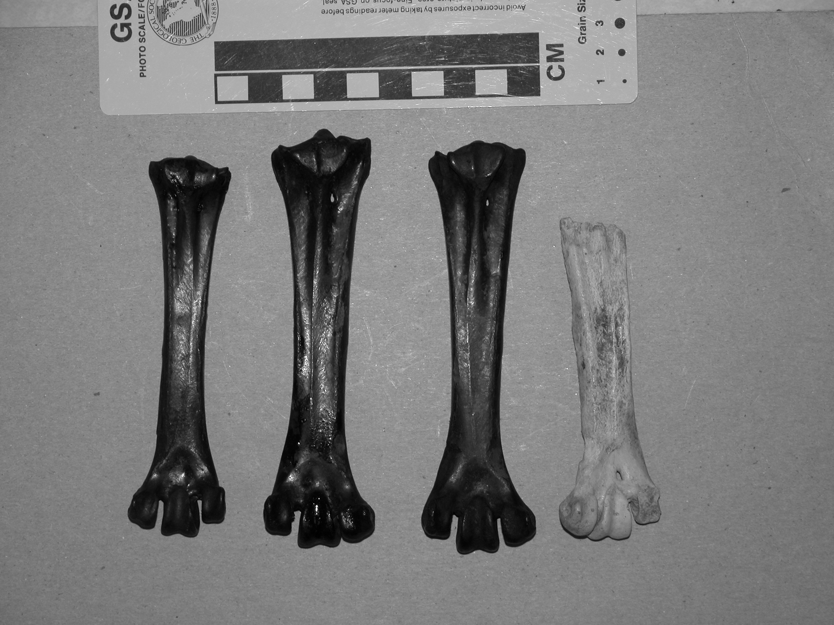
Figure 1: Type specimen of G. amplus (UCMP 9834 on right) compared with the more robust TMT specimens from the RLB collections (LACMHC xxx). Scale bar in cm.
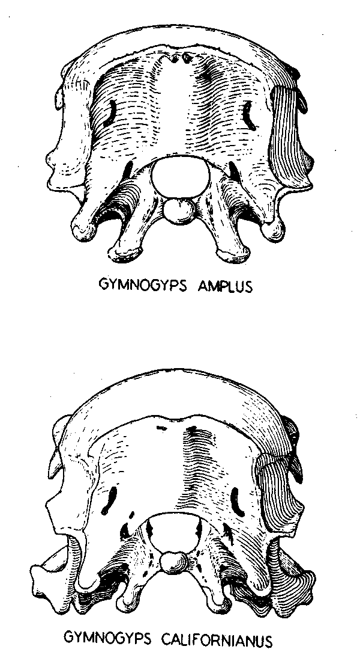
Figure 2: Posterior views of skulls of G. amplus and G. californianus, showing the differences in the skull proportions and the shape of the occipital processes (after Fisher, 1944, fig. 6, p. 284).
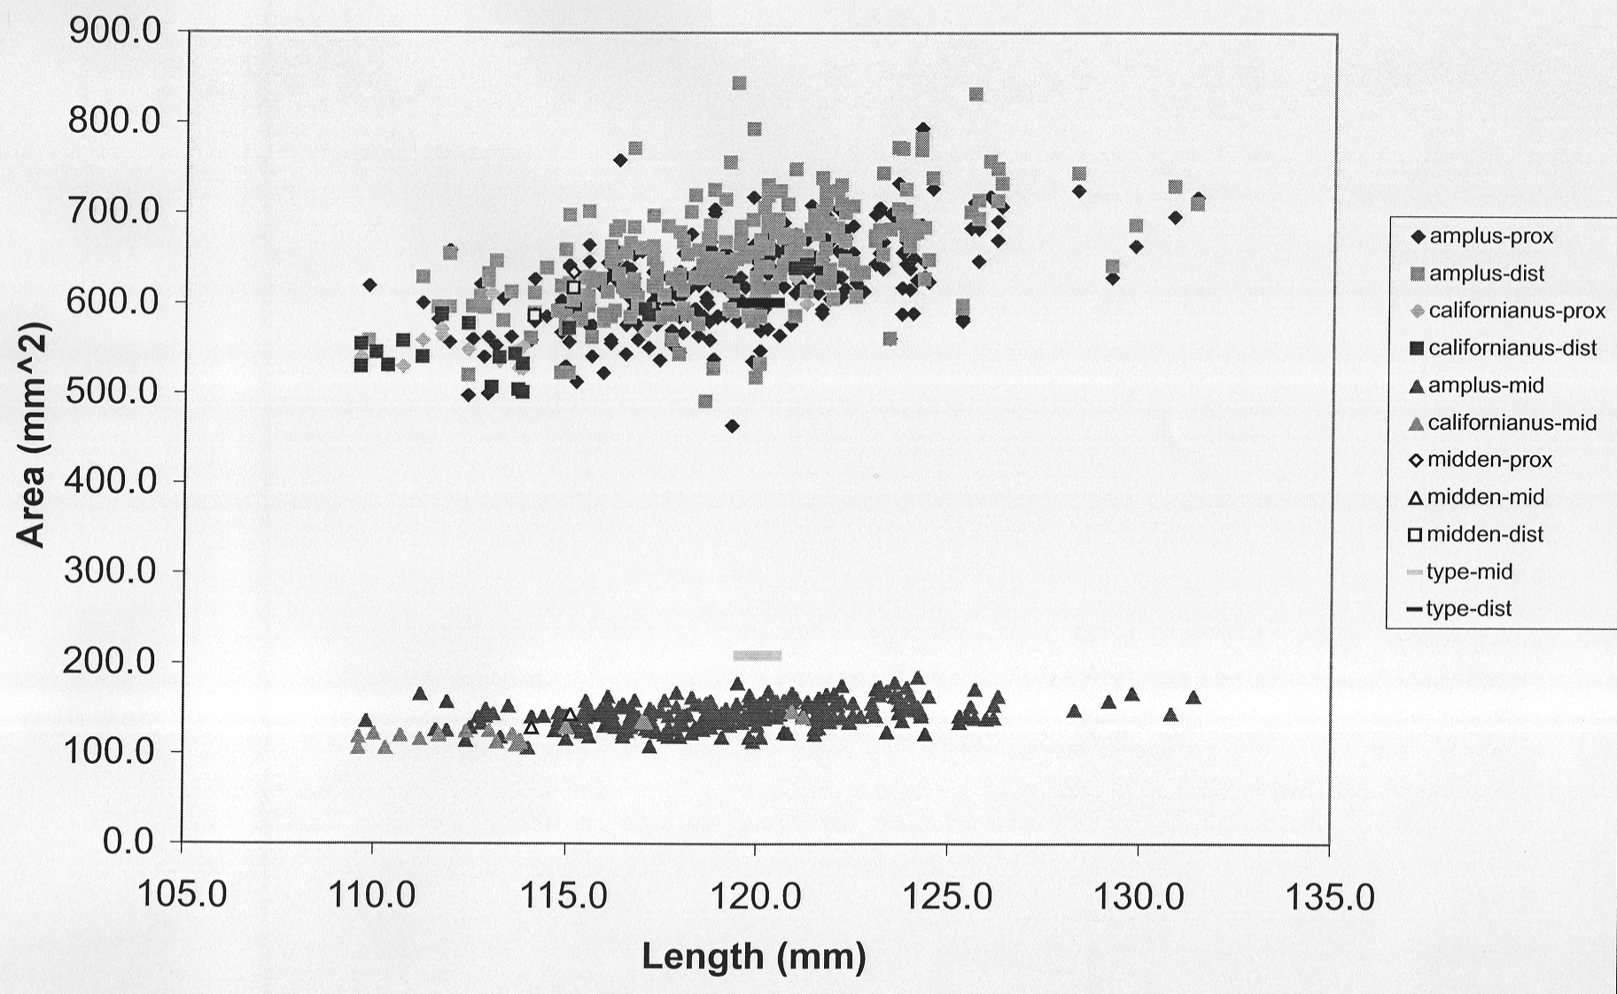
Figure 3: Plot of TMT dimensions from modern and RLB Gymnogyps.

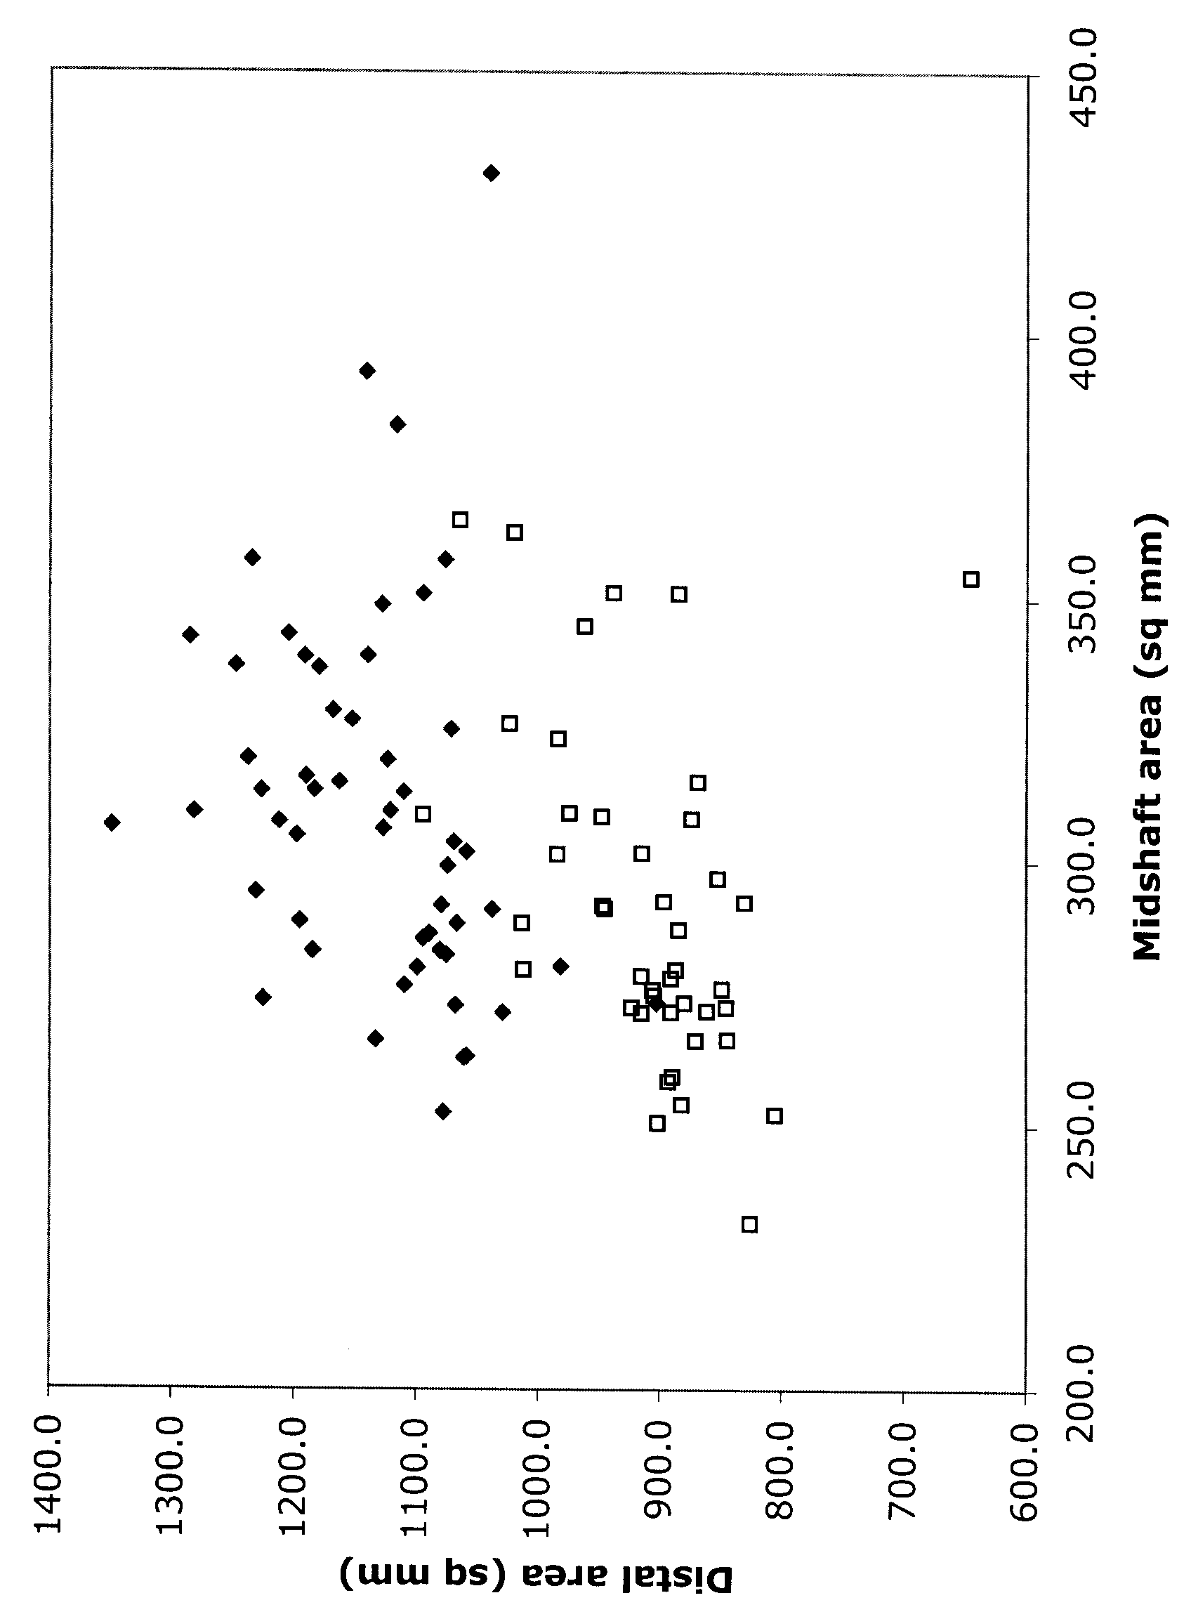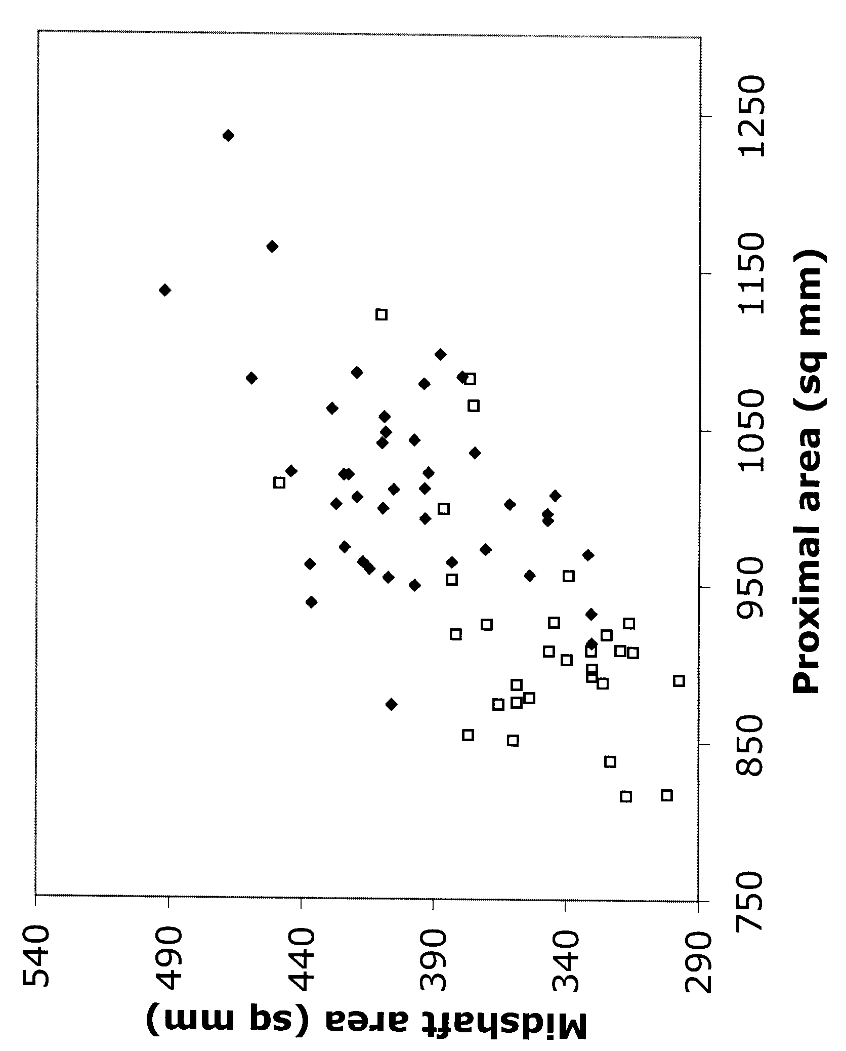
Figure 4: A. Plot of cross-sectional area of distal femur (ordinate) versus midshaft area (abscissa), showing the clear separation between modern condor femora (open squares) and RLB condors (solid diamonds). B. Plot of cross-sectional area of proximal femur versus midshaft area, showing separation between modern condors (open squares) and RLB condors (solid diamonds). All measurements in mm.
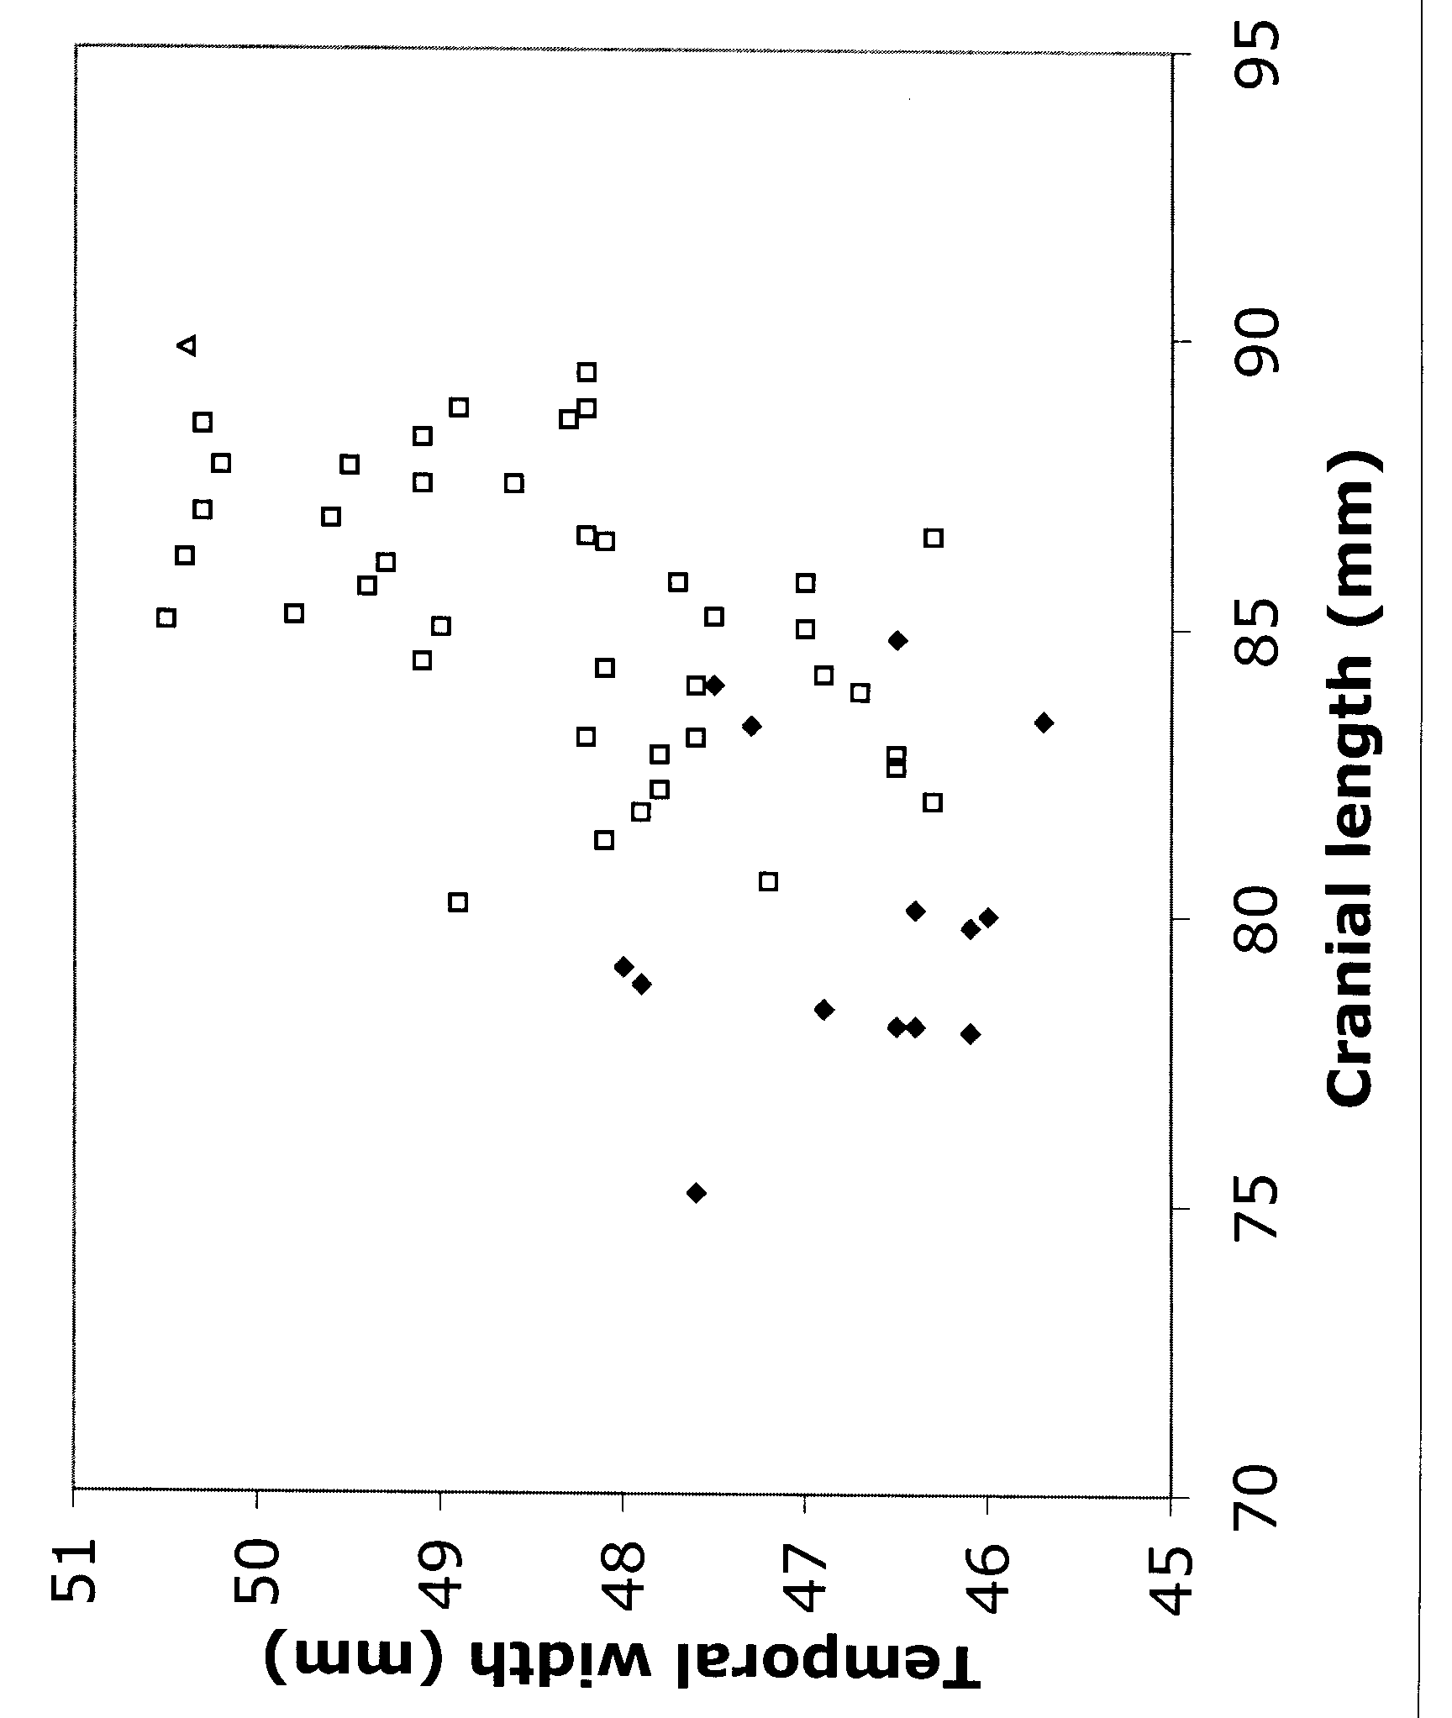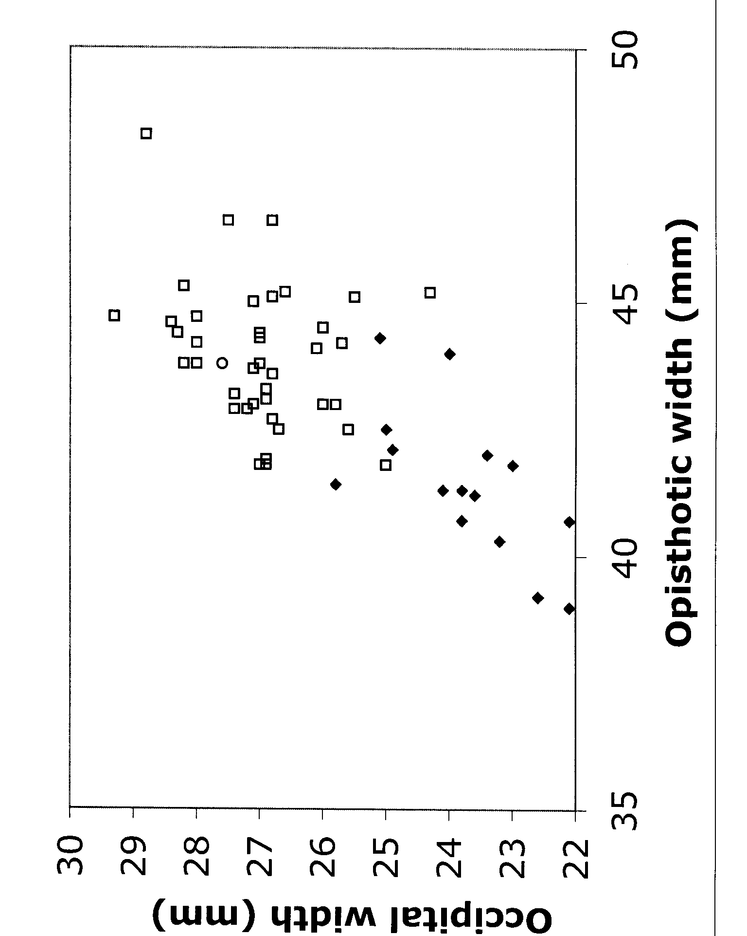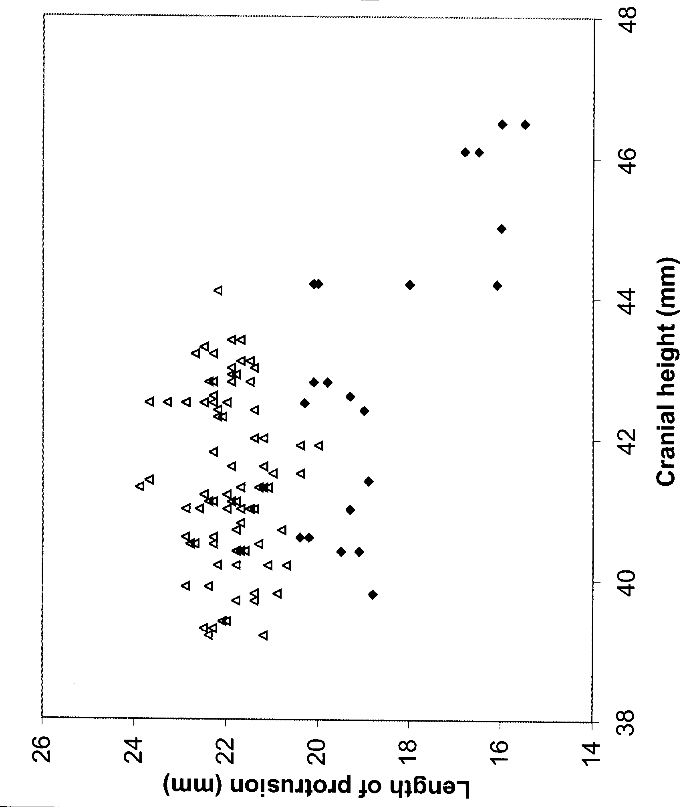
Figure 5: Bivariate plots of skull dimensions, showing the distinction between modern condors (solid diamonds) and RLB specimens (open squares). A. Cranial length versus temporal width. B. Occipital width vs. opisthotic width. C. Length of occipital processes versus cranial height. All measurements in mm.
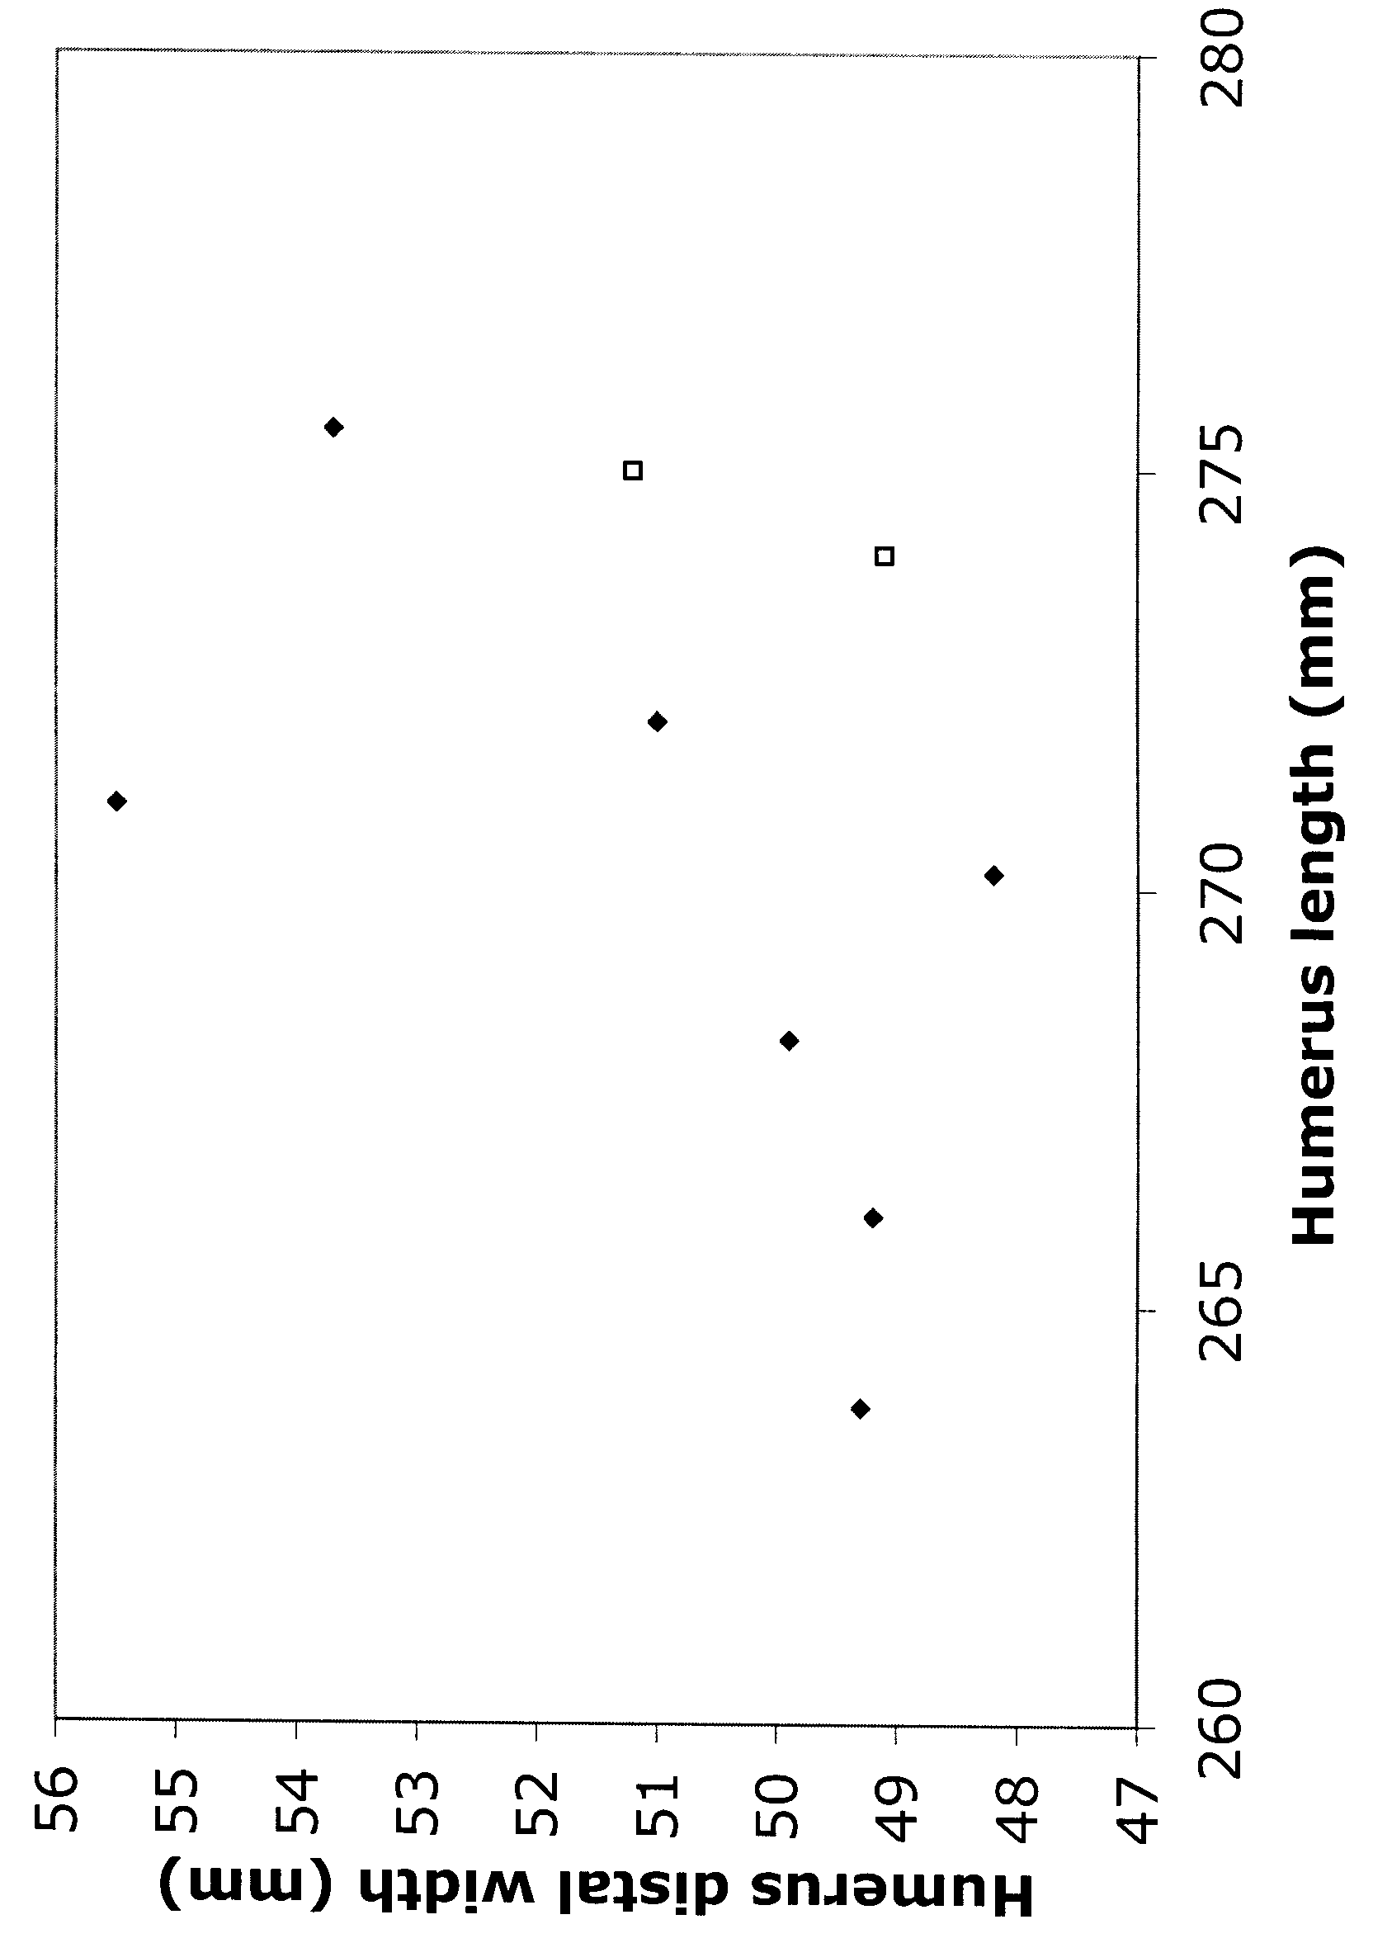
Figure 6: Condors do not show marked sexual size dimorphism. Here, the humerus length is plotted against the humerus distal width for sexed specimens of G. californianus. The few female humeri (open boxes) fall within the range of the scatter of male humeri (solid diamonds). All measurements in mm.
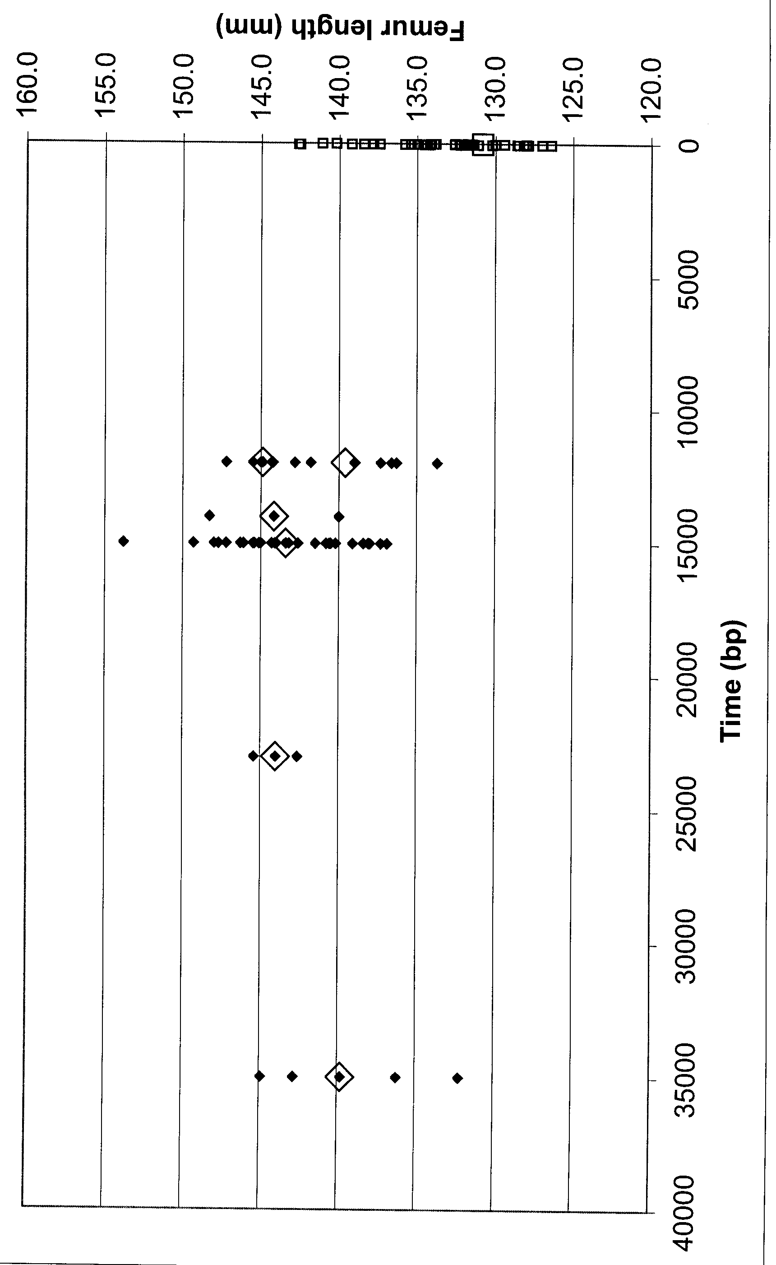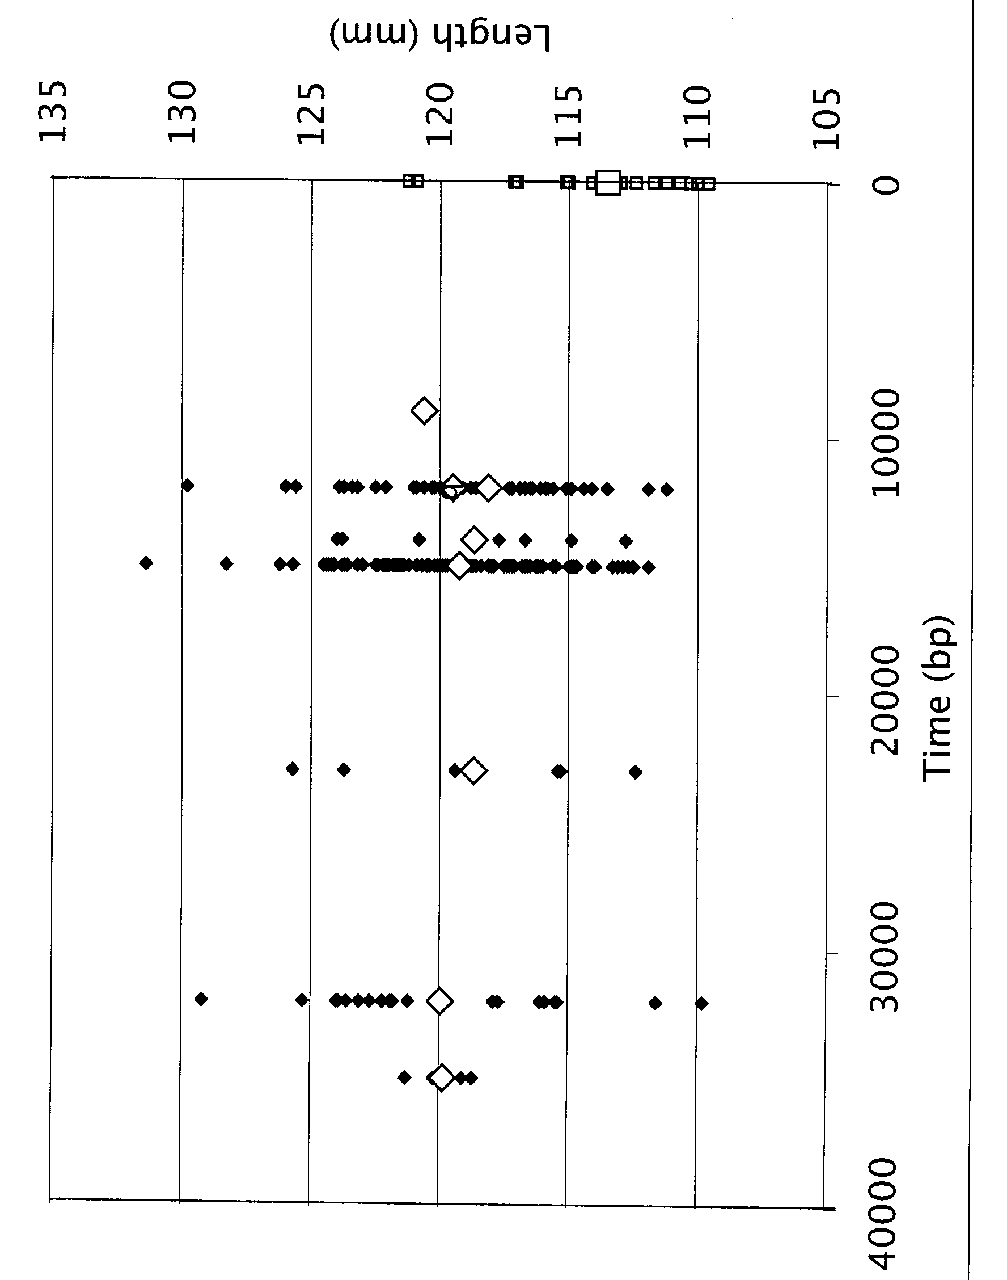
Figure 7: Size trends through time in RLB and modern condors. A. Femur length over time. B. TMT length through time Solid diamonds = individual RLB condor specimens; large open diamond = mean for time interval; small open squares = modern condor data points; large open square = mean for modern condors.. In each dated sample from a RLB pit, the mean is statistically indistinguishable from the previous and subsequent sample. This is despite the fact that the climate changed dramatically over the 40,000 years represented by these samples, from the glacial conditions beginning around 40 ka, and peaking at 20 ka to the beginning of the Holocene interglacial at 10 ka.

