- What is meant by “background” extinction? (2)

- Extinctions were known to Darwin as an important component of evolution: TRUE/FALSE?

- Which extinction scenario occurs when extinction is selective, but not in ways related to the ability of organisms to adapt in normal times?
a) “fair game” b) “field of bullets” c) “wanton extinction”

- The vast majority of species that have ever lived are now extinct: TRUE/FALSE?

- Raup attributes the deaths at the K-T extinction event to the “field of bullets” scenario: TRUE/FALSE?

- Mammals and dinosaurs co-existed for more than 100 million years: TRUE/FALSE?

- To the right of the geologic time scale, label with arrows two of the five major mass extinctions, and to the right of the arrow write the name of the extinction. (2)
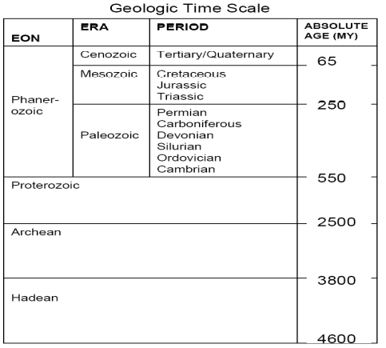

- Define pseudo-extinction or provide an example. (1)

