1. What is “evo-devo”, and how did the authors use its ideas here? (How do they justify their assertion that each stage had to be present in order for the next one to arise?) (2)
2. The authors propose five different stages of bird feather evolution. Briefly describe the proposed evolutionary sequence as indicated in this series of pictures. (2)

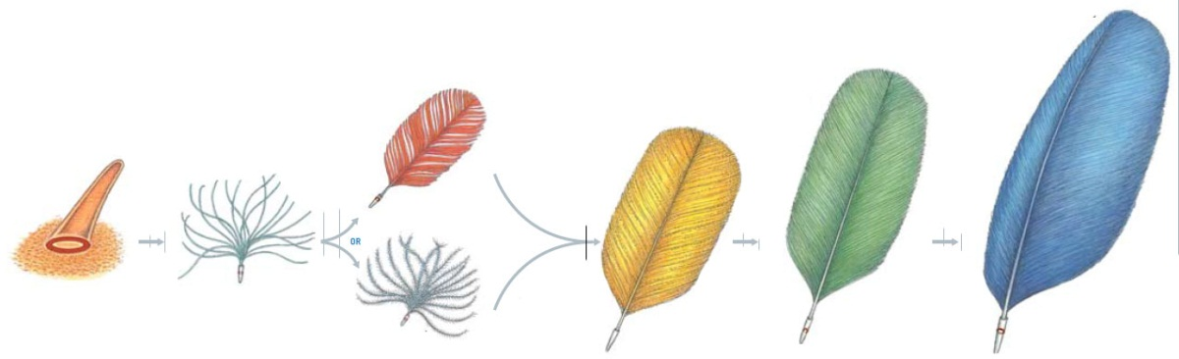

1. What paleontological evidence supports their model? (2)
2. True or False: This developmental model supports the older hypothesis that the first feathers arose as modified scales. (1)
3. True or False: Asymmetrical flight feathers are known from fossils of dinosaurs which are classified as non-avian. (1)
4. A new specimen that was discovered as this paper went to press (mentioned in a sidebar on the last page). What is its significance for this paper’s conclusions? (2)