Safe Whistle
System overview: anonymous tip channel for journalism
Testnet prototype · November 2026
Prototype. It runs on testnets (Sepolia, Rabdi and World ID in a test environment) and with fictional data. No real source should rely on it.

1. The problem the system solves
People with information of public interest often only hand it over if they cannot be identified. Common channels fail in six ways:
- Exposed identity. Email, forms and accounts link the tip to a network address (IP), a login or a phone number.
- Blind trust in the platform. Whoever hosts the form can read, keep, lose or hand over the content.
- Spam and abuse. An open anonymous channel gets flooded; requiring registration destroys anonymity.
- Fake newsroom. The source has no way to be sure they are talking to the right outlet.
- No proof. After publication, no one can prove that the document existed on a given date, that it was not altered, or that the source is its author.
- No safe reply path. The newsroom cannot reply without discovering who the source is.
How Safe Whistle solves it. The source encrypts the tip in their own browser, so that only the newsroom can open it. The newsroom is identified by a public name (for example, redacao.eth) that publishes the encryption key. The source proves they are a real and unique person, without saying who they are. An intermediary service (the relayer) publishes the encrypted envelope to public storage and hands custody to the newsroom. The newsroom decrypts, classifies and replies through an anonymous reply box.

2. Technologies
Technology | What it is for | Use in the prototype
ENS v2 | Identifies the newsroom by name and publishes the public key, the key version, the receipt policy, the administrator and the journalists (subnames) | Sepolia testnet
Arkiv | Stores the encrypted envelopes, the notes and the replies, with an owner (custody) and a lifetime | Rabdi testnet; maximum lifetime of about 182 days, renewable
World ID | Proves that the person is real and unique per newsroom and per month, without revealing who they are | Test environment (staging), with a simulator
libsodium | Cryptography: XChaCha20-Poly1305 (text), X25519 sealed box (keys and replies) and BLAKE2b (hashes) | Runs in the browser
MetaMask (wallet) | Login and signing for the administrator and the journalists | Only in the newsroom dashboard
PBKDF2 (WebCrypto) | Protects the key backup with a password | Runs in the browser
Public RPC | Access to the networks (reading and sending transactions) | Configurable address
TypeScript, Node.js, viem, Vitest | Code, access to the networks and automated tests without a browser | Development

3. Components
Component | Role | Who uses it | Where it runs
Source screen | Find the newsroom, write and encrypt, prove humanity, send, keep the receipt, read replies and verify files | Source | Browser
Newsroom dashboard | Register the newsroom, generate keys and backup, define the policy, manage the team, read the inbox, classify, reply and renew deadlines | Administrator and journalist | Browser, with wallet
Relayer | Receives the encrypted envelope, checks the World ID proof and the newsroom’s policy (read from ENS), publishes to Arkiv paying the cost, transfers custody to the newsroom and renews deadlines. It does not record IP or content | System operator | Server
ENS (external) | Public directory of newsrooms and public keys | Everyone | Blockchain
Arkiv (external) | Public store of encrypted envelopes, notes and replies | Everyone | Blockchain
World ID (external) | Checks the proof of unique personhood | Relayer | World service
Internal libraries | Rules and cryptography, ENS and Arkiv access, screen logic and the list of allowed addresses (which generates the browser security policy) | Screens and relayer | Alongside each component

4. Roles
Role | Who they are | What they do | What they cannot do
Source | Anyone. Anonymous, without an account and without a wallet | Chooses the newsroom, writes, proves they are human, sends, keeps the receipt, reads replies, verifies files and proves authorship | Does not read tips or access the newsroom’s inbox
Administrator | The newsroom’s custodial wallet (one per newsroom) | Registers the newsroom, generates and keeps the keys, defines the policy, registers and revokes journalists, delivers the keyring, rotates the key. Also reads, classifies and replies | Does not see who the source is. Without the backup, they lose access to the tips
Journalist | Owner of an active subname (maria.redacao.eth) who received the keyring | Reads, classifies (new, under review, verified, discarded), replies under their own name and renews deadlines | Does not register the team, does not rotate the key, does not change the policy, does not delete tips

5. Use cases

5.1 Simple case: the administrator receives and replies alone
- The administrator connects the wallet to the dashboard and registers the newsroom (for example, redacao.eth). The dashboard generates the newsroom’s key pair and publishes the public key and the policy to ENS. That is 8 transactions.
- Right after, they generate the key backup, protected by a password. Without it, closing the dashboard causes the keys to be lost.
- The source opens the source screen, types redacao.eth and sees the policy (categories and maximum size).
- The source chooses the category, writes the tip and proves they are a real person through World ID. The text is encrypted in the browser before it leaves.
- The source sends it. The relayer checks the proof and the policy, publishes the envelope to Arkiv and hands custody to the newsroom. The source downloads and keeps the receipt.
- The administrator opens the inbox, selects the tip and it is decrypted in the browser itself. They set the status (for example, under review).
- The administrator replies. The reply is encrypted for the source’s reply box and published to Arkiv.
- The source opens the receipt in the replies tab and reads the reply, identified with the newsroom’s name.

5.2 Case with a journalist
- The journalist opens the dashboard, connects their wallet and generates the read key. They keep the private one and send only the public one to the administrator.
- The administrator registers the journalist (name, wallet address and public key). This creates the subname maria.redacao.eth in ENS, in 2 transactions.
- The administrator generates the keyring, which is a copy of the newsroom’s keys encrypted for the journalist’s public key, and delivers it through any channel.
- The journalist imports the keyring. From then on, they read the inbox, decrypt and classify the tips.
- When the journalist replies, the reply is signed by their wallet and carries the name maria.redacao.eth. The source sees who replied.
- If the journalist leaves the team, the administrator revokes them and rotates the key. Revocation removes the name from ENS, but does not erase a keyring already delivered; the new key protects future tips (section 6.3).

6. The key system
The system uses three ideas. First: each tip is encrypted with a new key, and that key is “wrapped” (encrypted) for those who may read it. Second: each role has its own keys, and private keys never leave their owner. Third: the wallet signs and identifies who did what, but decrypts nothing.

6.1 The keys, one by one
Key
Who generates it
Where it is kept
What it is for
Who has it
Content key
symmetric, 256 bits
The source, new for each tip
Only in memory; goes wrapped inside the envelope
Encrypts the text and the attachment
No one after sending; whoever opens the envelope recovers it
Newsroom key
X25519 pair, versioned
The administrator, in the dashboard
Public: ENS. Private: dashboard memory and backup
The source wraps the content key for the public one; the private one opens it
Public: everyone. Private: administrator and journalists with the keyring
Reply box key
X25519 pair, ephemeral
The source, one pair per tip
Public: in the envelope. Private: in the receipt
The newsroom encrypts the reply for the public one; the source opens it with the private one
Public: everyone. Private: only the source
Salt
32 bytes
The source
In the receipt
With the text, it forms the commitment (hash) recorded in the envelope: proof of authorship
Only the source
Journalist read key
X25519 pair
The journalist, on their device
Public: ENS (subname). Private: with them
Receives the keyring
Public: everyone. Private: the journalist
Keyring
The administrator
Delivered to the journalist, encrypted
Grants access to the newsroom’s keys (all versions)
Administrator and journalist
Backup and password
PBKDF2 (600 thousand iterations)
The administrator
File kept by them; the password only in their memory
Recover the newsroom’s keys in another session or device
Administrator
Wallet
ECDSA pair
Each administrator and journalist
In MetaMask
Signs the dashboard login and the transactions on ENS and Arkiv; defines the “creator” of each record
The owner
Relayer wallet
The operator
On the server
Pays the cost and creates the records in Arkiv. It decrypts nothing
The operator
World signing key
The operator
On the server
Signs the proof-of-unique-personhood request
The operator
Diagram: who keeps each key
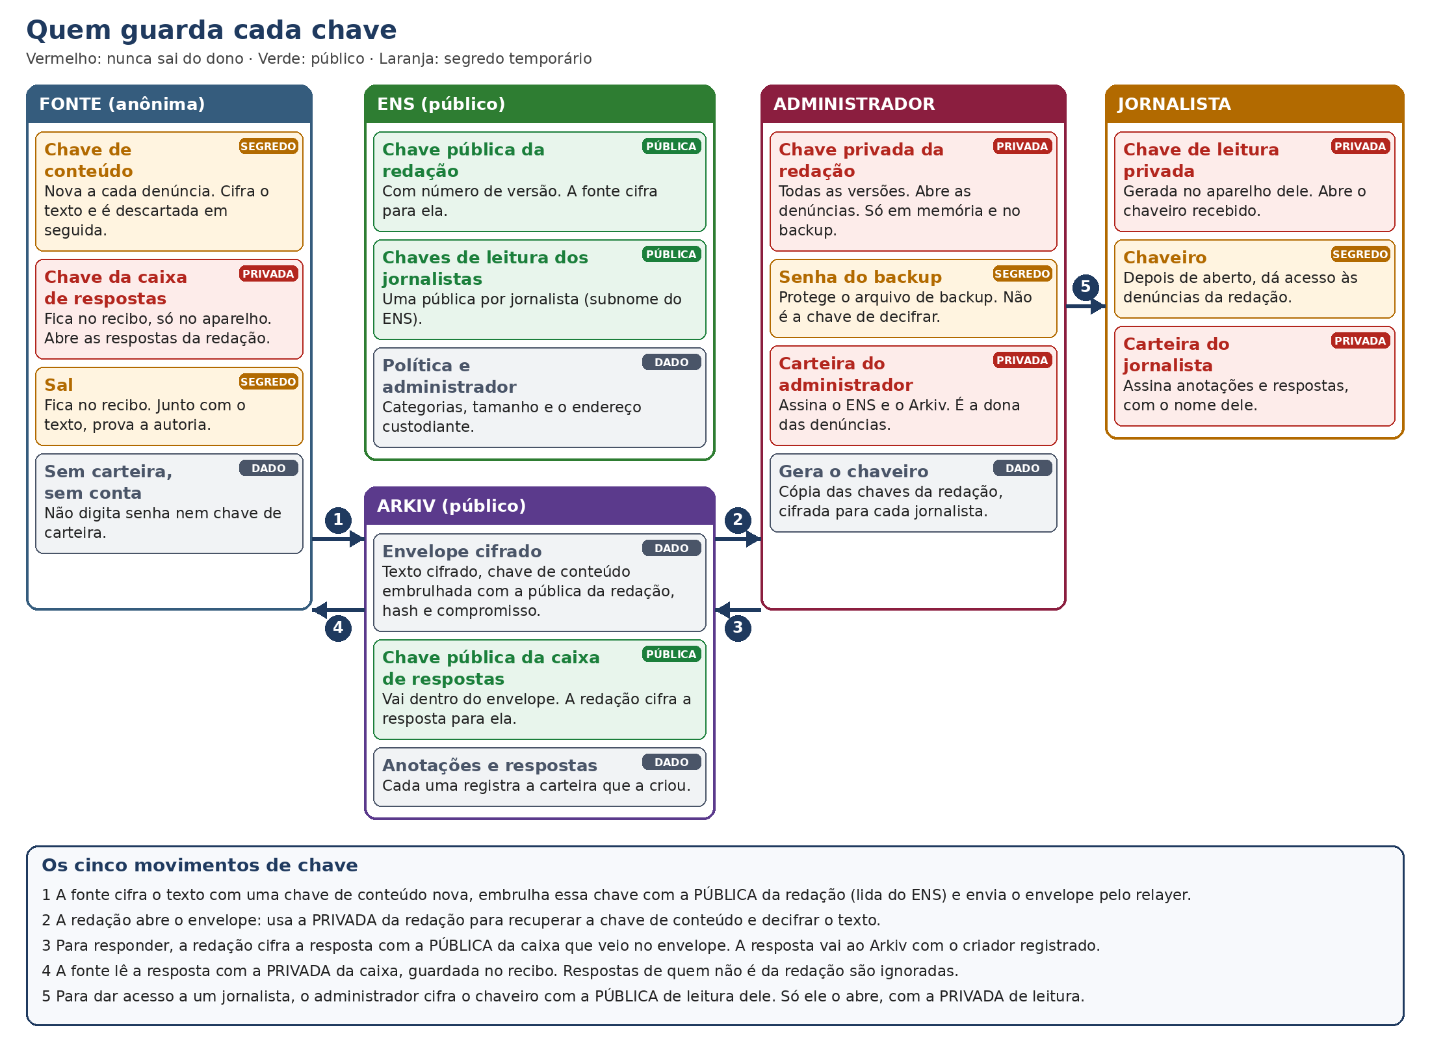
Who keeps each key: source, ENS, Arkiv, administrator and journalist, with the five key movements

6.2 How a tip is protected, step by step
- The source generates the content key, the reply box pair and the salt.
- It encrypts the text with the content key. The encryption also authenticates the newsroom name, the key version and the category: changing any of them prevents opening.
- It wraps the content key with the newsroom’s public key, read from ENS.
- It computes the hash of the encrypted text (identifies the envelope) and the commitment, which is the hash of the text with the salt.
- It assembles the envelope and sends it through the relayer. The receipt (box private key, salt and hash) stays only with the source.
- The newsroom opens the content key with the newsroom’s private key of the indicated version and decrypts the text. The relayer, Arkiv and ENS never have a key that decrypts.

6.3 Versions, rotation and key loss
- Rotating the key creates a new version. Old tips still open, because the old keys remain in the keyring and in the backup.
- Revoking a journalist removes the subname from ENS, but does not undo a keyring already delivered. Therefore, after revoking, the key is rotated and the new keyring is delivered to the others.
- Losing the backup means losing access to the newsroom’s tips. Losing the receipt means losing the replies and the proof of authorship for that tip.

6.4 Who can write: authenticity
Status notes and replies only count if they are created by the administrator’s wallet or by an active journalist’s wallet. The chain records who created each record and ENS confirms the role. Anything coming from any other wallet is ignored and counted, and the screen reports how many records were ignored. Thus, no outsider can change the status of a tip or send a fake reply to the source.

7. How anonymity works

7.1 What protects anonymity
- No account and no wallet. The source does not log in, does not provide an email and does not use a wallet.
- Encryption in the browser. The text leaves the device already encrypted. No intermediary server reads it.
- Proof of humanity without identity. World ID generates an identifier (the nullifier) per person and per action. The action is “newsroom + month”. The same person in another newsroom, or in another month, generates another identifier, and therefore submissions are not linked to each other. The relayer keeps only a hash of that identifier, to block the second submission in the same month, and never records it together with the tip.
- Relayer without traces. It does not record IP, headers, body, proof or identifiers. The log only has route, status and a code.
- Nothing in Arkiv points to the source. The record creator is the relayer, and custody passes to the newsroom. The public attributes are only newsroom, category, month, hash, key version and size.
- Ephemeral reply box. The newsroom replies to a key created for that tip, not to a person. Only the receipt opens the reply.
- Only declared addresses. The app talks only to the services on the list (RPC, relayer and the World bridge), with no third-party trackers, fonts or scripts, and the browser security policy enforces this.

7.2 What each party can see
Party | What they see
Newsroom and journalists | The text, the category, the approximate time and the size. They do not know who sent it, unless the content itself reveals it
Relayer | The network address (IP) and the connection time, the encrypted envelope and the proof. It does not read the text and does not record the IP
World ID | The proof and the action (the newsroom and the month). It does not see the text
RPC provider | The IP and which queries were made, such as the newsroom name
Anyone (ENS and Arkiv are public) | Newsroom, category, month, hash, key version, size and block time. Never the text
Whoever observes the source’s network (ISP, workplace network) | That the device accesses the app and the services. They do not see the content, which travels encrypted

7.3 Where anonymity is limited
- The IP is seen by the relayer, the RPC provider and the World bridge. The system does not record it, but it exists in the connection.
- Time correlation. Sending right after an event, or when only you had access to the information, can link the submission to you.
- The content can identify you. Details few people know and your writing style.
- Attachments carry metadata (author, company, location, edit history).
- Compromised device. Whoever controls your device sees what you write before encryption.
- Fake newsroom. Anyone can register a name similar to that of an outlet.
- World App. Opening the proof link in the World App connects the phone where your account is to the World servers.
- A global observer of the network and adversaries with access to several points at the same time are outside what the prototype promises.

7.4 Where the Tor network comes in
The system does not use or embed any anonymity network. The Tor network (or a VPN) comes in as a layer chosen by the source, on their own device and outside the app: the browser traffic goes through it before reaching the relayer, the RPC and World, so that these services see the network’s exit address and not the source’s IP. It protects the network address, but not the content (which is already encrypted), nor does it correct the lapses in section 7.5.
Transparency. No test in this project was run over the Tor network. That demonstration is blocked on this computer, by workplace environment rule. If it is done, it will be run by a colleague on another machine and recorded stating who ran it and where.

7.5 Precautions the source should take
- Protect the network before opening the app. Use a VPN or the Tor Browser, by your own choice. Avoid the workplace, school or home network if it can be linked to you.
- Use a browser and a device not linked to your identity. Private window, no personal accounts open and no extensions that identify you.
- Clean the attachments. Remove metadata (author, company, location, edit history) before attaching. Prefer text or a clean copy.
- Be careful with the content. Avoid details only a few people know, and pay attention to names, dates and your way of writing.
- Be careful with timing and frequency. Do not send right after an event that points to you. Wait and space out submissions.
- Confirm the newsroom name through another trusted channel, letter by letter, before sending.
- Keep the receipt in a safe, separate place. Do not leave it in cloud storage linked to your name or on the work phone, and do not send it to anyone. Whoever has the receipt reads the replies and proves authorship; without it, you lose the reply channel.
- Do the World ID proof on a protected network. World sees that someone proved to be human for that newsroom in that month, but does not see the text. Remember that the phone with your World account connects to the service.
- Do not use your personal wallet. The source does not need a wallet; any request to connect a wallet on that screen is a sign of a problem.
- Be suspicious of replies. Only trust a reply shown with the newsroom’s name or a journalist’s name. A notice of ignored replies indicates an attempted scam. Do not send extra documents through other channels to anyone claiming to be from the newsroom without confirming.
- Remember that it is a prototype. Do not put a real person at risk with it.

8. Current state and limits
- It is a prototype on testnets, with fictional data.
- The code has automated and end-to-end tests. The manual dashboard test with MetaMask, in a real browser, is missing.
- No anonymity network has been tested (section 7.4).
- Tips live in Arkiv for about 182 days and depend on renewal by the relayer or the newsroom.
- Each newsroom has a single administrator. Without the backup, access to the tips is lost.
- World ID is in a test environment; the proof with the real app in production has not been validated.

9. Hackathon tracks
The project competes in four tracks, one per core technology. Each one is used because it solves a real part of the problem, not as decoration. Adding up the first places, it is US$ 9,250; the 2nd and 3rd place prizes also count.
Track | Prize (1st place / total) | Technology in the system
ENS: Best Use of ENSv2 | US$ 3,000 / 7,000 | Newsroom identity, public key, policy and team
Arkiv: Build on Arkiv (from scratch) | US$ 3,000 / 4,000 | Queryable store of envelopes, replies and notes
Ethereum Foundation: Best CROPS App | US$ 2,000 / 3,500 | Open, private and secure client, without trackers
World: Best Use of IDKit | US$ 1,250 / 2,500 | Proof of unique personhood, without identity
Track we are not pursuing: Best Use of Anon-RPC (Ethereum Foundation). It awards apps that route traffic through an anonymity network, and ours does not embed any (section 7.4). The Ethereum Foundation pays a single prize per project, and we chose CROPS.

9.1 ENS: Best Use of ENSv2
How the system uses it. ENSv2 (Sepolia network) is the backbone of trust. Each newsroom is a .eth name with its own resolver, which publishes the public key, the key version, the receipt policy and the administrator’s address. The team lives in a subname registry of the newsroom: each journalist is nome.redacao.eth, with the read key published. Each person’s role (administrator or journalist) is decided by reading ENS, and revocation is an unregister in the registry. The dashboard discovers a wallet’s newsrooms from the registry events. Nothing is hardcoded: everything the screen shows is read from ENS.
Arguments for the presentation.
- Without ENS there is no verifiable newsroom identity: it is what guarantees the source that the key they use belongs to the right newsroom.
- It uses ENSv2-specific features, not just the name: own resolver per newsroom, subname registry for the team, name registration with commit-reveal and revocation in the registry.
- ENS decides who writes (administrator or active journalist), but not who reads: reading is decided by cryptography. This separation is deliberate.
- It can be checked live: each step of the registration (8 transactions) and of the journalist registration (2 transactions) appears on Etherscan.

9.2 Arkiv: Build on Arkiv (from scratch)
How the system uses it. Arkiv (Rabdi network) is the product’s public database. There are three record types: tip (the encrypted envelope), reply (encrypted for the source’s box) and note (the status). The search fields (newsroom, category, month, status) are indexed, which allows listing the inbox without our own server. The relayer creates each tip and transfers ownership to the newsroom; the record is read-only and accepts extension by anyone, which allows renewing the deadline without being the owner. Large attachments are split into parts. A tip’s date comes from the block in which it was recorded.
Arguments for the presentation.
- Arkiv is not decorative: it is where the tip lives, is queried, gets a date and passes into the newsroom’s custody.
- We measured the real behavior, and it is documented: a limit of about 126 KiB per record, a maximum lifetime of about 182 days and mandatory renewal.
- Secrecy does not come from Arkiv (it is public): it comes from cryptography. Arkiv delivers what it does well, querying and proof of date.
- The creator of each record is checked by the chain, which prevents fake notes or replies.

9.3 Ethereum Foundation: Best CROPS App
How the system uses it. CROPS stands for censorship-resistant, open-source, private and secure. The system meets all four: censorship-resistant because the content lives on public networks (ENS and Arkiv), with no central database; open because the code is free (MIT license); private because the tip is encrypted in the browser, the relayer records neither IP nor content and the proof of humanity does not identify; secure because it uses only libsodium, authenticated formats and a network policy that the screen itself enforces. The source screen has no third-party trackers, fonts or scripts, and the addresses it contacts are a declared list, enforced by the browser security policy.
Arguments for the presentation.
- The central property is privacy without sacrificing the others: end-to-end encryption and anti-spam without identifying anyone.
- Honesty about limits: the source’s network address remains visible to the relayer, the RPC and World. The system does not hide this: network protection is the source’s choice, outside the app (section 7.4), and the document says what the system does not protect.
- Not embedding an anonymity network keeps the client simple and auditable.
- Points to clarify with the judges: whether a public RPC counts as a third-party service (the RPC is configurable and declared), and that the proof of humanity contacts the World servers.

9.4 World: Best Use of IDKit
How the system uses it. The source screen uses IDKit to request the unique personhood proof (the proofOfHuman credential). The proof’s action is “newsroom + month”, and therefore each person sends one tip per newsroom per month. The request is signed on the server, and verification is also done on the server, checking environment, action and the proof identifier. The relayer keeps only a hash of that identifier and never records it together with the tip. We validated it with the World simulator: the first proof was accepted, the one for another newsroom was accepted, and the second submission from the same person was refused.
Arguments for the presentation.
- It solves the classic problem of anonymous channels: blocking spam without identifying anyone.
- Minimal credential: we only need to know that it is a unique person, not their age, nationality or other data.
- Alternative paths handled: a denied, expired or canceled proof sends nothing; a second submission in the month is refused with a clear message.
- A proof from one newsroom is not valid in another, and submissions from the same person are not linked to each other.

9.5 General arguments for the presentation
- Each technology solves a real part: ENS gives trust in the newsroom, Arkiv gives queryable storage and proof of date, World ID gives anti-spam without identity, and CROPS describes the property the whole delivers.
- No custom contracts and no custom cryptography: we use already-published contracts and the libsodium library, which reduces the error surface.
- Complete flow, not just one piece: tip, reading, reply, date and integrity verification, and proof of authorship.
- Authenticity: only the administrator and active journalists can add notes and reply; the rest is ignored and counted.
- Proven quality: more than 600 automated tests and end-to-end tests against real ENS and Arkiv in a local environment, with a verifier that ensures no original text, private key or off-list address leaves the app.
- Honesty about limits: prototype on testnets, with the network address limitation and the note that no anonymity network was tested.
3-minute demo walkthrough. (1) The administrator registers the newsroom and shows the transactions on Etherscan. (2) The source searches for the name, writes and proves they are human. (3) The submission appears in Arkiv with hash and date, unreadable. (4) The administrator decrypts it in the dashboard and replies. (5) The source reads the reply with the receipt. (6) A verifier confirms the date and the hash.
Likely questions from the judges.
Question | Short answer
Isn’t the relayer a central point? | It is the system’s only service, and we say so. It does not read the content, does not record IP or identifiers, and cannot delete or change what it published after handing over custody. The mitigation is to allow multiple relayers
And the source’s network address? | It remains visible to the relayer, the RPC and World. Protection is the source’s choice, outside the app, and the document explains the precautions
Does World ID identify the source? | No. The identifier is per person and per action (newsroom and month), is kept only as a hash and never together with the tip
Why ENS and not just a list of keys? | ENS gives verifiable identity, roles and publicly auditable revocation, without one of our servers to trust
Why Arkiv and not an ordinary database? | It gives indexed querying, proof of date from the block and transferable custody, without depending on one of our servers
Delivery items, so we do not forget. Arkiv: README with the addresses of the wallets that write and an executable query, schema.md and friction.md files, one answer file per criterion and the AI usage statement. CROPS: section in the README with the list of contacted addresses and a demo of up to 3 minutes. World: short summary (debrief) of the IDKit usage. All tracks: live demo and open code.

