DBS
SECTION 1: DDL (DATA DEFINITION LANGUAGE)
DDL COMMANDS:
1. CREATE
2. ALTER
3. DROP
4. TRUNCATE
5. RENAME

QUESTION 1 - CREATE TABLE

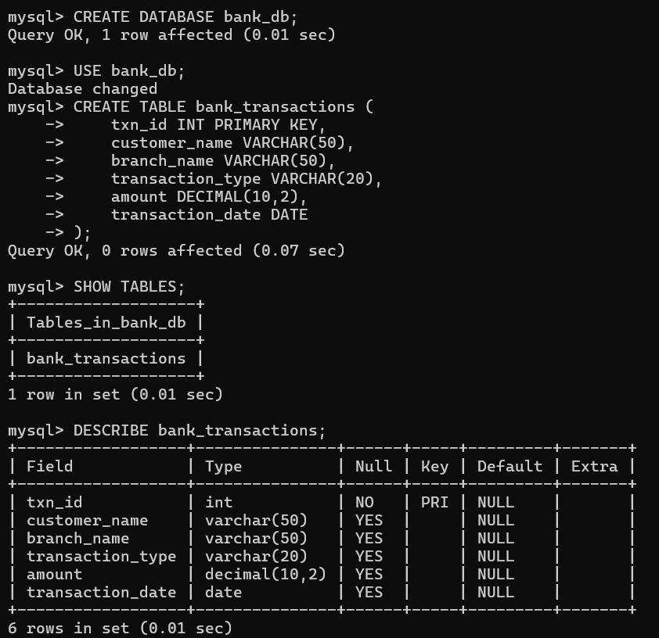

QUESTION 2 - ALTER TABLE ADD COLUMN

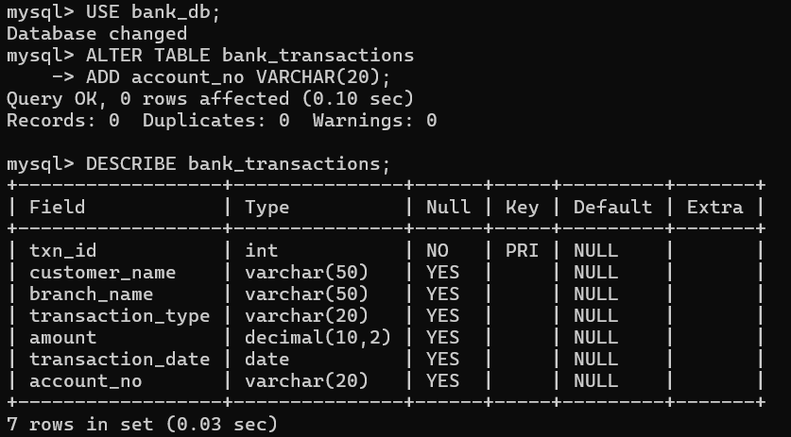

QUESTION 3 - ALTER TABLE MODIFY COLUMN

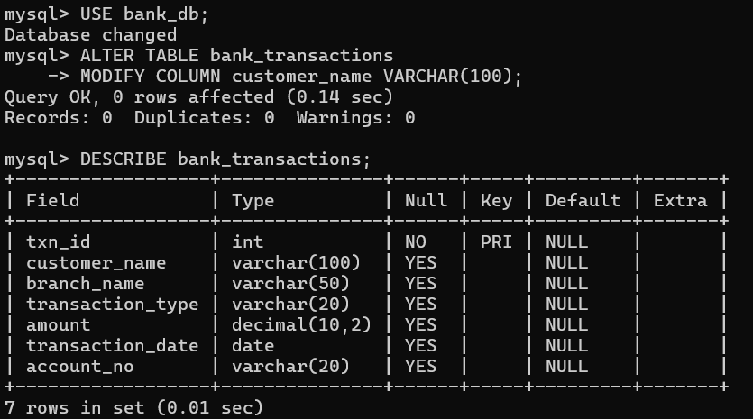

QUESTION 4 - RENAME TABLE

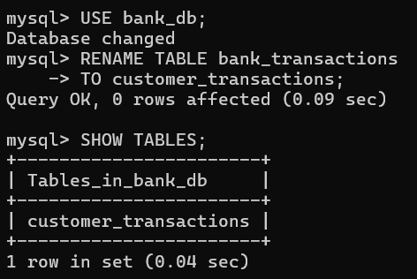

QUESTION 5 - TRUNCATE TABLE

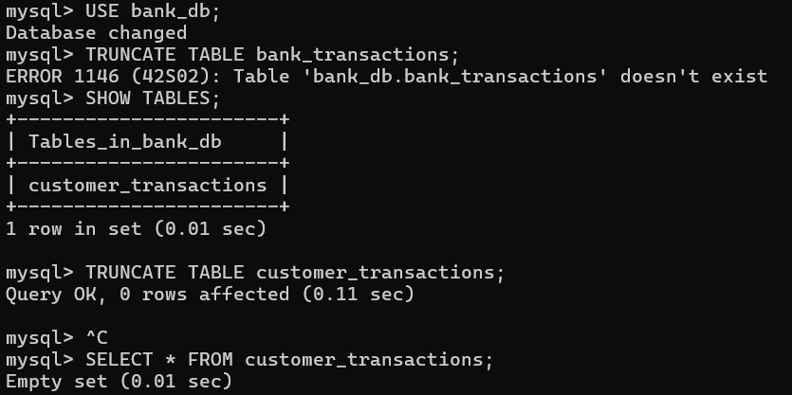

QUESTION 6 - DROP TABLE

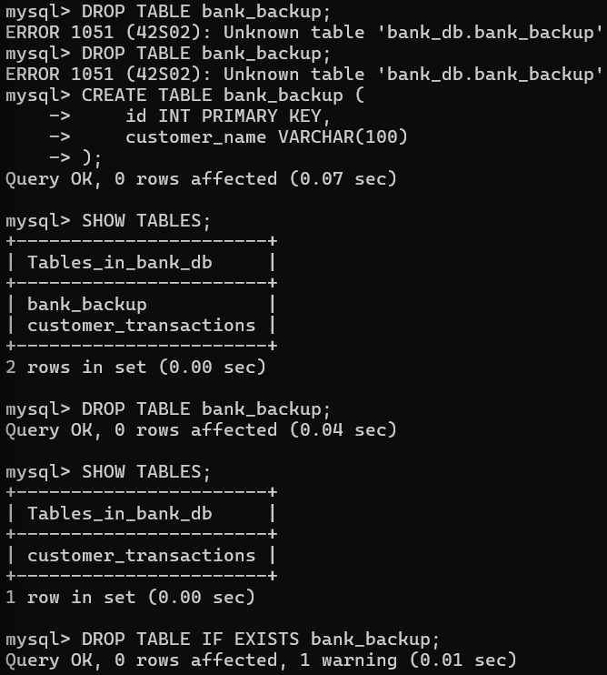

SECTION 2: DML (DATA MANIPULATION LANGUAGE)
DML COMMANDS:
1. INSERT
2. UPDATE
3. DELETE
4. SELECT
STEP 1: INSERT SAMPLE DATA
INSERT INTO bank_transactions VALUES
(101,'Ravi','Hyderabad','Deposit',5000,'2024-01-05'),
(102,'Sita','Hyderabad','Withdrawal',2000,'2024-01-06'),
(103,'Kiran','Vijayawada','Deposit',12000,'2024-01-08'),
(104,'Anil','Vizag','Deposit',8000,'2024-01-10'),
(105,'Priya','Hyderabad','Withdrawal',3500,'2024-01-11'),
(106,'Ramesh','Vizag','Deposit',15000,'2024-01-12'),
(107,'Keerthi','Vijayawada','Withdrawal',1000,'2024-01-13'),
(108,'Rahul','Hyderabad','Deposit',9000,'2024-01-14'),
(109,'Sneha','Vizag','Withdrawal',4000,'2024-01-15'),
(110,'Madhu','Vijayawada','Deposit',11000,'2024-01-16');

QUESTION 7 – INSERT

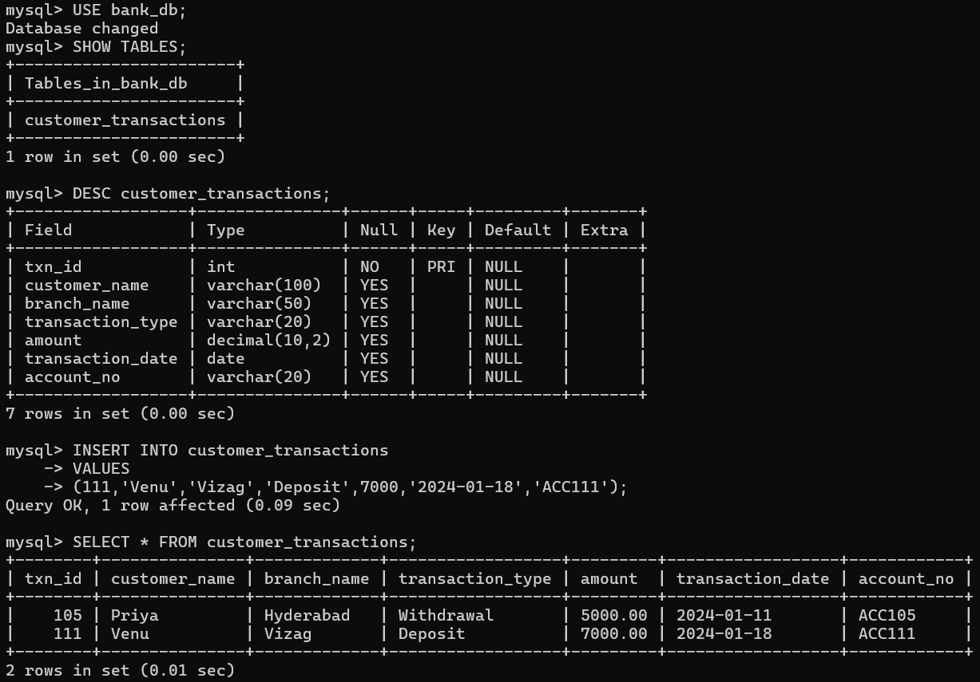

QUESTION 8 - UPDATE

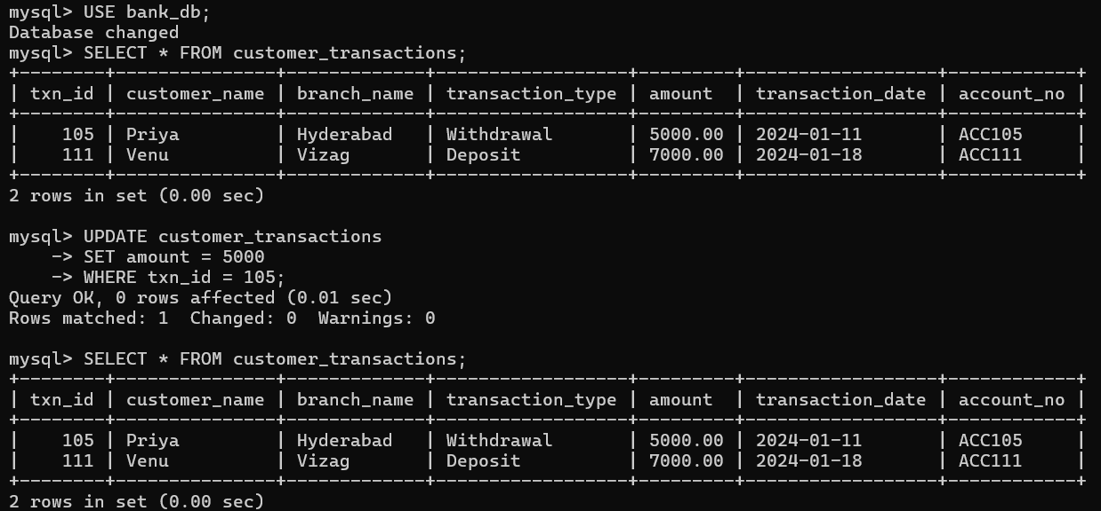

QUESTION 9 – DELETE

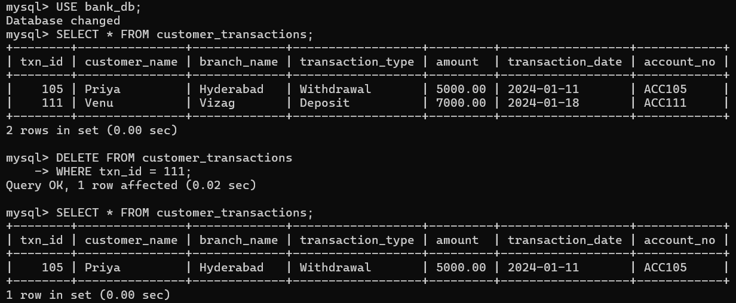

QUESTION 10 – SELECT

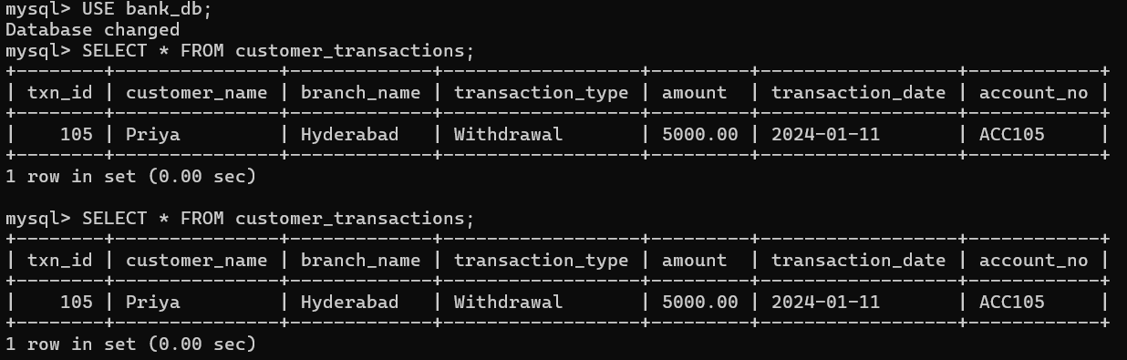

QUESTION 11 - SELECT WITH WHERE

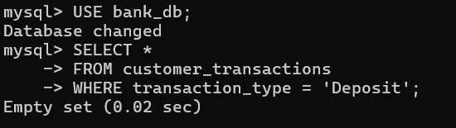

QUESTION 12 - SELECT WITH ORDER BY

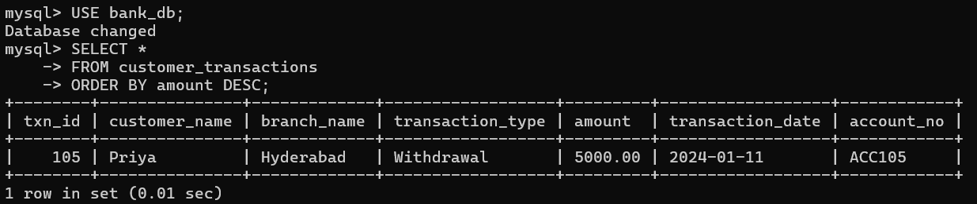

SECTION 3: DCL (DATA CONTROL LANGUAGE)

DCL COMMANDS:
1. GRANT
2. REVOKE

QUESTION 13 - GRANT SELECT

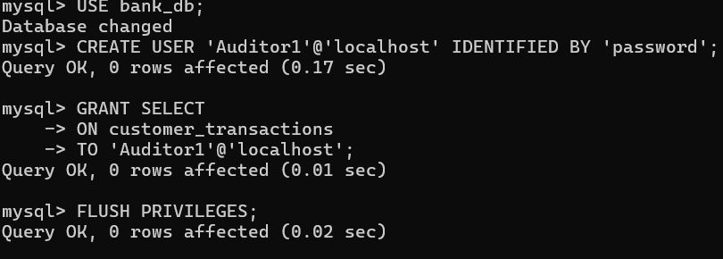

QUESTION 14 - GRANT ALL PRIVILEGES

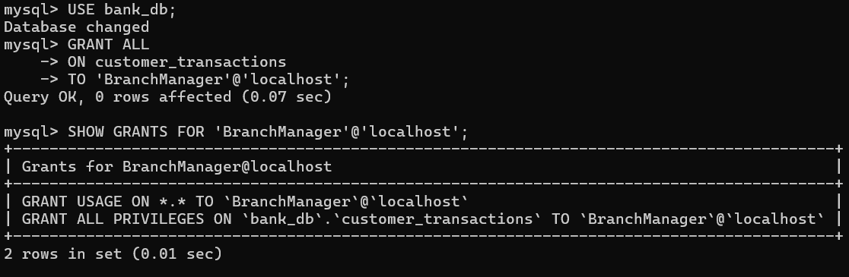

QUESTION 15 - REVOKE SELECT

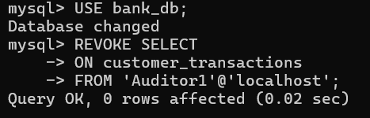

QUESTION 16 - REVOKE ALL

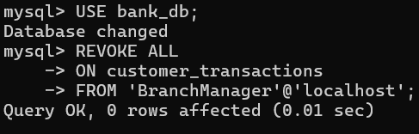

SECTION 4: TCL (TRANSACTION CONTROL LANGUAGE)

TCL COMMANDS:
1. COMMIT
2. SAVEPOINT
3. ROLLBACK

QUESTION 17 - COMMIT

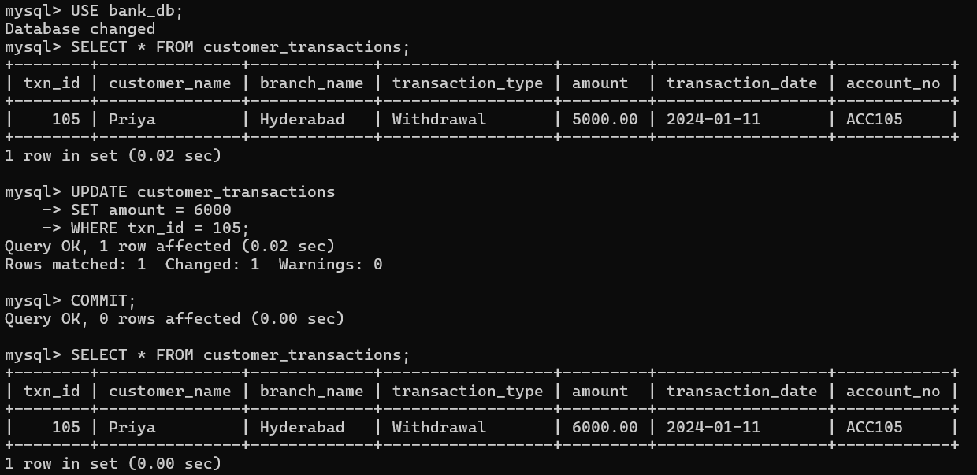

QUESTION 18 - SAVEPOINT

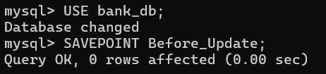

QUESTION 19 - ROLLBACK TO SAVEPOINT

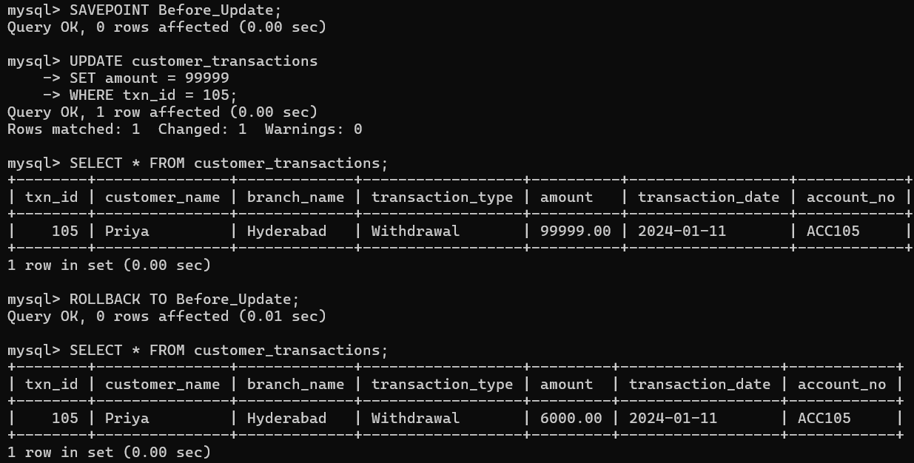

QUESTION 20 - FULL TCL EXAMPLE

