ER DIAGRAMS
- Problem
Draw of ER model for company considering the following constraints −
  - In a company, an employee works on many projects which are controlled by one department.
  - One employee supervises many employees.
  - An employee has one or more dependents.
  - One employee manages one department.

Solution:
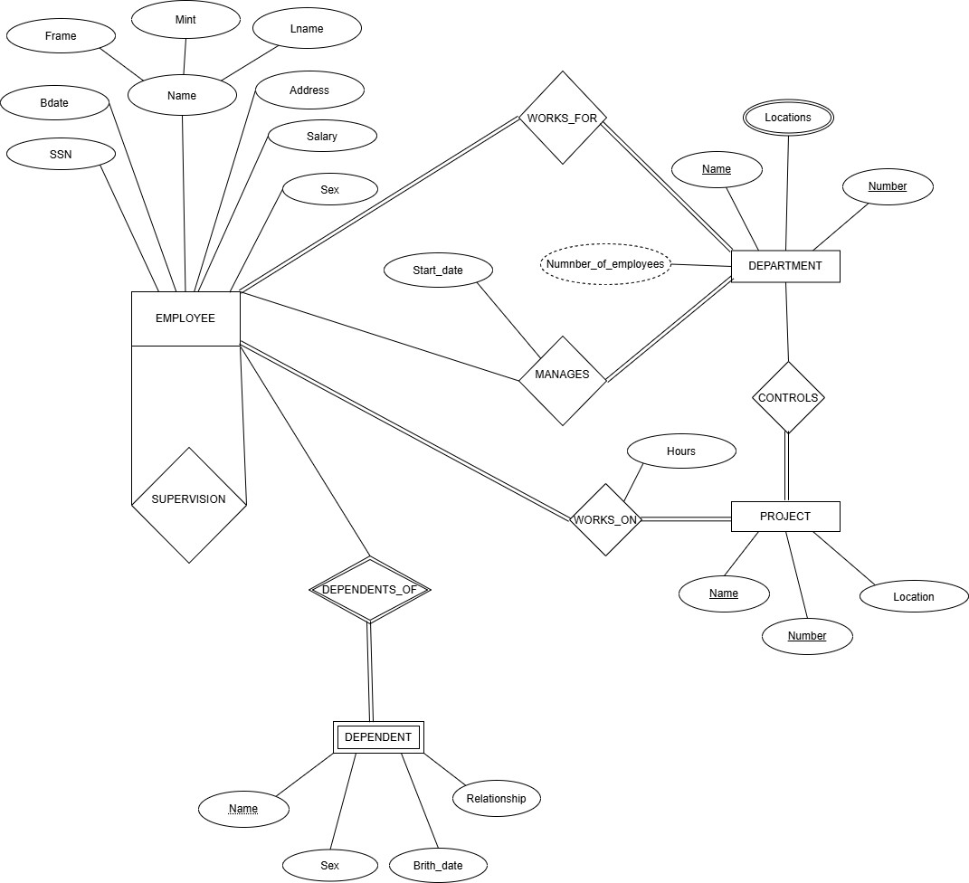

Draw an ER model for library management application considering the following constraints
−
  - In a library multiple students can enroll.
  - Students can become a member by paying an appropriate fee.
  - The books in the library are identified by a unique ID.
  - Students can borrow multiple books from subscribed libraries.

Solution:
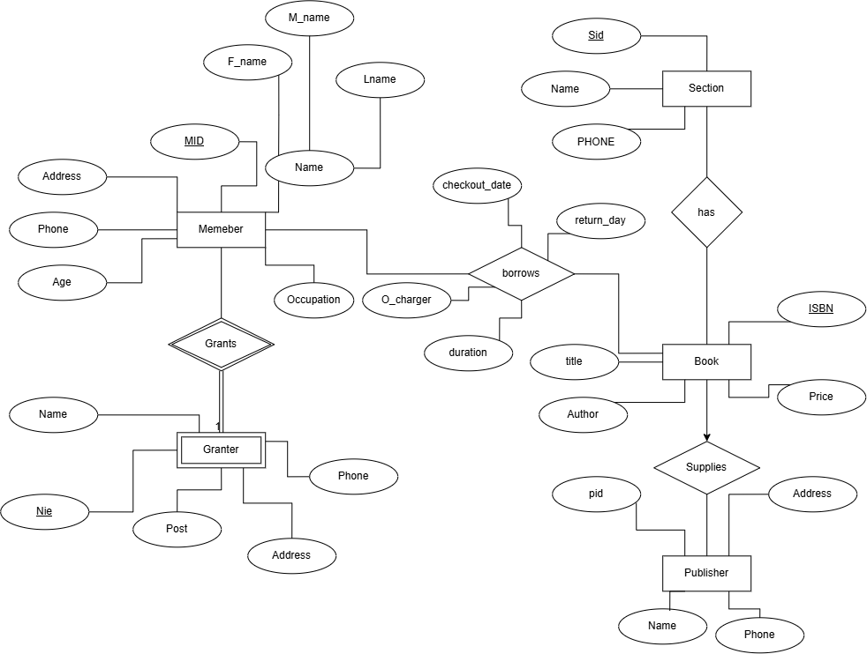

Draw an ER model of the Banking database application considering the following constraints
−
  - A bank has many entities.
  - Each customer has multiple accounts.
  - Multiple customers belong to a single branch.
  - Single customer can borrow multiple loans.
  - A branch has multiple employees. Solution:
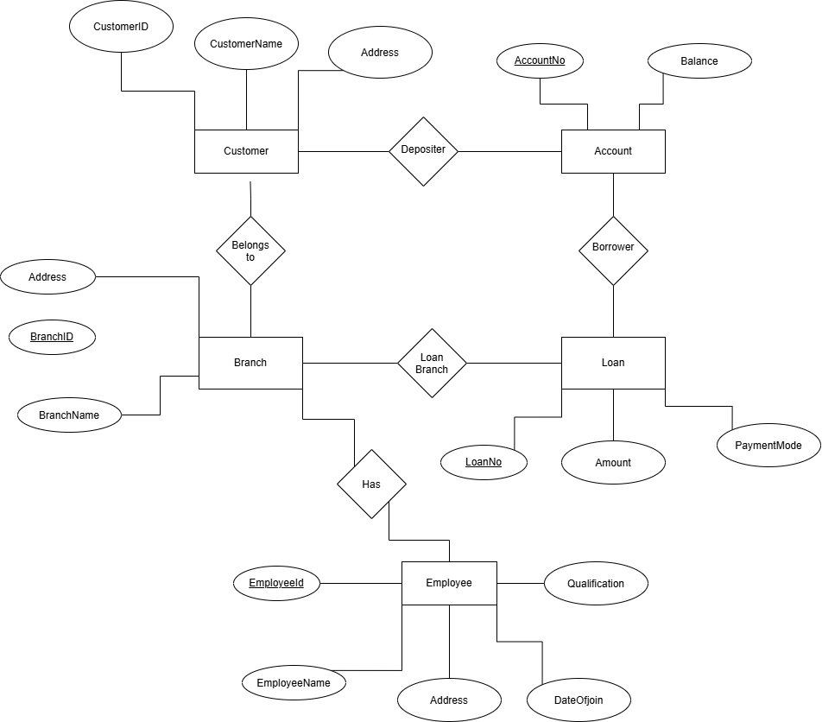

Drawing of ER model of university database application considering the constraints
  - A university has many departments.
  - Each department has multiple instructors (one person is HOD). Here the HOD refers to the head of department.
  - An instructor belongs to only one department.
  - Each department offers multiple courses, each subject is taught by a single instructor.
  - A student may enroll for many courses offered by different departments.

Solution:
