INFO 6068 Capstone
Test Strategy
The Oracle

Team Members:
Youtianjian Li (Student ID: 1110472)
Krystine Yuan Li (Student ID: 1055526)
Dhaval Prahladkumar Patel (Student ID: 1092865)
Vijay Shrestha (Student ID: 0987076)

Amendment History:
Version | Date | Amendment History
1.0 | 2022/05/19 | Initial draft created
1.1 | 2022/05/20 | Introduction and roles & responsibilities updated by Krystine Yuan Li
1.2 | 2022/05/22 | Testing overview updated by Vijay Shrestha
1.3 | 2022/05/23 | Test data and testing tools updated by Dhaval Prahladkumar Patel
1.4 | 2022/05/24 | Testing environment updated by Youtianjian Li
1.5 | 2022/05/25 | Final draft of test strategy created
1.6 | 2022/05/26 | Final draft of test strategy revised by team The Oracle
1.7 | 2022/05/27 | Acronyms added by Vijay Shrestha
1.8 | 2022/05/28 | Introduction and Scope updated by Krystine Yuan Li
1.9 | 2022/05/29 | Test strategy document finalized by team The Oracle

Reviewers:
This document must be reviewed by the following:
Name | Signature | Title / Responsibility | Date | Version
Vijay Shrestha | VS | Project Manager / Manage the entire project, report progress, and conduct meetings. | 2022/05/25 | 1.5
Krystine Yuan Li | KL | The Scribe / Taking meeting minutes and maintaining IAD | 2022/05/25 | 1.5
Dhaval Prahladkumar Patel | DP | Resource Manager / Manage resource pools assigned to projects | 2022/05/25 | 1.5
Youtianjian Li | YL | Steering Committee / Oversee entire project lifecycle and provide guidance. | 2022/05/25 | 1.5

Approvals:
This document must be approved by the following:
Name | Signature | Title / Responsibility | Date | Version
Shrijy Atodaria |  | Project Sponsor / Aligning the project with business goals, strategy and objectives.
Vijay Shrestha | VS | Project Manager / Manage the entire project and delegate tasks. | 2022/05/25 | 1.5

Distribution:
Marketing Department

Related Documents:
These documents will provide additional information.
Ref no | Doc Reference Number | Title | Version
Ref 01 | 1001 | Ewheelz Travel Application | 1.0

Glossary of Terms:
List any terms used in this document.
Term | Acronym | Definition
Functional Requirement Specification | FRS | Document that describes what the system must do
Quality Assurance | QA | Person who ensures the quality in each phase of SDLC
Hyper Text Markup Language | HTML | Markup language used in website development
Cascading Style Sheet | CSS | Style sheet language used for describing the presentation of a document written in a markup language such as HTML
Java 2 Platform Enterprise Edition | J2EE | Collection of Java Application Programming Interface (APIs) that helps software developers to write server-side applications
Solid State Drive | SSD | Mass storage device like a hard disk drive
Unified Functional Testing | UFT | Software that provides functional and regression test automation for software applications and environments
User Acceptance Testing | UAT | Also called application testing or end-user testing is a phase of software development in which the software is tested in the real world by its intended audience
Software Development Life Cycle | SDLC | It is a process that produces software with highest quality and lowest cost in the shortest time period

Table of Contents
Table of Contents 3
1. Introduction 4
1.1. Objectives 4
1.2. Scope 4
2. Roles and Responsibilities 4
3. Testing Overview 4
3.1. Test Lifecycle 4
3.2. Test Approach 4
3.3. Standards 4
3.4. Test Stages 4
3.5. Reviews and Inspections 5
3.6. Test Documentation 5
3.7. Test Execution 6
3.8. Entry & Exit Criteria 6
3.9. Test Results Capture 6
3.10. Progress Reporting 7
4. Test Data 7
5. Testing Environments 7
5.1. Specification 7
6. Testing Tools 7
6.1. Test Management Tools 7
6.2. Test Automation Tools 7

Introduction

Objectives
The test goals serve as the foundation for determining the scope and techniques of the test. For thorough testing of our travel and tourist office system that automates the activities. Each module will be subjected to separate usability and reliability testing. We assure the successful operation of each module and conduct software testing by testing each module separately, so that users may quickly and easily locate their goals when making trip arrangements and have a pleasant travel experience.

Scope
This test strategy will cover the following:
In Scope:
- Functional: The administrator has the right to modify and delete each data and edit for each travel route. After the user enters the destination display the travel route, and the ticket price, allowing the user to view the booking details.
- Non-Functional: Prepare for a large influx of users during peak travel periods, test the software for proper operation during peak periods, and ensure that user data is stored correctly. Allow users to have a good experience.
Out of Scope:
- Security: Users are required to ensure the security of their transactions when making ticket purchases on the Software. Protect the user's personal information on the software from being leaked.
- Data protection: The user's reservation information data is stored correctly to ensure that the user can find the travel information at any time. Detailed booking information for all users is maintained in the booking module.
- Disaster recovery: To prevent system crashes, store all data well and recover user data the first time when the system is restored.

Roles and Responsibilities
Roles | Responsibilities
Project Manager/Test Manager | Manage the overall testing process and team
Scribe/ QA | Record meetings decision and perform QA
Proof Reading / Test Engineer | Format the document and perform testing
Moderator / Test Analyst | Moderate the meeting and analyse business rule

Testing Overview

Test Lifecycle
In traditional development process, there is a set of well-defined steps involving planning, designing, coding, testing and deployment that might take several months to complete and reach the end users. In addition, the traditional development process requires stakeholders to provide pre-decided detailed requirements. Agile process on the other hand does not need pre-decided detailed requirement due to its iterative technique. Heeding these issues, the team Oracle has decided to follow Agile testing for this project. Agile testing lifecycle is as follow:
Sprint Planning
Sprint is basically breaking down large complex projects into smaller manageable pieces. In sprint there is a pre-decided time period in which the team has to work upon the requirement and accomplish the task within the duration. The Sprint kick-off meeting is conducted to discuss about the goals that need to be achieved in each of the sprints and involves stakeholders such as product owner, developer, and tester. Daily scrum is conducted where team members discuss about the task they are working on, task completed, and obstacles faced while working on the task.
Designing Test Cases
The testing team designs the test case as per the functional requirement document (FRS) and it is important for the testing team to cooperate with the developers in order to accurately design the test cases. Test case design signifies the testing technique being followed. Once the test cases are documented, it is handed over to the developers and Quality Assurance (QA) manager for review, in order to remove and defect.
Test Execution
This is the process where; the quality of the developed software is tested thoroughly. The team works together in an agile environment to execute testing. As soon as the development process completes and the software is made available for QA, the testing process starts.
Review Product Stability
The primary advantage of Agile methodology is that new features can be added, or any existing feature can be removed easily. With Agile method, new requirements can be accommodated at any stage of development without complexities. Having said that, it is important to maintain product stability and restrict the requirement flow. It is the responsibility of the testing team to validate the requirement changes and maintain stability.
Regression and Deployment
To deploy a quality software, manual and automated test cases are run after new user stories are added to the agile development process to test the impact on existing functionality. The following illustration describes the Agile testing in detail:
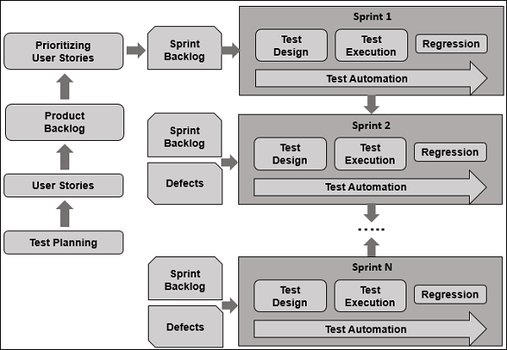
Figure 1: Agile Testing Life Cycle | © 2022 Tutorials Point

Test Approach
For this project, the team Oracle will be following Agile testing approach. Agile testing process is continuous rather than sequential like Waterfall testing. Agile testing requires minimal planning and there is less documentation. Agile testing begins at an early stage of the project so that any issues can be fixed. In this approach, test is performed in every iteration. Each time new requirements are added, or logics are released, regression testing is performed. User acceptance testing is performed at the end of every sprint in Agile approach. Tester needs to work closely with the development team to analyze requirements and planning.

Standards

For our severity scale, we used Nielsen's suggested severity rating scale:
- 0 = There is no usability issue
- 1 = Minor cosmetic issue
- 2 = Minor usability issue
- 3 = Major usability issue and must be fixed
- 4 = Usability disaster that must be fixed as soon as possible

Test Stages
Each test stage is a discrete form of testing with its own objectives, methods and requirements coverage and therefore a set of its own test scripts.
A coverage matrix of all the Test Stages / Test Areas to be covered in each Test Release is appended below
Test Areas/ Test Type | Unit Testing | Integration Testing | System Testing | Acceptance Testing | Smoke Testing | Usability Testing
Functional

Non-Functional

Business Processes

Volume

Performance

Security (including Penetration Testing)

Data Protection

Usability

Interface Tests

Installation & Configuration

Systems & Service Management & Service Level Reporting

Network Worthiness

Disaster Recovery

Helpdesk Tools & Processes

Management Information Reporting

Audit

Resilience

Capacity Planning

Data Migration

Training Processes, Contents & Effectiveness

Cutover & Fallback & Go-Live Simulation

Back-up, recovery, journaling

Operations Support Processes

Commissioning

Reviews and Inspections

Reviews

Project review is an important process because it helps to identify the strength, and weakness of the team as well as it helps stakeholders to understand whether the work done served its purpose or not. This project will be reviewed internally by performing gap analysis to identify whether the project results match the initial objectives or not. Deliverables will be checked for acceptable level of quality. The team will also check whether the project goal has been achieved or not and ensure that all the stakeholders are satisfied. It is also important to identify areas of future development, lesson learned while working on the project and report findings as well as document recommendations. Review will be conducted by reading important documents, independent reviewers will be encouraged to get involve in review process. Surveys and interviews will be conducted for data collection. Every finding will be documented and reported to respective stakeholders.

Inspections and Walkthroughs
Walkthrough is an informal process of performing group or individual review. For this project walkthrough will be performed by explaining the completed work to stakeholders in an informal meeting to get suggestion and feedback. Walkthrough is an informal static process of QA with a purpose.
Inspection is a formal in-depth group review conducted to identify issues and their cause. It can be combined with systematic testing to deploy error-free programs. Mostly inspection consist of moderator, author, reader, recorder, and inspector. Inspection consists of six stages i.e., planning, overview meeting, preparation, inspection meeting, rework, and follow-up. For this project, the moderator will plan the inspection, the author will describe the objective of project in overview meeting, and inspector will examine the complete work in preparation phase. Likewise, during inspection meeting, the reader will read out the any documentation of accomplished task and inspector will point out the defects if existed. In addition, in rework phase, the author will make changes as per the action plan from inspection meeting and changes are validated by the author in follow-up phase.

Test Documentation
Document | Phase and cycle
Test Strategy | Initial planning phase
Test Plans | Planning phase
Test Specifications | Development phase
Test Scripts | Execution phase
Test Report | Test closure phase

Test Execution
For this project, test will be executed in four phases i.e., Agile Quadrant 1, Agile Quadrant 2, Agile Quadrant 3, and Agile Quadrant 4. In Agile Quadrant 1, code quality is of utmost priority. Basically, unit and component testing will be performed in this phase. In Agile Quadrant 2, project requirement is of utmost priority. Business processes and rules will be tested in this phase. Testing possible scenarios, testing of user experience and pair testing will occur in this phase. In Agile Quadrant 3, reviews are carried out and feedbacks are generated for quadrants one and two. These feedbacks serve as a basis to perform automation testing. Usability testing, collaborative testing, user acceptance testing, exploratory testing, and pair testing with users will occur in this phase. In Agile Quadrant 4, non-functional requirements such as performance, security, etc. are prioritize. Stress testing, data migration testing, load testing, infrastructure testing, scalability testing, etc. will occur in this phase. The following illustration describes Agile test execution in more detail:
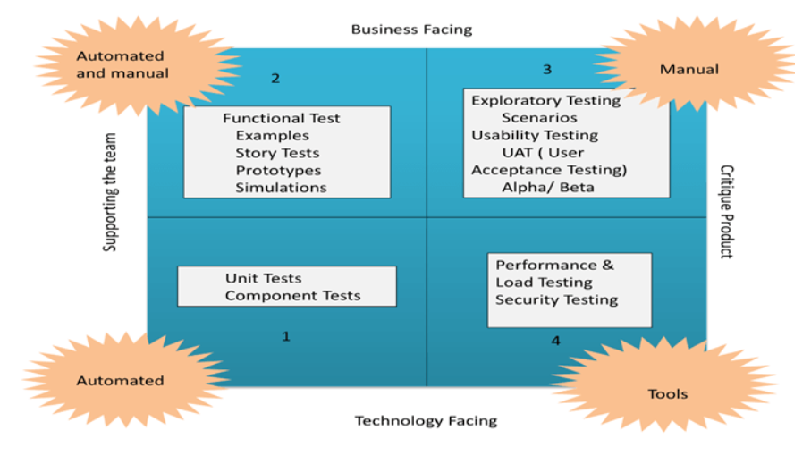
Figure 2: Agile Test Execution Phases | © Copyright - Guru99 2022

Test environment consists of hardware, software and data. Every tester will be using the laptop and various software such as Java, Apache Tomcat and MySQL. Test data will be generated automatically but, in some cases, manually generated data will be used. Most of the test take place in individual’s personal space. Team members will be coordinating virtually to share test results and receive feedbacks.

Recording Actual Results versus Expected Results
Each artifact from the testing will be recorded in a dedicated spreadsheet. This spreadsheet will be updated in regular basis with indication of test pass or test failure. Test will be considered as pass if actual result matches the expected result, and it will be considered as fail if actual result does not match the expected result. In case of test failure, all the test logs are documented and artifact are submitted to the development team.

Escalation of Issues for resolution
Test might fail due to network issue or server issue, validation failure or scripting issue, and bugs in code. In case of failure, it is important to rerun the test to get desired output. Likewise, all the test execution logs must be documented properly. If test fails due to flaws in the program, the issue must be assigned a severity level and escalated to the development team for mitigation. The escalation process will involve identification and documentation of issue, review of issue, reporting of issue, issue escalation and issue resolution. The criteria for escalation include:
- If the issue affects more than one module
- Unresolved issue
- High priority unresolved issue
An issue will be escalated by following the path below:
- Project Manager
- Steering Committee
- Executive Team

Test Execution Roles
For this project, there are four significant testing roles as discussed below:
QA Engineer:
This role covers all the testing process as well as constantly monitors each phase of SDLC to ensure that the software developed meets the quality standard. The key responsibility is to ensure that the software works seamlessly before pushed into production.
Test Manager:
Test manager are like project manager. It is a management role within QA or test team. The key responsibility is to manage the testing process, communicate with the stakeholders and analyze the reports.
Test Engineer:
Test engineer is specialized in various testing approaches such as manual testing, exploratory testing, performance testing, etc.
Test Analyst:
This role mainly focusses on business problems rather than technical challenges. Main responsibility is to ensure that the functional requirements of the products are met. The key responsibility involves designing, developing, running and troubleshoot test to identify any issue in code.

Entry & Exit Criteria
In simple terms test entry criteria is a set of conditions that need to be fulfilled to perform testing. It ensures the accuracy of testing process. Likewise, test exit criteria, is a set of conditions or requirements that need to be fulfilled before closing the testing process. It helps to conclude the testing process without hampering the efficiency of the software.

Entry and Exit Criteria
Entry Criteria
Following are the entry criteria for this project:
- Availability of testable code
- Well defined requirement that has been approved
- Availability of enough and desired test data
- Availability of well-developed test cases
- Availability of test environment and other required resources
Exit Criteria
Following are the exit criteria for this project:
- Tight deadlines and insufficient budget
- Execution of all test cases
- Coverage of all or sufficient functionalities and requirements
- Mitigation of all issues and defects
- No high severity unresolved bugs
- Acceptable defects

Test Results Capture
Test results will be captured using Excel sheet. A template will be created to capture the test results. The template will include test case ID that will be specific and unique. Likewise, it will include columns like description that will basically describe system, test level, test method, and field values. In addition, there will be columns for pre-condition, expected result, actual result, expected post condition, actual post condition, pass or fail, severity and comments.

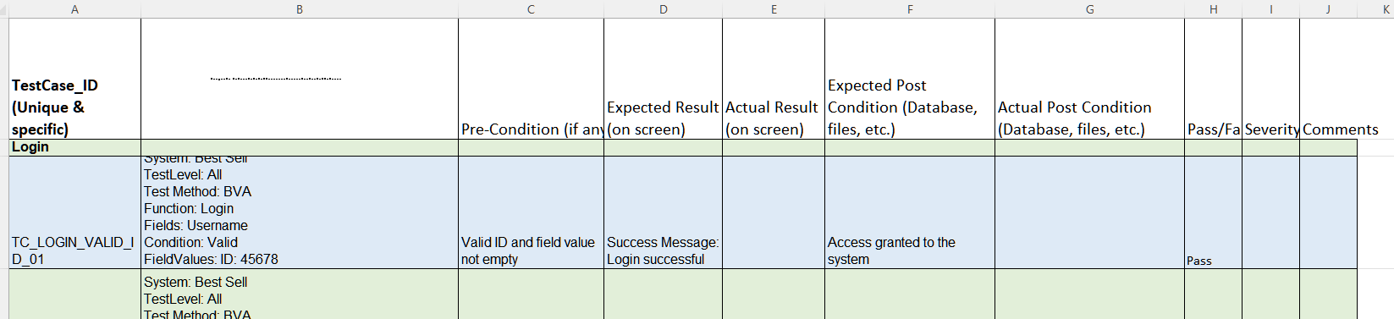
Figure 3: Sample of Spreadsheet to capture test results

Progress Reporting
Reporting test result is important because it helps to identify the current status of the project and quality of the software. Likewise, stakeholders can take corrective action following test reports.

Test Report
For this project, the team Oracle will be creating a dedicated test report template in Excel sheet that will include project information such as project name and description, test objective such as test type and purpose, test summary such as test passed, test failed and test blocked, and defect information such as defect description, priority and status. The primary intention will be to make the test report detail, clear, standard, and specific. Test report will be generated at the end of each testing phase and submitted to the stakeholders with recorded or live presentation.

Test Data

Test Type | Source of Test Data
White box testing | Will be provided by the developers
Usability testing | End users
Integration testing | Provided by the testers
Test Automation | Excel document prepared by testers
System testing | Testers

Testing Environments

Specification

Identification of the physical components, the communications, the system and middleware necessary
- Laptop / Desktop
- Intel Core / AMD Ryzen CPU
- 8G memory
- 256G SSD storage
- 100Mbps net access

Other software or supplies needed to support testing
- Java and J2EE installations
- HTML, JavaScript, CSS
- Tomcat 5.5
- MySQL 5.0
- Chrome / Edge / Firefox browser

Security and access requirements to the test area and equipment
Because security and accessibility are dependent on numerous factors such as time, hardware, software, and personnel. Evaluating and managing these factors will ensure that the team is able to obtain the appropriate test methods, determine the resources required, and ensure the consistency and structure of the tests.
A phased testing process ensures that each team member can keep pace and can resume the testing process at an appropriate breakpoint. Testing was therefore divided into the following phases:
- Planning. Individuals apply to the team, or the team assigns individuals the appropriate team roles, scope of tasks, timelines and corresponding resources for the subsequent smooth execution of the test
- Implementation. The core objectives of the testing tasks, individuals complete the corresponding testing objectives on time and as needed according to the planned tasks, record the testing process and results, and provide documentation support for subsequent analysis and repair.
- Post-implementation. Analyze the identified vulnerabilities and deficiencies, find their root causes, create report documents, and archive the documentation generated by the entire testing process.
To ensure that the test results are safe and valid, the testing process needs to guarantee:
- Each test environment is independent of the other. Each test environment is independent of each other. Ensure that the current test process is not influenced by others' test environments or past tests.
- Determine the test data backup and recovery strategy. Data destruction or loss due to exceptions in the testing process happens from time to time, and a proper data recovery and backup strategy can minimize the damage caused by testing exceptions.

Test tools and utilities required
- Junit
- Selenium
- JMeter
- MySQL slap
- Wireshark

Any other testing needs
- Test risk management documentation. Used to avoid test risks and to ensure that appropriate mitigation measures are in place when test risks are encountered.
- Test review and approval tool or process. Used to review tests for reasonableness, validity, and consistency and to accept test results.
.

Testing Tools

Test Management Tools
Test management software is used to keep track of how testing should be done, organize testing activities, and report on the status of testing.
It is critical that activities are allocated and tracked appropriately during the project's timeline. A test management tool not only assists team members in assigning tasks to specific individuals, but it also allows them to track whether the action was completed and by whom.
Installing and using a test management application requires minimal programming expertise, which reduces training time. The systems are simple to use, versatile, and accessible.

Test Automation Tools
Automation testing tools are apps that use automated test scripts to check function and/or non-functional requirements.
It is a piece of software that allows users to specify software testing activities that are then executed with minimal human input.
There are some test automation solutions that require coding knowledge, and others that do not. There are also hybrid tools that combine the greatest features of both. They allow testers and other professionals who don't know how to code to construct test cases using a visual interface. Engineers can then utilize a language like JavaScript to enhance those test cases.
When it comes to the numerous types of software that test automation tools enable, they also differ. Tools that target desktop (e.g., Windows) apps are available. When testing tools are mentioned nowadays, most people instantly think of online and mobile apps. Web testing is a broad topic that may be broken into numerous subcategories.
Some of the test automation tools are:
- Katalon Studio
- UFT
- SeleniumT
- Test Complete
- Testim

To pick the right tool, one should consider testing requirements of the project, assess the skills of the team members on the tool, evaluate the ROI of the tools, pricing etc.

