EX3:

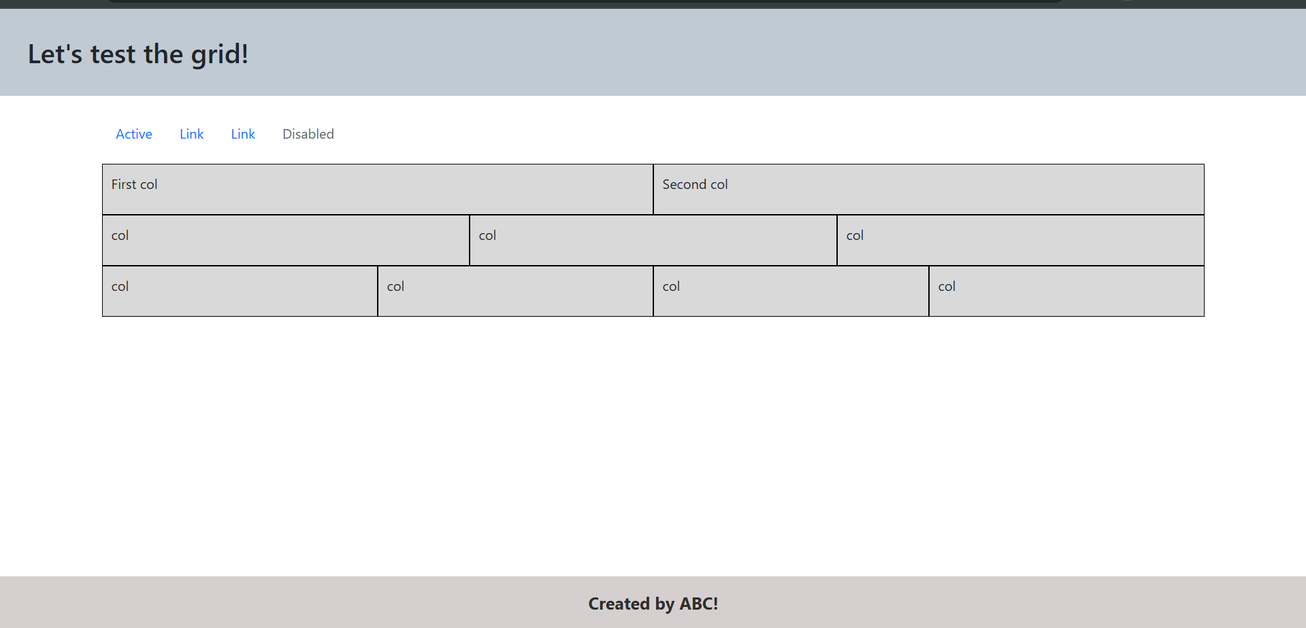

<!DOCTYPE html>

<html lang="en">

<head>

  <meta charset="UTF-8" />

  <meta name="viewport" content="width=device-width, initial-scale=1.0" />

  <title>Exercise 3 - Full-Width Header & Sticky Footer</title>

  <link

    rel="stylesheet"

    href="https://cdn.jsdelivr.net/npm/bootstrap@5.3.0/dist/css/bootstrap.min.css"

  />

  <style>

    html, body {

      height: 100%;

      margin: 0;

      display: flex;

      flex-direction: column;

    }

    .main-content {

      flex: 1;

    }

    .header {

      width: 100%;

      background-color: #c0cad3;

      padding: 2rem;

      text-align: left;

    }

    footer {

      width: 100%;

      background-color: #d6cfcf;

      color: #2d2d2d;

      padding: 1rem;

      text-align: center;

      font-size: 1.25rem;

      font-weight: bold;

    }

    .grid-box {

      background-color: #d9d9d9;

      border: 1px solid black;

      padding: 10px;

      text-align: left;

      vertical-align: top;

      height: 60px;

    }

    .grid-text {

      margin: 0;

    }

    .row {

    margin: 0; /\* Loại bỏ khoảng cách mặc định \*/

    gap: 0; /\* Loại bỏ khoảng trống giữa các cột \*/

  }

  </style>

</head>

<body>

  <!-- Header full-width -->

  <div class="header">

    <h2 class="m-0">Let's test the grid!</h2>

  </div>

  <!-- Nội dung chính -->

  <div class="main-content container my-4">

    <!-- Nav links -->

    <ul class="nav mb-3">

      <li class="nav-item">

        <a class="nav-link active" href="#">Active</a>

      </li>

      <li class="nav-item">

        <a class="nav-link" href="#">Link</a>

      </li>

      <li class="nav-item">

        <a class="nav-link" href="#">Link</a>

      </li>

      <li class="nav-item">

        <a class="nav-link disabled" href="#">Disabled</a>

      </li>

    </ul>

    <div class="row g-0">

      <div class="col grid-box"><p class="grid-text">First col</p></div>

      <div class="col grid-box"><p class="grid-text">Second col</p></div>

    </div>

    <div class="row g-0">

      <div class="col grid-box"><p class="grid-text">col</p></div>

      <div class="col grid-box"><p class="grid-text">col</p></div>

      <div class="col grid-box"><p class="grid-text">col</p></div>

    </div>

    <div class="row g-0">

      <div class="col-3 grid-box"><p class="grid-text">col</p></div>

      <div class="col-3 grid-box"><p class="grid-text">col</p></div>

      <div class="col-3 grid-box"><p class="grid-text">col</p></div>

      <div class="col-3 grid-box"><p class="grid-text">col</p></div>

    </div>

  </div>

  <!-- Footer full-width, luôn ở cuối -->

  <footer>

    Created by ABC!

  </footer>

  <script src="https://cdn.jsdelivr.net/npm/bootstrap@5.3.0/dist/js/bootstrap.bundle.min.js"></script>

</body>

</html>

EX4:

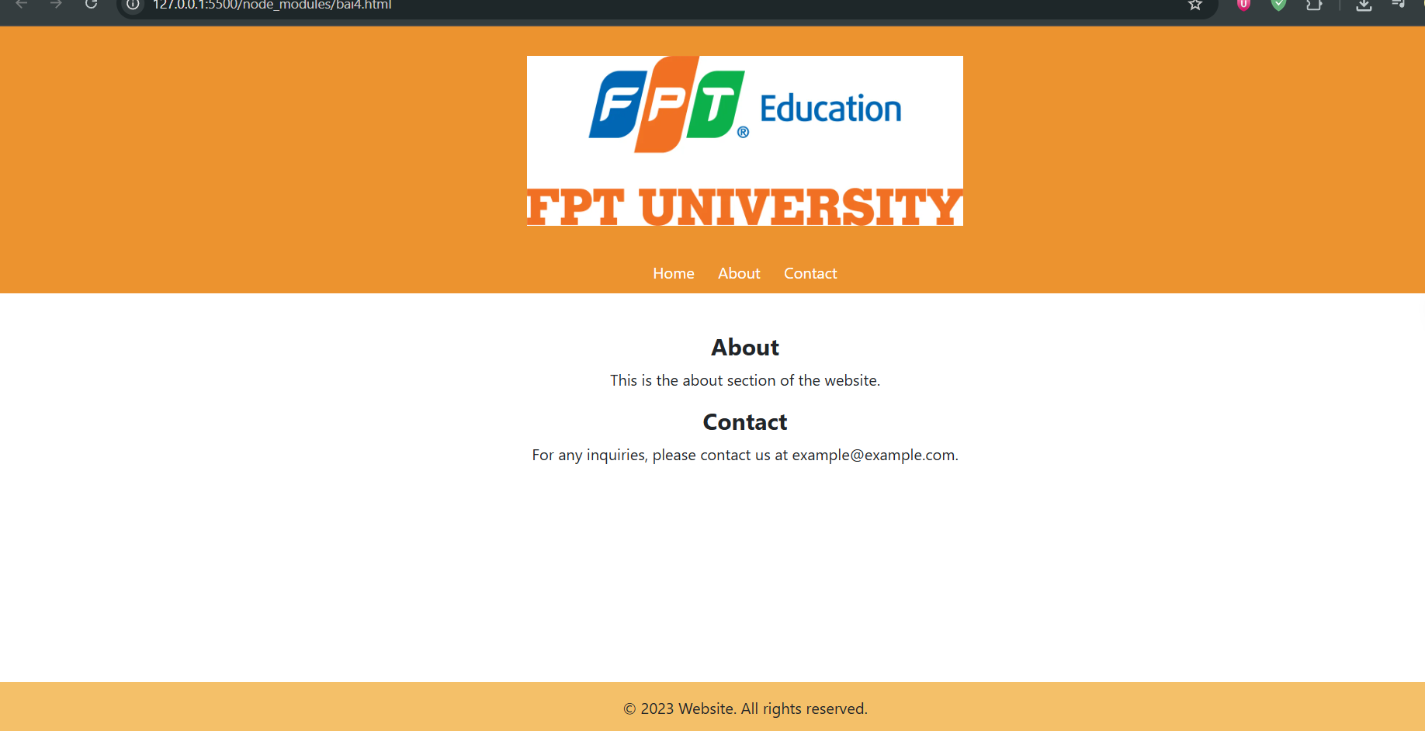  
<!DOCTYPE html>

<html lang="en">

<head>

  <meta charset="UTF-8">

  <meta name="viewport" content="width=device-width, initial-scale=1.0">

  <title>Exercise 4 - FPT University</title>

  <link rel="stylesheet" href="https://cdn.jsdelivr.net/npm/bootstrap@5.3.0/dist/css/bootstrap.min.css">

  <style>

    html, body {

  height: 100%;

  margin: 0;

  padding: 0;

  display: flex;

  flex-direction: column;

}

.header {

  background-color: #ec932f;

  padding: 30px 0 10px;

  text-align: center;

}

.logo {

  max-width: 450px;

  height: auto;

}

.navbar-custom {

  background-color: #ec932f;

  padding: 10px;

  text-align: center;

}

.navbar-custom a {

  color: white;

  text-decoration: none;

  margin: 0 10px;

}

.content {

  padding: 40px 20px;

  text-align: center;

  flex: 1;

}

footer {

  background-color: #f4c069;

  text-align: center;

  padding: 15px;

}

  </style>

</head>

<body>

  <div class="header">

    <img src="preview.webp" alt="FPT Logo" class="logo mb-3">

  </div>

  <div class="navbar-custom">

    <a href="#">Home</a>

    <a href="#">About</a>

    <a href="#">Contact</a>

  </div>

  <div class="content">

    <h4><strong>About</strong></h4>

    <p>This is the about section of the website.</p>

    <h4><strong>Contact</strong></h4>

    <p>For any inquiries, please contact us at example@example.com.</p>

  </div>

  <footer>

    © 2023 Website. All rights reserved.

  </footer>

</body>

</html>

EX5:



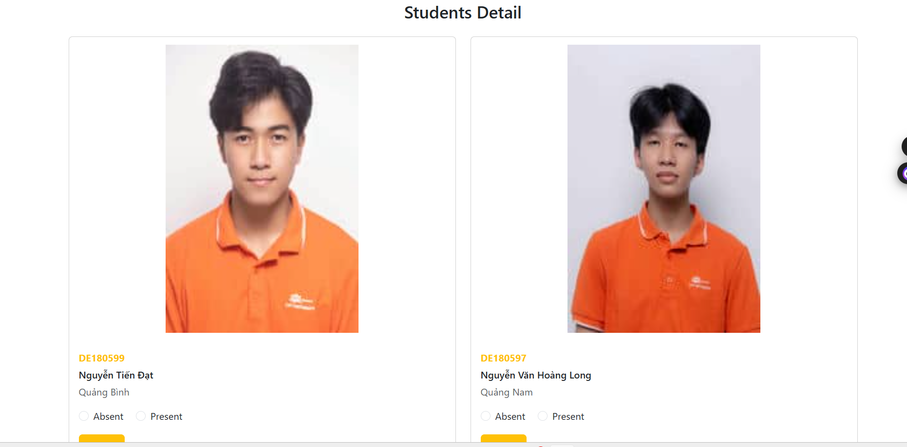

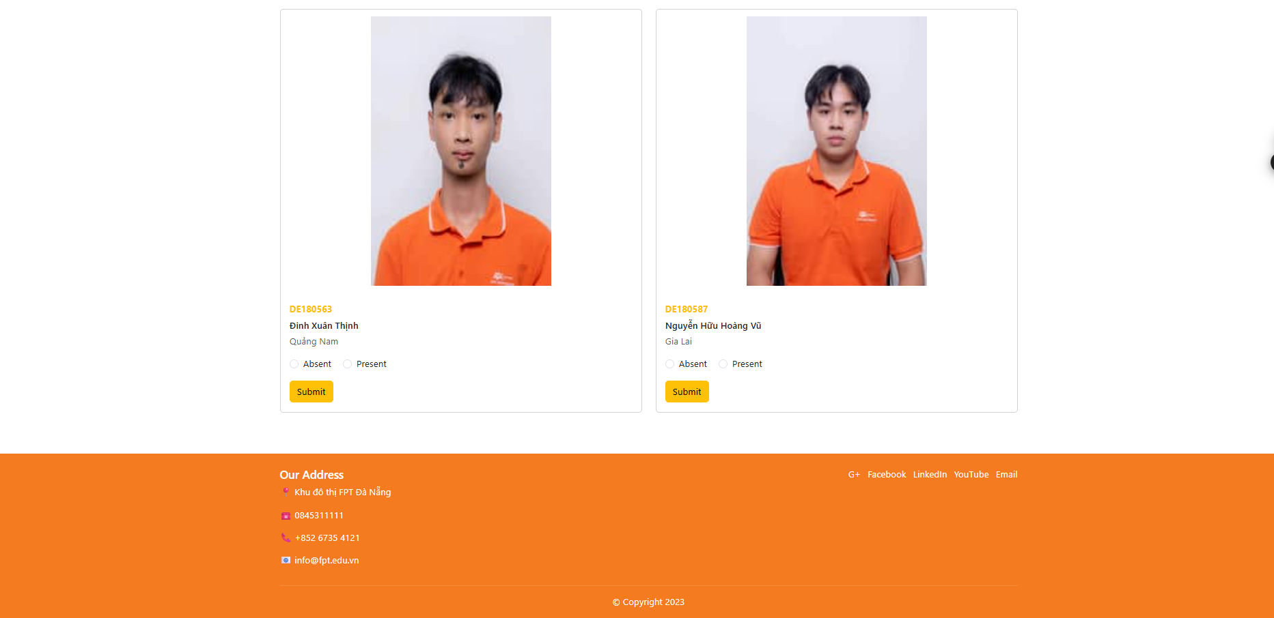

<!DOCTYPE html>

<html lang="en">

<head>

  <meta charset="UTF-8">

  <meta name="viewport" content="width=device-width, initial-scale=1.0">

  <title>FPT University - Students Detail</title>

  <link href="https://cdnjs.cloudflare.com/ajax/libs/bootstrap/5.3.0/css/bootstrap.min.css" rel="stylesheet">

  <style>

    .top-bar {

      background-color: #cd852d;

    }

    .banner {

      background-color: #f47b20;

    }

    .banner img {

      width: 100%;

      height: 600px;

      object-fit: fill;

    }

    .card img {

      width: 50%;

      height: 500px;

      object-fit: contain;

      display: block; /\* Ensures the image is treated as a block element \*/

      margin: 0 auto;

    }

    footer {

      background-color: #f47b20;

      color: white;

    }

  </style>

</head>

<body>

  <!-- Top Bar -->

  <div class="top-bar p-3">

    <div class="container-fluid d-flex justify-content-between align-items-center">

      <div class="d-flex align-items-center">

        <img src="preview.webp" alt="FPT Logo" height="40">

        <nav class="ms-3">

          <a href="#" class="text-decoration-none text-warning">Trang chủ</a> |

          <a href="#" class="text-decoration-none text-warning">Ngành học</a> |

          <a href="#" class="text-decoration-none text-warning">Tuyển sinh</a> |

          <a href="#" class="text-decoration-none text-warning">Sinh viên</a>

        </nav>

      </div>

      <div class="d-flex align-items-center">

        <label class="me-2">Search:</label>

        <input type="search" class="form-control form-control-sm" style="width: 150px;">

      </div>

    </div>

  </div>

  <div class="banner">

    <img src="sinhvien.webp" alt="Students Banner">

  </div>

  <div class="container mt-3">

    <nav aria-label="breadcrumb">

      <ol class="breadcrumb">

        <li class="breadcrumb-item"><a href="#" class="text-warning">Home</a></li>

        <li class="breadcrumb-item active">Students</li>

      </ol>

    </nav>

  </div>

  <div class="container my-5">

    <h3 class="text-center mb-4">Students Detail</h3>

    <div class="row">

      <div class="col-md-6 mb-4">

        <div class="card">

          <img src="dat.jpg" class="card-img-top" alt="Student 1">

          <div class="card-body">

            <p class="mb-1 fw-bold text-warning">DE180599</p>

            <p class="mb-1 fw-semibold">Nguyễn Tiến Đạt</p>

            <p class="mb-3 text-muted">Quảng Bình</p>

            <div class="mb-3">

              <div class="form-check form-check-inline">

                <input class="form-check-input" type="radio" name="status1" id="absent1">

                <label class="form-check-label" for="absent1">Absent</label>

              </div>

              <div class="form-check form-check-inline">

                <input class="form-check-input" type="radio" name="status1" id="present1">

                <label class="form-check-label" for="present1">Present</label>

              </div>

            </div>

            <button class="btn btn-warning">Submit</button>

          </div>

        </div>

      </div>

      <div class="col-md-6 mb-4">

        <div class="card">

          <img src="long.jpg" class="card-img-top" alt="Student 2">

          <div class="card-body">

            <p class="mb-1 fw-bold text-warning">DE180597</p>

            <p class="mb-1 fw-semibold">Nguyễn Văn Hoàng Long</p>

            <p class="mb-3 text-muted">Quảng Nam</p>

            <div class="mb-3">

              <div class="form-check form-check-inline">

                <input class="form-check-input" type="radio" name="status2" id="absent2">

                <label class="form-check-label" for="absent2">Absent</label>

              </div>

              <div class="form-check form-check-inline">

                <input class="form-check-input" type="radio" name="status2" id="present2">

                <label class="form-check-label" for="present2">Present</label>

              </div>

            </div>

            <button class="btn btn-warning">Submit</button>

          </div>

        </div>

      </div>

      <div class="col-md-6 mb-4">

        <div class="card">

          <img src="thinh.jpg" class="card-img-top" alt="Student 3">

          <div class="card-body">

            <p class="mb-1 fw-bold text-warning">DE180563</p>

            <p class="mb-1 fw-semibold">Đinh Xuân Thịnh</p>

            <p class="mb-3 text-muted">Quảng Nam</p>

            <div class="mb-3">

              <div class="form-check form-check-inline">

                <input class="form-check-input" type="radio" name="status3" id="absent3">

                <label class="form-check-label" for="absent3">Absent</label>

              </div>

              <div class="form-check form-check-inline">

                <input class="form-check-input" type="radio" name="status3" id="present3">

                <label class="form-check-label" for="present3">Present</label>

              </div>

            </div>

            <button class="btn btn-warning">Submit</button>

          </div>

        </div>

      </div>

      <div class="col-md-6 mb-4">

        <div class="card">

          <img src="vu.jpg" class="card-img-top" alt="Student 4">

          <div class="card-body">

            <p class="mb-1 fw-bold text-warning">DE180587</p>

            <p class="mb-1 fw-semibold">Nguyễn Hữu Hoàng Vũ</p>

            <p class="mb-3 text-muted">Gia Lai</p>

            <div class="mb-3">

              <div class="form-check form-check-inline">

                <input class="form-check-input" type="radio" name="status4" id="absent4">

                <label class="form-check-label" for="absent4">Absent</label>

              </div>

              <div class="form-check form-check-inline">

                <input class="form-check-input" type="radio" name="status4" id="present4">

                <label class="form-check-label" for="present4">Present</label>

              </div>

            </div>

            <button class="btn btn-warning">Submit</button>

          </div>

        </div>

      </div>

    </div>

  </div>

  <footer class="mt-auto py-4">

    <div class="container">

      <div class="row">

        <div class="col-md-6">

          <h5>Our Address</h5>

          <p>📍 Khu đô thị FPT Đà Nẵng</p>

          <p>☎️ 0845311111</p>

          <p>📞 +852 6735 4121</p>

          <p>📧 info@fpt.edu.vn</p>

        </div>

        <div class="col-md-6 text-md-end">

          <p>

            <a href="#" class="text-white text-decoration-none me-2">G+</a>

            <a href="#" class="text-white text-decoration-none me-2">Facebook</a>

            <a href="#" class="text-white text-decoration-none me-2">LinkedIn</a>

            <a href="#" class="text-white text-decoration-none me-2">YouTube</a>

            <a href="#" class="text-white text-decoration-none">Email</a>

          </p>

        </div>

      </div>

      <hr class="text-white-50">

      <p class="text-center mb-0">© Copyright 2023</p>

    </div>

  </footer>

  <script src="https://cdnjs.cloudflare.com/ajax/libs/bootstrap/5.3.0/js/bootstrap.bundle.min.js"></script>

</body>

</html>