**PRACTICAL EXAMINATION 01**Subject code: FER202 – SP25   
Duration: 85 minutes

You need to create a laptop management application using **JSON Server**, **ReactJS**, **Hooks**, **React Router**, and **React Bootstrap**. The application should include the following functionalities:

1. **Create a ReactJS Application.** (0.5 mark)

* Initialize a new ReactJS project.

1. **Create and configure JSON Server** (0.5 mark)**:**

* Create a db.json file in the root folder to initialize a mock server with the laptop and user account data as shown below:

{

"Laptops": [

{

"id": 1,

"brand": "Dell",

"model": "XPS 13",

"year": 2023,

"price": "$999",

"image": "/images/dell-xps13.jpg"

},

{

"id": 2,

"brand": "Apple",

"model": "MacBook Pro",

"year": 2022,

"price": "$2500",

"image": "/images/macbook-pro.jpg"

},

{

"id": 3,

"brand": "HP",

"model": "Spectre x360",

"year": 2021,

"price": "$1800",

"image": "/images/hp-spectre.jpg"

},

{

"id": 4,

"brand": "Lenovo",

"model": "ThinkPad X1",

"year": 2020,

"price": "$1600",

"image": "/images/lenovo-thinkpad.jpg"

}

],

"UserAccounts": [

{

"id": 1,

"username": "admin",

"password": "1234567",

"account_type": "admin",

"status": "active"

},

{

"id": 2,

"username": "jane",

"password": "1234567",

"account_type": "user",

"status": "inactive"

},

{

"id": 3,

"username": "alice",

"password": "1234567",

"account_type": "user",

"status": "active"

},

{

"id": 4,

"username": "bob",

"password": "1234567",

"account_type": "guest",

"status": "active"

}

]

}

1. **Create a Login Form.** (3 marks)

* Create a login form with 2 input fields: **Username**, **Password**.
  + Check the validity of the login credentials.
  + If the user enters the correct **username** and **password**, a modal should appear displaying the message 'Welcome, <username> login Successful!'.
  + If the username or password is incorrect, an **alert** should appear with the message **"Invalid username or password!"**.

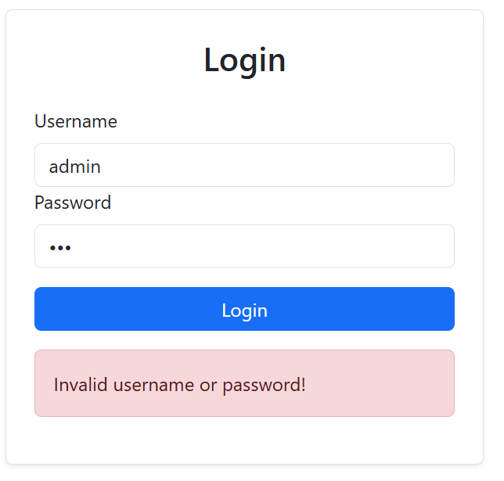

* Use **PropTypes** to ensure:
  + The **setUser** function is passed correctly as a required prop.
  + The username and password fields are both strings and are required.

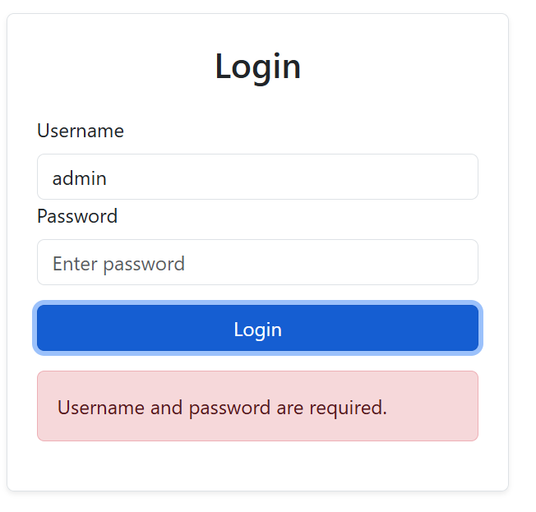

1. Create Laptop Management Form (4 marks)

* Display Laptop List (1 mark):
  + Fetch and display laptop details (brand, model, year, price, image) from the JSON Server.

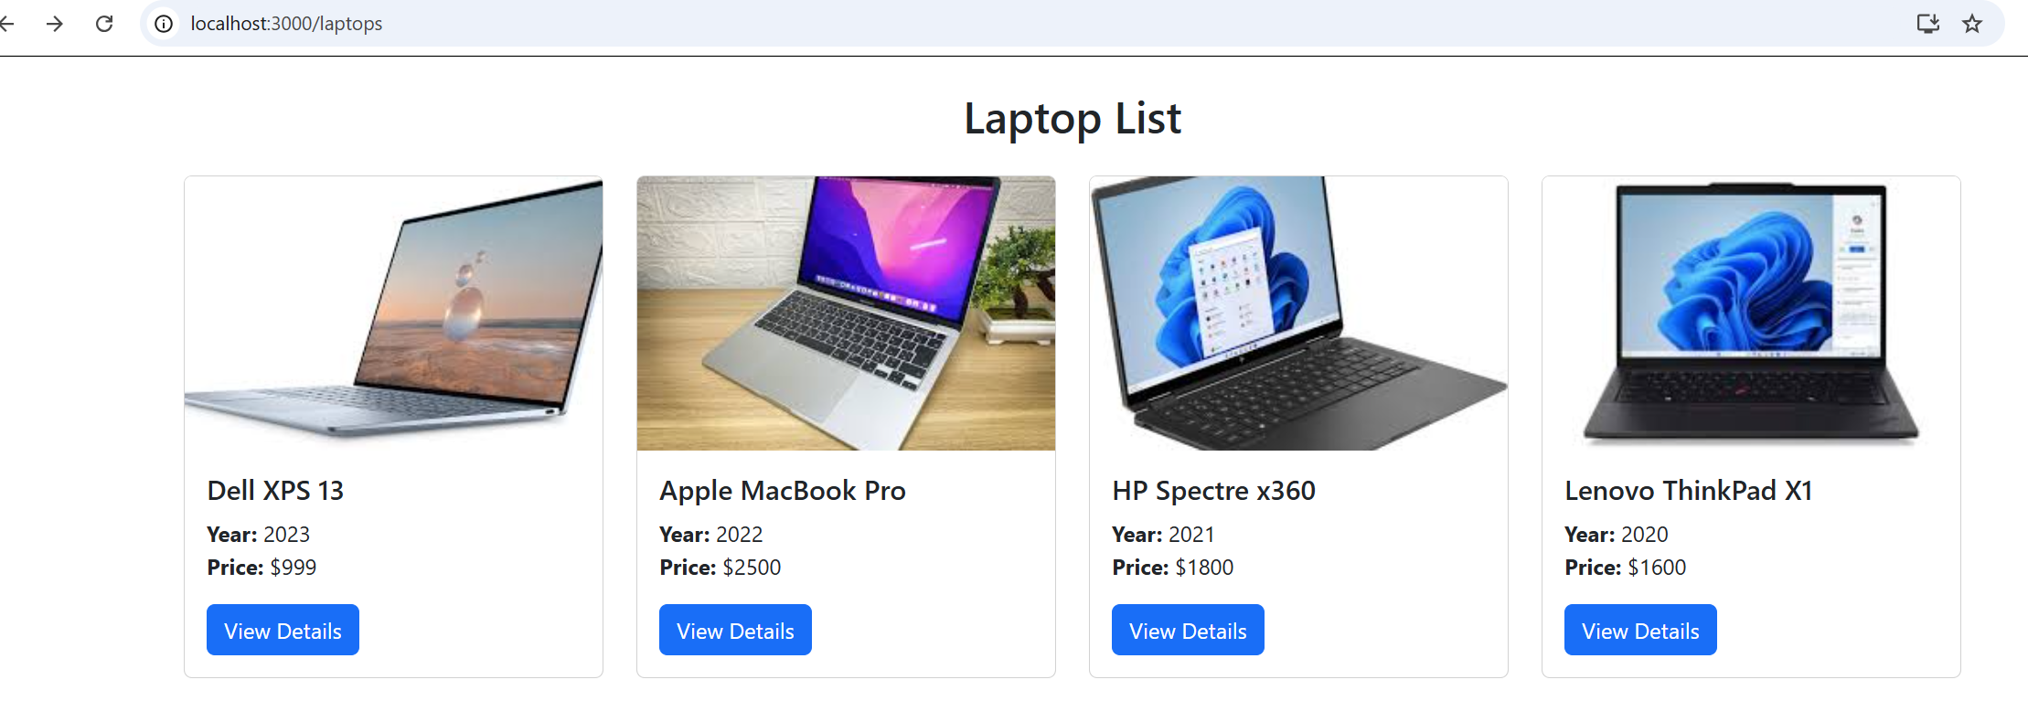

* View Details (1 mark):
  + Each laptop in the list should have a "View Details" button.
  + When clicked, it should display detailed information about the laptop: brand, model, year, price, description, image.
  + The URL should contain the **laptop id** as a parameter, e.g., /laptops/:id.
  + If the laptop with the given id is not found, show a 404 Not Found Page.

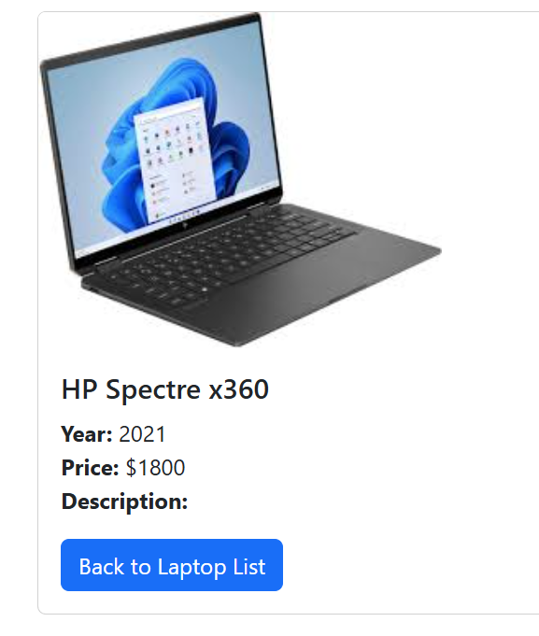

* Search by Name (2 marks):
  + Create an input field for name search.
  + The user can enter a name and filter the laptop list by the entered name.
  + When the user clicks the **Search** button, the laptop list should be filtered and displayed based on the entered name.

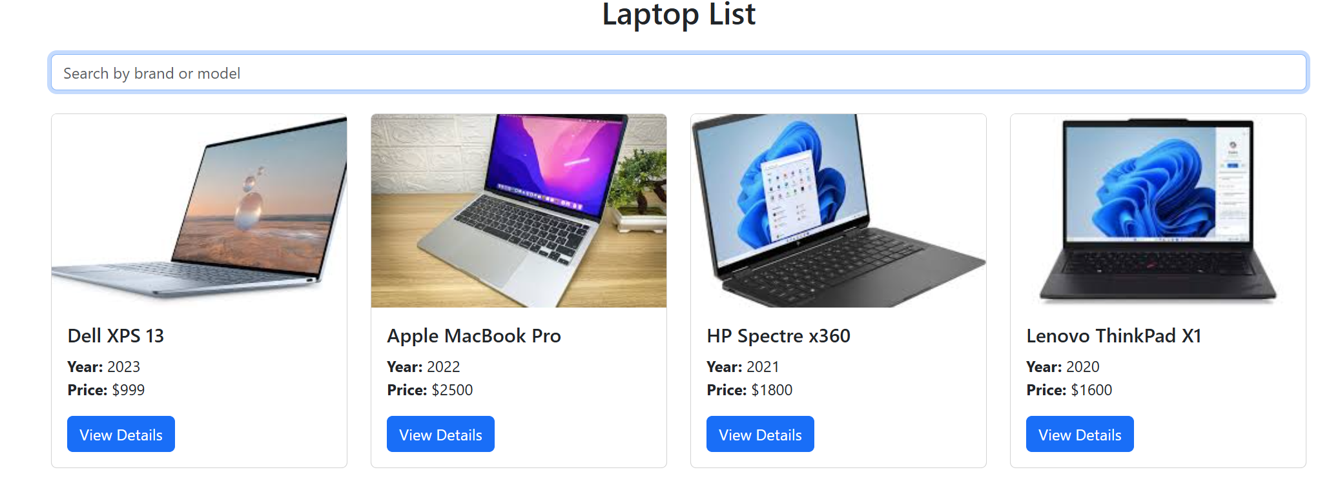

1. **User Interface** (1 mark)

* Use **React Bootstrap** to style the interface and ensure that the application is responsive on mobile devices.
* Ensure that all components are properly validated using PropTypes.
* Build a user-friendly and easy-to-use user interface.

1. **Routing** (1 mark)**:**

* Use React Router for navigation between the following pages:
  + The **Login** form page.
  + The **Laptop Management** page.
  + The **Laptop Detail** page.
* Ensure users can seamlessly navigate the application without issues.

**Note:**

* Students need to install and configure all required packages for the project in **10 minutes** **while the Internet is available**, such as: json-server, react-router-dom, react-bootstrap bootstrap, prop-types, axios, …
* Students are allowed to use resources on their computer, but may only use the Internet to download and install required packages via the Terminal, and then submit their exam.
* **If identical assignments are detected, the student's work will receive a score of zero.**
* **If the exercise is incorrect or doesn't produce the correct result, the student's work will receive a score of zero.**
* **When compressing the file for submission, please exclude the node_modules folder.**

The materials that students must submit to the lsmdn system for marking include:

1. FPTUniversity_FER202.zip
2. The PE01.docx that snap your codes, result.