import React from "react";

function Exercise1() {

  const employee = { name: "John Doe", age: 30, department: "IT" };

  const { name, age, department } = employee;

  return (

    <div>

      <h2>Exercise 1 – Destructuring</h2>

      <h1>{name}</h1>

      <p>Age: {age}</p>

      <p>Department: {department}</p>

    </div>

  );

}

export default Exercise1;

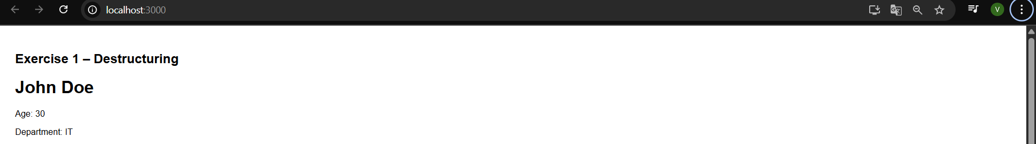

2.

import React from "react";

function Exercise2() {

  const employees = [

    { id: 1, name: "Anna", department: "HR", age: 50 },

    { id: 2, name: "Brian", department: "IT", age: 40 },

    { id: 3, name: "Clara", department: "Finance", age: 19 },

    { name: "Ann", department: "Finance", age: 22 },

    { name: "Elisabeth", department: "HR", age: 16 },

  ];

  return (

    <div>

      <h2>Exercise 2 – List of Employees</h2>

      <ul>

        {employees.map((e, index) => (

          <li key={e.id || index}>

            {e.name} - {e.department}

          </li>

        ))}

      </ul>

    </div>

  );

}

export default Exercise2;

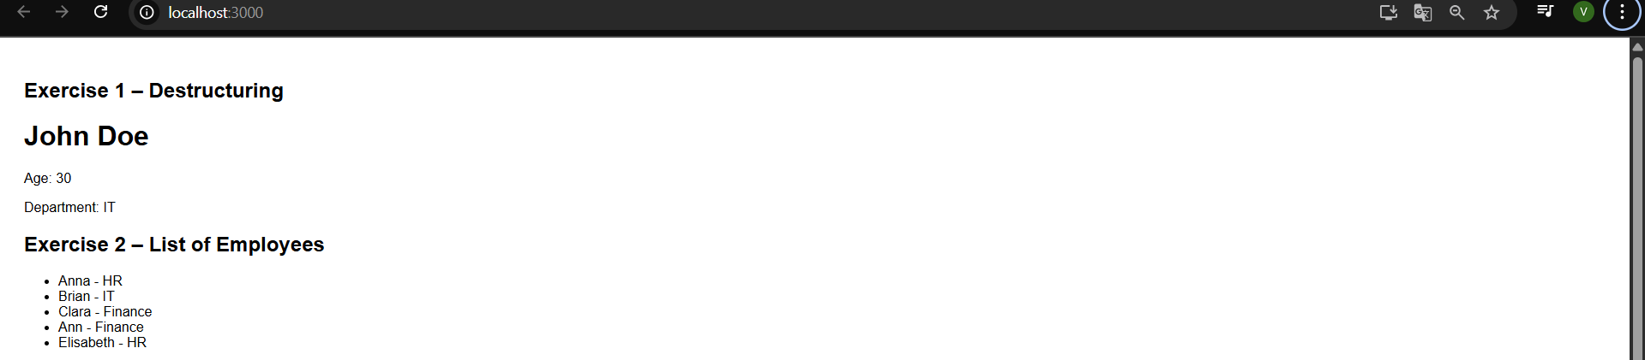

3.

import React from "react";

function Exercise3() {

  const employees = [

    { id: 1, name: "Anna", department: "HR" },

    { id: 2, name: "Brian", department: "IT" },

    { name: "Clara", department: "Finance" },

  ];

  return (

    <div>

      <h2>Exercise 3 – Employee Table</h2>

      <table border="1" cellPadding="5">

        <thead>

          <tr>

            <th>ID</th>

            <th>Name</th>

            <th>Department</th>

          </tr>

        </thead>

        <tbody>

          {employees.map((e, index) => (

            <tr key={e.id || index}>

              <td>{e.id || index + 1}</td>

              <td>{e.name}</td>

              <td>{e.department}</td>

            </tr>

          ))}

        </tbody>

      </table>

    </div>

  );

}

export default Exercise3;

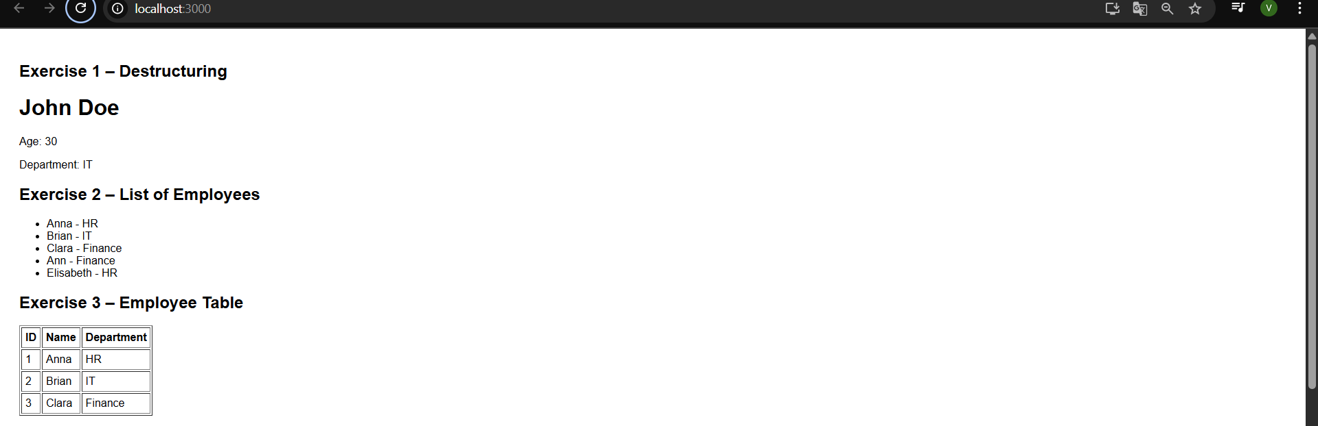

4.

function Exercise4() {

  const averageAge = (...ages) => {

    const total = ages.reduce((sum, age) => sum + age, 0);

    return (total / ages.length).toFixed(2);

  };

  const ages = [30, 40, 50, 60];

  return (

    <div>

      <h2>Exercise 4 – Average Age</h2>

      <p>Average Age: {averageAge(...ages)}</p>

    </div>

  );

}

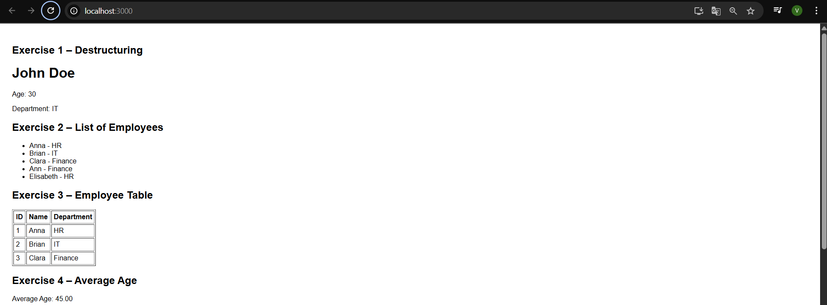

5.

import React from "react";

function Exercise5() {

  const employees = [

    { name: "Anna" },

    { name: "Brian" },

    { name: "Clara" },

    { name: "Ann" },

    { name: "Elisabeth" },

  ];

  return (

    <div>

      <h2>Exercise 5 – Dropdown</h2>

      <select>

        {employees.map((e, index) => (

          <option key={index}>{e.name}</option>

        ))}

      </select>

    </div>

  );

}

export default Exercise5;

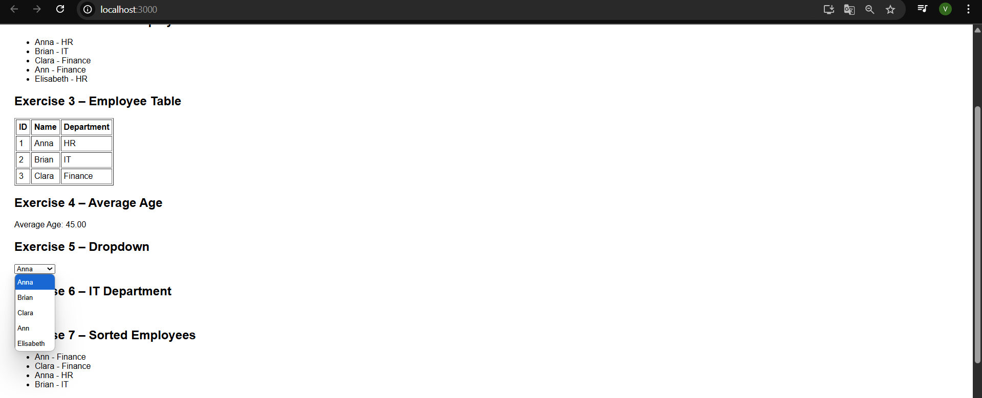

6.import React from "react";

function Exercise6() {

  const employees = [

    { name: "Anna", department: "HR" },

    { name: "Brian", department: "IT" },

    { name: "Clara", department: "Finance" },

  ];

  const itEmployees = employees.filter((e) => e.department === "IT");

  return (

    <div>

      <h2>Exercise 6 – IT Department</h2>

      <ul>

        {itEmployees.map((e, index) => (

          <li key={index}>{e.name}</li>

        ))}

      </ul>

    </div>

  );

}

export default Exercise6;

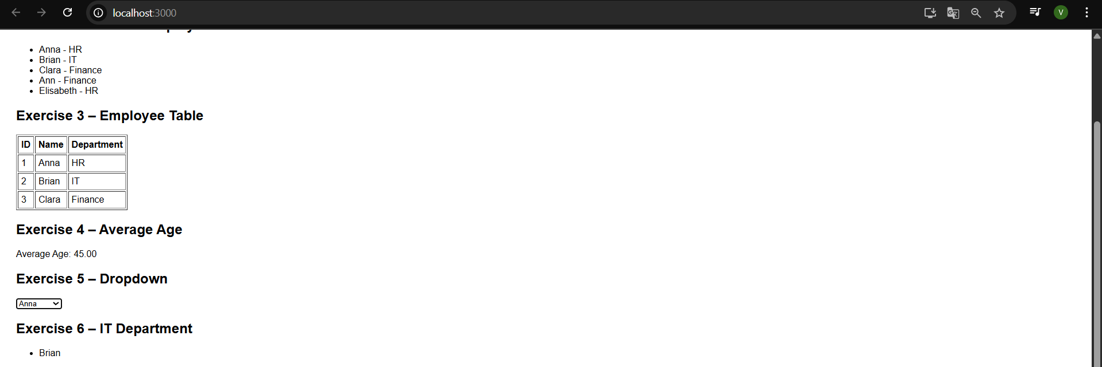

7.import React from "react";

function Exercise7() {

  const employees = [

    { name: "Anna", department: "HR" },

    { name: "Brian", department: "IT" },

    { name: "Clara", department: "Finance" },

    { name: "Ann", department: "Finance" },

  ];

  const sorted = [...employees].sort((a, b) => {

    const d = a.department.localeCompare(b.department);

    return d !== 0 ? d : a.name.localeCompare(b.name);

  });

  return (

    <div>

      <h2>Exercise 7 – Sorted Employees</h2>

      <ul>

        {sorted.map((e, index) => (

          <li key={index}>

            {e.name} - {e.department}

          </li>

        ))}

      </ul>

    </div>

  );

}

export default Exercise7;

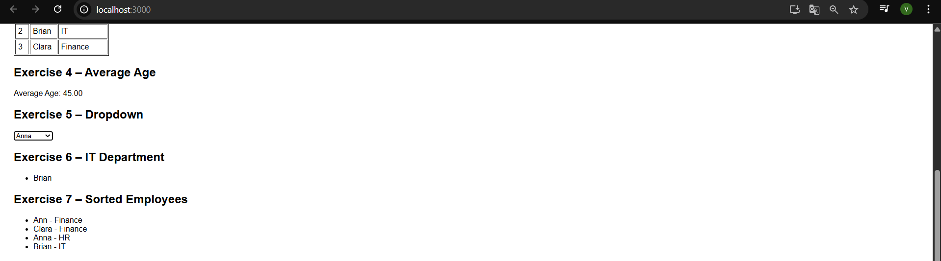

8.import React from "react";

function Exercise8() {

  const employees = [

    { name: "Anna", department: "HR" },

    { name: "Brian", department: "IT" },

    { name: "Clara", department: "Finance" },

    { name: "Ann", department: "Finance" },

    { name: "Elisabeth", department: "HR" },

  ];

  const grouped = employees.reduce((acc, emp) => {

    const dept = emp.department;

    if (!acc[dept]) acc[dept] = [];

    acc[dept].push(emp);

    return acc;

  }, {});

  return (

    <div>

      <h2>Exercise 8 – Grouped by Department</h2>

      {Object.entries(grouped).map(([dept, emps]) => (

        <div key={dept}>

          <h3>{dept}</h3>

          <ul>

            {emps.map((e, index) => (

              <li key={index}>{e.name}</li>

            ))}

          </ul>

        </div>

      ))}

    </div>

  );

}

export default Exercise8;

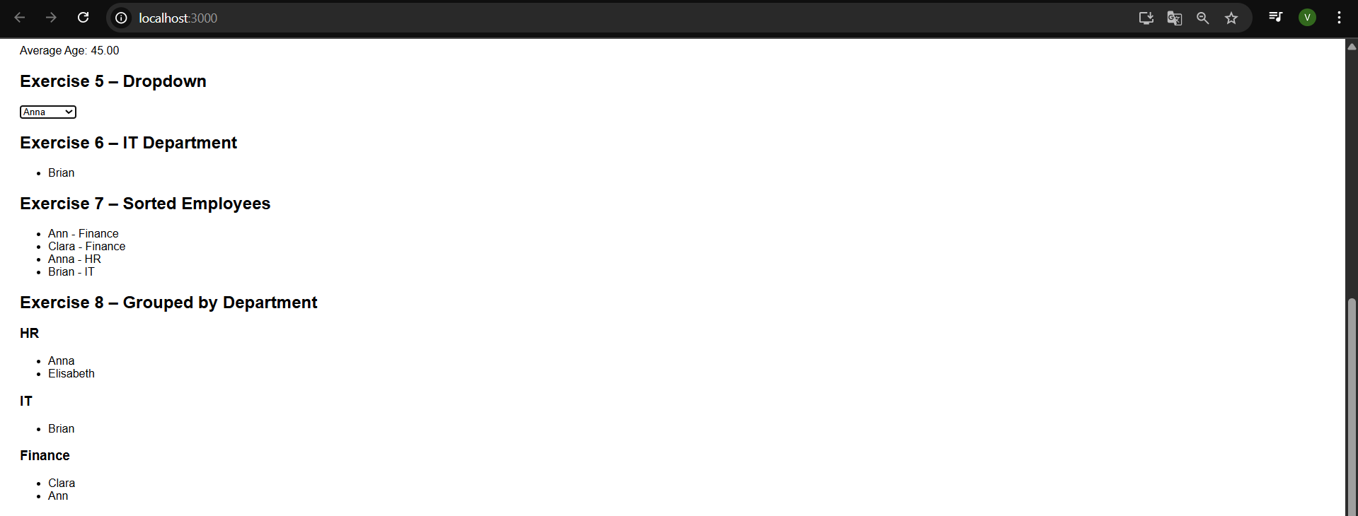

9.import React from "react";

function Exercise9() {

  const employees = [

    { name: "Anna", age: 50 },

    { name: "Clara", age: 19 },

    { name: "Elisabeth", age: 16 },

  ];

  const isTeenager = employees.some((e) => e.age >= 10 && e.age <= 20);

  return (

    <div>

      <h2>Exercise 9 – Teenager Check</h2>

      <p>{isTeenager ? "Yes" : "No"}</p>

    </div>

  );

}

export default Exercise9;



10.import React, { useState } from "react";

function Exercise10() {

  const employees = [

    { name: "Anna", department: "HR" },

    { name: "Brian", department: "IT" },

    { name: "Clara", department: "Finance" },

  ];

  const [search, setSearch] = useState("");

  const filtered = employees.filter((e) =>

    e.name.toLowerCase().includes(search.toLowerCase())

  );

  return (

    <div>

      <h2>Exercise 10 – Search Employee by Name</h2>

      <input

        type="text"

        placeholder="Search..."

        value={search}

        onChange={(e) => setSearch(e.target.value)}

      />

      <ul>

        {filtered.map((e, index) => (

          <li key={index}>

            {e.name} - {e.department}

          </li>

        ))}

      </ul>

    </div>

  );

}

export default Exercise10;



App.js:

import React from "react";

import Exercise1 from "./Ex/Exercise1";

import Exercise2 from "./Ex/Exercise2";

import Exercise3 from "./Ex/Exercise3";

import Exercise4 from "./Ex/Exercise4";

import Exercise5 from "./Ex/Exercise5";

import Exercise6 from "./Ex/Exercise6";

import Exercise7 from "./Ex/Exercise7";

import Exercise8 from "./Ex/Exercise8";

import Exercise9 from "./Ex/Exercise9";

import Exercise10 from "./Ex/Exercise10";

function App() {

  return (

    <div style={{ padding: "20px", fontFamily: "Arial" }}>

      <Exercise1 />

      <Exercise2 />

      <Exercise3 />

      <Exercise4 />

      <Exercise5 />

      <Exercise6 />

      <Exercise7 />

      <Exercise8 />

      <Exercise9 />

      <Exercise10 />

    </div>

  );

}

export default App;