MediCare Hospital Management System
Database Management Systems – Project Report
Harsika S V · Reg. No. 25MIS1082
M.Tech CSE (Data Science) · VIT Chennai
Course code: __________ Faculty: __________ Date: __________

1. Introduction
MediCare is a web application for the front desk of a small hospital or clinic. The receptionist uses it to register patients, keep a list of doctors and their fees, book appointments, run the daily token queue and print bills. All information is stored in a MySQL relational database, and every screen reads from and writes to that database through PHP.
The project shows the full cycle of a database application: a frontend for the user, a backend that checks input and runs SQL, and a relational schema with keys and constraints that keep the data correct.

2. Problem Statement and Objectives
Many small clinics still keep patient details in registers or spreadsheets. The same patient is written down many times, queue numbers are given by hand, and bills are added up on paper. This leads to duplicate records, lost visit history and wrong totals.
Objectives:
- Store patients, doctors, appointments, queue tokens and bills in five related tables.
- Register a new patient together with a booked first visit in one transaction; keep token generation and billing as later, separate steps.
- Show view-all, first record, last record, search, insert, update and delete in the website.
- Calculate bills on the server and prevent duplicate tokens and duplicate bills.
- Protect history: records that are linked to visits or bills cannot be deleted.
- Keep it simple to install with XAMPP on Windows and easy to explain.

3. Functional Requirements
Module | What it does
Dashboard | Live counts of patients, doctors, appointments and waiting tokens; status summary; recent appointments; live queue.
Patients | Register a patient and book the first appointment in one form (appointment section first, patient section second, saved in one transaction). List, search by name / ID / phone, edit, safe delete, first and last record, total count.
Doctors | Add, list, search, edit, safe delete, active / inactive status, consultation fee.
Appointments | Book later visits for registered patients in two steps (review, then confirm), last doctor pre-selected, search and filter, reschedule, cancel without deleting, change status.
Token Queue | Generate a daily token for a scheduled appointment of today; Waiting → In Consultation → Completed; cancel and re-open; one token per appointment.
Billing | Bill a completed visit; fee filled from the doctor; lab, medicine and discount entered; total calculated in PHP; one bill per visit; search; printable receipt.

4. Technology Stack
Layer | Technology
Frontend | HTML5, CSS3 (single stylesheet), vanilla JavaScript
Backend | PHP 8 with PDO, prepared statements, sessions, CSRF tokens
Database | MySQL / MariaDB (XAMPP), InnoDB engine, utf8mb4
Tools | XAMPP (Apache + MySQL + phpMyAdmin), VS Code, Chrome / Edge
No framework, package manager or online service is used. The site runs at http://localhost/medicare/ and works without internet.

5. ER Diagram
There are five entities. A doctor attends many appointments and a patient books many appointments, so APPOINTMENT links them (it resolves the many-to-many relationship between patients and doctors). Each appointment can get at most one token and at most one bill. A patient may optionally prefer one doctor.
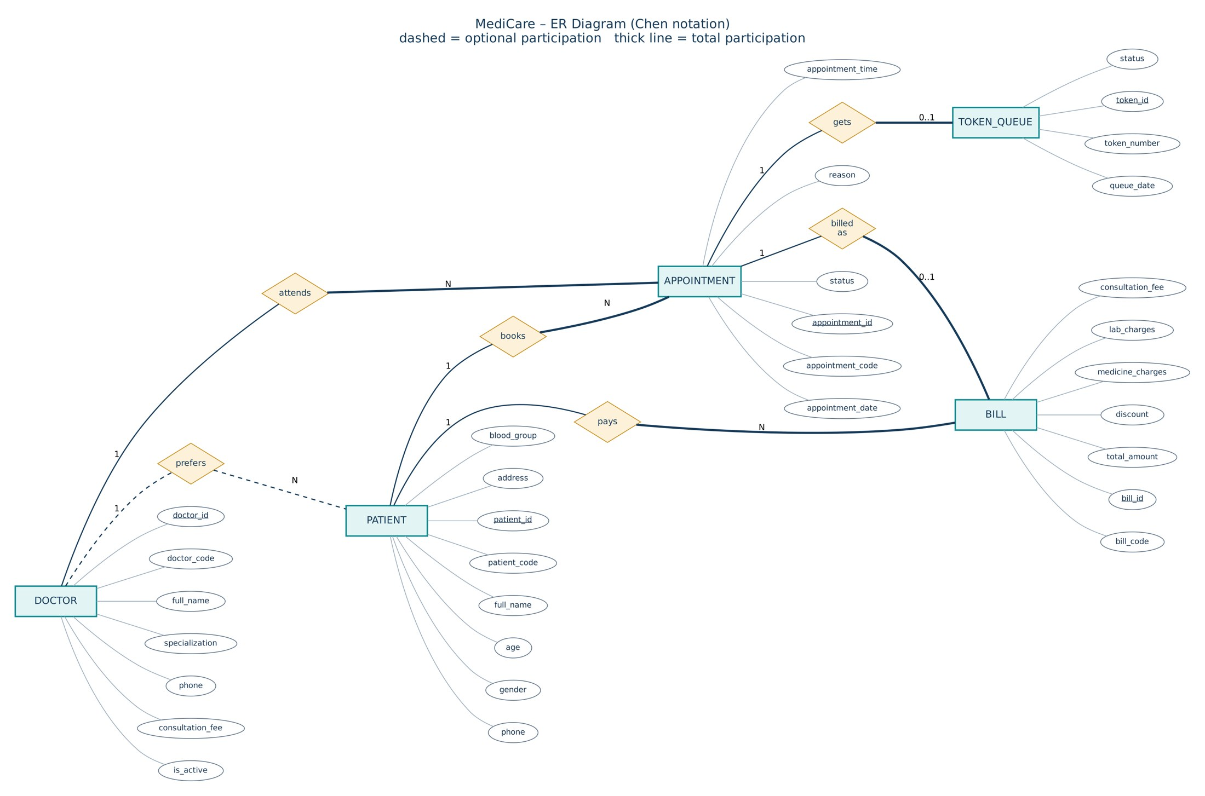
Figure 1: ER diagram (Chen notation). Underlined attributes are keys.

6. Relational Schema and Relationships
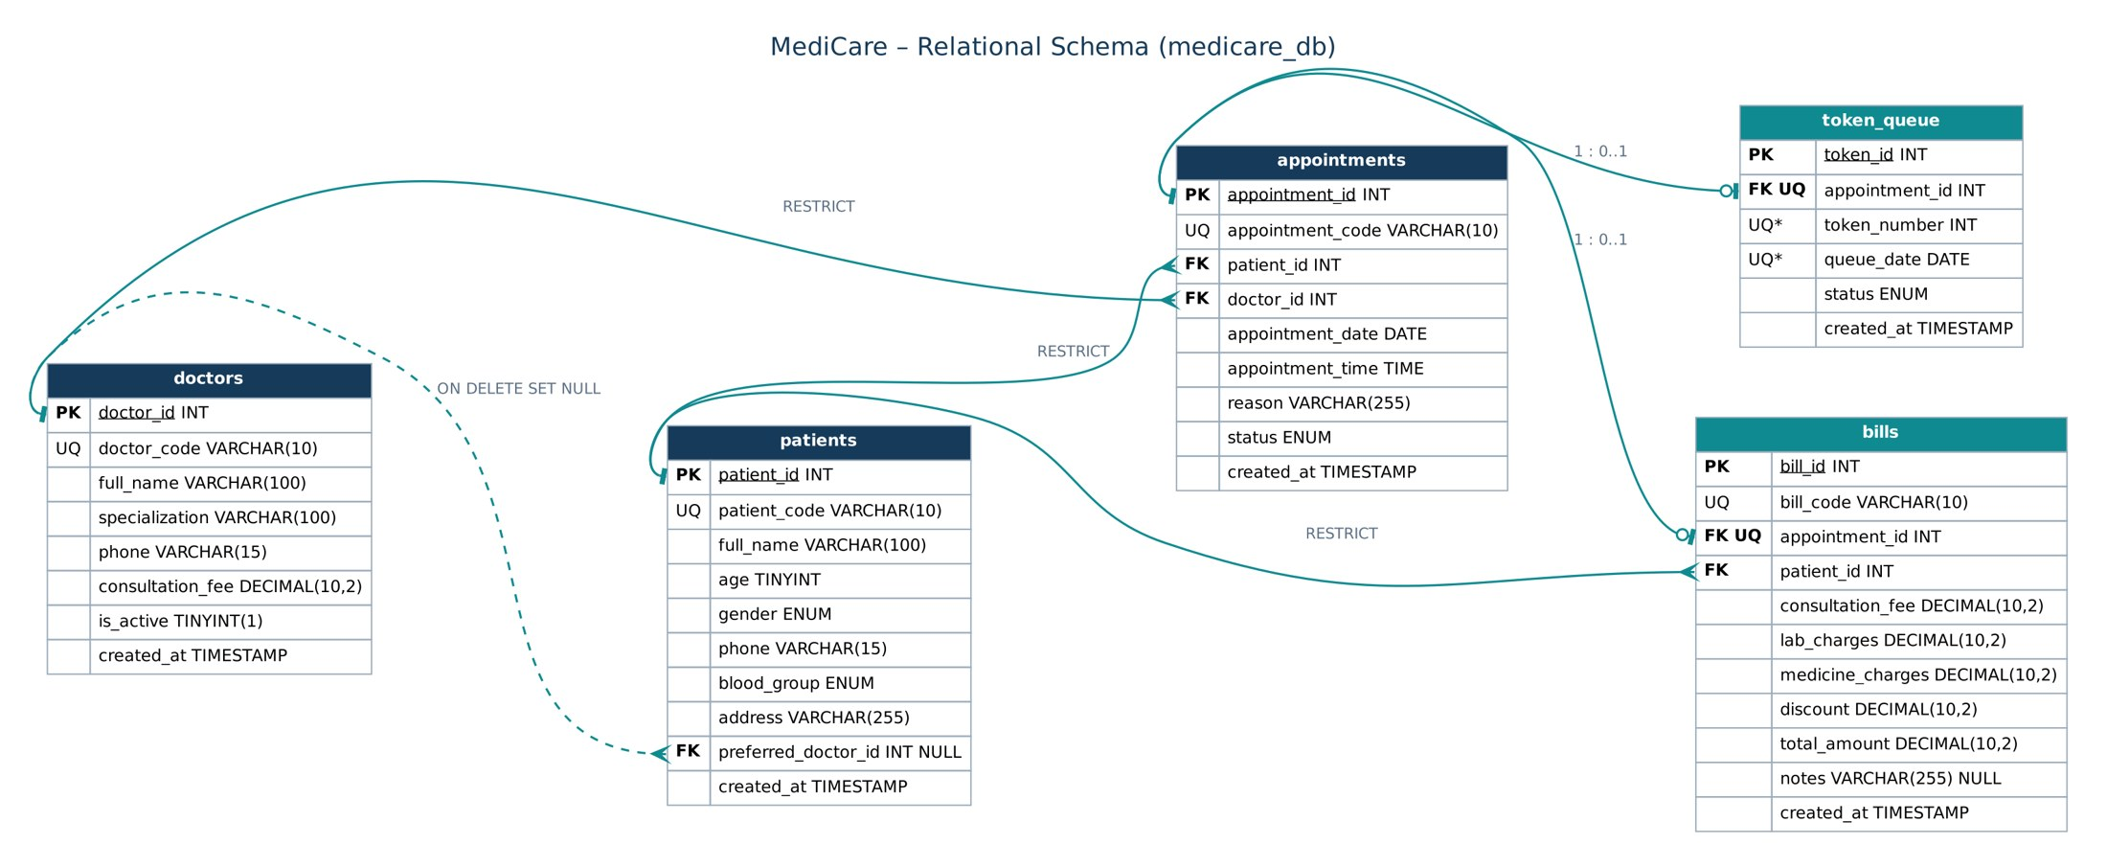
Figure 2: Relational schema of medicare_db with primary, unique and foreign keys.
Relationship | Cardinality | Foreign key | Delete rule
Doctor – preferred by – Patient | 1 : N (optional) | patients.preferred_doctor_id | SET NULL
Patient – books – Appointment | 1 : N | appointments.patient_id | RESTRICT
Doctor – attends – Appointment | 1 : N | appointments.doctor_id | RESTRICT
Appointment – gets – Token | 1 : 0..1 | token_queue.appointment_id (UNIQUE) | RESTRICT
Appointment – billed as – Bill | 1 : 0..1 | bills.appointment_id (UNIQUE) | RESTRICT
Patient – pays – Bill | 1 : N | bills.patient_id | RESTRICT

Creation order. doctors → patients → appointments → token_queue → bills. Every foreign key points to a table created earlier, so there is no circular dependency.
Constraints. UNIQUE keys on every readable code (PT-, DR-, AP-, BL-), on patient name + phone, on (queue_date, token_number) and on the appointment in token_queue and bills. CHECK constraints keep age between 0 and 120, all amounts non-negative, the discount within the subtotal and the stored total equal to subtotal minus discount. ENUM columns restrict gender, blood group and status values.
Normalisation. Each table describes one thing and its columns depend only on its key (3NF). One deliberate exception is bills.patient_id, which can also be reached through the appointment; it is kept for a direct bill–patient link and is always copied from the appointment. The fee in a bill is a snapshot of the fee at billing time, so old receipts do not change.
Limitation. MySQL has no partial unique index, so "one active token per appointment" is implemented as "one token row per appointment". A cancelled token is re-opened instead of a new row being added.

7. Frontend Design and Modules
The interface uses navy for the sidebar and headings, teal for actions and warm gold for highlights, on a light background. Every page shares the same header, sidebar and footer (includes/header.php, sidebar.php, footer.php) and one stylesheet. Tables, forms, search boxes and status badges look the same across modules. Green and red messages confirm every action. On small screens the sidebar becomes a slide-out menu.
Folder | Files and purpose
patients/ | index (list, search, first/last), create, edit, delete, patient_helpers (form + validation)
doctors/ | index, create, edit, delete, doctor_helpers
appointments/ | index (list, filter, status), create (review → confirm), edit, cancel, update_status, appointment_helpers
queue/ | index (daily queue), generate (new token), update_status (call, complete, cancel, re-open)
billing/ | index (bills + search), create (bill form + server calculation), receipt (printable)
config/, includes/ | database.php (one PDO connection); functions.php (escaping, CSRF, flash messages, money helpers)

8. Important SQL Queries and Code

8.1 Table definition (bills)
CREATE TABLE bills (
bill_id INT UNSIGNED NOT NULL AUTO_INCREMENT,
bill_code VARCHAR(10) NOT NULL,
appointment_id INT UNSIGNED NOT NULL,
patient_id INT UNSIGNED NOT NULL,
consultation_fee DECIMAL(10,2) NOT NULL, lab_charges DECIMAL(10,2) NOT NULL,
medicine_charges DECIMAL(10,2) NOT NULL, discount DECIMAL(10,2) NOT NULL,
total_amount DECIMAL(10,2) NOT NULL, ...
PRIMARY KEY (bill_id),
UNIQUE KEY uq_bill_appointment (appointment_id), -- one bill per visit
CONSTRAINT fk_bill_appointment FOREIGN KEY (appointment_id)
REFERENCES appointments (appointment_id) ON DELETE RESTRICT
) ENGINE=InnoDB;

8.2 DBMS operations used in the website
Operation | SQL (simplified) | Where
View all | SELECT p.*, d.full_name FROM patients p LEFT JOIN doctors d ON … ORDER BY p.patient_id | patients/index.php
First record | SELECT … FROM patients ORDER BY patient_id ASC LIMIT 1 | patients/?view=first
Last record | SELECT … FROM patients ORDER BY patient_id DESC LIMIT 1 | patients/?view=last
Search | WHERE full_name LIKE ? OR patient_code LIKE ? OR phone LIKE ? | all index pages
Insert | INSERT INTO appointments (…) VALUES (?, ?, ?, ?, ?, ?, ?) | all create pages
Update | UPDATE doctors SET full_name = ?, consultation_fee = ? … WHERE doctor_id = ? | edit / status pages
Delete | DELETE FROM patients WHERE patient_id = ? | patients/, doctors/ delete
Aggregate | SELECT status, COUNT(*) FROM appointments GROUP BY status | index.php
Processing | total calculated in PHP, then INSERT INTO bills … in a transaction | billing/create.php

8.3 Next token number and bill calculation (PHP)
// queue/generate.php – token numbers restart every day
$stmt = $pdo->prepare('SELECT COALESCE(MAX(token_number), 0) + 1 FROM token_queue WHERE queue_date = ?');
$stmt->execute([$today]);

// billing/create.php – money handled in paise to avoid rounding errors
$fee = money_to_paise($appt['consultation_fee']);
$subtotal = $fee + $lab + $med;
if ($disc > $subtotal) { $errors[] = 'Discount cannot be more than the subtotal.'; }
$total = $subtotal - $disc;

8.4 Transactions: two tables changed together
// patients/create.php – a new patient and their first appointment are saved together
$pdo->beginTransaction();
$pdo->prepare('INSERT INTO patients (...) VALUES (?, ?, ?, ?, ?, ?, ?, ?)')->execute([...]);
$patientId = (int) $pdo->lastInsertId();
$pdo->prepare('INSERT INTO appointments (...) VALUES (?, ?, ?, ?, ?, ?, ?)')->execute([..., $patientId, ...]);
$pdo->commit(); // on any PDOException: $pdo->rollBack() – neither row is kept

// queue/update_status.php – completing a token also completes its appointment
$pdo->beginTransaction();
$pdo->prepare('UPDATE token_queue SET status = ? WHERE token_id = ?')->execute([$newStatus, $tokenId]);
$pdo->prepare("UPDATE appointments SET status = 'Completed' WHERE appointment_id = ?")->execute([$apptId]);
$pdo->commit();

Security. All queries with user input use PDO prepared statements; output is escaped with htmlspecialchars; every form that changes data carries a CSRF token and is sent by POST; pages redirect after saving so a refresh cannot submit twice; and every field is checked again on the server.

9. Output Screenshots and Testing

9.1 Screenshots
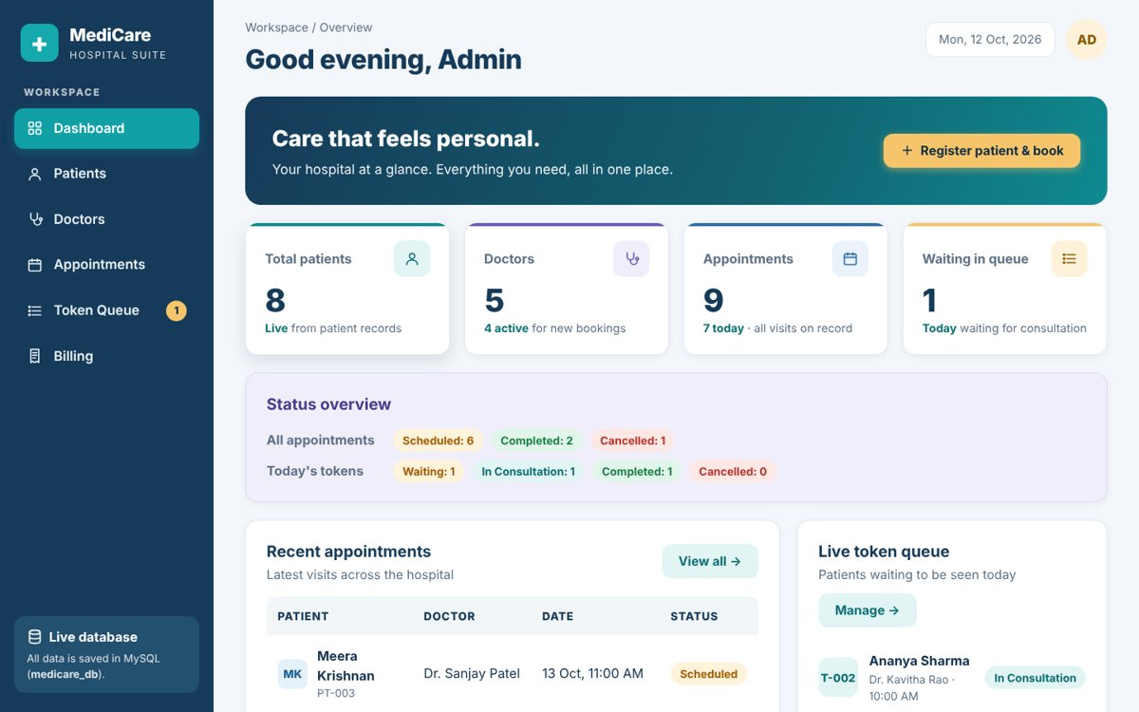  Fig 3: Dashboard with live counts | 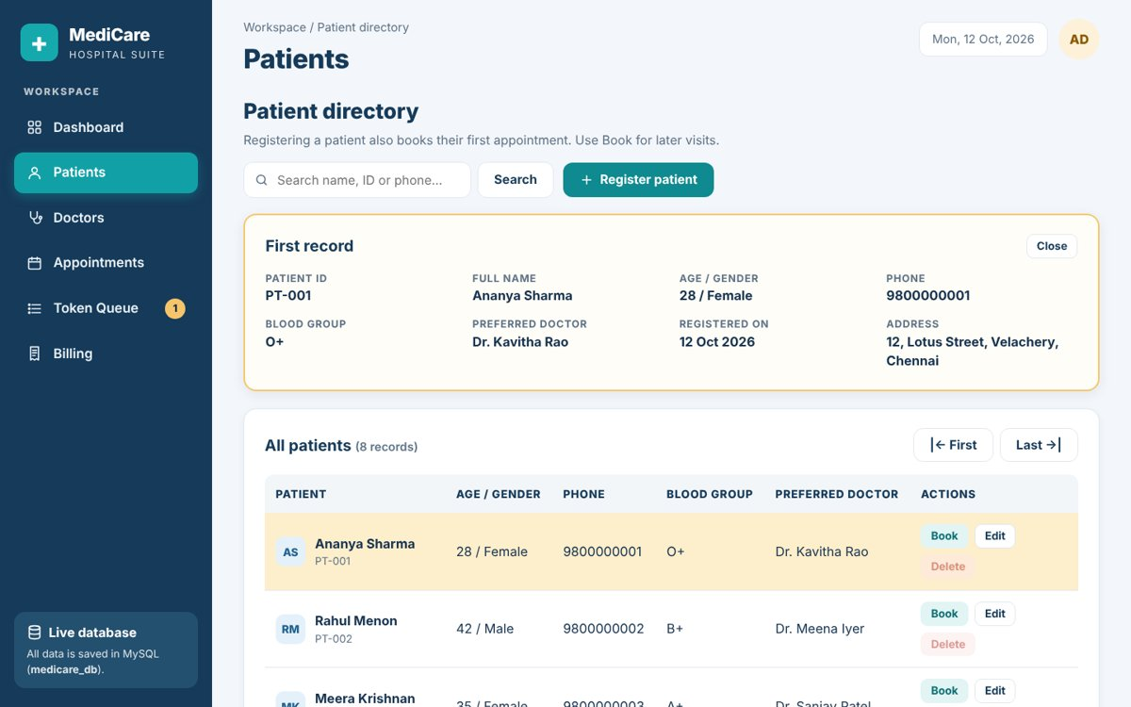  Fig 4: Patients – first record view
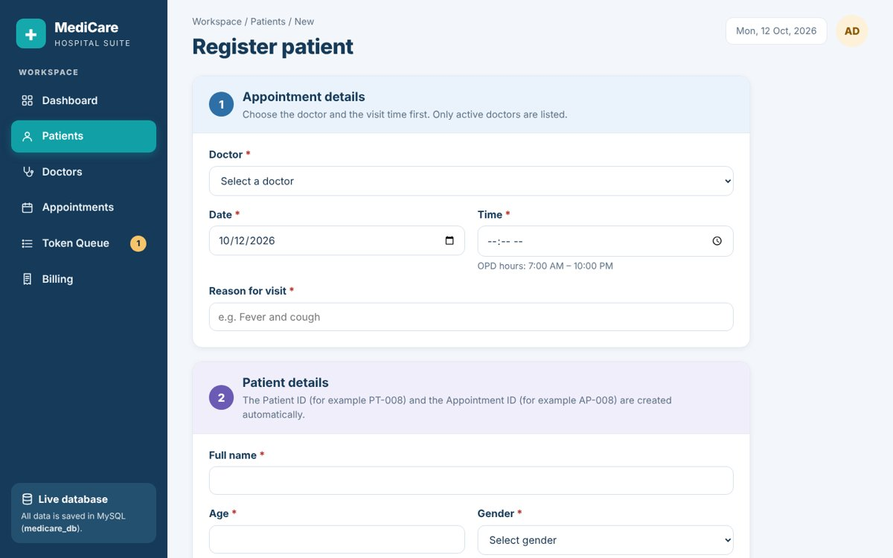  Fig 5: Register patient & book appointment | 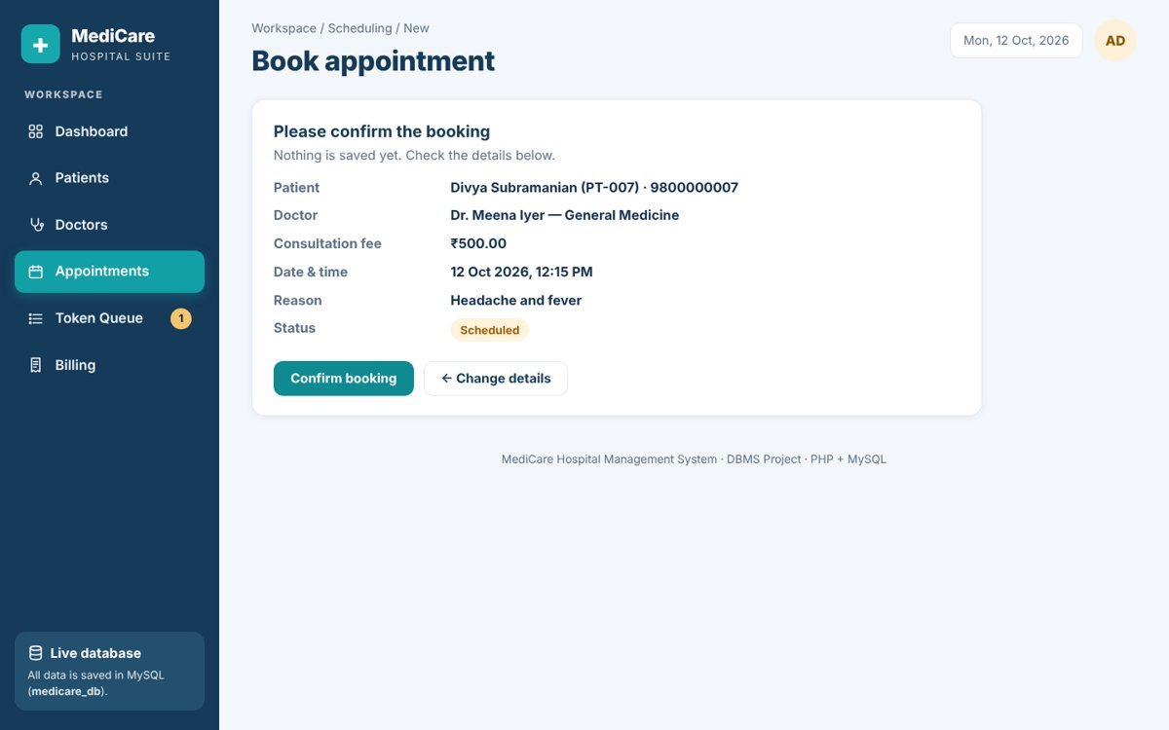  Fig 6: Booking – confirm step
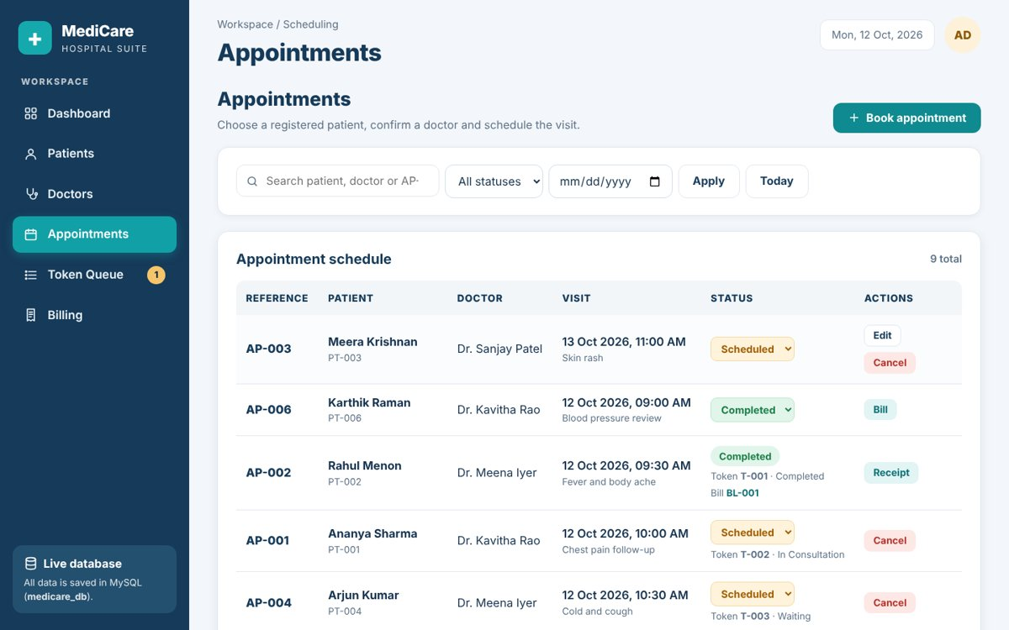  Fig 7: Appointment schedule | 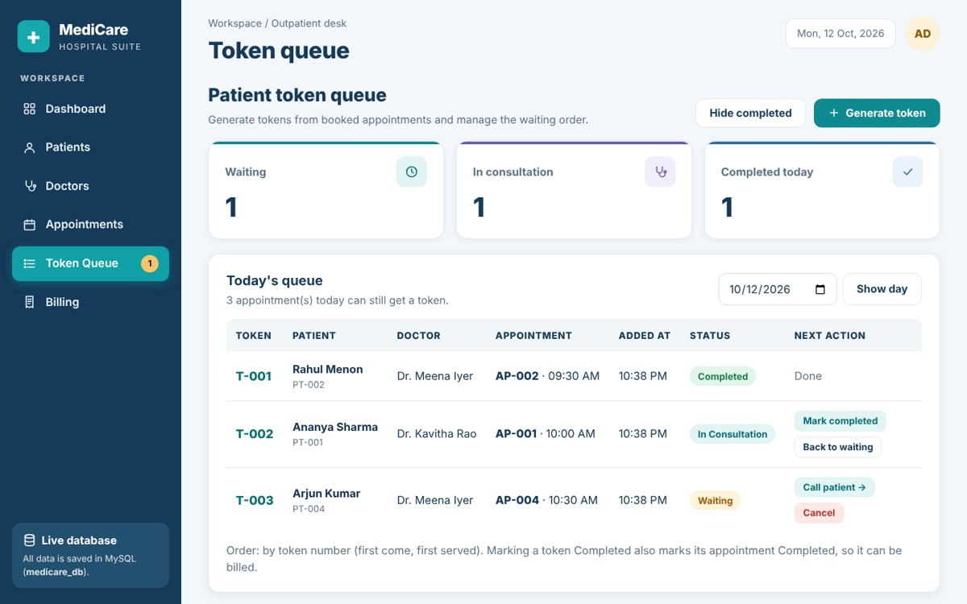  Fig 8: Token queue
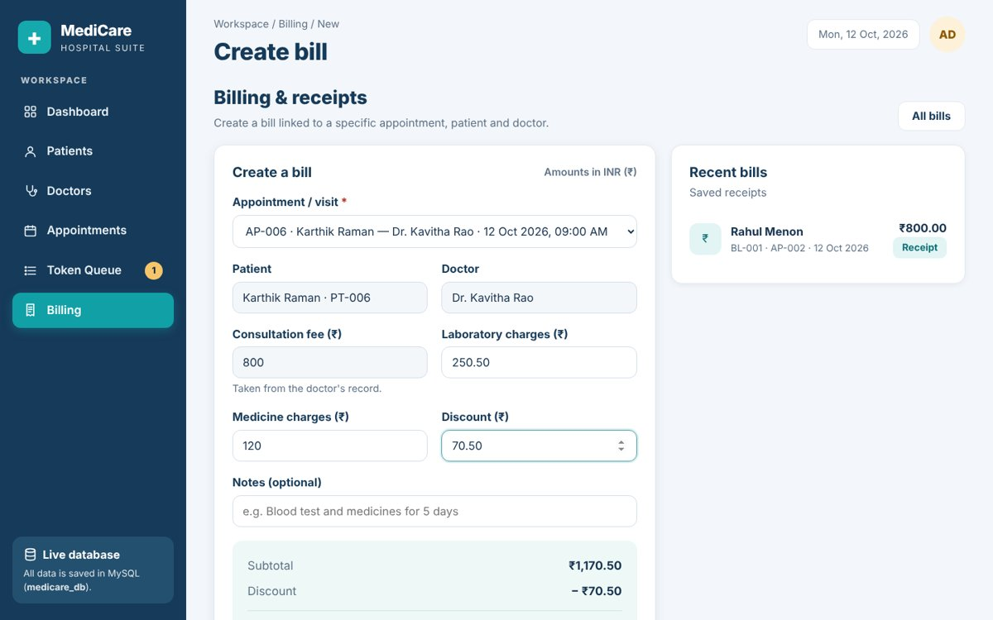  Fig 9: Bill with live total | 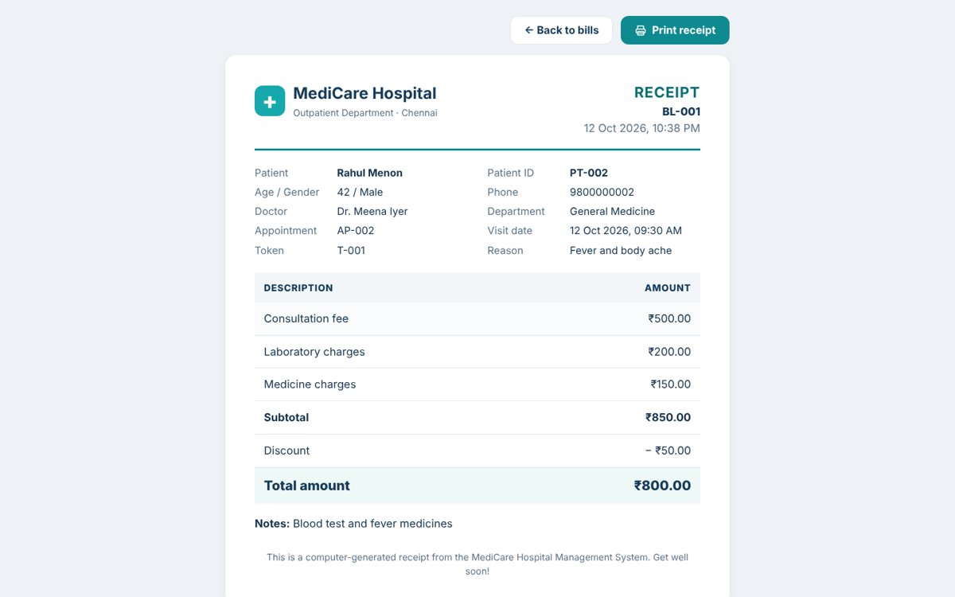  Fig 10: Printable receipt

9.2 Test results
Test case | Expected result | Result
Register patient + book appointment | PT-008 and AP-008 saved together; no token created | Pass
Appointment insert forced to fail | Patient row rolled back too; nothing saved | Pass
Same registration form sent twice | Saved only once | Pass
Search PT-004 / 9800000005 | Only the matching patient is shown | Pass
First / Last record | PT-001 / PT-007 shown and highlighted | Pass
Delete patient who has appointments | Blocked with a message | Pass
Book same doctor, same date and time | "Doctor already has appointment" error | Pass
Book with a past date | "Date cannot be in the past" error | Pass
Generate token twice for one visit | Second request refused | Pass
Token for a cancelled / future visit | Refused | Pass
Mark token completed | Appointment becomes Completed | Pass
Bill 800 + 250.50 + 120 − 70.50 | Total ₹1,100.00 saved and printed | Pass
Second bill for the same visit | Refused ("already billed") | Pass
Discount larger than subtotal | Refused | Pass
The full checklist (about 60 manual tests) is in docs/TESTING.md. Before delivery, the same flows were also run as 106 automated checks.

10. Conclusion and Future Enhancements
MediCare meets the assignment goals: a working frontend, a PHP backend and a normalised MySQL database with five related tables. It demonstrates viewing all records, the first and last record, searching, inserting, updating, deleting and processing (token generation and bill calculation). Foreign keys with RESTRICT, UNIQUE keys and CHECK constraints make the database itself refuse data that would break visit or billing history.
Possible enhancements:
- Login with roles (admin, receptionist, doctor) and password hashing.
- Prescriptions and lab results linked to each visit.
- SMS or email reminders for appointments.
- Daily and monthly revenue reports with charts.
- A waiting-room display screen that refreshes the token queue automatically.

