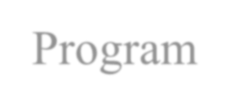

Concept Note for CHANAKYA Fellowships and Technology Development

Program

# Name of the Scheme: Lab to Market- Commercializing Innovations

* Name of the Applicant: Dr. Amit M. Joshi, Assistant Professor, MNIT Jaipur

# Project Title : iGLU : Intelligent Glucose Measurément Device

•



Problem Identified



70M+ Indians suffer from Diabetes to grow further at 9% by 2030 (according to

International Diabetes Federation)

Frequent pricks cause of trauma and inconvenience

Need of a

non-invasive, discreet and easy to use glucose measurement device

Cost effective scalable solution required



Smart Healthcare Solution for diabetes people to have blood glucose measurement and control

  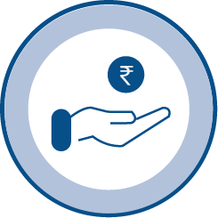 

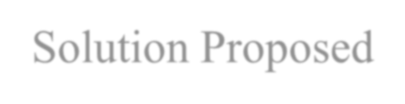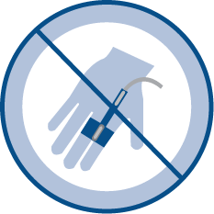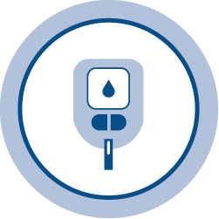

* Solution Proposed

Complete

Diabetes Management System

# Innovation

Non-invasive

solution

Insulin

adjustment Continuous

Glucose

Monitoring

Cost Effective Integration with mobile application

## Short NIR spectroscopy with optical detection

Optical detection method absorption spectroscopy of 940 nm, ML-based model for accurate glucose estimation

## Affordable Frequent Glucose Measurement

Proposed solution would be portable and cost- effective for the purpose of the continuous glucose measurement

## Personalized glucose management framework

Caloric and nutrient Calculation, Exercise, diet control and comprehensive control

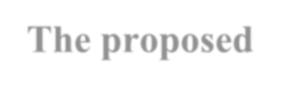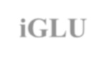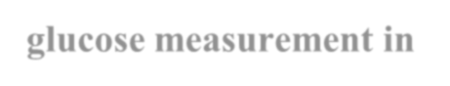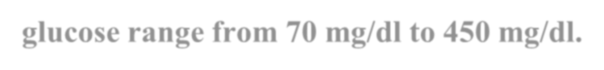

**The proposed iGLU device would provide precise glucose measurement in the**

**full glucose range from 70 mg/dl to 450 mg/dl.**

Current Status of Research/Technology

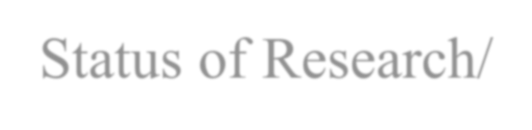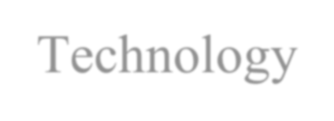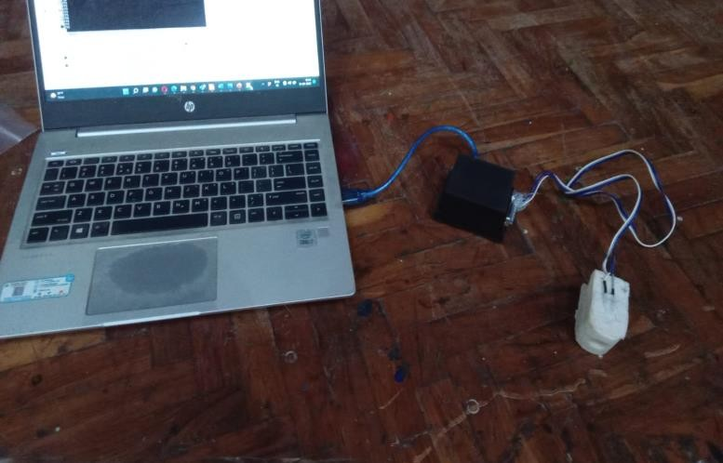

Development

## Short NIR



**optical spectroscopy** Light is received after absorption of by glucose molecules

**03**

## 01 02

**ML Based Glucose Prediction**

Efficient ML model would able to estimate blood glucose

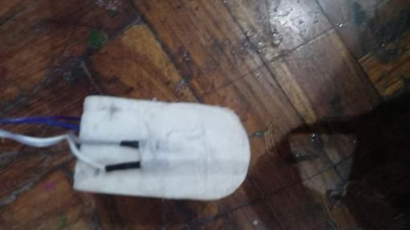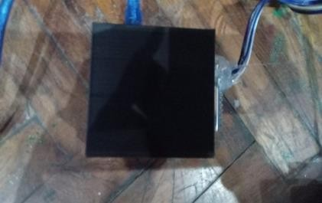**Detector received Light variation** The intensity of the light which is received at detector would change as concentration of glucose in the blood vessel

**The current prototyping has been verified around 500 subjects with accuracy of**

**around 90%.**



Business Model

Glucose Measurement Market

01

* + Glucose Measurement Market in 2021: $14.8 billion
  + Expect 5.3 % CAGR in 2026
  + Hospital,diagnostic centres & clinics

02 Non-Invasive Market

* + Non-Invasive blood glucose monitoring devices market $74.5 million in 2026
  + Market growth acceleration rate CAGR:

11.05%



India Non-Invasive Glucometer

03

* + 80 million population with Diabetes
  + 2.35 million adults with Type I Diabetes
  + Prevalence rate 10.8% in Urban 7.2% in Rural

Budget

* + - Recuííing Cost: 8,20,000 INR
    - Non-íecuííing : 1,80,000 INR

# ľotal Estimated Budget : 10,00,000 INR