Republic of the Philippines



**BULACAN STATE UNIVERSITY**

# College of Information and Communication Technology

City of Malolos

**A NARRATIVE REPORT ON**

# ON-THE-JOB TRAINING UNDER ACCENTURE’S ATLP PROGRAM

Presented to:

The Faculty of College of Information and Communications Technology Bulacan State University

In Partial Fulfillment

Of the Requirement for the Degree of

Bachelor of Science in Information Technology

Submitted by:

(Group members)

(section)

Submitted to:

Adviser

# TABLE OF CONTENTS

Title Page……………………………………………………………………….………1

Table of contents……………………………………………………………….……...2

Acknowledgment……………………………………………………………………....n Dedication……………………………..………………………………………………..n

**Part I:**

History/Background……………………………………………………………….…….n

Vision & Mission ………………………………………..…………………………n Administration/Staff/Focal Person………………………………………..……………n

**Part II: Project Development**

Project Consultation..............................................................................................n

Pictures of Group Meeting for Project Development.............................................n

Meetings/Seminars with Accenture………............................................................n

Udemy Individual Certificate…………………………………………………………n

Screenshots of the Developed Project……………………………………………….n

Pictures of Project Presentation………………………………………………………n

**Part III: Internship Reflection**

Individual Reflection on Fieldwork Experience ………………………………………n

## APPENDICES

Appendix A: NDA Between Accenture and Students………..……………………n

Appendix B: ATLP Guidelines………………...……….……………………….……n

Appendix C: Schedule of Account Reactivation.…………………………….……n

Meeting/Seminars with Accenture

Project Consultation

Appendix D: Other Pictures……….…………….…………………………………..n

Appendix E: Resume……………….…………………………………….………..…n

# ACKNOWLEDGEMENT

Lorem ipsum dolor sit amet, consectetur adipiscing elit, sed do eiusmod tempor incididunt ut labore et dolore magna aliqua. Ut enim ad minim veniam, quis nostrud exercitation ullamco laboris nisi ut aliquip ex ea commodo consequat. Duis aute irure dolor in reprehenderit in voluptate velit esse cillum dolore eu fugiat nulla pariatur. Excepteur sint occaecat cupidatat non proident, sunt in culpa qui officia deserunt mollit anim id est laborum.

Lorem ipsum dolor sit amet, consectetur adipiscing elit, sed do eiusmod tempor incididunt ut labore et dolore magna aliqua. Ut enim ad minim veniam, quis nostrud exercitation ullamco laboris nisi ut aliquip ex ea commodo consequat. Duis aute irure dolor in reprehenderit in voluptate velit esse cillum dolore eu fugiat nulla pariatur. Excepteur sint occaecat cupidatat non proident, sunt in culpa qui officia deserunt mollit anim id est laborum.

# DEDICATION

Lorem ipsum dolor sit amet, consectetur adipiscing elit, sed do eiusmod tempor incididunt ut labore et dolore magna aliqua. Ut enim ad minim veniam, quis nostrud exercitation ullamco laboris nisi ut aliquip ex ea commodo consequat. Duis aute irure dolor in reprehenderit in voluptate velit esse cillum dolore eu fugiat nulla pariatur. Excepteur sint occaecat cupidatat non proident, sunt in culpa qui officia deserunt mollit anim id est laborum.

Lorem ipsum dolor sit amet, consectetur adipiscing elit, sed do eiusmod tempor incididunt ut labore et dolore magna aliqua. Ut enim ad minim veniam, quis nostrud exercitation ullamco laboris nisi ut aliquip ex ea commodo consequat. Duis aute irure dolor in reprehenderit in voluptate velit esse cillum dolore eu fugiat nulla pariatur. Excepteur sint occaecat cupidatat non proident, sunt in culpa qui officia deserunt mollit anim id est laborum.

# PART I

# HISTORY/BACKGROUND

# VISION & MISSION

# ADMINISTRATION/ STAFF/ FOCAL PERSON

## HISTORY

Accenture PLC is a global professional services company and provides consulting services in digital, technology and operations.

* [Infosys Limited Story](https://successstory.com/companies/infosys-limited)
* [Hewlett-Packard (HP) Story](https://successstory.com/companies/hewlett-packard)

One of the leading multinational companies in the field of management consulting and outsourcing, Accenture Incorporated has now become the global leader in consulting services and is also a Fortune 500 Company. Not only is the brand now on Fortune’s list, but also offers efficient services and solutions to multiple companies who are on the Fortune Global 100 and Global 500 lists.

Accenture was previously a business and technology consulting division of an accounting organization called Arthur Andersen. The first undertaking was automating payroll processing and manufacturing for a client in Kentucky. In 1989, [Arthur Andersen](https://en.wikipedia.org/wiki/Arthur_Andersen) and Andersen Consulting became separate units of [Andersen Worldwide Société Coopérative](https://en.wikipedia.org/wiki/Andersen_Worldwide_Soci%C3%A9t%C3%A9_Coop%C3%A9rative) (AWSC). On 1 January 2001, Andersen Consulting adopted its current name, "Accenture".

## Accenture (Global) Mission, Vision & Values

## Accenture (Global) Mission Statement

Accenture solves our clients' toughest challenges by providing unmatched services in strategy, consulting, digital, technology and operations. We partner with more than three-quarters of the Fortune Global 500, driving innovation to improve the way the world works and lives. With expertise across more than 40 industries and all business functions, we deliver transformational outcomes for a demanding new digital world.

## Accenture (Global) Vision Statement

Our core values shape the culture and define the character of our company.

We live the core values through individual behaviors. They serve as a foundation in how we act and make decisions.

**Accenture (Global) Values**

* CLIENT VALUE CREATION
* CLIENT VALUE CREATION
* ONE GLOBAL NETWORK
* INTEGRITY
* RESPECT FOR THE INDIVIDUAL
* STEWARDSHIP

## ADMINISTRATION/STAFF/FOCAL PERSON

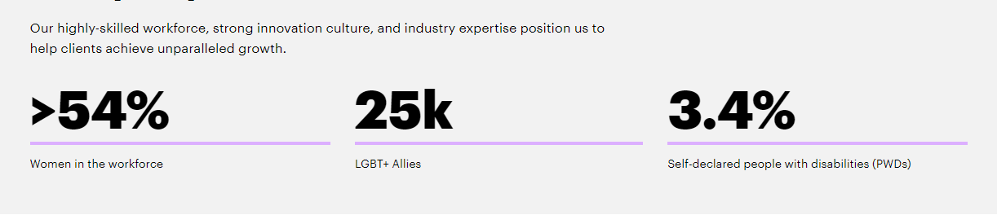

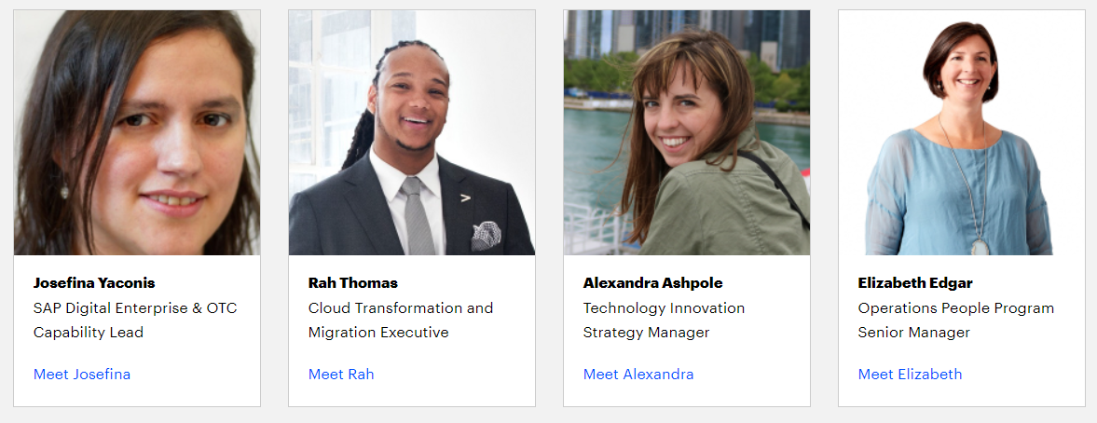

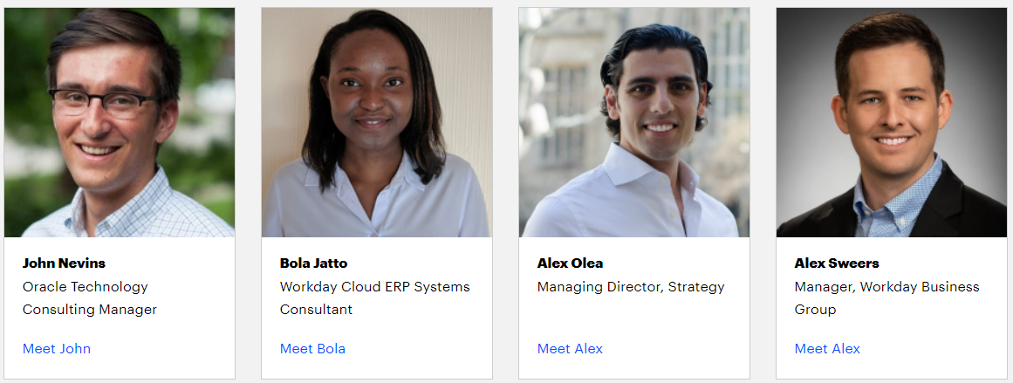

For more Administrative/Staff:  
https://www.accenture.com/ph-en/careers/life-at-accenture/meet-our-people

**For Philippines Focal person**

Ms. FLORRAINE FERNANDEZ - Accenture Delivery Center in the Philippines - Campus Strategic Sourcing | HR - Gateway Office Tower Araneta Center, Cubao, QC

Mr. BOGARD PAGUIGAN - Associate Director and ATA Lead of Accenture Technology in the Philippines.

# PART II

**Project Consultation**

**Pictures of Group Meeting for Project Development**

**Meetings/Seminars with Accenture**

**Udemy Individual Certificate**

**Project Development**

[1 to 2 paragraphs of discussion of the objective of the project]

Lorem ipsum dolor sit amet, consectetur adipiscing elit, sed do eiusmod tempor incididunt ut labore et dolore magna aliqua. Ut enim ad minim veniam, quis nostrud exercitation ullamco laboris nisi ut aliquip ex ea commodo consequat. Duis aute irure dolor in reprehenderit in voluptate velit esse cillum dolore eu fugiat nulla pariatur. Excepteur sint occaecat cupidatat non proident, sunt in culpa qui officia deserunt mollit anim id est laborum.

[1 to 2 paragraphs of discussion of the project consultation]

Lorem ipsum dolor sit amet, consectetur adipiscing elit, sed do eiusmod tempor incididunt ut labore et dolore magna aliqua. Ut enim ad minim veniam, quis nostrud exercitation ullamco laboris nisi ut aliquip ex ea commodo consequat. Duis aute irure dolor in reprehenderit in voluptate velit esse cillum dolore eu fugiat nulla pariatur. Excepteur sint occaecat cupidatat non proident, sunt in culpa qui officia deserunt mollit anim id est laborum.

[2 to 3 paragraphs of discussion of the Process of project development, Group meetings]

[Note: You can attach an image if you like]

## Project Consultation

[Provide Pictures and Details of Every project consultation]

### Figure _ shows the project consultation by Mr. Gabriel M. Galang - Area Chair for Web and Mobile Applications Development specialization track, and Mr. Aaron Paul M. Delarosa - College Secretary. They discussed about our projects....



**Figure _. Project Consultation...**

[Provide as many as possible]

## Pictures of Group Meeting for Project Development

[Provide Pictures and Details Every Group Meetings for Project Development]

### Figure _ shows the group's 1st online meeting for project development. The group utilized MS Teams for online video conferencing. Lore ipsum...



**Figure _. First Online Meeting for Project Development**

[Provide as many as possible]

## Meetings/Seminars

[Provide Pictures and Details of Every Meetings with Accenture and every seminars attended during OJT ex. Dean's Keno's talk about IMRAD and the CICT Week's Seminars/Orientation]

### Figure _ shows the 1st meeting with the Accenture Representative. Accenture discussed about lore ipsum...



**Figure _. First meeting with the Accenture Representative**

Figure _ shows the webinar for IMRAD provided by CICT. Dean Keno Piad discussed about lore ipsum...



**Figure _. Webinar for IMRAD**

## [Provide as many as possible]

## Udemy Individual Certificate

[Provide the Individual Member's Certificates of the courses taken under ATLP]

**Mr. Juan Dela Cruz**

### Figure _ shows Mr. Juan Dela Cruz's Certificate for the course "React JS Lorem Ipsum". [Add details]Lore ipsum...



**Figure _. Mr. Juan Dela Cruz's Certificate for the course "React JS Lorem Ipsum"**

### Figure _ shows Mr. Juan Dela Cruz's Certificate for the course "Complete Interview Lorem Ipsum". [Add details]Lore ipsum...



**Figure _. Mr. Juan Dela Cruz's Certificate for the course "Complete Interview Lorem Ipsum"**  
  
**[Provide also the Certificate for VSCode, GIT, Complete Web, and Angular]**

**Ms. Anne B. Mateo**

### Figure _ shows Ms. Anne B. Mateo 's Certificate for the course "React JS Lorem Ipsum". [Add details]Lore ipsum...



**Figure _. Ms. Anne B. Mateo 's Certificate for the course "React JS Lorem Ipsum"**

### Figure _ shows Ms. Anne B. Mateo 's Certificate for the course "Complete Interview Lorem Ipsum". [Add details]Lore ipsum...



**Figure _. Ms. Anne B. Mateo 's Certificate for the course "Complete Interview Lorem Ipsum"**  
  
**[also Provide the Certificate for VSCode, GIT, Complete Web, and Angular]**

[Provide all the certificates of all the members]

# PART III

**Individual Reflection on Fieldwork Experience**

**Screenshots of the Developed Project**

**Pictures of Project Presentation**

## Individual Reflection on Fieldwork Experience

**Mr. Juan Dela Cruz**

[1 to 2 pages of Individual reflection of each group members] Lorem ipsum dolor sit amet, consectetur adipiscing elit, sed do eiusmod tempor incididunt ut labore et dolore magna aliqua. Ut enim ad minim veniam, quis nostrud exercitation ullamco laboris nisi ut aliquip ex ea commodo consequat. Duis aute irure dolor in reprehenderit in voluptate velit esse cillum dolore eu fugiat nulla pariatur. Excepteur sint occaecat cupidatat non proident, sunt in culpa qui officia deserunt mollit anim id est laborum.

Lorem ipsum dolor sit amet, consectetur adipiscing elit, sed do eiusmod tempor incididunt ut labore et dolore magna aliqua. Ut enim ad minim veniam, quis nostrud exercitation ullamco laboris nisi ut aliquip ex ea commodo consequat. Duis aute irure dolor in reprehenderit in voluptate velit esse cillum dolore eu fugiat nulla pariatur. Excepteur sint occaecat cupidatat non proident, sunt in culpa qui officia deserunt mollit anim id est laborum.

**Ms. Anne B. Mateo**

[1 to 2 pages of Individual reflection]Lorem ipsum dolor sit amet, consectetur adipiscing elit, sed do eiusmod tempor incididunt ut labore et dolore magna aliqua. Ut enim ad minim veniam, quis nostrud exercitation ullamco laboris nisi ut aliquip ex ea commodo consequat. Duis aute irure dolor in reprehenderit in voluptate velit esse cillum dolore eu fugiat nulla pariatur. Excepteur sint occaecat cupidatat non proident, sunt in culpa qui officia deserunt mollit anim id est laborum.

Lorem ipsum dolor sit amet, consectetur adipiscing elit, sed do eiusmod tempor incididunt ut labore et dolore magna aliqua. Ut enim ad minim veniam, quis nostrud exercitation ullamco laboris nisi ut aliquip ex ea commodo consequat. Duis aute irure dolor in reprehenderit in voluptate velit esse cillum dolore eu fugiat nulla pariatur. Excepteur sint occaecat cupidatat non proident, sunt in culpa qui officia deserunt mollit anim id est laborum.

## Screenshots of the Developed Project

[Provide Pictures and Details of the Developed System. Provide at least every feature of the system]

### Figure _ shows the Login Page of the developed system. In this web page, Lorem ipsum...



**Figure _. Login Page**

[Provide at least every feature of the system]

## Pictures of Project Presentation

[Provide Pictures and Details of the Group's Project Presentation]

### Figure _ shows the project presentation with the panels. The group started to present the Lorem ipsum...



**Figure _. Presentation of the Project**

[Provide as many as possible]

# CHAPTER IV: APPENDICES

**Appendix A: NDA Between Accenture and Students**

**Appendix B: ATLP Guidelines**

**Appendix C: Schedule of Account Reactivation**

**Appendix D: Other Pictures**

**Appendix E: Individual Resume**

## ­APPENDIX A: NDA Between Accenture and Students

## Appendix B: ATLP Guidelines

## Appendix C: Schedule of Account Reactivation

[Individual for every member, please create table]

|  |  |
| --- | --- |
| Juadn Dela Cruz | Jan, 25 – 31, 2022 |
|  |  |
|  |  |

## Appendix D: Other Pictures

## Appendix E: Individual Resume

## 