**Assignment Questions on Digital Marketing**

1. **Create a blog or website using Blogspot and WordPress. Customize the theme design and post new article with 500 words.**

**BLOGSPOT LINK:** [**https://vjeditstudio.blogspot.com/**](https://vjeditstudio.blogspot.com/)

**WORDPRESS LINK:** [**https://vijayanbu20020.wordpress.com**](https://vijayanbu20020.wordpress.com)

1. **Create a New Facebook Business Page and post one social media poster for your brand.**

**FACEBOOK LINK:** [**https://www.facebook.com/vjeditstudio**](https://www.facebook.com/vjeditstudio)



1. **Create and design a social media advertisement poster using canva.**

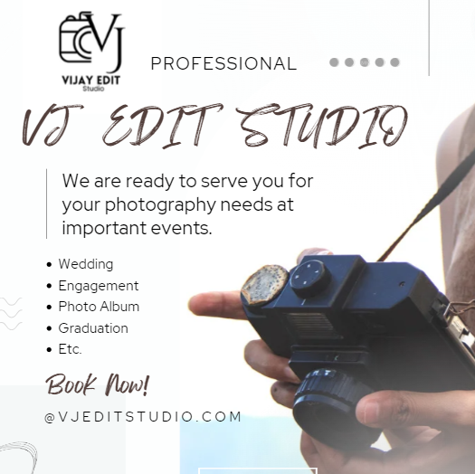

1. **Create email newsletter design using MailChimp or canva tool.**

