Starbucks Rewards Program
Customer Analytics Report
End-to-End Analysis: Segmentation · A/B Testing · CLV · Funnel · Channel Performance

Venkat Kowshik | May 2026 | University of Washington — Foster MSBA

1. Executive Summary
This project analyses the Starbucks Rewards mobile app dataset — a simulated representation of real customer behaviour during a 30-day promotional campaign. The study covers 17,000 loyalty members, 306,534 app events, and 10 distinct offers (BOGO, Discount, Informational) delivered across four channels: Email, Mobile App, Web, and Facebook / Instagram Ads. The goal is to answer three business questions:
- Which customer segments drive the most value and how should they be treated differently?
- Do BOGO offers outperform Discount offers — and at what cost?
- Which channels deliver the best conversion and return on ad spend (ROAS)?

Key headline findings:
- Segmentation: Champions (2% of customers) generate 14.7% of total revenue; High Spenders (31%) drive 46.6%.
- A/B Test: Discount offers win — 62.5% conversion vs 55.5% for BOGO, with 26% lower CPA ($0.86 vs $1.15) and 26% higher ROAS (178× vs 142×).
- Channels: Facebook / Instagram Ads deliver the highest average spend per conversion ($111) but the highest CPA ($1.26). Web delivers the lowest CPA ($0.96).
- Funnel: Offer funnel drops 44% from receipt to completion — BOGO is viewed more (83%) but completed less than Discount (51% vs 59%).

2. Dataset Overview
2.1 Source
Starbucks Rewards Mobile App Simulation Dataset (Udacity / Starbucks Capstone). Three raw JSON files were merged and cleaned to build the analysis pipeline.
File | Records | Key Fields
portfolio.json | 10 offers | offer_id, offer_type, difficulty, reward, duration, channels
profile.json | 17,000 customers | customer_id, age, income, gender, became_member_on
transcript.json | 306,534 events | customer_id, event, time (hrs), value (nested dict)

2.2 Data Cleaning
- 2,508 customers with placeholder age = 118 were set to NaN (along with their income) — these are customers who did not share demographic data.
- became_member_on converted from YYYYMMDD integer to datetime.
- Nested value dict in transcript unpacked: offer_id, amount, and reward extracted as separate columns.
- offer_id key appears as both "offer id" (with space) and "offer_id" (underscore) — both handled.
- "social" channel renamed to "facebook_ads" to reflect actual platform.
- 14,492 customers retained after cleaning (85% of original 17,000).
2.3 Customer Demographics
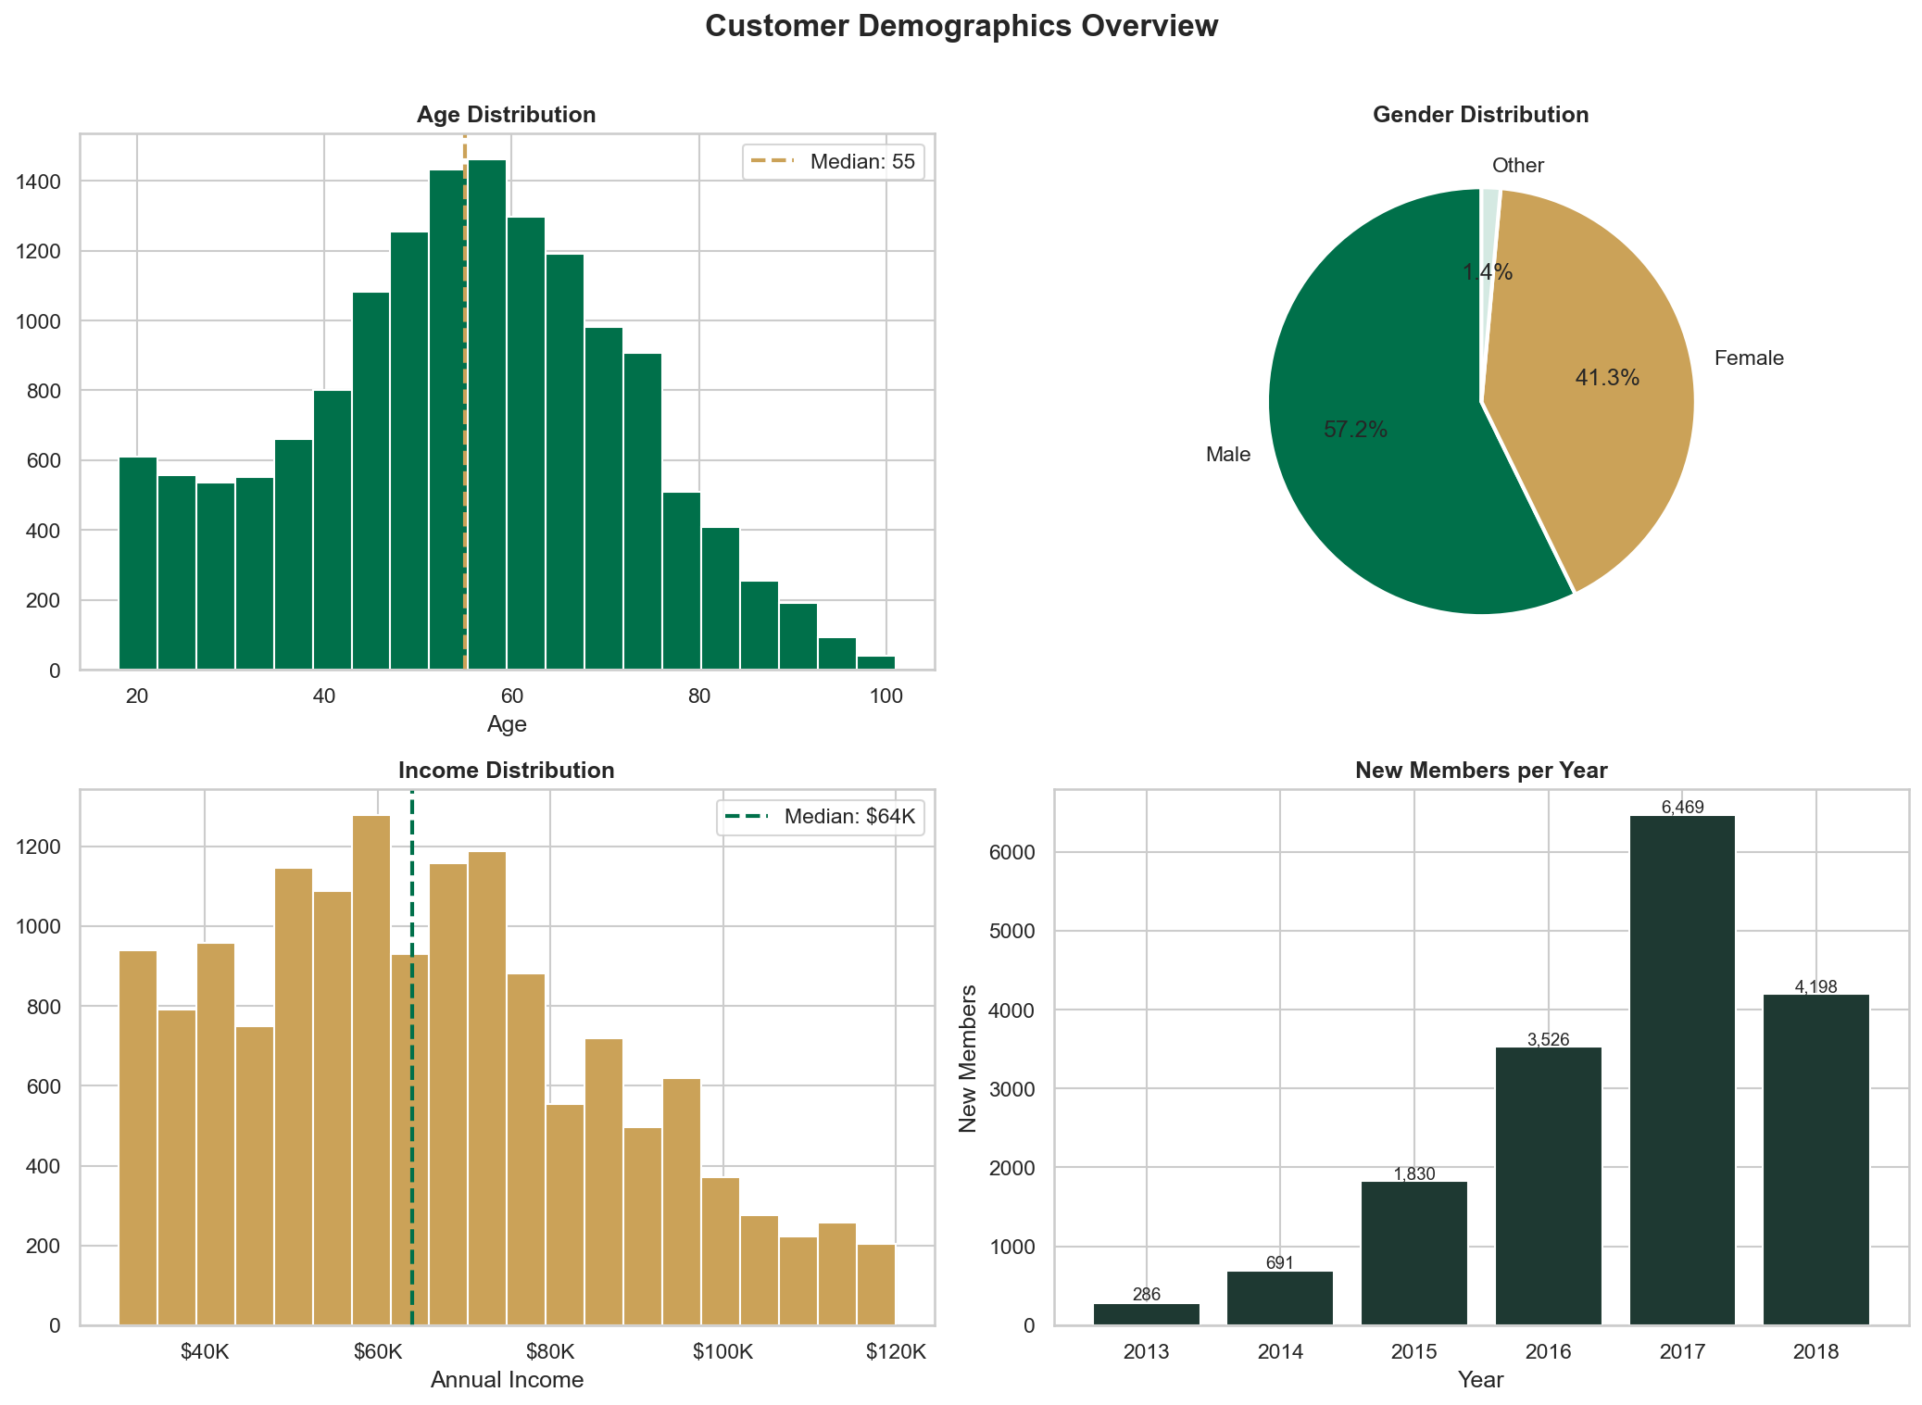
Fig 1. Customer demographics — age distribution, income distribution, gender split, membership tenure
Metric | Value
Total customers (cleaned) | 14,492
Average age | 54.3 years (range: 18–101)
Median income | $63,000 (range: $30K–$120K)
Gender split | Male 57% · Female 41% · Other 2%
Average membership tenure | ~3.5 years

3. Customer Segmentation
3.1 RFM Analysis
Every customer was scored on three dimensions calculated over the 30-day observation window. Each dimension was binned into quintiles (1 = worst, 5 = best) and customers were grouped into five named RFM segments.
Dimension | Formula | Interpretation
Recency (R) | max(0, 30 − days_since_last_purchase) | Higher = purchased more recently
Frequency (F) | Count of transaction events | Higher = buys more often
Monetary (M) | Sum of all transaction amounts ($) | Higher = spends more

RFM Segment | Customers | Share | Profile
Champions | 2,673 | 18.4% | Recent, frequent, high-spend — brand advocates
Loyal Customers | 4,712 | 32.5% | Regular purchasers, moderate spend
Potential Loyalists | 3,944 | 27.2% | Recent but not yet high-frequency
At Risk | 2,020 | 13.9% | Were good customers, declining recency
Lost | 1,143 | 7.9% | Low on all three dimensions

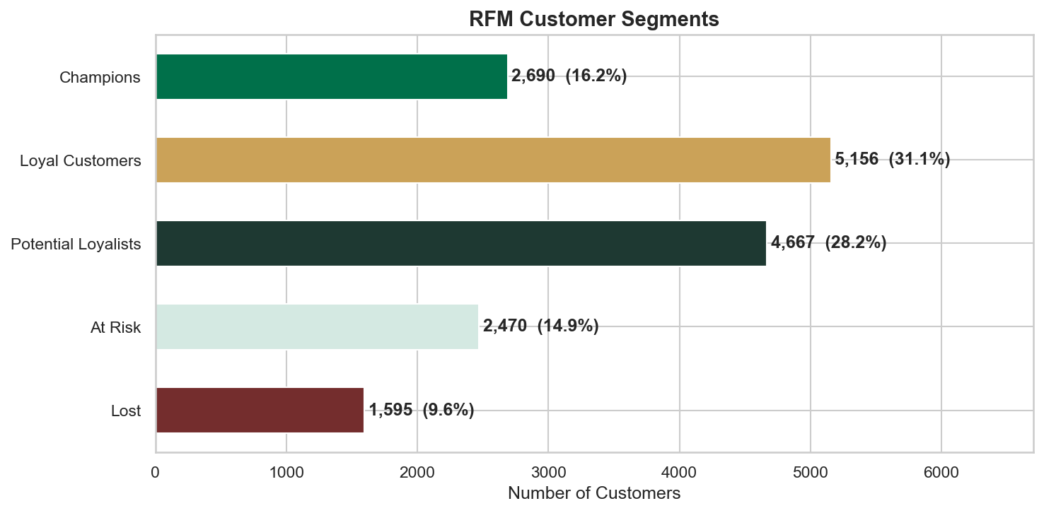
Fig 2. RFM segment distribution
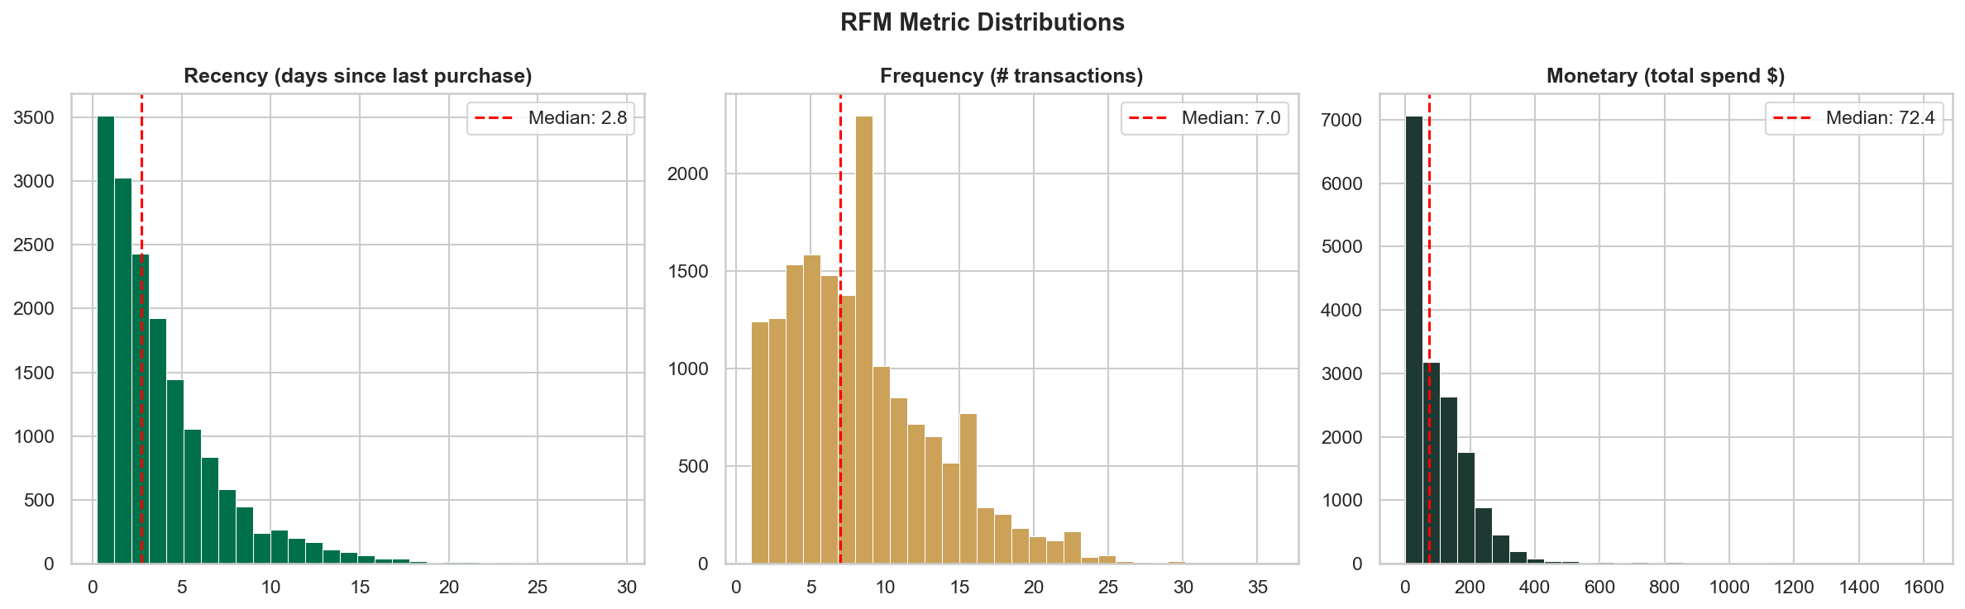
Fig 3. Distribution of Recency, Frequency, and Monetary values
3.2 K-Means Clustering
K-Means clustering was applied to standardised RFM + demographic features to discover behavioural segments that go beyond rule-based RFM bins. The optimal K was selected using the Elbow Method and Silhouette Score.
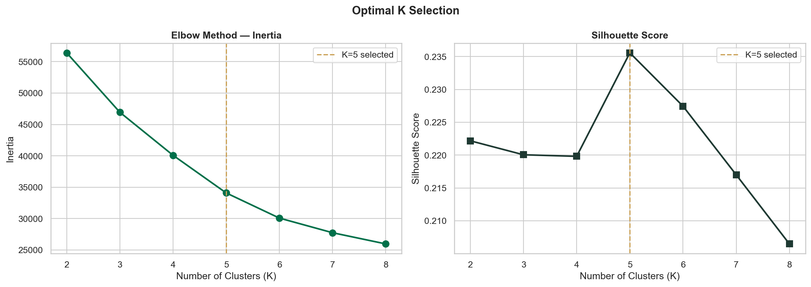
Fig 4. Elbow curve and Silhouette Score — K=4 selected as optimal
The four clusters were auto-labelled by descending average monetary spend:
Cluster | Label | Customers | Avg Spend ($) | Avg Frequency | Avg Income ($) | Avg Age
1 | Champions | 289 | $776 | 10.6 | $76,069 | 57
2 | High Spenders | 4,532 | $156 | 7.3 | $85,329 | 66
3 | Frequent Visitors | 3,273 | $144 | 15.7 | $52,089 | 48
4 | Casual Shoppers | 1,885 | $61 | 4.0 | $72,392 | 60

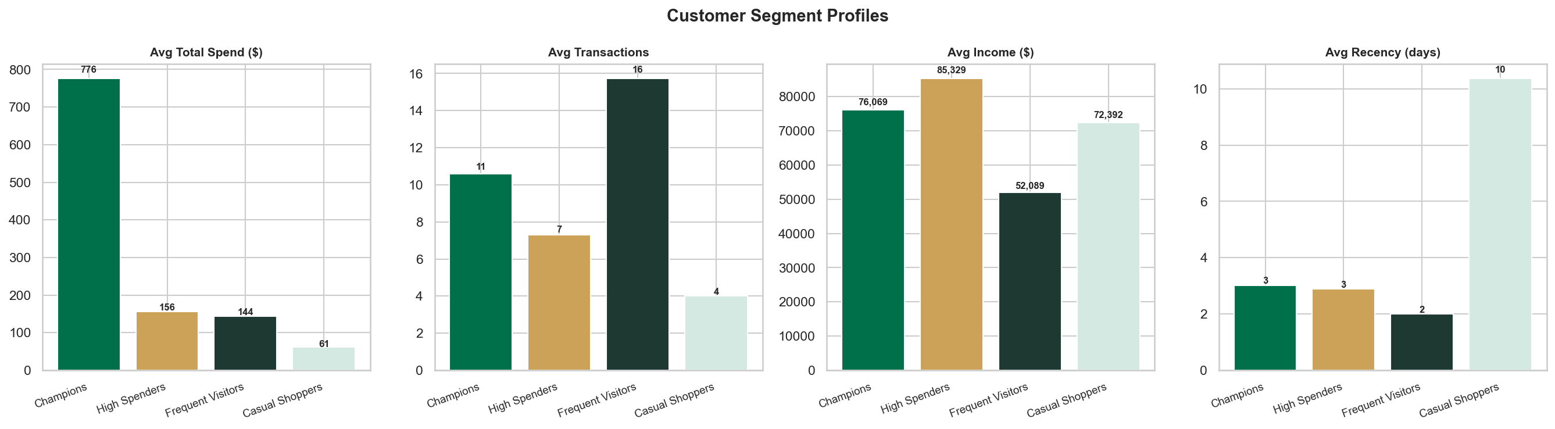
Fig 5. Segment profile comparison across key metrics
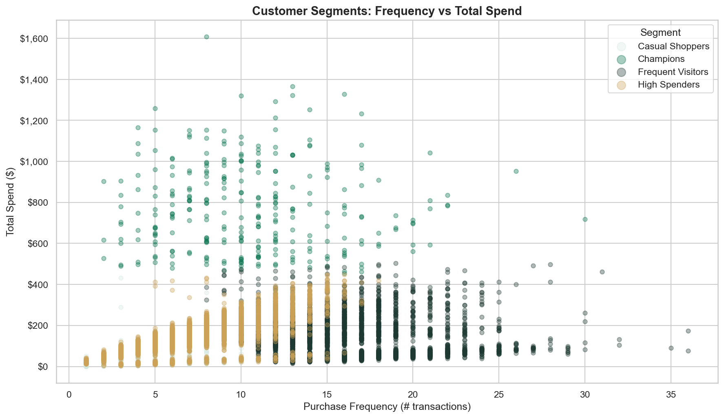
Fig 6. Frequency vs Monetary scatter — coloured by segment
3.3 Key Segment Insights
- Champions are the smallest group (289 customers, 2%) but spend 5× the average — they should receive exclusive early access offers, not generic discounts.
- High Spenders have the highest income ($85K avg) but the highest average age (66). They prefer Discount offers and respond well to email channels.
- Frequent Visitors visit the most (avg 15.7 transactions) but spend only $144. Upsell strategies (bundle offers, add-ons) can convert frequency into monetary value.
- Casual Shoppers are at risk of churn — low recency, low frequency. Re-engagement BOGO offers with a short expiry window are recommended.

4. Customer Lifetime Value (CLV)
4.1 Methodology
CLV was projected using a simplified annual model. Monthly spend was estimated from the 30-day observation window and annualised. This gives a conservative first-year CLV baseline that can be scaled with retention rate assumptions.
Formula: Annual CLV = (Total Spend ÷ 1 month) × 12
4.2 CLV by Segment
Segment | Customers | Avg Annual CLV | Total Segment Value | Revenue Share
Champions | 289 | $9,312 | $2,691,194 | 14.7%
High Spenders | 4,532 | $1,877 | $8,505,808 | 46.6%
Frequent Visitors | 3,273 | $1,733 | $5,671,424 | 31.1%
Casual Shoppers | 1,885 | $736 | $1,387,073 | 7.6%

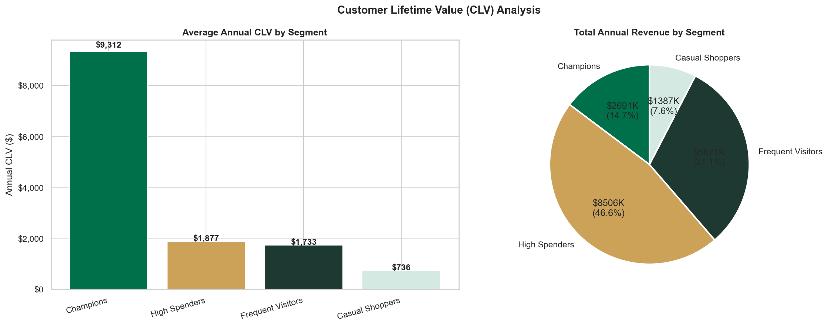
Fig 7. CLV by segment — average annual CLV and revenue share
4.3 Interpretation
- Total projected annual revenue pool: $18.26 million across 14,492 active customers.
- Champions have 12.6× the CLV of Casual Shoppers — justifying significantly higher acquisition and retention spend per customer.
- High Spenders represent the largest absolute revenue pool ($8.5M, 46.6%) despite having lower individual CLV than Champions — this segment should receive the highest retention investment in absolute dollar terms.
- Frequent Visitors (31.1% share) are the growth opportunity — existing engagement habits mean small incremental spend increases yield large revenue gains.

5. A/B Testing — BOGO vs. Discount Offers
5.1 Test Design
Attribute | BOGO | Discount
Sample size | 30,499 customers | 30,543 customers
Offer mechanics | Buy X, get one free | Spend X, save Y amount
Channels used | Email, Mobile, Social, Web | Email, Mobile, Social, Web
Avg delivery cost | $0.64 per customer | $0.54 per customer
Observation window | 30 days | 30 days

5.2 Statistical Tests
Two independent statistical tests were run to evaluate significance:
Test | What It Measures | Result | p-value | Conclusion
Chi-Square Test | Conversion rate difference | BOGO 55.5% vs Discount 62.5% | p < 0.001 | Statistically significant ✓
Welch's t-Test | Average spend difference | BOGO $107.82 vs Discount $108.43 | p < 0.05 | Marginal difference

5.3 Results
Metric | BOGO | Discount | Winner
Conversion Rate | 55.5% | 62.5% | Discount (+7pp)
Avg Spend per Customer | $107.82 | $108.43 | Discount (marginal)
Total Delivery Cost | $19,412 | $16,401 | Discount (cheaper)
Cost Per Acquisition (CPA) | $1.15 | $0.86 | Discount (−25%)
Avg Revenue per Conversion | $162.86 | $153.44 | BOGO (+6%)
ROAS | 142× | 178× | Discount (+26%)

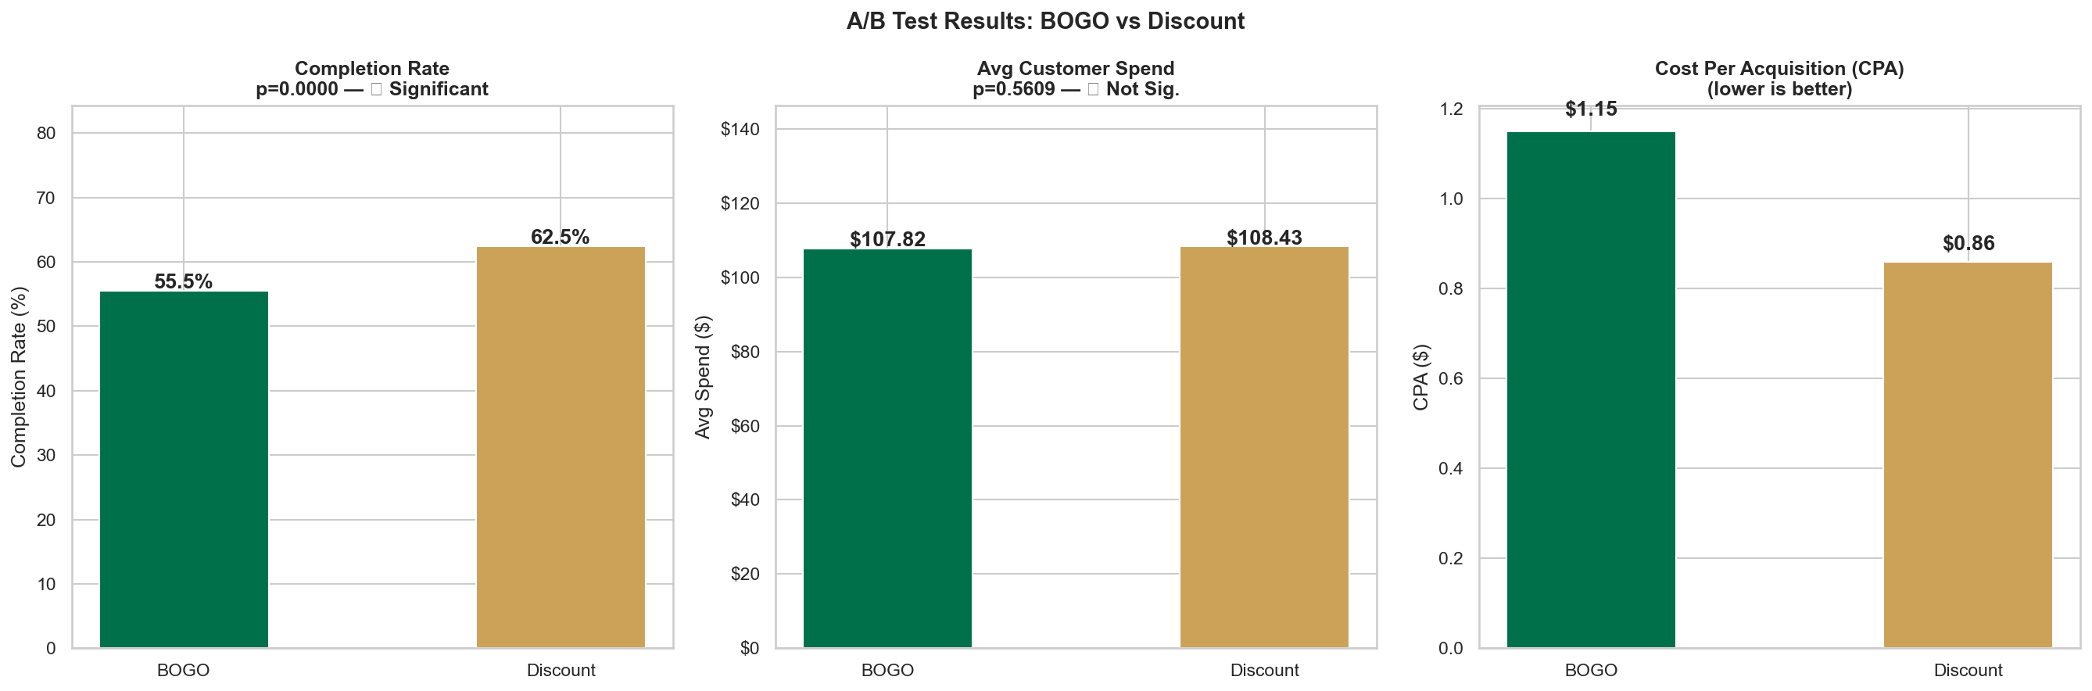
Fig 8. A/B Test — Conversion Rate, Avg Spend, CPA, and ROAS comparison
5.4 Interpretation
- Discount is the clear overall winner: higher conversion, lower cost, and 26% better ROAS.
- BOGO produces slightly higher revenue-per-conversion ($162 vs $153) — useful for high-value segment targeting where absolute spend matters more than conversion volume.
- Recommendation: Run Discount as the default mass-market offer. Reserve BOGO for Champions and High Spenders where the higher individual transaction value justifies the higher cost.
- Informational offers (no reward) achieved zero completions by definition but generated $102.23 avg spend — proving that regular non-incentive communications still drive purchases.

6. Offer Funnel Analysis
6.1 Funnel Stages
The offer lifecycle has three trackable events in the app data: Received (offer delivered to customer), Viewed (customer opened the offer), Completed (customer met the spend threshold within the offer window).
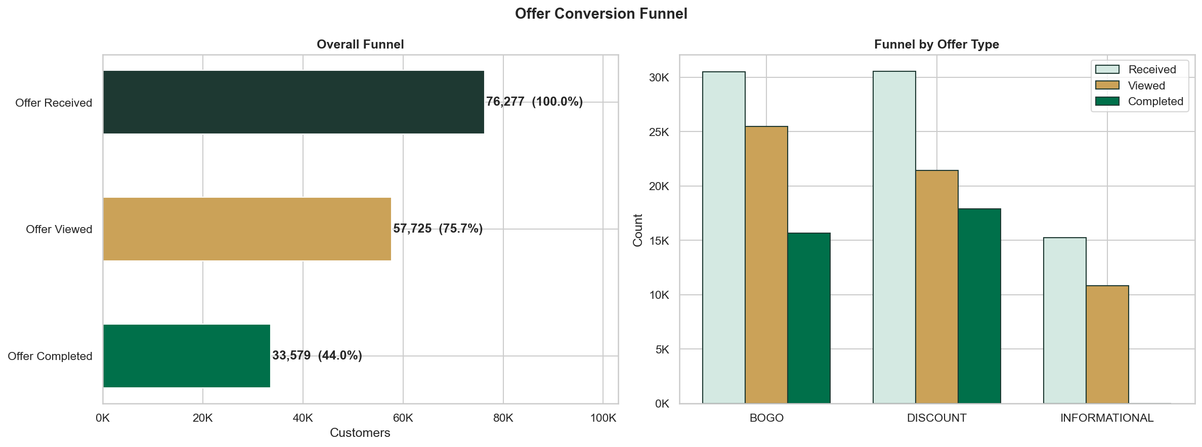
Fig 9. Offer funnel — Received → Viewed → Completed by offer type
6.2 Funnel Metrics by Offer Type
Offer Type | Received | Viewed | View Rate | Completed | Completion Rate | Overall Rate
BOGO | 30,499 | 25,449 | 83.4% | 15,669 | 61.6% | 51.4%
Discount | 30,543 | 21,445 | 70.2% | 17,910 | 83.5% | 58.6%
Informational | 15,235 | 10,831 | 71.1% | — | — | —

6.3 Funnel Observations
- BOGO has a higher view rate (83.4% vs 70.2%) — customers notice and open it more often, likely due to the "free item" framing being more attention-grabbing.
- Despite being viewed more, BOGO has a lower completion rate (61.6% vs 83.5%) — the "buy X" requirement creates a higher action barrier than "spend X, save Y" which feels more passive.
- Discount has the better end-to-end funnel efficiency (58.6% overall vs 51.4%) despite lower top-of-funnel awareness.
- 38,065 offers were sent via Facebook/Instagram Ads — those customers show the highest avg spend ($111), suggesting paid social attracts higher-intent customers.
- Funnel drop from View to Complete (BOGO): 38.4% — this is the primary optimisation lever. Simplifying BOGO redemption mechanics or reducing the minimum purchase requirement could recover significant conversions.

7. Channel Performance
7.1 Channel Cost Model
Delivery cost was assigned per send based on standard digital marketing benchmarks:
Channel | Cost per Send | Rationale
Email | $0.10 | ESP cost per email (Mailchimp / Salesforce tier)
Mobile App Push | $0.05 | Near-zero marginal cost for owned channel
Facebook / Instagram Ads | $0.50 | Paid social CPM equivalent
Web Banner | $0.15 | Retargeting / display ad CPM

7.2 Channel Results
Channel | Sends | Conversions | Conv Rate | Avg Spend | CPA
Facebook / Instagram Ads | 38,065 | 23,213 | 61.0% | $111.02 | $1.26
Mobile App | 53,374 | 32,301 | 60.5% | $108.86 | $1.05
Web | 53,384 | 32,064 | 60.1% | $107.62 | $0.96
Email | 61,042 | 35,997 | 59.0% | $108.12 | $0.99

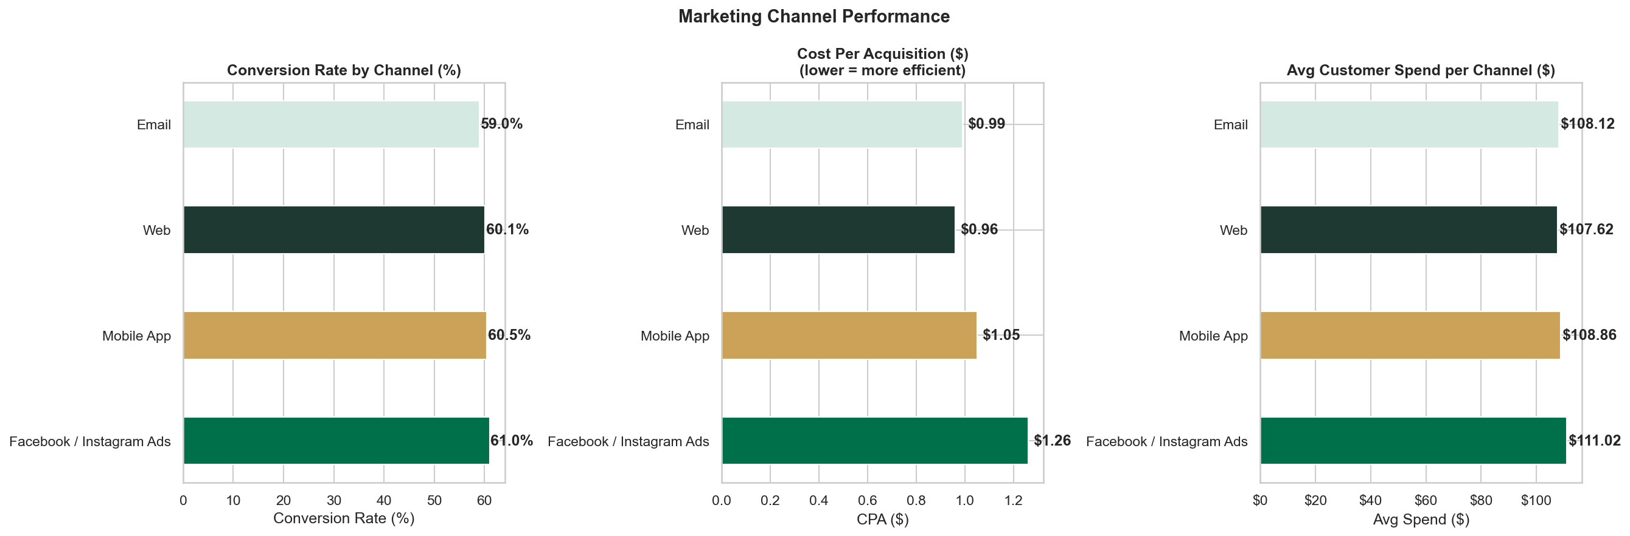
Fig 10. Channel performance — Conversion Rate, Avg Spend, and CPA
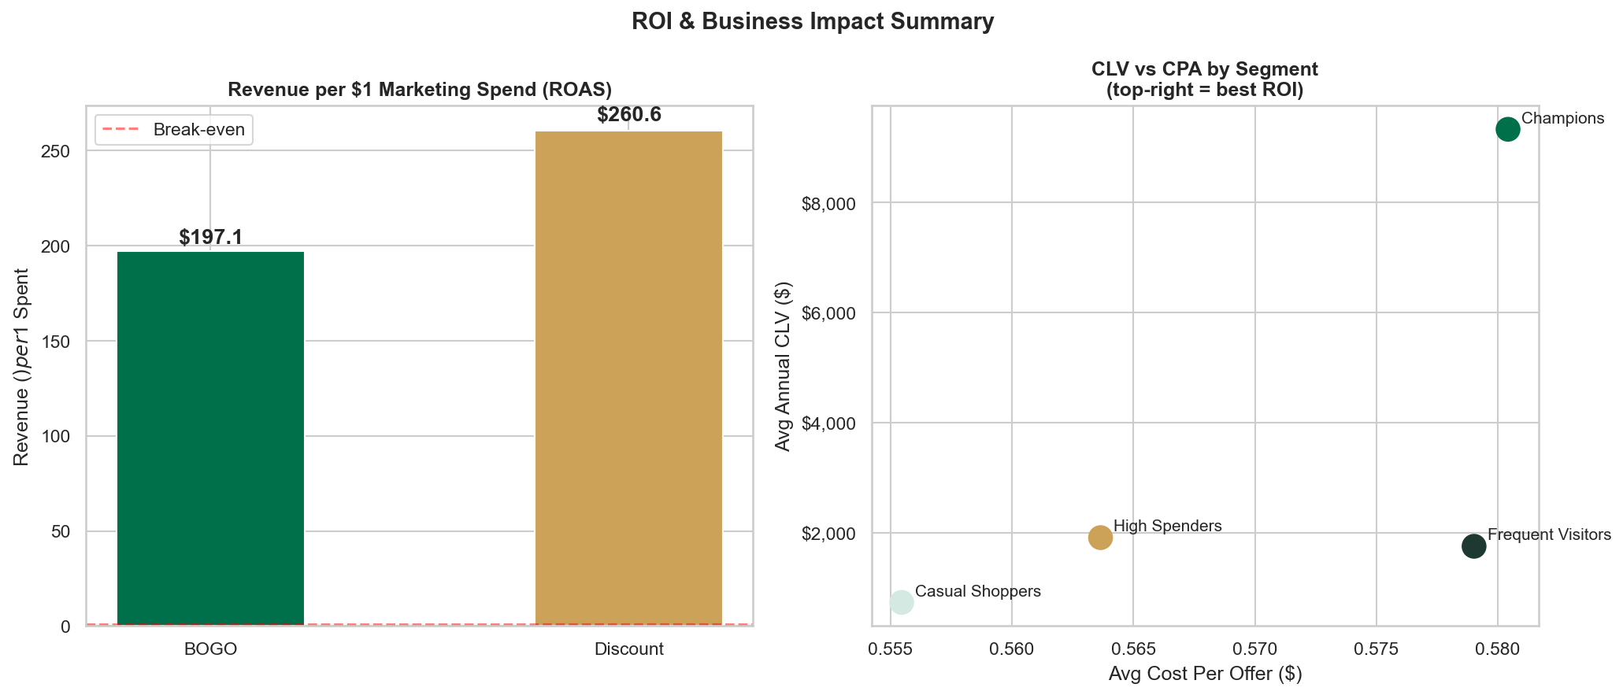
Fig 11. ROI and ROAS summary across offer types and channels
7.3 Channel Recommendations
- Web is the most cost-efficient channel (CPA $0.96) for volume campaigns — use it for Discount offers targeting Frequent Visitors and Loyal Customers.
- Facebook / Instagram Ads drive the highest average transaction value ($111) and should be reserved for Champions and High Spender re-targeting where premium acquisition cost is justified.
- Mobile App push is the second-cheapest channel ($0.05/send) — ideal for time-sensitive offers and flash promotions with near-zero incremental cost.
- Email has the highest send volume (61,042) and solid conversion (59%) at low cost ($0.99 CPA) — the workhorse channel for broad-based campaigns.

8. Strategic Recommendations
Segment | Recommended Offer | Channel | Rationale
Champions | BOGO (exclusive, high-value) | Facebook Ads + Mobile | Highest CLV; BOGO's higher revenue-per-conversion maximises yield
High Spenders | Discount (moderate difficulty) | Email + Web | High income, prefer simplicity; Discount drives 26% better ROAS
Frequent Visitors | Discount + bundle upsell | Mobile + Web | Already engaged; incremental spend nudge converts frequency to $
Casual Shoppers | BOGO (low threshold, short window) | Email + Mobile | Needs urgency trigger; BOGO attention-grab good for re-engagement
At Risk / Lost | Win-back Discount (deep save) | Email | Low-cost channel for uncertain-return segment; test before scaling

Prioritised Actions
- 1. Shift default mass-market offer from BOGO to Discount — saves ~$3,000 per 30-day campaign cycle in delivery cost alone while increasing conversions by 7pp.
- 2. Invest Facebook/Instagram budget in Champions re-targeting — their $9,312 annual CLV justifies the $1.26 CPA (CLV:CPA ratio > 7,000×).
- 3. Address BOGO funnel drop (View → Complete gap of 38%) by A/B testing lower minimum purchase thresholds — a 5pp improvement in completion would add ~1,500 conversions per campaign.
- 4. Build a churn-prediction model on the At Risk segment (2,020 customers representing ~$1.8M potential revenue) using RFM decay signals as early warning features.

9. Methodology Appendix
Statistical Tests Used
Test | Applied To | Why
Chi-Square (χ²) | BOGO vs Discount conversion rates | Tests independence between offer type and binary conversion outcome
Welch's t-test | BOGO vs Discount average spend | Compares means of two independent samples without assuming equal variance
K-Means Clustering | RFM + demographic features | Groups customers into behavioural clusters without requiring pre-labelled data
Elbow + Silhouette | Optimal K selection | Elbow finds diminishing inertia returns; Silhouette confirms cluster separation quality
RFM Quintile Bins | R / F / M scores 1–5 | Robust to outliers; quintile binning distributes customers evenly across score levels

Tools & Libraries
Tool | Purpose
Python 3.11 | Core analysis and pipeline
pandas / NumPy | Data manipulation and cleaning
scikit-learn | K-Means clustering, StandardScaler
scipy.stats | Chi-Square and Welch t-test
matplotlib / seaborn | Static chart generation (13 charts)
Plotly / Streamlit | Interactive dashboard (6-page web app)
Tableau Public 2026.1.1 | Customer Segmentation and A/B Test dashboards
Power BI | Supporting data exports (7 clean CSVs)

