MATHS
ASSIGNMENT NO. 1

Convergence, Divergence of an infinite series (Ratio, Root, Logarithmic Test):-

- Test the convergence of the series:
(i) 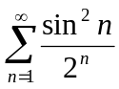 (ii) 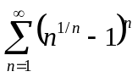
- Test lgt or dgt:
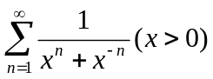
- (a) 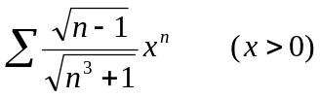, (b) 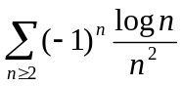
- Prove that the series 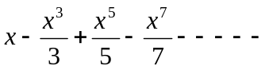is absolutely egt if –1 < x < 1.
- Test the convergence of the series
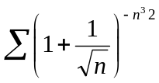
- Test the following series for absolute convergence
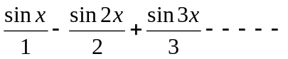
- Find the interval of convergence of series
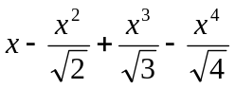 ……..
- 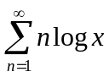
- Test for the convergence of the series
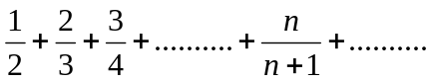
- Test convergence(i) 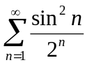 (ii)
ASSIGNMENT – 2
Successive Differentiation
Leibnitz theorem (without proof)
- Prove that the value of the nth derivative of 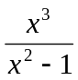 for x = 0 is zero when n is even and {-Ln} when n is odd and > 1.
- If y = (x² = 1)^{n} prove that (x² – 1) y_{n+2} + 2xy_{n+1}. Hence prove if P_{n} = 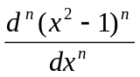 show that 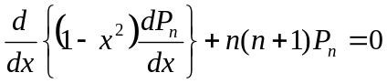
- Determine yn(0) if y = e^{msin-1x}
- If y = tan⁻¹ 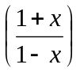 find y_{n}
- If f(x) = m cos⁻¹ x find f^{n}(0) when n is even.
- If y = e^{asin-1x}, prove that
(1 – x²) y_{n+2} – (2n + 1) y_{n+1} x – (n² + a²)y_{n} = 0
- If y = sin⁻¹ x prove that
(1 – x²) y_{n+2} – (2x + 1)x y_{n+1} – x² y_{n} = 0
- If y = 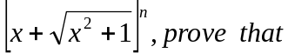
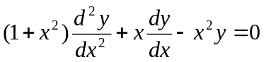

ASSIGNMENT – 3
Curvature and Asymptotes
Q1. Find the radius of curvature at the point(3a/2, 3a/2) on the curve x³ + y³ = 3axy.
Q2. Find the radius of curvature at the point (x, y) on the curve xy=c²
Q3. If ρ and ρ’ be the radii of curvature at the extremities of two conjugate diameters of an ellipse, prove that (ρ^{2/3} + ρ`^{2/3}) (ab)^{2/3} = a² + b².
Q4. Prove that the radius of curvature at any point (x, y) of the curve x^{2/3} + y^{2/3} = a^{2/3} is three times the length of the perpendicular from the origin to the tangent at (x, y).
Q5. Prove that for the ellipse x=acos t, y = bsin t 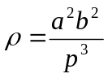, where p is the perpendicular from centre upon tangent at (acost, bsint).
Q6. Find all the asymptotes of curve
(i) x²y² (x² – y²) = (x² + y²)³
(ii) y³ – xy² – x²y + x³ + x² – y² = 1
Q7. Find the asymptotes parallel to axes for the curve 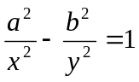
Q8. Find the asymptotes of curve
(i) x³ + x²y – xy² – y³ – 3x – y – 1 = 0
(ii) y³ + x²y + 2xy² + y + 1 = 0
Q9. Find asymptotes parallel to the axes of curve y² x – a² (x+a) = 0.
Q10. Find the curvature of x=4 cos t, y = 3 sin t. at what points on the ellipse does the curvature have greatest and least values. What are magnitudes.

ASSIGNMENT – 4
Maclaurin’s & Taylor’s Series
Error and Approximation
Curve Tracing
Q1. Calculate the approximate value of to four places of decimal by taking the first four terms of an appropriate expansion.
Q2. Find the change in total surface area of a right circular cone when the altitude is constant and the radius changes by δr.
Q3. If A is the area of a Δ having sides equal to a, b, c and s is the semi-perimeter, prove that the error in A resulting from a small error in measurement of c is given by 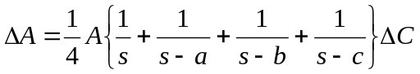
Q4. A soap bubble of radius 2cm shrinks to radius 1.9cm. Estimate the decrease in
(i) Volume (ii) Surface area
Q5. Apply Maclaurin’s theorem to prove that
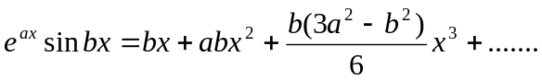
Q6. Apply Taylor’s theorem to find 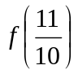is f(x) = x³ + 3x² + 15x - 10
Q7. Show that 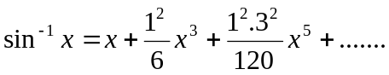 and hence find approximate value of π.
Q8 Prove that 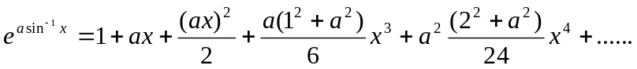 and show that 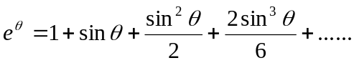
Q9. Using Maclaurin’s series, give the expansion of sin⁻¹x and sin x.
Q10. which trigonometric function cannot be expanded by Maclaurin’s Theorem?
Q11. Trace the curve x^{2/3} + y^{2/3} = a^{2/3}
Q12. Trace the curve 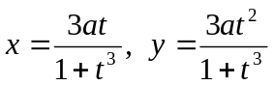
ASSIGNMENT – 5
REDUCTION FORMULA

- Derive the reduction formula for 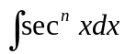, Use to find 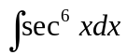
- If 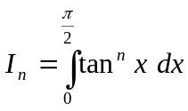, show that I_{n} + I_{n-2} = 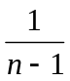 and deduce I₅.
- If I_{m,n} = 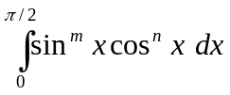; prove that I_{m,n} = 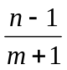I_{m}, n-2; where m, n εI. Evaluate 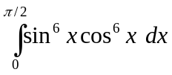
- If 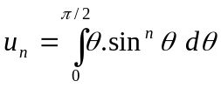, prove that 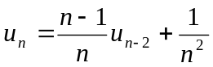. Hence find u₃.
- Using properties of definite integral show that 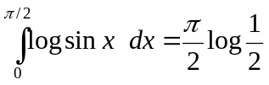
- Evaluate 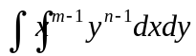 over the positive quadrant of the ellipse 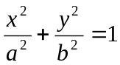.
- 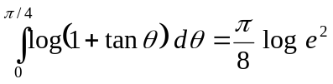 prove.
- If 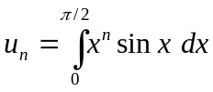, n > 1, prove that u_{n} + n(n-1) u_{n-2} = 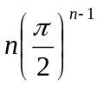
- Show that 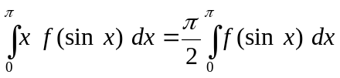
- Evaluate 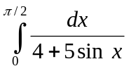

ASSIGNMENT – 6
AREA UNDER CURVE
VOLUME & SURFACE AREA OF SOLID OF REVOLUTION
LENGTH OF CURVE
Q1. Find the volume of the solid formed by the revolution of the cissoid y²(a-x) = a²x about its asymptote.
Q2. Find the length of cardioid r = a(1 – cos θ) lying outside the circle r = a cos θ.
Q3. Find the area of the surface generated by revolving an arc of the cycloid x = a(θ + sin θ); y = a(1 – cos θ) about the tangent at the vertex.
Q4. Find the whole area of the curve a² x² = y³ (2a-y)
Q5. Find the length of the arc of the cycloid x = a(t-sin t), y = a(1 – cos t)
Q6 Find the volume of the solid generates by revolving one loop catenary y = c cos h(x/c) about the axis of x.
Q7. Find the perimeter fo the curve r = a(1 – cos θ)
Q8. The part of parabola y² = 4ax cut off by the latus rectum is revolvrd about the tangent at the vertex. Find the volume of the reel thus generated.
Q10. For the cycloid x = a(θ + sin θ), y = a (1 – cos θ), prove that 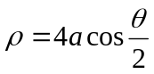
Q11. Show that the area of the loop of the curve a²y² = x² (2a – x) (x – a) is 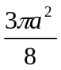
Q12. Find the perimeter of the cardiode r = a(1 – cos θ) & show that arc of the upper half of the curve is bisected by the line θ = 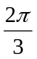
Q13. Find the area of the loop of curve xy² + (x + a)² (x + 2a) = 0
Q14. Find the volume of solid generated by revolving about the x-axis , the area enclosed by the arch of the cycloid x = a(θ + sin θ), y = a(1 + cos θ) about the x-axis

ASSIGNMENT – 7
MATRICES

Q1. State Cayley Hamilton’s Theorem. Write down the eigen values of A² if
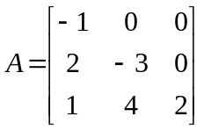
Q2. Verify Cayley Hamilton theorem for 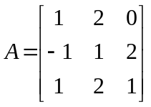. Hence find A⁻¹.
Q3. Find eigen values and eigen vectors of 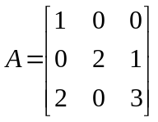.
Q4. Find the Characteristic equation of matrix 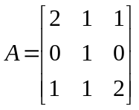 and hence find the
matrix represented by .
Q5. Find the inverse of the matrix 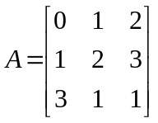 by E-row operations.
Q6. Find the rank of the matrix 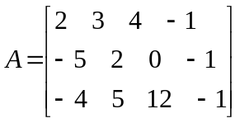.
Q7. Reduce the matrix 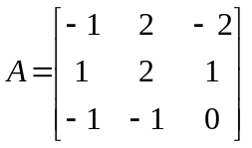 to the diagonal form.
Q8. For what values of d and µ the system of equations x + y+ z = 6, x + 2y + 3z =10,
x + 2y + d z = µ have (i) No solution (ii) Unique solution (iii) more than one
solution.
Q9. Find the rank of matrix 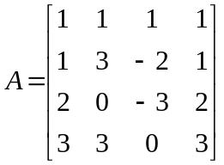.
Q10. Find the Ch. Roots of A⁻¹ where 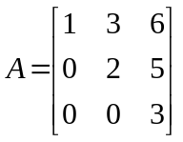.
Q11. Find the non-singular matrices P and Q such that PAQ is in the normal form
where 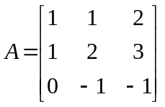.

ASSIGNMENT – 8
DIFFERENTIAL EQUATIONS

Q1. Find the values of λ for which the diff. eqn. 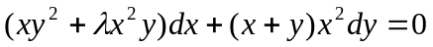 is exact.
Q3. Obtain the complete solution of the diff. eqn. 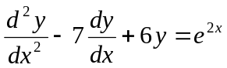 and determine constants so that y = 0 when x =0.
Q4. Solve 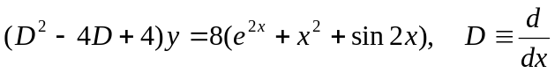
Q5. Solve (a) 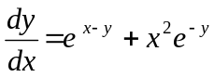
(b) 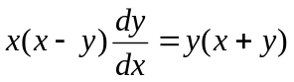
Q6. Use method of variation of parameters, solve 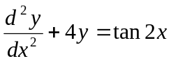
Q7. Solve
(i) 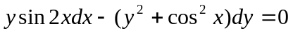
(ii) 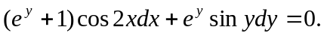
(iii) 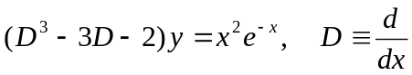
Q8. Solve the simultaneous equations
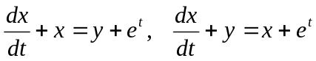.
Q9. Apply the variation of parameters
(i) 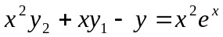
(ii) 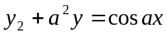
Q10. Solve
(i) 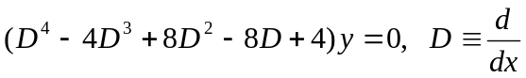
(ii) 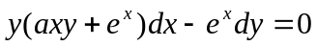

BETA AND GAMMA FUNCTION
- State and prove relation between Beta and Gamma function.

- State and prove Duplication formula.

