**bookCritics - Book Review**

**Introduction**

A form of literary criticism, book reviews are written opinions about a particular book. They can take many forms. Book reviews can be brief or long. They can critique and/or summarize the book. They can be written by readers or professional book reviewers. Reader reviews tend to be more personal, focusing on the individual reader’s experience while reading the book. But since readers can have such widely differing views of the same book, it is valuable for all involved when a book has a variety of reader reviews available.

“A book review is a form of literary criticism in which a book is merely described (summary review) or analyzed based on content, style, and merit. A book review may be a primary source, opinion piece, summary review or scholarly review.” – Wikipedia

For Authors, book reviews can be more important than you may think. Reading through the reviews written about your books can really help you better understand what it is your readers are looking for. Answering questions like, what are your readers enjoying about your work? What do they think is missing? And, what do they connect with? Can do a lot for helping you understand your audience.

‘bookCritics’ is a book review platform, connecting readers, professional reviewers and authors all in one place. It provides reviews for books written by professional reviewers and a center for discussing readers viewpoints.

**Benefits**

Here are three reasons why book reviews are vital to writers and readers.

* Saves Time, Decreases Risk to Readers
* Greater Visibility, Greater Chance of Getting Found by More Readers
* More Sales

**Features**

* Common place for authors, expert reviewers and readers.
* Read reviews about the book written by experts.
* Overall rating for the book.
* Recommendation of similar books.
* Discussion boards for readers to discuss their views on the book.
* Follow your favorite author and get updated on recent books.
* Monitoring tools to track your reading progress.

**Market Survey**

|  |  |  |
| --- | --- | --- |
|  | **Pros** | **Cons** |
| **Amazon Book Review** | * Quantity of books: there is a review for almost any book out there * Quantity of reviews: plenty of reviews for each book * Sorting: I love the option sorting by stars or by highest voted | * No expert reviewers * Swayed by fans/hater reviewers * Most fake reviews * Smaller book reviews completely unreliable * Confirmation bias * Not really a book review site |
| **Google Books** | Higher quality reviews compared to Amazon | Easily deceived, especially for smaller books, the reviews can be fabricated |
| **Goodreads** | * You know the reviewers * You can better target subject matter experts compared to Amazon/Google Books | * Facebook of books * The best reviewers are not there: not all the top reviewers are on Goodreads |
| **Derek Sivers** | Does not mince words | No categories: summaries are all mixed in a single page, going from history to biographies to self-help |
| **The Power Moves** | Higher quality reviews | Not many books are reviewed |

**Wireframes**

bookCritics includes 5 screens – Home Page, Books Page, Blog, About Page, Particular Book Page. These wireframes are made in JustinMind Wireframe and Prototyping tool.

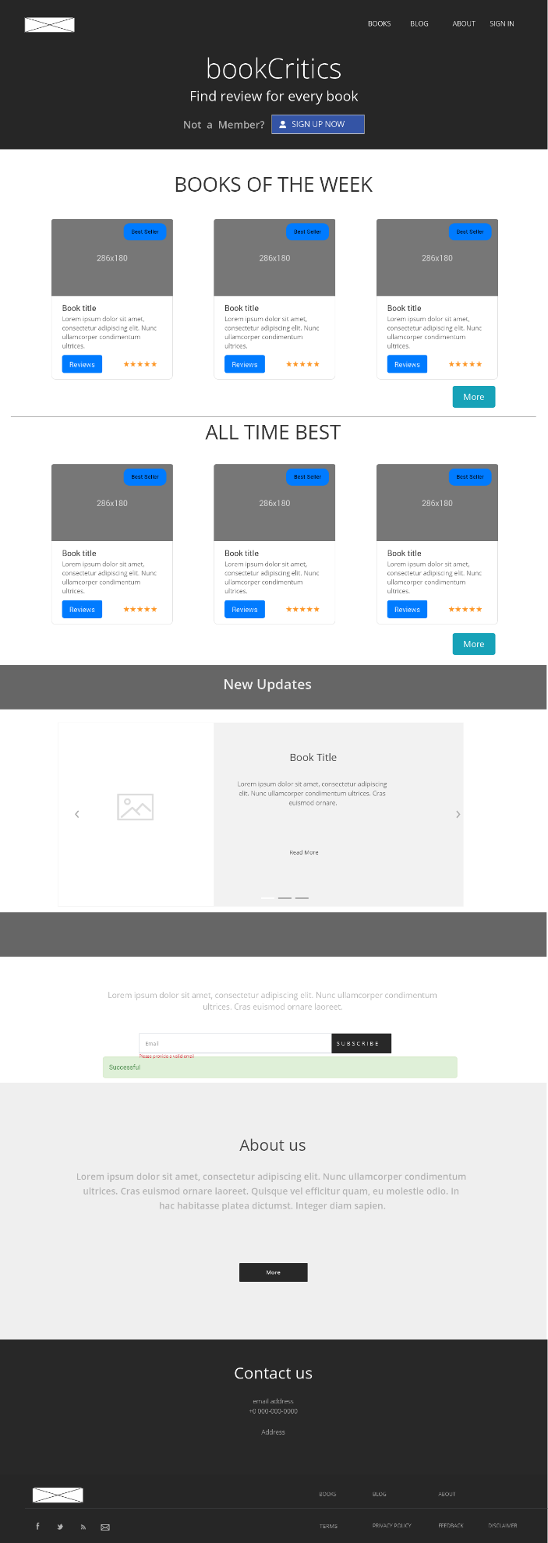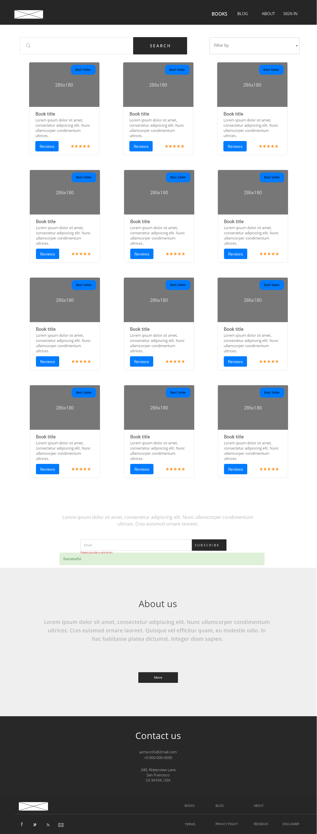

Figure Home Page

Figure Books Page

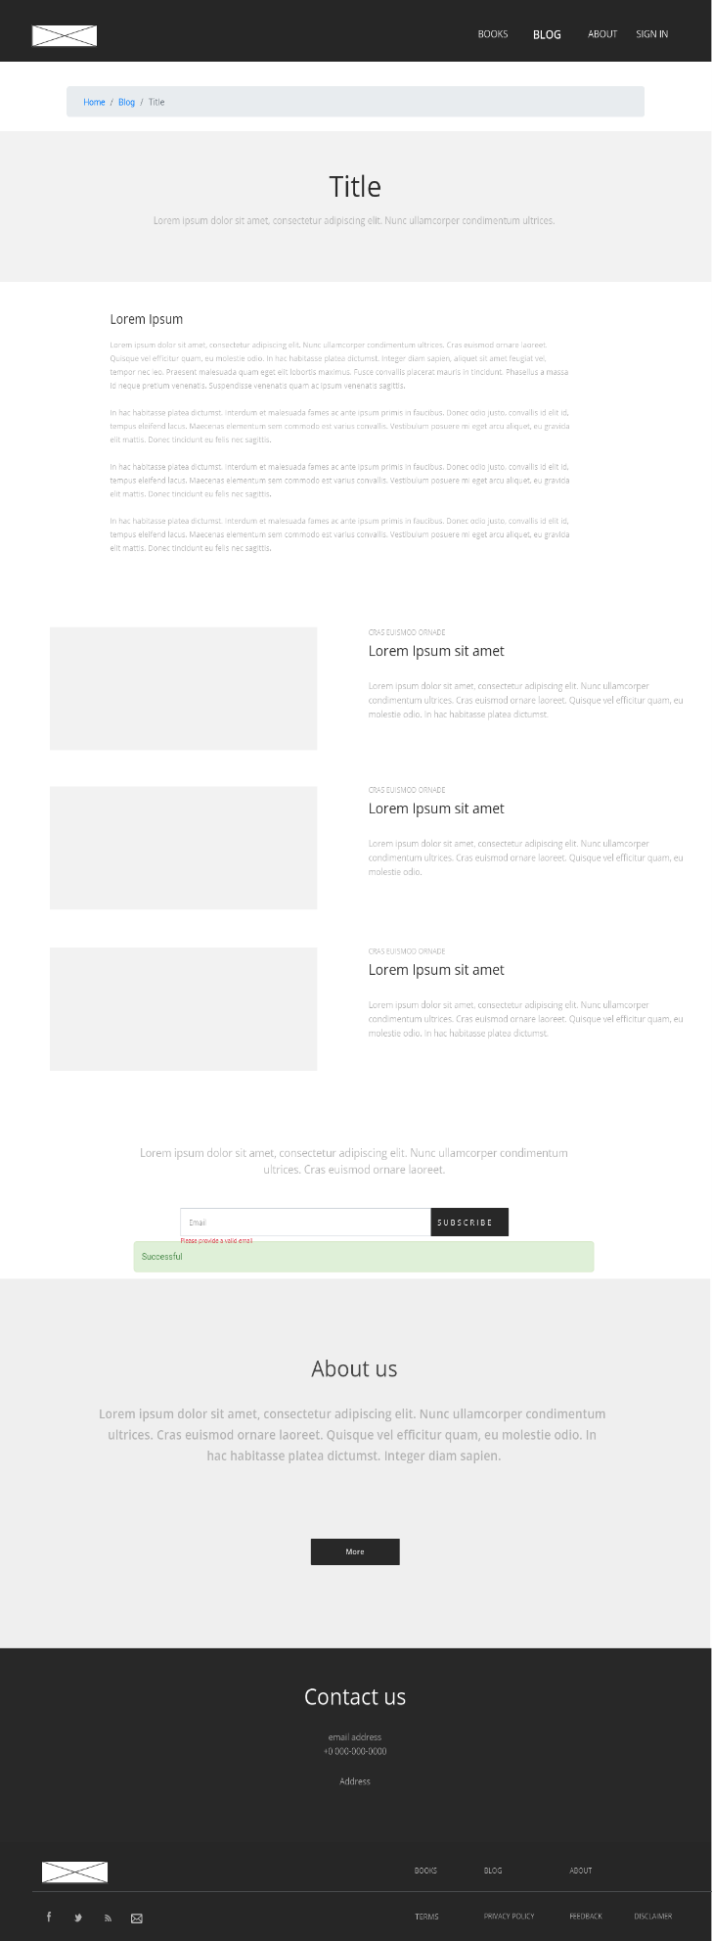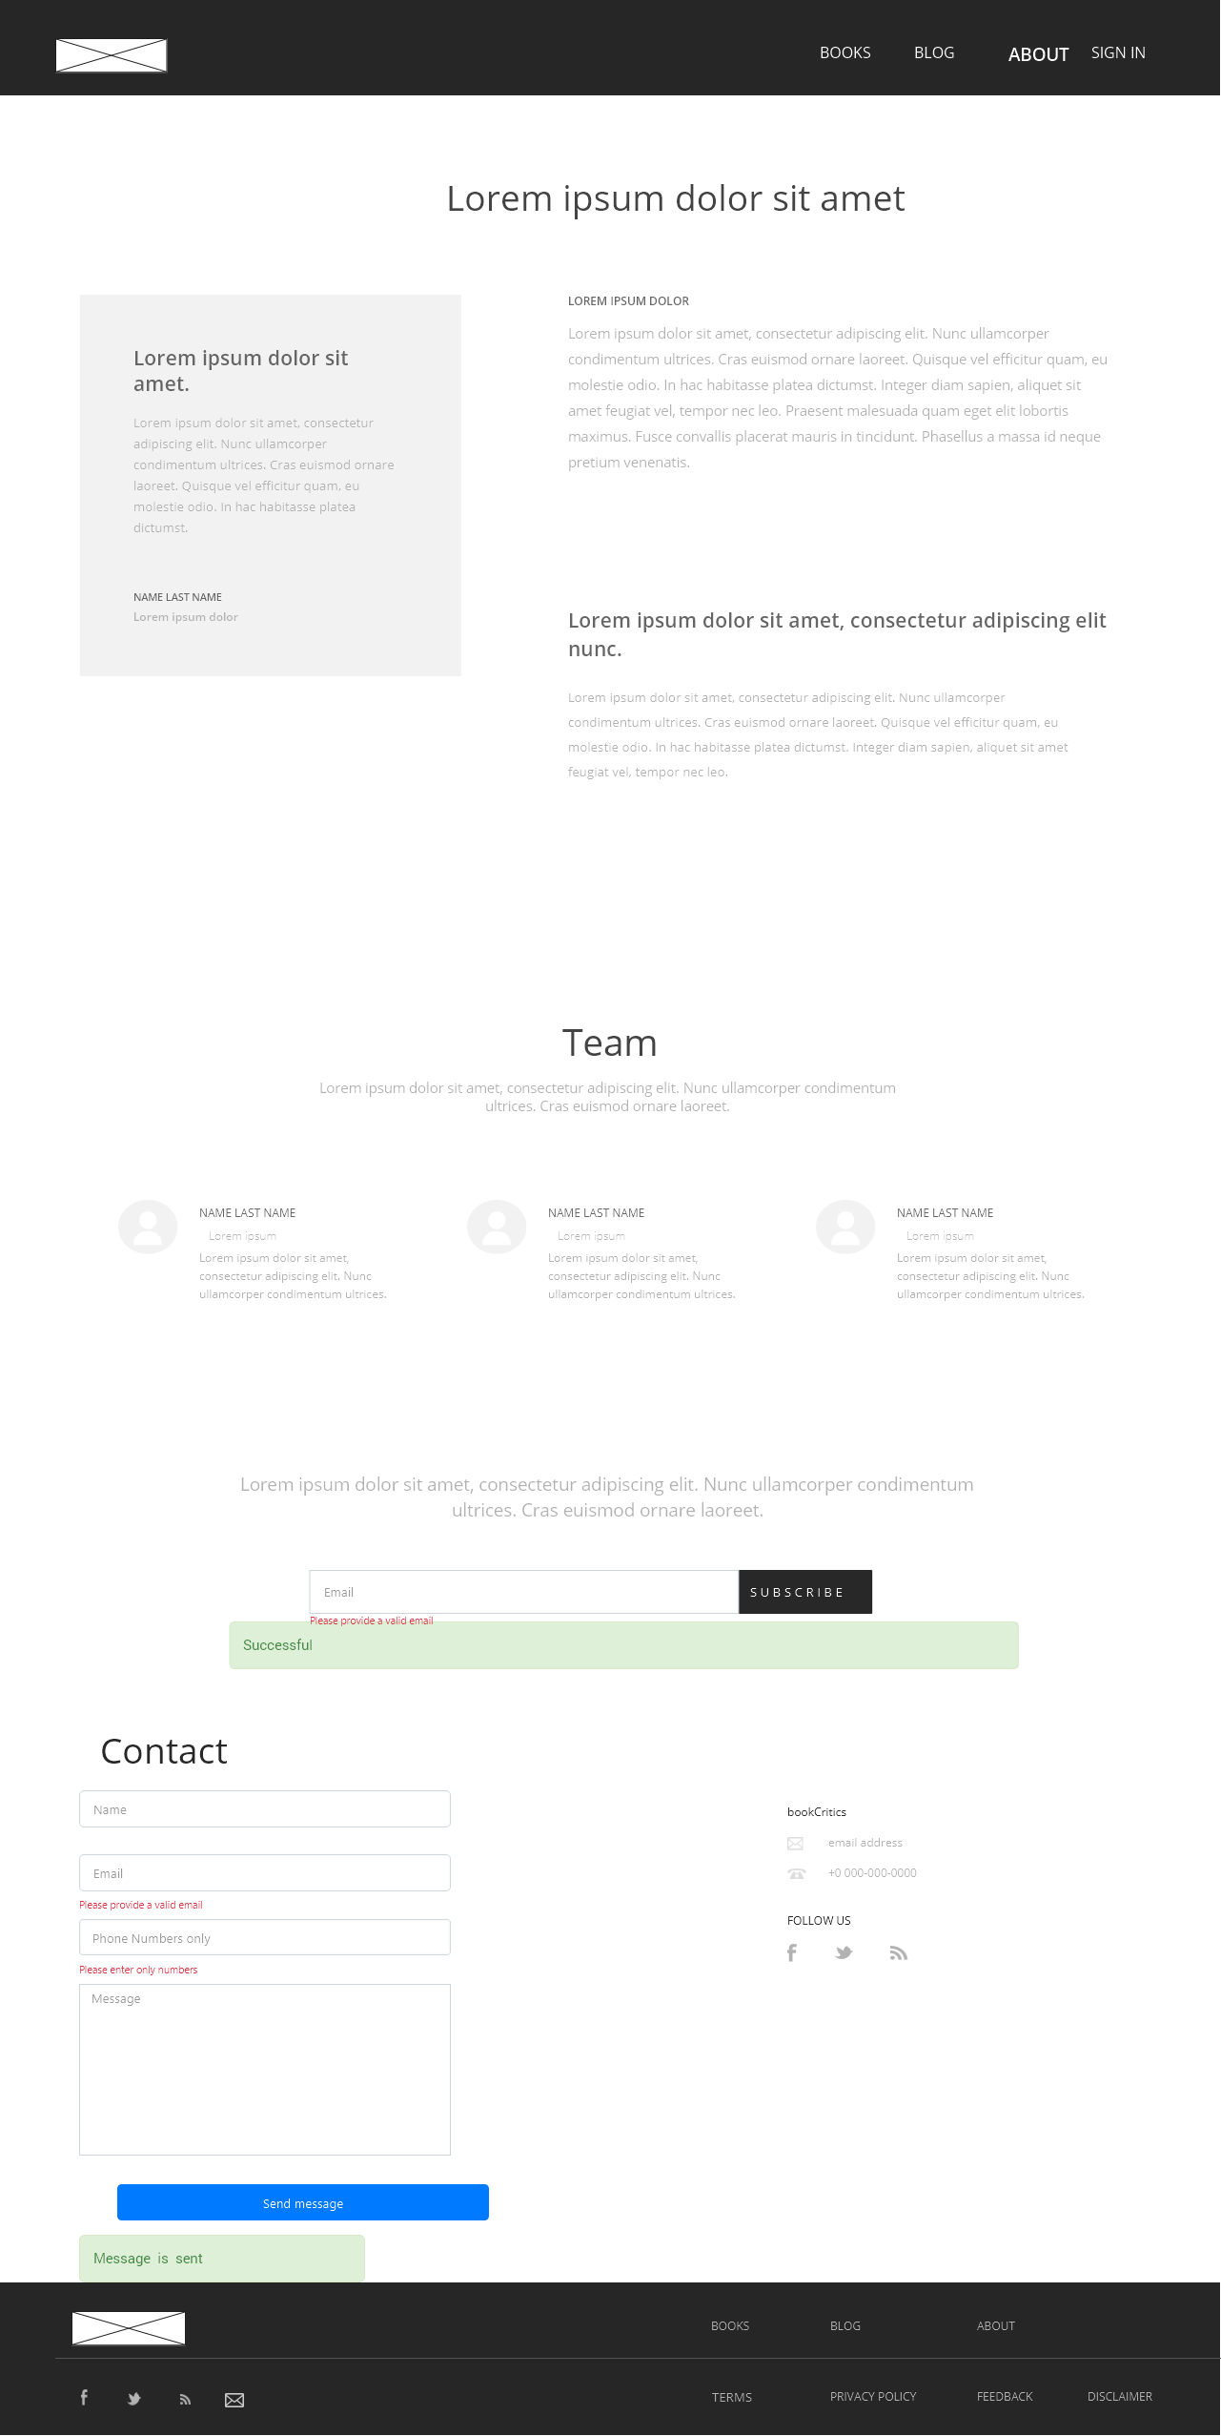

Figure Blog

Figure About Page

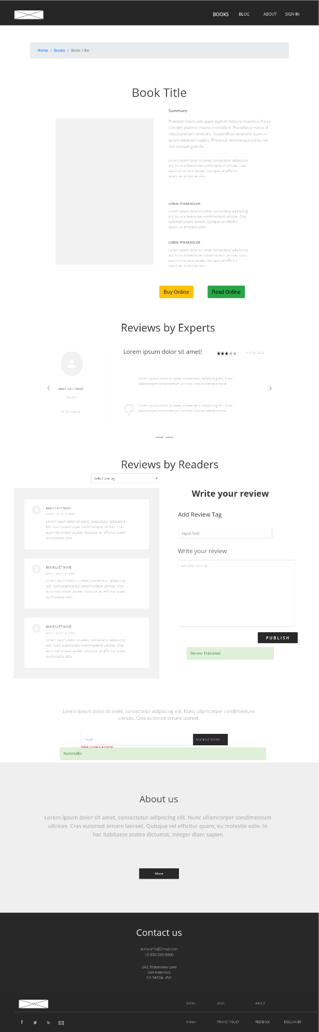

Figure Particular Book Page



|  |
| --- |
| bookCritics |
| 10/12/20, 6:48 PM |
| **Author:** Vinod Kumar R  **File name:** bookCritics.vp  **Version** 1.0 |

|  |
| --- |
| Screens |
|  |

# Navigations

02. Screens / bookCritics 

Home Page

|  |
| --- |
|  |

Interactions

|  |  |
| --- | --- |
| 1 | **on Mouse Down:** changes style of 'books': text color 🡪  **on Mouse Up:** changes style of 'books': text color 🡪  **on Click:** goes to 'Books' 🡪 |
| 2 | **on Mouse Down:** changes style of 'review': text color 🡪  **on Mouse Up:** changes style of 'review': text color 🡪  **on Click:** goes to 'Blog' 🡪 |
| 3 | **on Mouse Down:** changes style of 'about': text color 🡪  **on Mouse Up:** changes style of 'about': text color 🡪  **on Click:** goes to 'About' 🡪 |
| 4 | **on Mouse Down:** changes style of 'terms': text color 🡪  **on Mouse Up:** changes style of 'terms': text color 🡪 |
| 5 | **on Mouse Down:** changes style of 'review': text color 🡪  **on Mouse Up:** changes style of 'review': text color 🡪 |
| 6 | **on Mouse Down:** changes style of 'about': text color 🡪  **on Mouse Up:** changes style of 'about': text color 🡪 |
| 7 | **on Mouse Down:** changes style of 'contact': text color 🡪  **on Mouse Up:** changes style of 'contact': text color 🡪 |
| 8 | **on Mouse Over:** changes style of 'rectangle_2': background color 🡪  **on Mouse Down:** changes style of 'rectangle_2': background color 🡪  **on Mouse Up:** changes style of 'rectangle_2': background color 🡪  **on Click:** goes to 'About' 🡪 |
| 9 | **on Mouse Over:** changes style of 'rectangle_2': background color 🡪  **on Mouse Down:** changes style of 'rectangle_2': background color 🡪  **on Mouse Up:** changes style of 'rectangle_2': background color 🡪  **on Click:** !EventsComposite.133! (count(Input_3.value) > '0') shows 'success' 🡪 hides 'success' 🡪 sets value '' to 'Input_3' 🡪 !EventsComposite.135! changes style of 'input_3': border color 🡪 |
| 10 | **on Focus In:** changes style of 'input_3': border color, shadow, 🡪 hides 'Text_6' 🡪  **on Focus Out:** !EventsComposite.133! ((Input_3.value = '') or not(regExp(Input_3.value, isEmail))) changes style of 'input_3': border color, shadow, 🡪 shows 'Text_6' 🡪 !EventsComposite.135! changes style of 'input_3': border color, shadow, 🡪 hides 'Text_6' 🡪 |
| 11 | **on Click:** sets active panel 'slide_2 1' with effect: slide left in 700ms 🡪 sets active panel 'controls_2 1' 🡪 |
| 12 | **on Click:** sets active panel 'slide_3 1' with effect: slide left in 700ms 🡪 sets active panel 'controls_3 1' 🡪 |
| 13 | **on Mouse Over:** changes style of 'arrow_left_1': color 🡪  **on Click:** sets active panel 'slide_3 1' with effect: slide right in 700ms 🡪 sets active panel 'controls_3 1' 🡪 |
| 14 | **on Mouse Over:** changes style of 'arrow_right_1': color 🡪  **on Click:** sets active panel 'slide_2 1' with effect: slide left in 700ms 🡪 sets active panel 'controls_2 1' 🡪 |
| 23 | **on Mouse Over:** changes style of 'button': background color 🡪  **on Click:** changes style of 'button': border color 🡪 goes to 'Particular Book' 🡪  **on Mouse Leave:** changes style of 'button': background color 🡪 |
| 24 | **on Mouse Over:** changes style of 'button': background color 🡪  **on Click:** changes style of 'button': border color 🡪 goes to 'Particular Book' 🡪  **on Mouse Leave:** changes style of 'button': background color 🡪 |
| 25 | **on Mouse Over:** changes style of 'button': background color 🡪  **on Click:** changes style of 'button': border color 🡪 goes to 'Particular Book' 🡪  **on Mouse Leave:** changes style of 'button': background color 🡪 |
| 26 | **on Mouse Over:** changes style of 'button': background color 🡪  **on Click:** changes style of 'button': border color 🡪 goes to 'Books' 🡪  **on Mouse Leave:** changes style of 'button': background color 🡪 |
| 27 | **on Mouse Over:** changes style of 'button': background color 🡪  **on Click:** changes style of 'button': border color 🡪 goes to 'Books' 🡪  **on Mouse Leave:** changes style of 'button': background color 🡪 |
| 28 | **on Mouse Over:** changes style of 'button': background color 🡪  **on Click:** changes style of 'button': border color 🡪 goes to 'Particular Book' 🡪  **on Mouse Leave:** changes style of 'button': background color 🡪 |
| 29 | **on Mouse Over:** changes style of 'button': background color 🡪  **on Click:** changes style of 'button': border color 🡪 goes to 'Particular Book' 🡪  **on Mouse Leave:** changes style of 'button': background color 🡪 |
| 30 | **on Mouse Over:** changes style of 'button': background color 🡪  **on Click:** changes style of 'button': border color 🡪 goes to 'Particular Book' 🡪  **on Mouse Leave:** changes style of 'button': background color 🡪 |
| 31 | **on Click:** goes to 'Home Page' 🡪 |
| 32 | **on Mouse Down:** changes style of 'books': text color 🡪  **on Mouse Up:** changes style of 'books': text color 🡪  **on Click:** goes to 'Books' 🡪 |
| 33 | **on Mouse Down:** changes style of 'reviews': text color 🡪  **on Mouse Up:** changes style of 'reviews': text color 🡪  **on Click:** goes to 'Blog' 🡪 |
| 34 | **on Mouse Down:** changes style of 'about': text color 🡪  **on Mouse Up:** changes style of 'about': text color 🡪  **on Click:** goes to 'About' 🡪 |
| 35 | **on Click:** shows 'Sign up' 🡪 |
| 36 | **on Mouse Down:** changes style of 'sign in': text color 🡪  **on Mouse Up:** changes style of 'sign in': text color 🡪  **on Click:** shows 'Login' 🡪 |

02. Screens / Home Page 

Other states

|  |  |
| --- | --- |
| Sin nombre.png |  |
| Sin nombre.png |  |
| Sin nombre.png | Interactions   |  |  | | --- | --- | | 15 | **on Click:** sets active panel 'slide_3 1' with effect: slide left in 700ms 🡪 sets active panel 'controls_3 1' 🡪 | | 16 | **on Click:** sets active panel 'slide_1 1' with effect: slide right in 700ms 🡪 sets active panel 'controls_1 1' 🡪 | | 17 | **on Mouse Over:** changes style of 'image_1': color 🡪  **on Click:** sets active panel 'slide_1 1' with effect: slide right in 700ms 🡪 sets active panel 'controls_1 1' 🡪 | | 18 | **on Mouse Over:** changes style of 'image_2': color 🡪  **on Click:** sets active panel 'slide_3 1' with effect: slide left in 700ms 🡪 sets active panel 'controls_3 1' 🡪 | |
| Sin nombre.png | Interactions   |  |  | | --- | --- | | 19 | **on Click:** sets active panel 'slide_2 1' with effect: slide right in 700ms 🡪 sets active panel 'controls_2 1' 🡪 | | 20 | **on Click:** sets active panel 'slide_1 1' with effect: slide left in 700ms 🡪 sets active panel 'controls_1 1' 🡪 | | 21 | **on Mouse Over:** changes style of 'image_3': color 🡪  **on Click:** sets active panel 'slide_2 1' with effect: slide right in 700ms 🡪 sets active panel 'controls_2 1' 🡪 | | 22 | **on Mouse Over:** changes style of 'image_4': color 🡪  **on Click:** sets active panel 'slide_1 1' with effect: slide left in 700ms 🡪 sets active panel 'controls_1 1' 🡪 | |

02. Screens / bookCritics 

Books

|  |
| --- |
|  |

Interactions

|  |  |
| --- | --- |
| 51 | **on Mouse Down:** changes style of 'books': text color 🡪  **on Mouse Up:** changes style of 'books': text color 🡪  **on Click:** goes to 'Books' 🡪 |
| 52 | **on Mouse Down:** changes style of 'review': text color 🡪  **on Mouse Up:** changes style of 'review': text color 🡪  **on Click:** goes to 'Blog' 🡪 |
| 53 | **on Mouse Down:** changes style of 'about': text color 🡪  **on Mouse Up:** changes style of 'about': text color 🡪  **on Click:** goes to 'About' 🡪 |
| 54 | **on Mouse Down:** changes style of 'terms': text color 🡪  **on Mouse Up:** changes style of 'terms': text color 🡪 |
| 55 | **on Mouse Down:** changes style of 'review': text color 🡪  **on Mouse Up:** changes style of 'review': text color 🡪 |
| 56 | **on Mouse Down:** changes style of 'about': text color 🡪  **on Mouse Up:** changes style of 'about': text color 🡪 |
| 57 | **on Mouse Down:** changes style of 'contact': text color 🡪  **on Mouse Up:** changes style of 'contact': text color 🡪 |
| 58 | **on Mouse Over:** changes style of 'rectangle_2': background color 🡪  **on Mouse Down:** changes style of 'rectangle_2': background color 🡪  **on Mouse Up:** changes style of 'rectangle_2': background color 🡪  **on Click:** goes to 'About' 🡪 |
| 59 | **on Mouse Over:** changes style of 'rectangle_2': background color 🡪  **on Mouse Down:** changes style of 'rectangle_2': background color 🡪  **on Mouse Up:** changes style of 'rectangle_2': background color 🡪  **on Click:** !EventsComposite.133! (count(Input_3.value) > '0') shows 'success' 🡪 hides 'success' 🡪 sets value '' to 'Input_3' 🡪 !EventsComposite.135! changes style of 'input_3': border color 🡪 |
| 60 | **on Focus In:** changes style of 'input_3': border color, shadow, 🡪 hides 'Text_6' 🡪  **on Focus Out:** !EventsComposite.133! ((Input_3.value = '') or not(regExp(Input_3.value, isEmail))) changes style of 'input_3': border color, shadow, 🡪 shows 'Text_6' 🡪 !EventsComposite.135! changes style of 'input_3': border color, shadow, 🡪 hides 'Text_6' 🡪 |
| 61 | **on Mouse Over:** changes style of 'rectangle_2': background color 🡪  **on Mouse Down:** changes style of 'rectangle_2': background color 🡪  **on Mouse Up:** changes style of 'rectangle_2': background color 🡪 |
| 62 | **on Mouse Over:** changes style of 'button': background color 🡪  **on Click:** changes style of 'button': border color 🡪 goes to 'Particular Book' 🡪  **on Mouse Leave:** changes style of 'button': background color 🡪 |
| 63 | **on Mouse Over:** changes style of 'button': background color 🡪  **on Click:** changes style of 'button': border color 🡪 goes to 'Particular Book' 🡪  **on Mouse Leave:** changes style of 'button': background color 🡪 |
| 64 | **on Mouse Over:** changes style of 'button': background color 🡪  **on Click:** changes style of 'button': border color 🡪 goes to 'Particular Book' 🡪  **on Mouse Leave:** changes style of 'button': background color 🡪 |
| 65 | **on Mouse Over:** changes style of 'button': background color 🡪  **on Click:** changes style of 'button': border color 🡪 goes to 'Particular Book' 🡪  **on Mouse Leave:** changes style of 'button': background color 🡪 |
| 66 | **on Mouse Over:** changes style of 'button': background color 🡪  **on Click:** changes style of 'button': border color 🡪 goes to 'Particular Book' 🡪  **on Mouse Leave:** changes style of 'button': background color 🡪 |
| 67 | **on Mouse Over:** changes style of 'button': background color 🡪  **on Click:** changes style of 'button': border color 🡪 goes to 'Particular Book' 🡪  **on Mouse Leave:** changes style of 'button': background color 🡪 |
| 68 | **on Mouse Over:** changes style of 'button': background color 🡪  **on Click:** changes style of 'button': border color 🡪 goes to 'Particular Book' 🡪  **on Mouse Leave:** changes style of 'button': background color 🡪 |
| 69 | **on Mouse Over:** changes style of 'button': background color 🡪  **on Click:** changes style of 'button': border color 🡪 goes to 'Particular Book' 🡪  **on Mouse Leave:** changes style of 'button': background color 🡪 |
| 70 | **on Mouse Over:** changes style of 'button': background color 🡪  **on Click:** changes style of 'button': border color 🡪 goes to 'Particular Book' 🡪  **on Mouse Leave:** changes style of 'button': background color 🡪 |
| 71 | **on Mouse Over:** changes style of 'button': background color 🡪  **on Click:** changes style of 'button': border color 🡪 goes to 'Particular Book' 🡪  **on Mouse Leave:** changes style of 'button': background color 🡪 |
| 72 | **on Mouse Over:** changes style of 'button': background color 🡪  **on Click:** changes style of 'button': border color 🡪 goes to 'Particular Book' 🡪  **on Mouse Leave:** changes style of 'button': background color 🡪 |
| 73 | **on Mouse Over:** changes style of 'button': background color 🡪  **on Click:** changes style of 'button': border color 🡪 goes to 'Particular Book' 🡪  **on Mouse Leave:** changes style of 'button': background color 🡪 |
| 74 | **on Click:** goes to 'Home Page' 🡪 |
| 75 | **on Mouse Down:** changes style of 'books': text color 🡪  **on Mouse Up:** changes style of 'books': text color 🡪 |
| 76 | **on Mouse Down:** changes style of 'reviews': text color 🡪  **on Mouse Up:** changes style of 'reviews': text color 🡪  **on Click:** goes to 'Blog' 🡪 |
| 77 | **on Mouse Down:** changes style of 'about': text color 🡪  **on Mouse Up:** changes style of 'about': text color 🡪  **on Click:** goes to 'About' 🡪 |
| 78 | **on Mouse Down:** changes style of 'signin': text color 🡪  **on Mouse Up:** changes style of 'signin': text color 🡪  **on Click:** shows 'Login' 🡪 |

02. Screens / bookCritics 

Particular Book

|  |
| --- |
|  |

Interactions

|  |  |
| --- | --- |
| 93 | **on Mouse Down:** changes style of 'books': text color 🡪  **on Mouse Up:** changes style of 'books': text color 🡪  **on Click:** goes to 'Books' 🡪 |
| 94 | **on Mouse Down:** changes style of 'review': text color 🡪  **on Mouse Up:** changes style of 'review': text color 🡪  **on Click:** goes to 'Blog' 🡪 |
| 95 | **on Mouse Down:** changes style of 'about': text color 🡪  **on Mouse Up:** changes style of 'about': text color 🡪  **on Click:** goes to 'About' 🡪 |
| 96 | **on Mouse Down:** changes style of 'terms': text color 🡪  **on Mouse Up:** changes style of 'terms': text color 🡪 |
| 97 | **on Mouse Down:** changes style of 'review': text color 🡪  **on Mouse Up:** changes style of 'review': text color 🡪 |
| 98 | **on Mouse Down:** changes style of 'about': text color 🡪  **on Mouse Up:** changes style of 'about': text color 🡪 |
| 99 | **on Mouse Down:** changes style of 'contact': text color 🡪  **on Mouse Up:** changes style of 'contact': text color 🡪 |
| 100 | **on Mouse Over:** changes style of 'rectangle_2': background color 🡪  **on Mouse Down:** changes style of 'rectangle_2': background color 🡪  **on Mouse Up:** changes style of 'rectangle_2': background color 🡪  **on Click:** goes to 'About' 🡪 |
| 101 | **on Mouse Over:** changes style of 'rectangle_2': background color 🡪  **on Mouse Down:** changes style of 'rectangle_2': background color 🡪  **on Mouse Up:** changes style of 'rectangle_2': background color 🡪  **on Click:** !EventsComposite.133! (count(Input_3.value) > '0') shows 'success' 🡪 hides 'success' 🡪 sets value '' to 'Input_3' 🡪 !EventsComposite.135! changes style of 'input_3': border color 🡪 |
| 102 | **on Focus In:** changes style of 'input_3': border color, shadow, 🡪 hides 'Text_6' 🡪  **on Focus Out:** !EventsComposite.133! ((Input_3.value = '') or not(regExp(Input_3.value, isEmail))) changes style of 'input_3': border color, shadow, 🡪 shows 'Text_6' 🡪 !EventsComposite.135! changes style of 'input_3': border color, shadow, 🡪 hides 'Text_6' 🡪 |
| 103 | **on Mouse Over:** changes style of 'rectangle_4': background color 🡪  **on Mouse Down:** changes style of 'rectangle_4': background color 🡪  **on Mouse Up:** changes style of 'rectangle_4': background color 🡪  **on Click:** shows 'success' 🡪 hides 'success' 🡪 |
| 112 | **on Click:** sets active panel 'slide_2 1' with effect: slide right in 700ms 🡪 sets active panel 'controls_2 1' 🡪 |
| 113 | **on Click:** sets active panel 'slide_1 1' with effect: slide left in 700ms 🡪 sets active panel 'controls_1 1' 🡪 |
| 114 | **on Mouse Over:** changes style of 'image_3': color 🡪  **on Click:** sets active panel 'slide_2 1' with effect: slide right in 700ms 🡪 sets active panel 'controls_2 1' 🡪 |
| 115 | **on Mouse Over:** changes style of 'image_4': color 🡪  **on Click:** sets active panel 'slide_1 1' with effect: slide left in 700ms 🡪 sets active panel 'controls_1 1' 🡪 |
| 116 | **on Mouse Over:** changes style of 'button': background color 🡪  **on Click:** changes style of 'button': border color 🡪  **on Mouse Leave:** changes style of 'button': background color 🡪 |
| 117 | **on Mouse Over:** changes style of 'button': background color 🡪  **on Click:** changes style of 'button': border color 🡪  **on Mouse Leave:** changes style of 'button': background color 🡪 |
| 118 | **on Mouse Over:** changes style of 'text_1': text color, text decoration 🡪  **on Click:** goes to 'Home Page' 🡪 |
| 119 | **on Mouse Over:** changes style of 'text_2': text color, text decoration 🡪  **on Click:** goes to 'Books' 🡪 |
| 120 | **on Click:** goes to 'Home Page' 🡪 |
| 121 | **on Mouse Down:** changes style of 'books': text color 🡪  **on Mouse Up:** changes style of 'books': text color 🡪 |
| 122 | **on Mouse Down:** changes style of 'reviews': text color 🡪  **on Mouse Up:** changes style of 'reviews': text color 🡪  **on Click:** goes to 'Blog' 🡪 |
| 123 | **on Mouse Down:** changes style of 'about': text color 🡪  **on Mouse Up:** changes style of 'about': text color 🡪  **on Click:** goes to 'About' 🡪 |
| 124 | **on Mouse Down:** changes style of 'signin': text color 🡪  **on Mouse Up:** changes style of 'signin': text color 🡪  **on Click:** shows 'Login' 🡪 |
| 139 | **on Focus In:** changes style of 'input': border color, shadow, 🡪  **on Focus Out:** changes style of 'input': border color, shadow, 🡪 |

02. Screens / Particular Book 

Other states

|  |  |
| --- | --- |
| Sin nombre.png |  |
| Sin nombre.png |  |
| Sin nombre.png | Interactions   |  |  | | --- | --- | | 104 | **on Click:** sets active panel 'slide_2 1' with effect: slide left in 700ms 🡪 sets active panel 'controls_2 1' 🡪 | | 105 | **on Click:** sets active panel 'slide_3 1' with effect: slide left in 700ms 🡪 sets active panel 'controls_3 1' 🡪 | | 106 | **on Mouse Over:** changes style of 'arrow_left_1': color 🡪  **on Click:** sets active panel 'slide_3 1' with effect: slide right in 700ms 🡪 sets active panel 'controls_3 1' 🡪 | | 107 | **on Mouse Over:** changes style of 'arrow_right_1': color 🡪  **on Click:** sets active panel 'slide_2 1' with effect: slide left in 700ms 🡪 sets active panel 'controls_2 1' 🡪 | |
| Sin nombre.png | Interactions   |  |  | | --- | --- | | 108 | **on Click:** sets active panel 'slide_3 1' with effect: slide left in 700ms 🡪 sets active panel 'controls_3 1' 🡪 | | 109 | **on Click:** sets active panel 'slide_1 1' with effect: slide right in 700ms 🡪 sets active panel 'controls_1 1' 🡪 | | 110 | **on Mouse Over:** changes style of 'image_1': color 🡪  **on Click:** sets active panel 'slide_1 1' with effect: slide right in 700ms 🡪 sets active panel 'controls_1 1' 🡪 | | 111 | **on Mouse Over:** changes style of 'image_2': color 🡪  **on Click:** sets active panel 'slide_3 1' with effect: slide left in 700ms 🡪 sets active panel 'controls_3 1' 🡪 | |

02. Screens / bookCritics 

Blog

|  |
| --- |
|  |

Interactions

|  |  |
| --- | --- |
| 140 | **on Mouse Down:** changes style of 'books': text color 🡪  **on Mouse Up:** changes style of 'books': text color 🡪  **on Click:** goes to 'Books' 🡪 |
| 141 | **on Mouse Down:** changes style of 'review': text color 🡪  **on Mouse Up:** changes style of 'review': text color 🡪  **on Click:** goes to 'Blog' 🡪 |
| 142 | **on Mouse Down:** changes style of 'about': text color 🡪  **on Mouse Up:** changes style of 'about': text color 🡪  **on Click:** goes to 'About' 🡪 |
| 143 | **on Mouse Down:** changes style of 'terms': text color 🡪  **on Mouse Up:** changes style of 'terms': text color 🡪 |
| 144 | **on Mouse Down:** changes style of 'review': text color 🡪  **on Mouse Up:** changes style of 'review': text color 🡪 |
| 145 | **on Mouse Down:** changes style of 'about': text color 🡪  **on Mouse Up:** changes style of 'about': text color 🡪 |
| 146 | **on Mouse Down:** changes style of 'contact': text color 🡪  **on Mouse Up:** changes style of 'contact': text color 🡪 |
| 147 | **on Mouse Over:** changes style of 'rectangle_2': background color 🡪  **on Mouse Down:** changes style of 'rectangle_2': background color 🡪  **on Mouse Up:** changes style of 'rectangle_2': background color 🡪  **on Click:** goes to 'About' 🡪 |
| 148 | **on Mouse Over:** changes style of 'rectangle_2': background color 🡪  **on Mouse Down:** changes style of 'rectangle_2': background color 🡪  **on Mouse Up:** changes style of 'rectangle_2': background color 🡪  **on Click:** !EventsComposite.133! (count(Input_3.value) > '0') shows 'success' 🡪 hides 'success' 🡪 sets value '' to 'Input_3' 🡪 !EventsComposite.135! changes style of 'input_3': border color 🡪 |
| 149 | **on Focus In:** changes style of 'input_3': border color, shadow, 🡪 hides 'Text_6' 🡪  **on Focus Out:** !EventsComposite.133! ((Input_3.value = '') or not(regExp(Input_3.value, isEmail))) changes style of 'input_3': border color, shadow, 🡪 shows 'Text_6' 🡪 !EventsComposite.135! changes style of 'input_3': border color, shadow, 🡪 hides 'Text_6' 🡪 |
| 150 | **on Mouse Over:** changes style of 'text_1': text color, text decoration 🡪  **on Click:** goes to 'Home Page' 🡪 |
| 151 | **on Mouse Over:** changes style of 'text_2': text color, text decoration 🡪 |
| 152 | **on Click:** goes to 'Home Page' 🡪 |
| 153 | **on Mouse Down:** changes style of 'books': text color 🡪  **on Mouse Up:** changes style of 'books': text color 🡪  **on Click:** goes to 'Books' 🡪 |
| 154 | **on Mouse Down:** changes style of 'reviews': text color 🡪  **on Mouse Up:** changes style of 'reviews': text color 🡪 |
| 155 | **on Mouse Down:** changes style of 'about': text color 🡪  **on Mouse Up:** changes style of 'about': text color 🡪  **on Click:** goes to 'About' 🡪 |
| 156 | **on Mouse Down:** changes style of 'signin': text color 🡪  **on Mouse Up:** changes style of 'signin': text color 🡪  **on Click:** shows 'Login' 🡪 |

02. Screens / bookCritics 

About

|  |
| --- |
|  |

Interactions

|  |  |
| --- | --- |
| 171 | **on Mouse Down:** changes style of 'books': text color 🡪  **on Mouse Up:** changes style of 'books': text color 🡪  **on Click:** goes to 'Books' 🡪 |
| 172 | **on Mouse Down:** changes style of 'review': text color 🡪  **on Mouse Up:** changes style of 'review': text color 🡪 |
| 173 | **on Mouse Down:** changes style of 'about': text color 🡪  **on Mouse Up:** changes style of 'about': text color 🡪 |
| 174 | **on Mouse Down:** changes style of 'terms': text color 🡪  **on Mouse Up:** changes style of 'terms': text color 🡪 |
| 175 | **on Mouse Down:** changes style of 'review': text color 🡪  **on Mouse Up:** changes style of 'review': text color 🡪 |
| 176 | **on Mouse Down:** changes style of 'about': text color 🡪  **on Mouse Up:** changes style of 'about': text color 🡪 |
| 177 | **on Mouse Down:** changes style of 'contact': text color 🡪  **on Mouse Up:** changes style of 'contact': text color 🡪 |
| 178 | **on Focus In:** changes style of 'input_11': border color, shadow, 🡪  **on Focus Out:** changes style of 'input_11': border color, shadow, 🡪 |
| 179 | **on Mouse Over:** changes style of 'button_4': background color 🡪  **on Click:** !EventsComposite.133! (((count(Input.value) > '0') and (count(Input_11.value) > '0')) and (count(Input_3.value) > '0')) shows 'success' 🡪 hides 'success' 🡪 sets value '' to 'Input, Input_3, Textarea_1, Input_11' 🡪 !EventsComposite.135! changes style of 'input, input_3, input_11': border color 🡪 |
| 180 | **on Focus In:** changes style of 'textarea_1': border color, shadow, 🡪  **on Focus Out:** changes style of 'textarea_1': border color, shadow, 🡪 |
| 181 | **on Focus In:** changes style of 'input_3': border color, shadow, 🡪 hides 'Text_6' 🡪  **on Focus Out:** !EventsComposite.133! ((Input_3.value = '') or not(regExp(Input_3.value, isEmail))) changes style of 'input_3': border color, shadow, 🡪 shows 'Text_6' 🡪 !EventsComposite.135! changes style of 'input_3': border color, shadow, 🡪 hides 'Text_6' 🡪 |
| 182 | **on Focus In:** changes style of 'input': border color, shadow, 🡪 hides 'Text_9' 🡪  **on Focus Out:** !EventsComposite.133! not(regExp(Input.value, isPhone)) changes style of 'input': border color, shadow, 🡪 shows 'Text_9' 🡪 !EventsComposite.135! changes style of 'input': border color, shadow, 🡪 hides 'Text_9' 🡪 |
| 183 | **on Mouse Over:** changes style of 'rectangle_2': background color 🡪  **on Mouse Down:** changes style of 'rectangle_2': background color 🡪  **on Mouse Up:** changes style of 'rectangle_2': background color 🡪  **on Click:** !EventsComposite.133! (count(Input_3.value) > '0') shows 'success' 🡪 hides 'success' 🡪 sets value '' to 'Input_3' 🡪 !EventsComposite.135! changes style of 'input_3': border color 🡪 |
| 184 | **on Focus In:** changes style of 'input_3': border color, shadow, 🡪 hides 'Text_6' 🡪  **on Focus Out:** !EventsComposite.133! ((Input_3.value = '') or not(regExp(Input_3.value, isEmail))) changes style of 'input_3': border color, shadow, 🡪 shows 'Text_6' 🡪 !EventsComposite.135! changes style of 'input_3': border color, shadow, 🡪 hides 'Text_6' 🡪 |
| 185 | **on Click:** goes to 'Home Page' 🡪 |
| 186 | **on Mouse Down:** changes style of 'books': text color 🡪  **on Mouse Up:** changes style of 'books': text color 🡪  **on Click:** goes to 'Books' 🡪 |
| 187 | **on Mouse Down:** changes style of 'reviews': text color 🡪  **on Mouse Up:** changes style of 'reviews': text color 🡪  **on Click:** goes to 'Blog' 🡪 |
| 188 | **on Mouse Down:** changes style of 'about': text color 🡪  **on Mouse Up:** changes style of 'about': text color 🡪 |
| 189 | **on Mouse Down:** changes style of 'signin': text color 🡪  **on Mouse Up:** changes style of 'signin': text color 🡪  **on Click:** shows 'Login' 🡪 |

**References**

* Amazon Book Review, <https://www.amazonbookreview.com/>
* Google Books, <https://books.google.com/>
* Goodreads, <https://www.goodreads.com/>
* Derek Sivers, <https://sive.rs/>
* Kirkus Reviews, <https://www.kirkusreviews.com/>
* The Power Moves, <https://thepowermoves.com/>
* BookBub, <https://media.bookbub.com/>
* Where To Find Book Recommendations Online by Sadie Trombetta, Bustle, <https://www.bustle.com/p/11-websites-for-readers-looking-for-new-book-recommendations-32650>
* The Book Club Bible
* LoveReading, Library Things
* Literary criticism, London Review of Books, National Book Critics Circle, The New York Review of Books, Self-Publishing Review