C# Test

Name - Varun Khadayate

# Fibonacci Series

## Code

using System;

using System.Collections.Generic;

using System.Linq;

using System.Text;

using System.Threading.Tasks;

class Question1

{

public static int FindFibonacci(int n)

{

int p = 0;

int q = 1;

for (int i = 0; i < n; i++)

{

int temp = p;

p = q;

q = temp + q;

}

return p;

}

static void Main()

{

Console.Write(" Enter a Number : ");

int n1 = Convert.ToInt32(Console.ReadLine());

Console.Write("\n The Fibonacci series of legth {0} is : \n", n1);

for (int i = 0; i < n1; i++)

{

Console.Write(" {0} ", FindFibonacci(i));

}

Console.WriteLine("\n");

}

## }

## Output

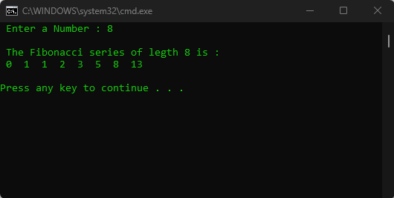

# Palindrome of a Number

## Code

using System;

using System.Collections.Generic;

using System.Linq;

using System.Text;

using System.Threading.Tasks;

class Question2

{

public static void Main()

{

int num, r, sum = 0, t;

Console.Write("Input a number: ");

num = Convert.ToInt32(Console.ReadLine());

for (t = num; num != 0; num = num / 10)

{

r = num % 10;

sum = sum * 10 + r;

}

if (t == sum)

Console.Write("The Number {0} is a palindrome number.\n", t);

else

Console.Write("The Number {0} is not a palindrome number.\n", t);

}

}

## Output

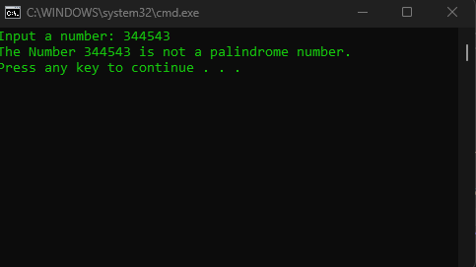

# Reverse Of String

## Code

using System;

using System.Collections.Generic;

using System.Linq;

using System.Text;

using System.Threading.Tasks;

class Question3

{

static string StrReverse(string str)

{

string reverse = "";

int strLen = 0;

strLen = str.Length - 1;

while (strLen >= 0)

{

reverse = reverse + str[strLen];

strLen--;

}

return reverse;

}

static void Main(string[] args)

{

string str = "";

string reverse = "";

Console.Write("Enter a string : \n");

str = Console.ReadLine();

reverse = StrReverse(str);

Console.WriteLine("\nReverse of string [{0}] is : \n {1}", str, reverse);

}

}

## Output

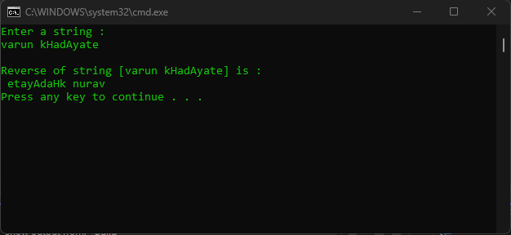

# Find Largest number in the list

## Code

using System;

using System.Collections.Generic;

using System.Linq;

using System.Text;

using System.Threading.Tasks;

class Question4

{

static void Main()

{

int i = 0;

int large = 0;

int[] arr = new int[5];

Console.WriteLine("Enter array elements : ");

for (i = 0; i < arr.Length; i++)

{

Console.Write("Element[" + (i + 1) + "]: ");

arr[i] = int.Parse(Console.ReadLine());

}

large = arr[0];

for (i = 1; i < arr.Length; i++)

{

if (large < arr[i])

large = arr[i];

}

Console.WriteLine("Largest element in array is : " + large);

}

}

## Output

