

A Project Report On

**School Management System**

**By**

Vardhaman Katariya

**Batch:** 2022-7400

**Center: Mumbai**

Under the Guidance of

**Chittaranjan Ghosh.**

**Technical Trainer**

**EduBridge**

(School of coding)

**Introduction:**

School Management System manages student, teacher and funds information in the school with regard to funds management. It improves existing system. It has the facility of maintaining the details of the student, teacher and funds thereby reducing the manual work. It will save time and energy which are spending in making reports and collecting data. School Management System can be accessed throughout the School with proper login provided.

**Modules:**

* Student Module
* Teacher Module
* Admin (School) Module

I have developed this Application in **Java and MySQL.**

The main objective of the School management system is to reduce manual work and time. It is difficult and time-consuming to collect fees information of each student and payment (Salary) information of each teacher. To avoid this problem, we have planned to develop a console-based School management system.

In Admin module, admin can add, update, delete, search,pay salary and receive fees. He can also view the total number of student and total number of teacher at present in the school.

* It manages the details of student records, teacher records, and funds management records.
* Saves the time of account and faculties.
* This system makes student information and teacher information more secure.

**Modules :**

* **Admin Module:** Admin can able to handle Student portal and Teacher portal. It maintain student and teacher funds of school.
* **Teacher Module:** Teacher can access this system by signing up. Teacher are able to view salary status, and teacher can change the password.
* **Student Module:** Student can access this system by signing up. Student are able to view fees status, and student can change the password.

**Software Requirements :**

**Front end:** Java.

**Back end**: MySQL workbench 8.0.25 CE.

**IDE:** Eclipse for Java EE Developers.

**Operating System:** Ubuntu / Linux.

# Data Dictionary:

* Database: SchoolManagement.
* Table 1: School.

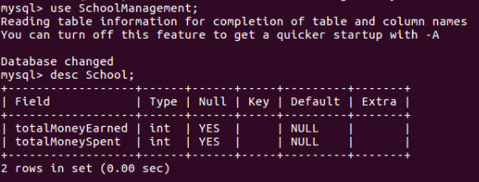

Table 2:Teacher.

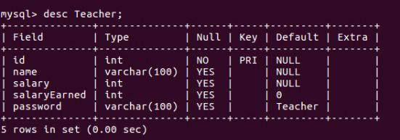

Table 3:Student.

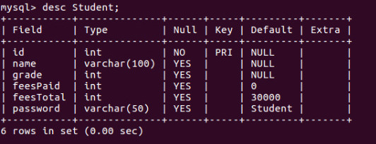

## Screenshot :

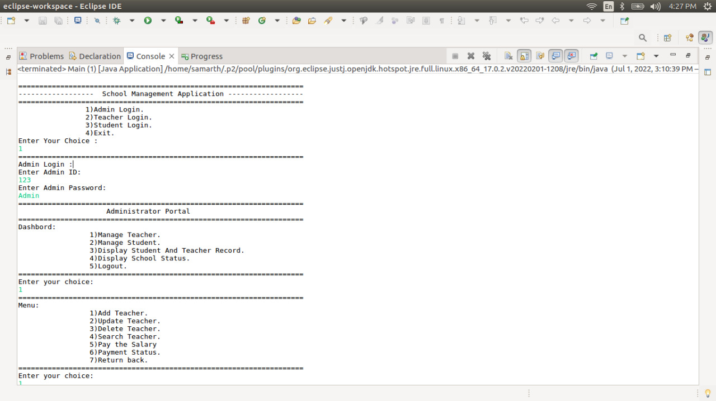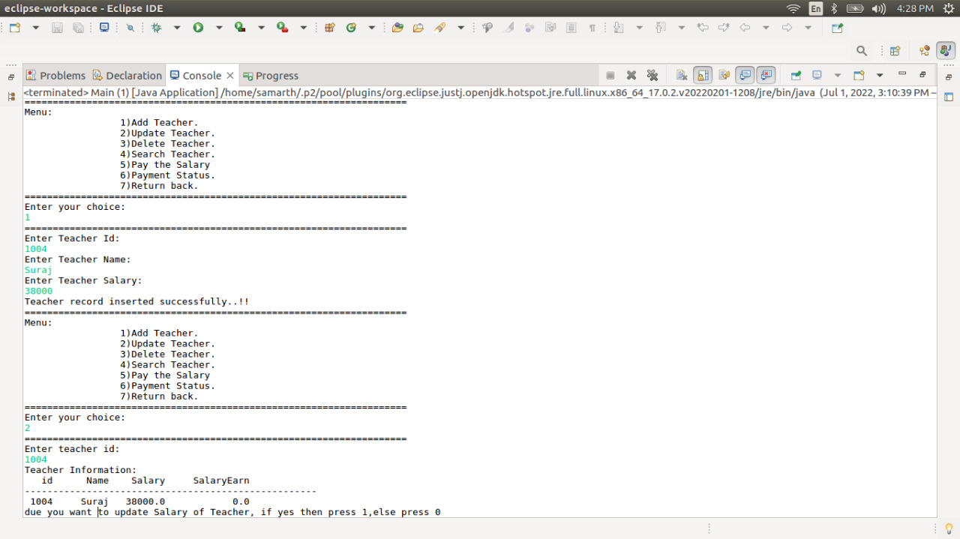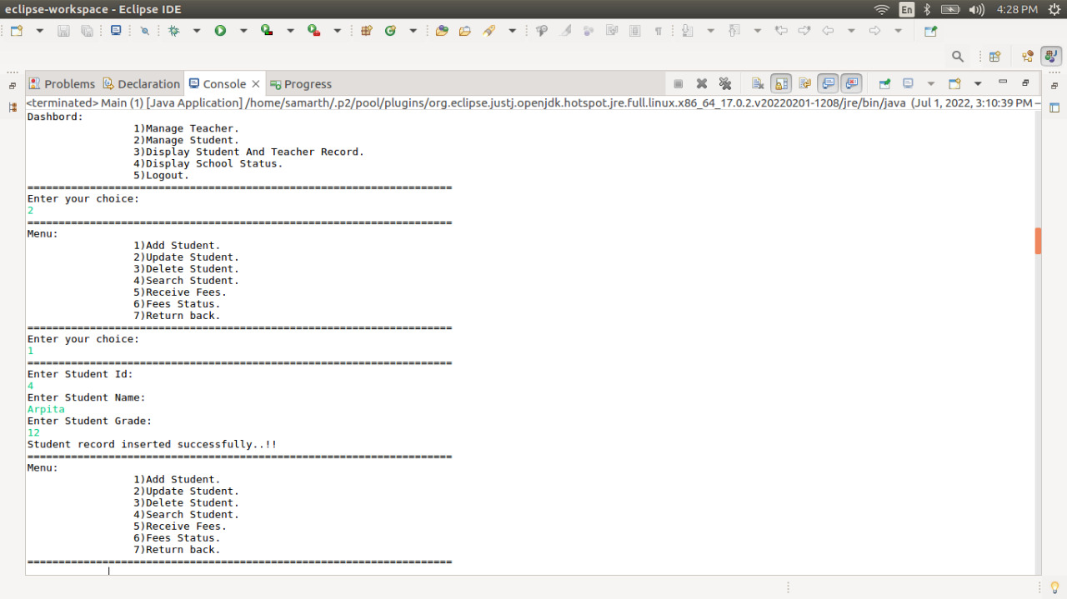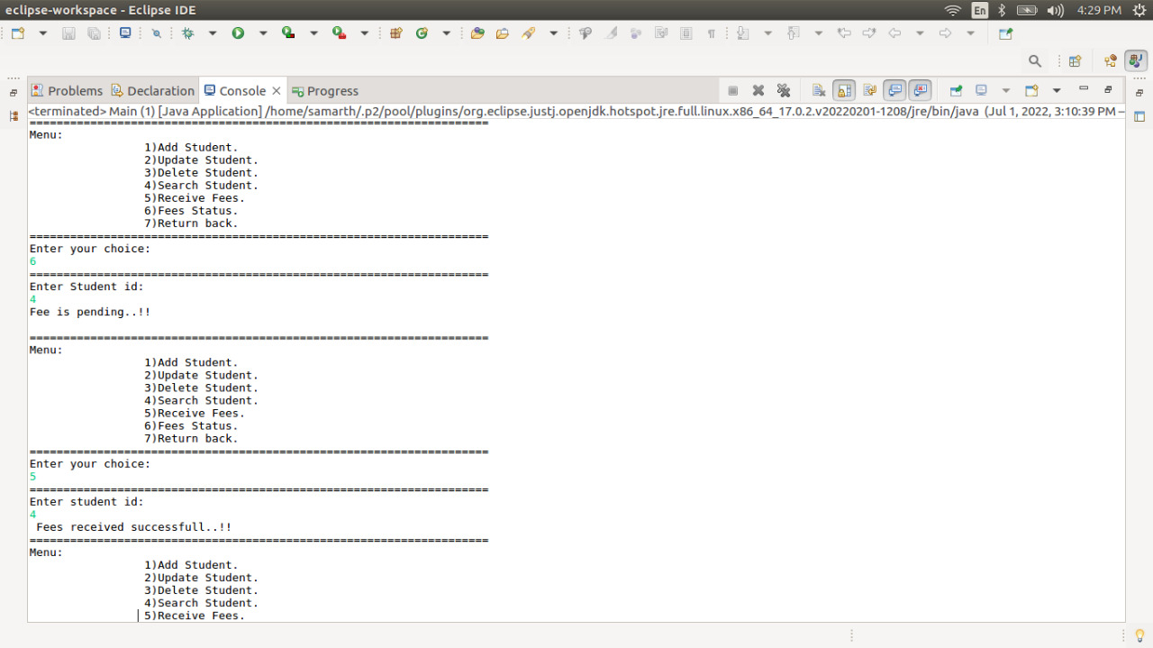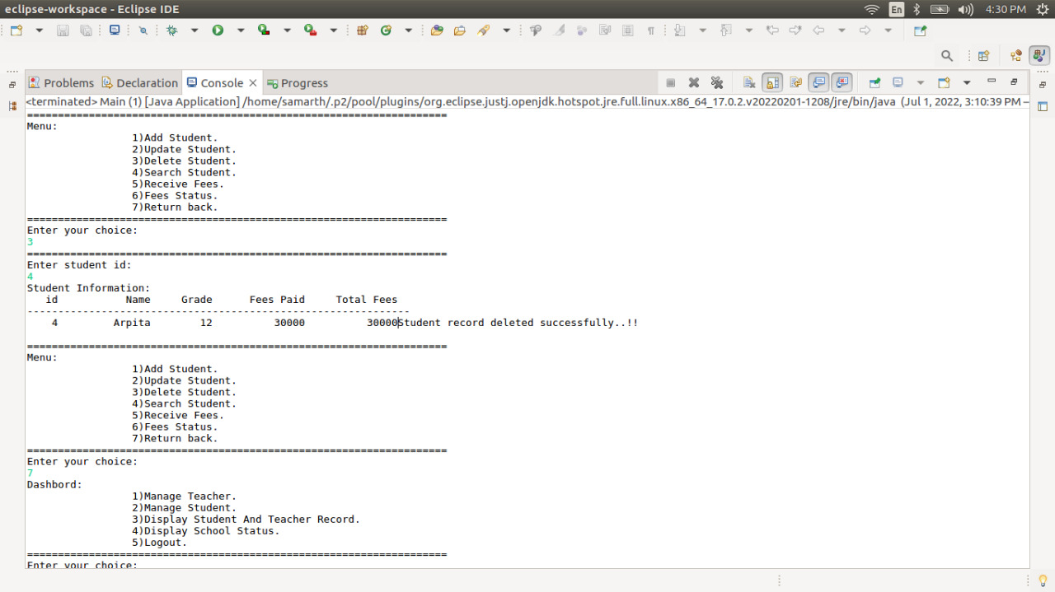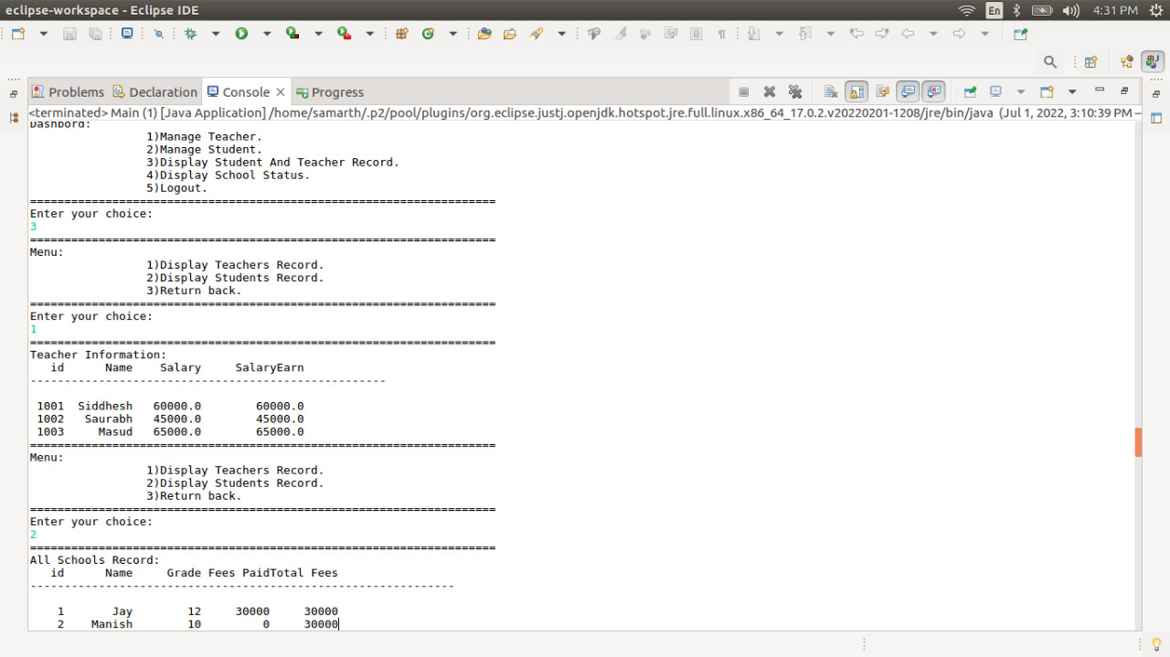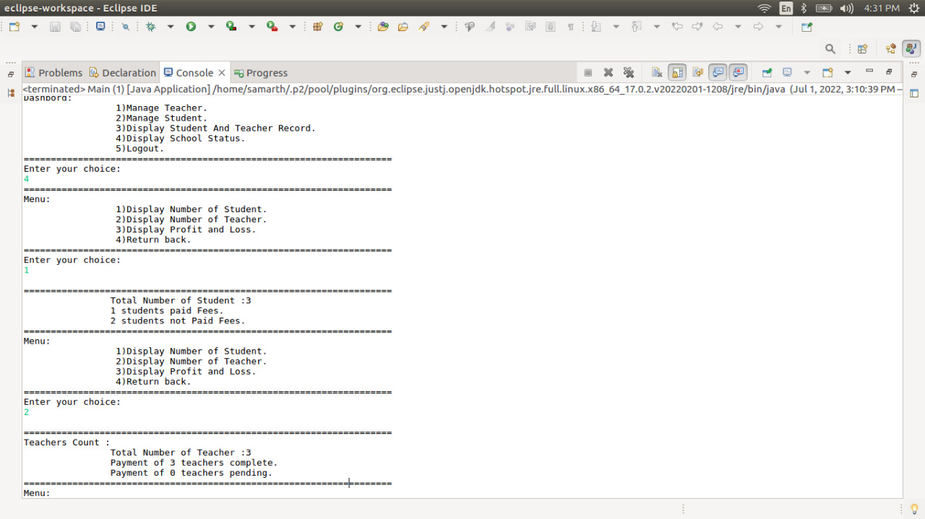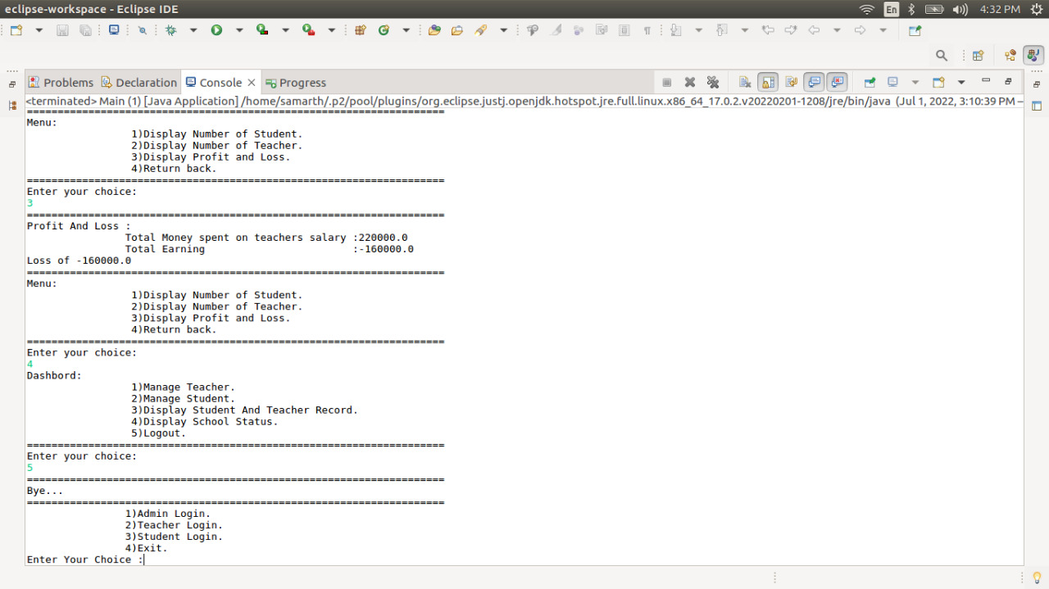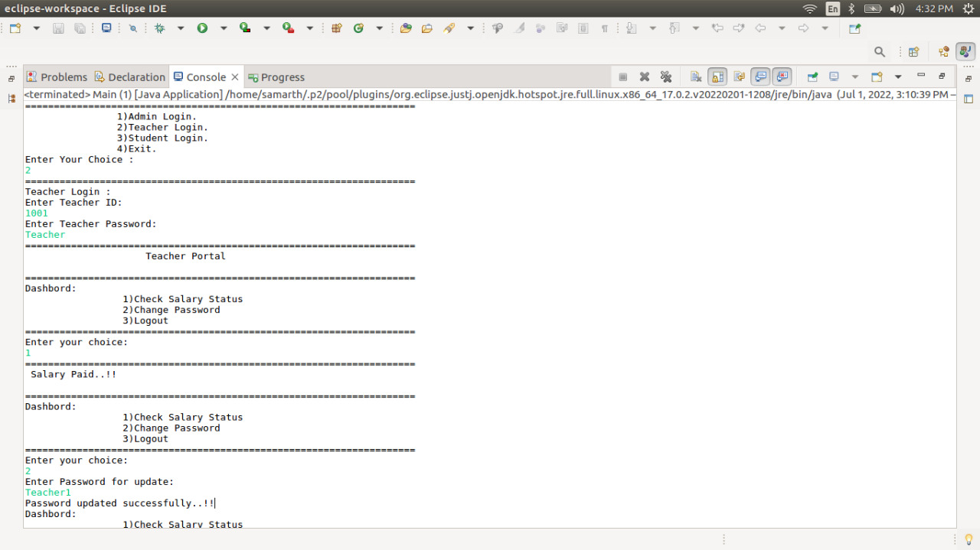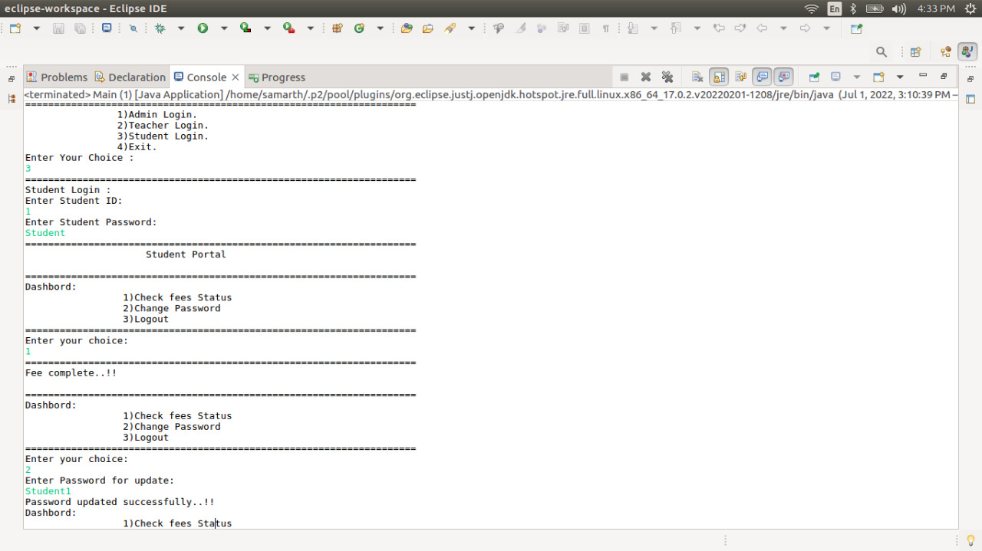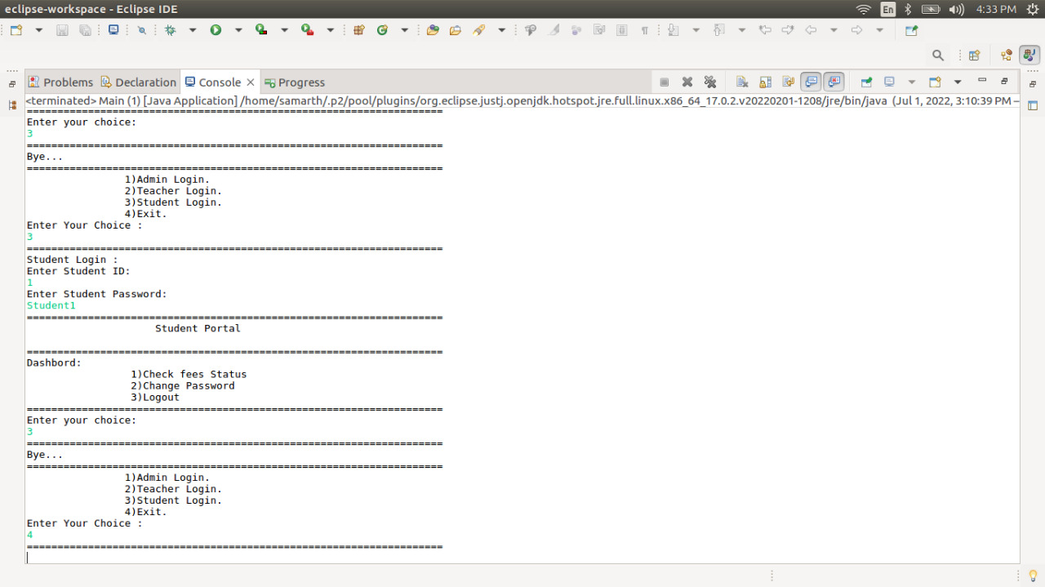

**Thank you…..**

**Suggestions?......**