SHIRIKA KOHLI
L E A T H E R D E S I G N S T U D E N T

A B O U T M E
A C A D E M I C S

Bachelors in Leather Design ₂₀₂₂ ₋ ₂₀₂₆

National Institute of Fashion and technology ,Chennai
SPECIALIZATION
Minor - Accessory design
Deepening specializtion - Handmade and Luxury Design
W O R K S H O P S
Aari Embroidery
Learned traditional hand-stitching techniques and their design applications.
Metal Etching
Learned metal etching as part of printmaking; applied etched designs through embossing techniques on leather surfaces.

12thGrade - CBSEBoard
2019 - 2020

Motivatedand outgoing individual with strong
Venkateshwar International School , New Delhi

V O L U N T E E R

interpersonal skills and a curious mindset. I
10thGrade - CBSEBoard

2017- 2018
NIFT Spectrum


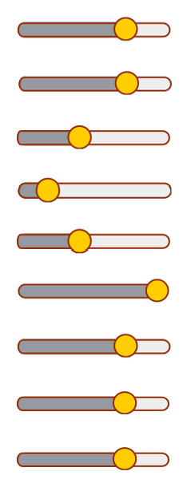
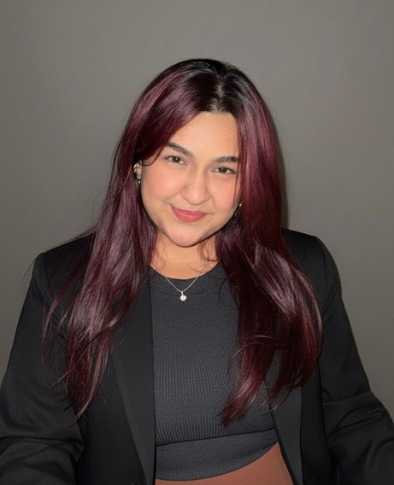
thrive in creative, collaborative environments and approach new experiences with enthusiasm and positivity.

+91 8800798782
shirika.kohli@nift.ac.in
S O F T W A R E S K I L L S
Clo 3D Rhino
Adobe Illustrator Adobe Indesign Adobe Photoshop MS Office Procreate
Autodesk Sketchbook Shoemaster
T E C H N I C A L S K I L L S
Pattern Making and construction Draping and styling
Material Handling Concept visualization Sketching and Rendering
Trend Research and marketing 3D modelling

L A N G U A G E

English - Proficient Hindi - Native tongue

I N T E R E S T S
Face painting Jacket painting Product designing
Resin art and products
Venkateshwar International School , New Delhi

E X P E R I E N C E



Summer Internship – Bharatiya International Limited, Chennai , Tamil Nadu ( June 2025 - August 2025 )
Worked on leather product development including design research, material selection, tech packs, and sampling support in a large-scale export manufacturing setup.
Craft Cluster Documentation –
Navakuruchi, Tamil Nadu ( June 2024 - 10days )
Visited and studied traditional bamboo craft as part of a DC Handicrafts & NIFT collaboration; documented local techniques, tools, and artisan practices for design research and cultural preservation.
Tannery training - Shalimar Tanning Company (June 2024 - 15days )
Undertook hands-on training to understand the complete leather processing cycle—from raw hide to finished leather
—gaining technical knowledge of tanning, finishing, and
quality control methods.
Freelance Artist & Creative Professional
Served as a judge for a face painting competition at IIT Madras
Painted custom denim jackets on commission
Created digital artwork for Mandonna, a research organization
Interdepartment Fest Indian International Leather Fair - Chennai Trade Centre

I N D U S T R Y V I S I T S

Potissimus Arrow Shoes - Vellore ( April 2025 ) Calsea Footwear - Vellore ( April 2025 )
CDS Soles - Vaniyambadi ( April 2025 )
Orion Commerx - Gurgaon ( feburary 2025 ) KH Exports - Ranipet ( April 2024 )
Sanghvi Sole Accessroies - Vellore ( April 2024 ) Prara Leathers - Ranipet ( October 2023 )

R E F E R E N C E S
SHANKAR NARAYANAN T R
Associate Professor NIFT Chennai
Email ID - sankara.tr@nift.ac.in Phone - 9044799465
TP BALACHANDAR
Assistant Professor & CC NIFT Chennai
Email - tp.balachandar@nift.ac.in Phone - 9677671265

