# Lung-Cancer-Detection-Using-Python

## Dataset

The Cancer Imaging Archive (TCIA)

http://www.cancerimagingarchive.net/

## Code files

Code have been written in Modular fashion

PredictCancer.py : Final program for testing a image

NeuralNetwork.py : MLP using SKlearn to learn the features and saving the Weights using pickle

LungCancerTrain.py : All Image processing techniques and code for training the model are written here

dataset_create.py : For making the folders of both positive and negative cases and naming the images in required format

Test Case images of both categories and added in the repository along with its terminal output for reference

## Dependencies

Python3 , OpenCV - cv2 , pickle , datafile libraries

## Output

Positive case

[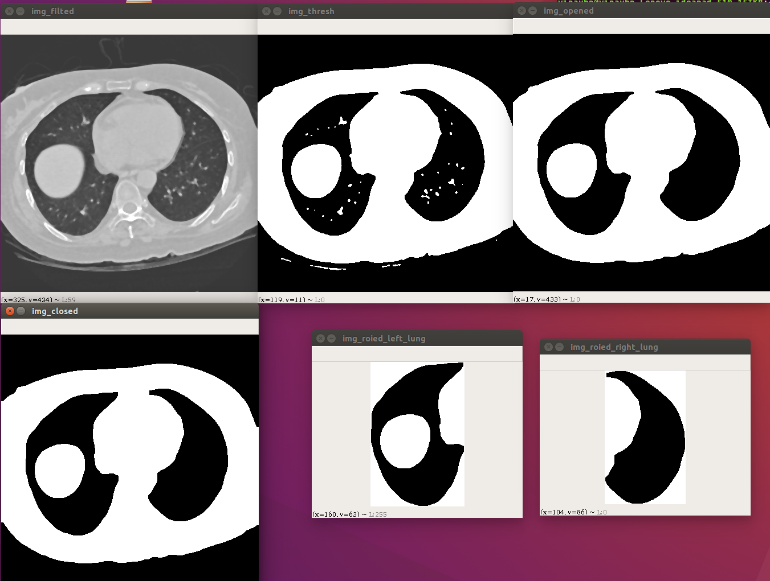](https://user-images.githubusercontent.com/33830482/42348966-c8301910-80c8-11e8-9427-34fba3c0b84c.png)

Negative case

[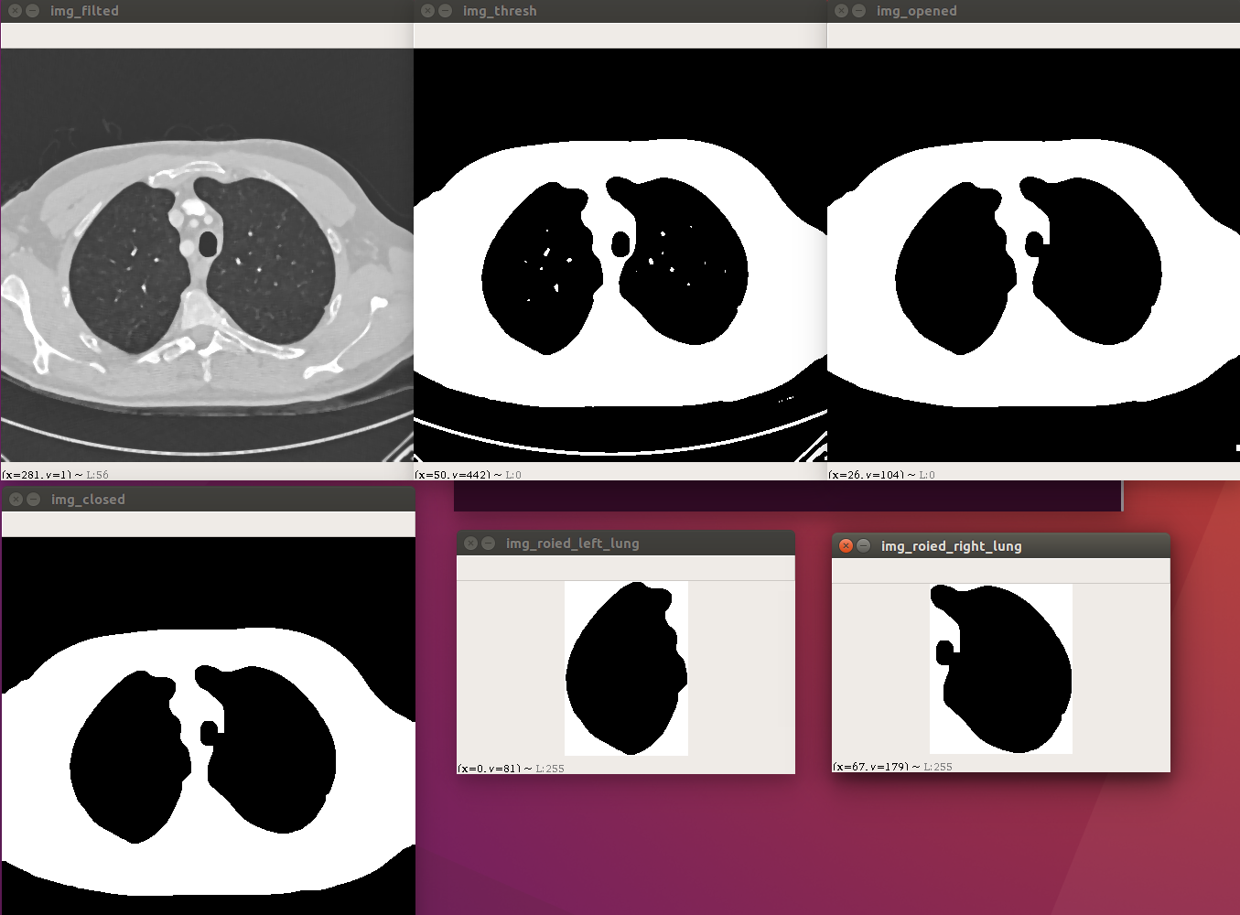](https://user-images.githubusercontent.com/33830482/42348968-c95ed394-80c8-11e8-8c2e-5f25a61f3ccd.png)

This work was done in partnership with my friend Tarun Bhargav Sriram as a project for Digital Image Processing elective.

Any queries about the project, contact at vinaybn8997@gmail.com