To send a bulk email:
(Important: If you want to include an attachment go to page 2 for instructions before you start setting up your email.)
When the page opens scroll to the bottom of the page to see the bulk email interface.
- Type your email address in the "From" field
- Type VBSA Homes in "Name" field.
- Type your email address in the "Reply to" field
- Place the curser in the "To" field. From the "Recordset fields" select "Email". Click the button and it will add this field into the "To" field.
- In the message area type a greeting "Hi" followed by a space. From the "recordset fields" select "Firstname" , click the button and it will add a field that will personalise each email by inserting the recipients first name from the database
- Tick the box for "Plain Text" alongside "Send as"
- Type in the subject and your message in the appropriate fields and click "Send".
This is how your email should look before you send it:
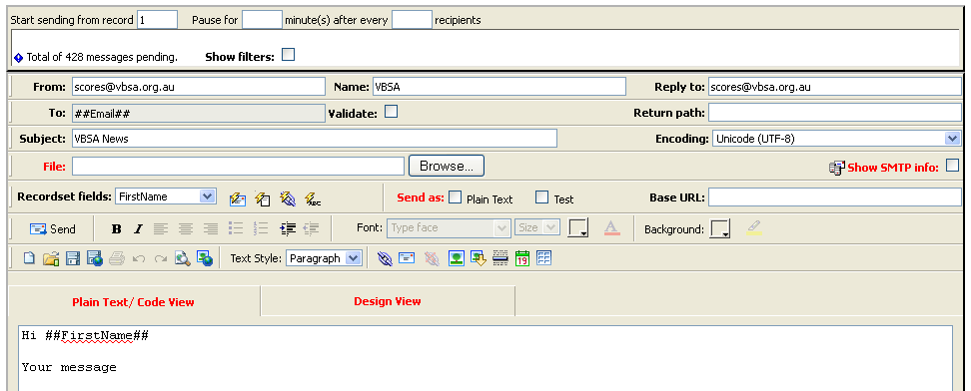

Adding an attachment (1 attachment only per email)
Upload your attachment first, just click the link “Please upload it now” and it will take you to an upload page.
- Click the "Browse" button and select the attachment from your filing system.
- Click the upload your file button and your attachment will be uploaded to the site
- IMPORTANT - Selected file must be a pdf file and less than 250kb or file will not upload.
- On completion you will be returned to the bulk email page
Now you have uploaded your attachment
- Click the “Browse” button alongside the “File” text field. 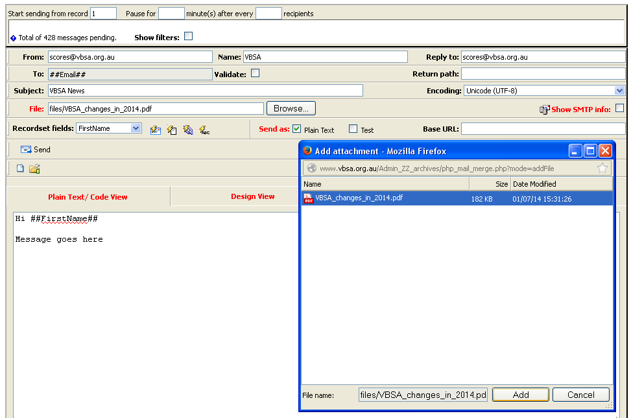
- This will bring up a popup, select the file you uploaded
- Click the “Add” button in the popup
- You will see your file has been inserted into the “File” field
- Fill in the rest of the email fields as per page 1 and click “Send”. Your email with attachment will be sent to everyone on the list that has an email address.

