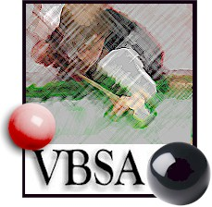
THE VICTORIAN BILLIARDS & SNOOKER ASSOCIATION

PROUDLY PRESENT

2013 VICTORIAN WOMENS STATE SNOOKER CHAMPIONSHIP

ELIMINATIONS SUNDAY 30TH JUNE
VENUE – BRUNSWICK CLUB

FINAL - THURSDAY 4TH JULY
AT THE YARRAVILLE CLUB
(with the mens final)

ENTRIES CLOSE 21ST JUNE

- Only Current Financial Members of VB&SA and Affiliated Associations are eligible to enter this tournament
- Losers to referee or pay $30
- Strict dress rules apply, plain long sleeve shirt, trousers, black shoes, waistcoat and bow tie
- NO jeans, runners tracksuits permitted
- Smoking NOT permitted in billiard room during tournament

ENTRY FEE - $45.00
B,C or D Grade Players $35.00
Pensioners $25
Juniors $15
Juniors – Under 21 at Jan 31st 2013

2013 Victorian Snooker Championship entry. Enter by paypal at www.vbsa.org.au

Please ensure all cheques made payable to Victorian Billiards & Snooker Association
Name
Address:
Postcode:
Telephone: (H) (W) (M)
If Under 18 Parent/Guardian:
Signature Name:
By Post: Completed Tournament Entry with Appropriate payment by cheque or money
order (no cash) made out to the VB&SA to :
George Hoy, VBSA Treasurer, Unit 36 Excelsior Apartments, 93 -103 High St Preston, 3072

