Depression Detection using EEG and Machine Learning

This project aims to detect depression using EEG signals and machine learning techniques.  
We have used real EEG data in EDF format, extracted frequency domain features (delta, theta, alpha, beta, gamma),  
and trained a classification model to distinguish between depressed and non-depressed subjects.  
  
The project is useful for neurologists, researchers, and developers interested in building real-world health AI tools.

# Project Pipeline

1. Load EEG signal (.edf files)  
2. Visualize raw signal  
3. Preprocess (bandpass filter)  
4. Extract features (power spectral density)  
5. Train classifier (optional - demo mode uses extracted features)  
6. Predict depression status

# Demo Information

You can upload an .edf file to the Streamlit web interface. The model will process it and show predicted features and the depression likelihood.  
  
GitHub: [Your GitHub URL here]  
Streamlit: [Your Streamlit demo link here]

# Sample Output Visualization

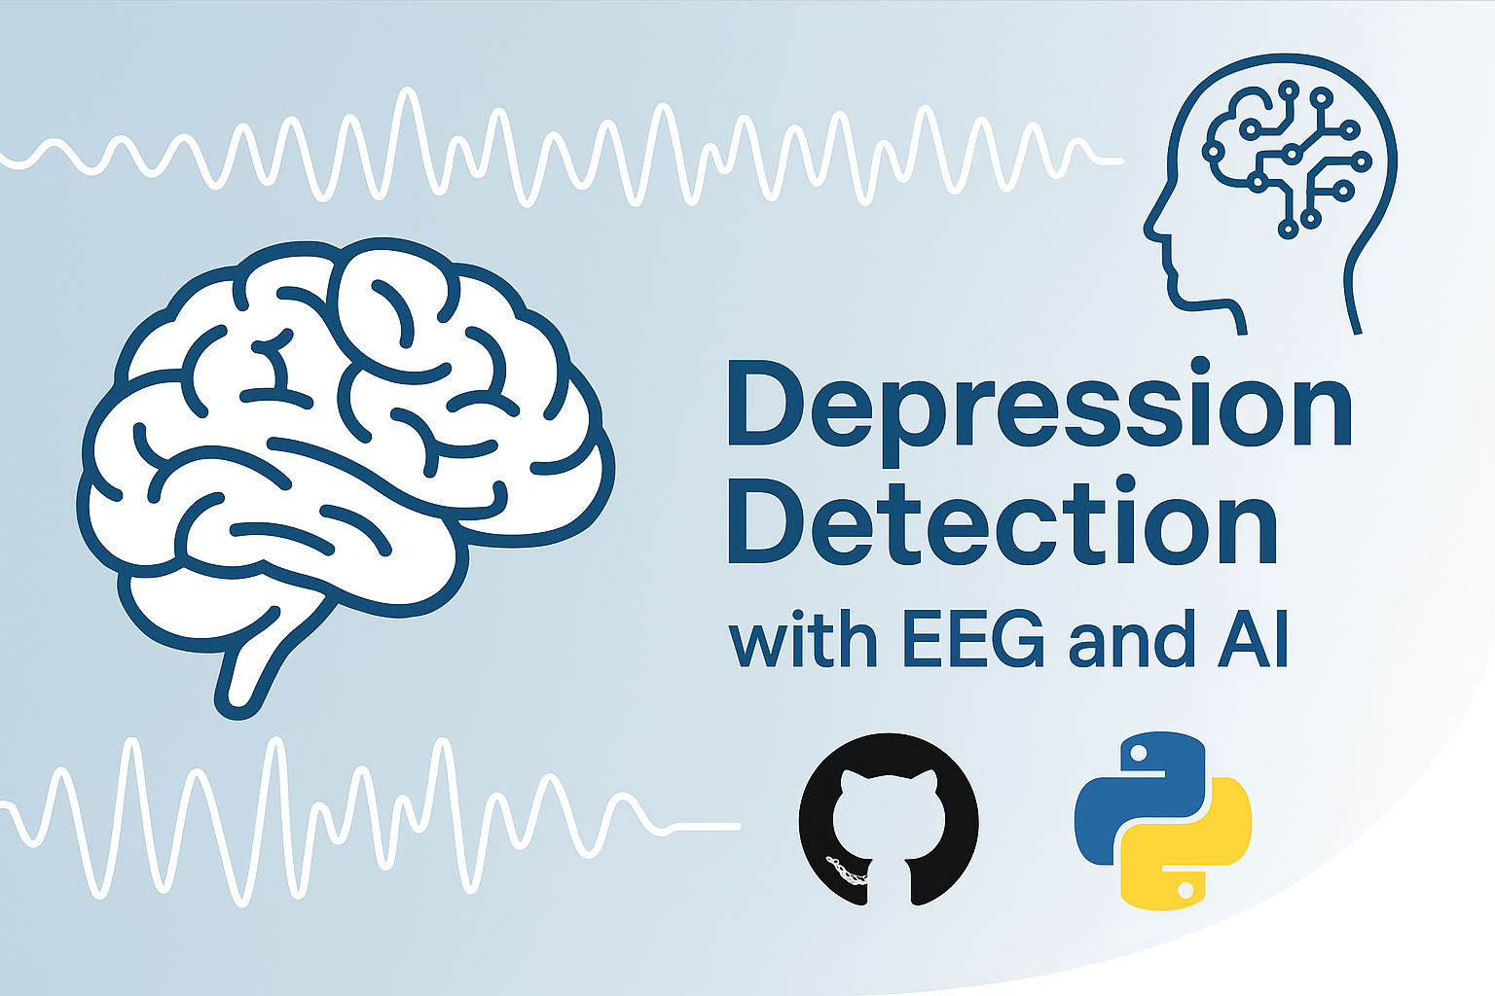

Figure: Visual representation of EEG-based depression detection.