*Name=Aditya Anal*

**HIVE TUTORIAL:**

For Internal Table Using Local File System:

That means data file present in local file system

1.Create a databases:

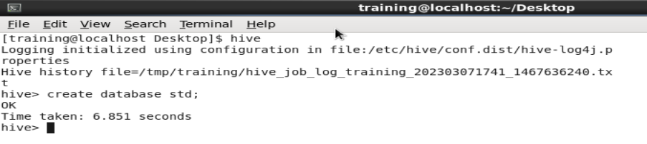

1.2Create a Internal Table:

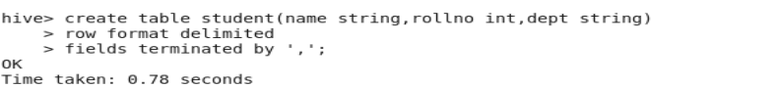

1.3Show The Create Table:

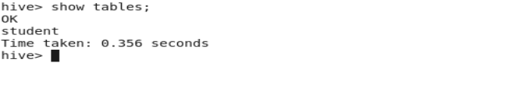

2. Load the data into internal table:

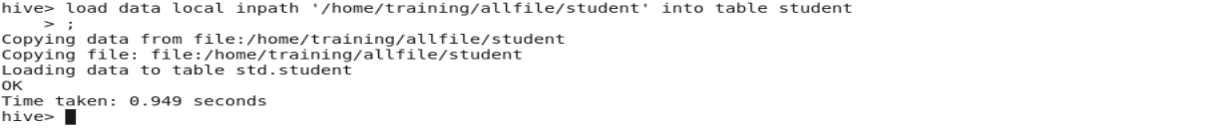

2.1 to show table in hadoop

Database name is std.db.

Table name is student.

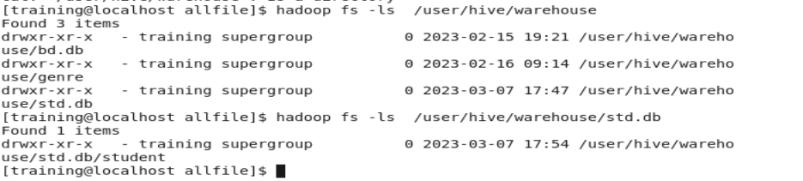

3. Display the content of the table:

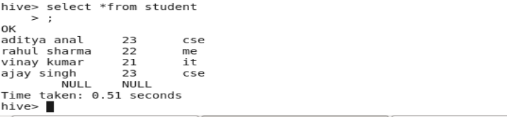

Attribute information:

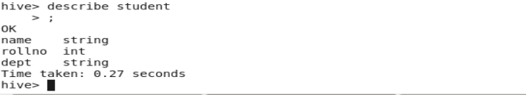

**CASE:**Add Another data in student table

This data is add in student table

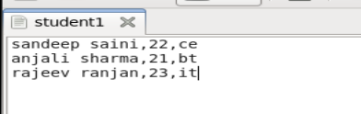

1.Load the data into internal table:

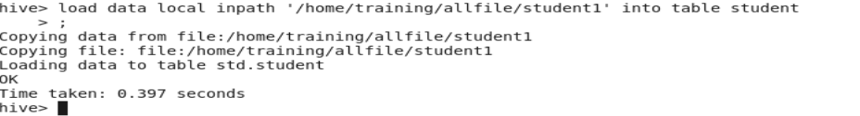

2. Display the Add content of the student table:

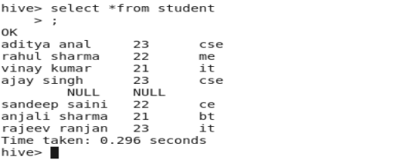

**Case:** to add different type of fields in student table :

To take a null value if fields type is not match

This type of data is add to student table

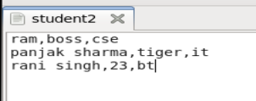

1. Load the data into internal table:

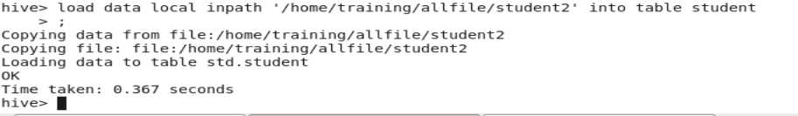

1. Display the content of the table:

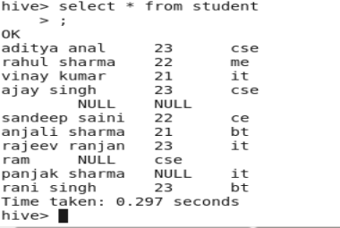

All datafile show in hdfs in hive path

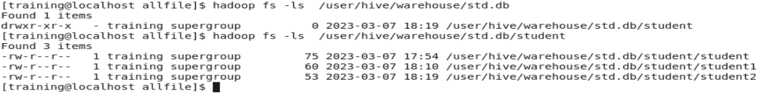

For Internal Table Using HDFS File System:

That means data file present in HDFS file system

1.Create a file in hdfs:

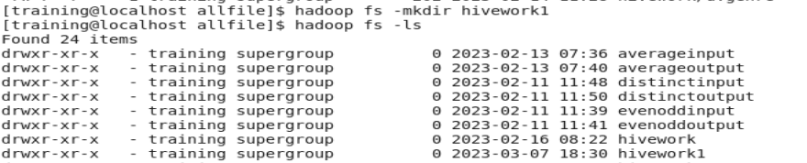

2.put data file into hdfs ( file name is hivework1):

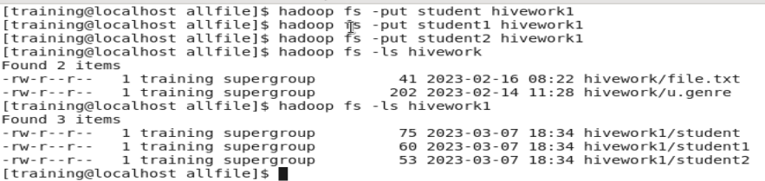

3.create table:

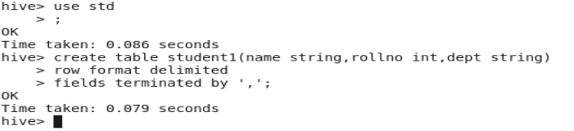

4.Load the data into internal table:

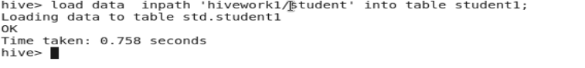



 4.Display the content of the table

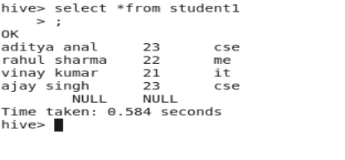

External Table :

* External Table is loosely coupled in nature. Data will be available in HDFS.The table is going to create on HDFS data.
* In other way, we can say like its creating schema on data.
* At the time of dropping the table it drops only schema, the data will be still available in HDFS as before.
* External tables provide an option to create multiple schemas for the data stored in HDFS instead of deleting the data every time whenever schema updates

1.create a external table:

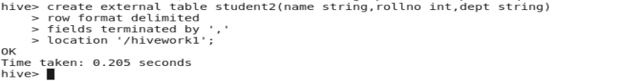

2.Display the content of the table:

