Git Environment
To create and activate a new virtual environment in Python, use the following commands in your terminal:
1. Create a new environment:
Replace myenv with your desired environment name.
python -m venv myenv e.g. python -m venv vaibhav
Create venv in specified location:
python -m venv D:\PythonEnvs\vaibhav_exact
This creates: D:\PythonEnvs\vaibhav_exact with full venv structure inside.
2. Activate the environment (cmd set in VScode):
vaibhav\Scripts\activate.bat
or D:\Github\vaibhav\Scripts\activate
3. Deactivate the environment (when done):
deactivate
To activate an existing environment from any folder:
Just use the activate script from the environment’s folder. For example, if your environment is in D:\envs\projectenv:
D:\envs\projectenv\Scripts\activate
After activation, any Python commands will use the libraries from that environment.
e.g. D:\Github\vaibhav\Scripts\activate
- To (change directory) cd to the same as env location (if already not same as env): cd D:\Github\vaibhav
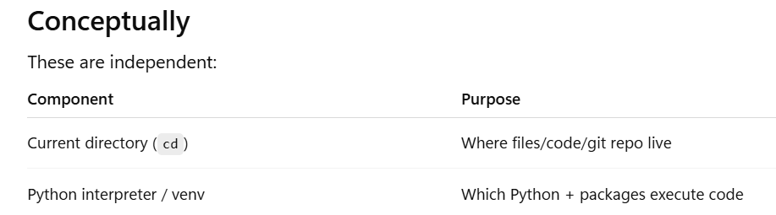
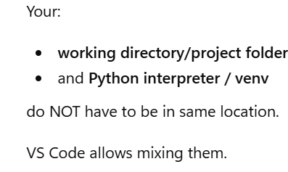
- You can check existing directory path using: cd
- Check your current directory: cd
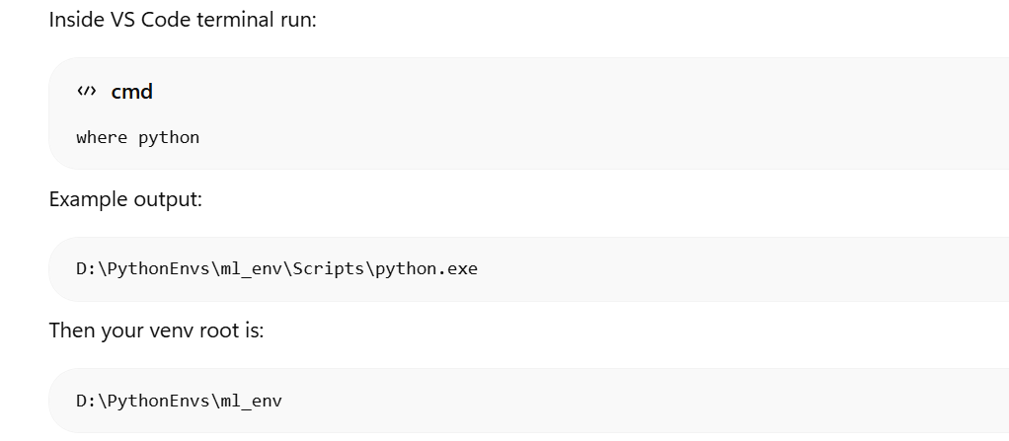
- Check your venv:
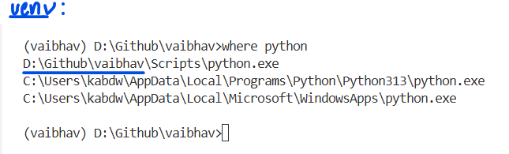
Example:

- To install packages in the environment:
1. With the "vaibhav" environment activated, use pip to install the required packages:
pip install pandas numpy matplotlib
2. To confirm if they are installed:
pip list
Set up VS Code to use the Environment:
- Ensure VS Code is using the "vaibhav" environment’s Python interpreter:
  - Press Ctrl + Shift + P to open the Command Palette.
  - Type and select Python: Select Interpreter.
  - Choose the interpreter from the "vaibhav" environment (it will typically be listed as something like Python <version> ('vaibhav') or the path to the environment’s Python executable, e.g., ./vaibhav/bin/python or .\vaibhav\Scripts\python.exe)
If you activated your venv in the terminal but did not select it as the Python interpreter in VS Code, here’s what can happen:
- VS Code might use a different Python interpreter (not your venv) when running or debugging code.
- Installed packages in your venv may not be found by VS Code, leading to import errors.
- Linting, IntelliSense, and code navigation may not reflect your venv’s packages.
- Terminal commands will use the venv, but running scripts with the VS Code "Run" button may not.
Summary:
Always select your venv as the Python interpreter in VS Code to ensure your code runs with the correct environment and dependencies.
Clear the command prompt:
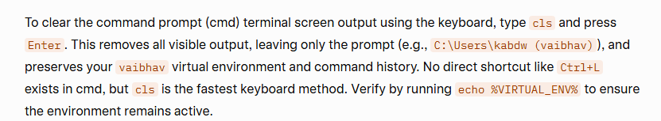

VScode
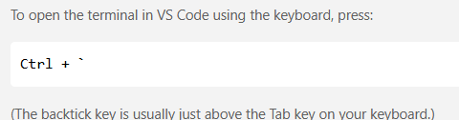

Commit to GitHub Repo
Assumptions: Repo already there in GitHub website, Git installed in local.
In VScode:
- Set the details:
git config --global user.name "vkabdwal"
git config --global user.email "vaibhav.kabdwal@gmail.com"
You can check if Git has your username and email configured by running these commands in your terminal:
git config --global user.name
git config --global user.email
This will display the name and email Git will use for your commits.
If you want to check for the current repository only (not global), omit --global:
git config user.name
git config user.email
If the values are shown correctly, Git has taken your username and email properly.
- Check your remotes:
git remote -v
If nothing is listed, you need to add your GitHub remote.
Add your GitHub remote:
git remote add origin https://github.com/yourusername/yourrepo.git
Go to your repository on GitHub and copy the URL (it looks like https://github.com/ yourusername/ your_repo.git).
- In your terminal, run: (Replace with your actual repo URL.):
D:\Github>git remote add origin https://github.com/vkabdwal/vscode_vk.git
Git does not push individual files; it pushes commits (which can include changes to one or more files) to a branch.
1. Stage the specific file: git add path/to/yourfile.py
For me: D:\Github>git add interview_questions.py
Staging is necessary every time you make a change that you want to include in your next commit.
- git add <file> (or git add .) stages your changes.
- Only staged changes are included in the next git commit.
- If you skip staging, your changes will not be committed.
2. Commit your changes: git commit -m "Describe your changes"
For me: D:\Github>git commit -m "First commit from VScode"
After you stage and commit, your changes are only saved locally on your computer.
If you want your changes to appear on GitHub (or any remote repository), you must push them:
3. Push to a specific branch: git push origin branch_name
For example, to push to revision_questions: git push origin revision_questions
Might see an authentication pop-up the first time.
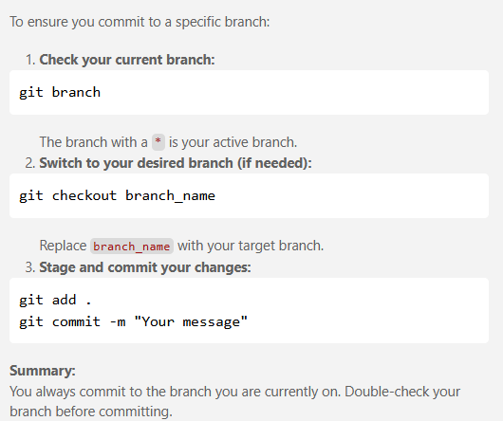
Important: You cannot directly edit the online GitHub repository (the "remote repo"). Instead, you work with a local copy of the repository on your laptop, make changes locally, and then push those changes to the desired branch on GitHub. Git is designed this way to ensure version control and collaboration safety.

Pulling code from a Repo
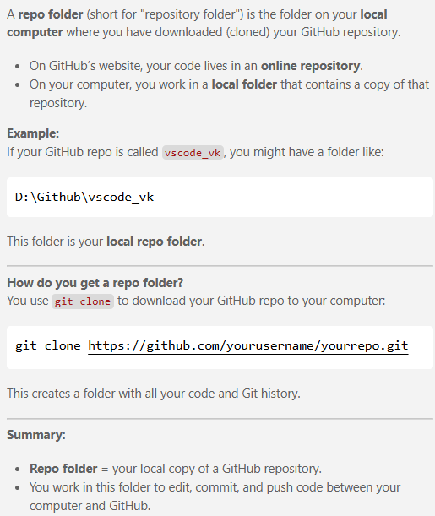


When you use git clone, you can specify the folder location by adding a path at the end of the command.
Syntax:
git clone <repo-url> <folder-path>
Example:
To clone into D:\Github\myproject:
git clone https://github.com/yourusername/yourrepo.git D:\Github\myproject
e.g. git clone https://github.com/vkabdwal/vscode_vk.git D:\Github\myproject_local
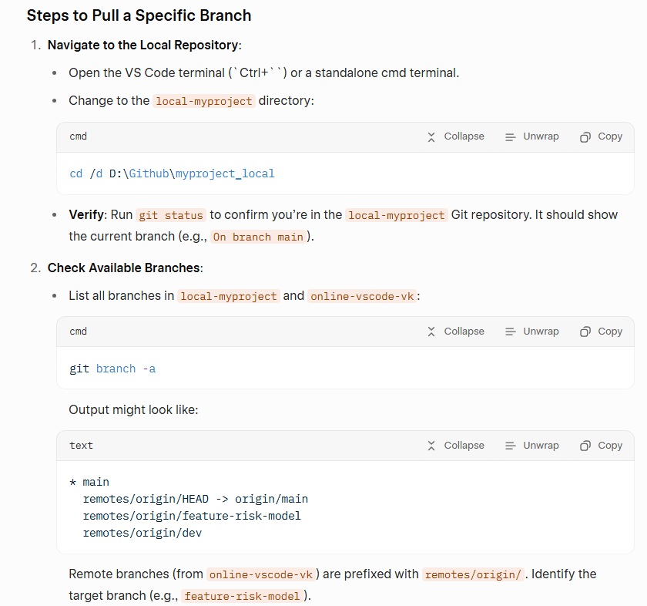
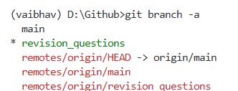

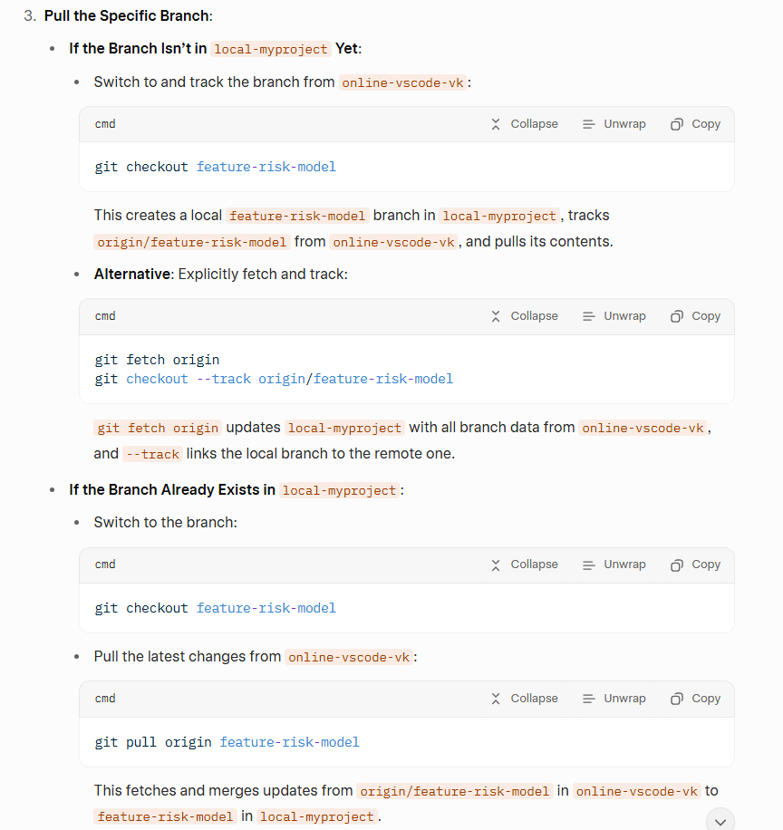

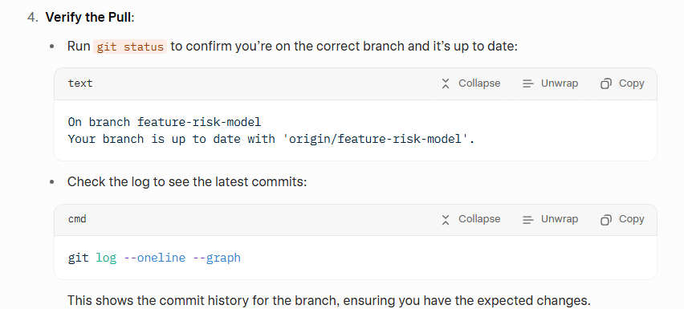

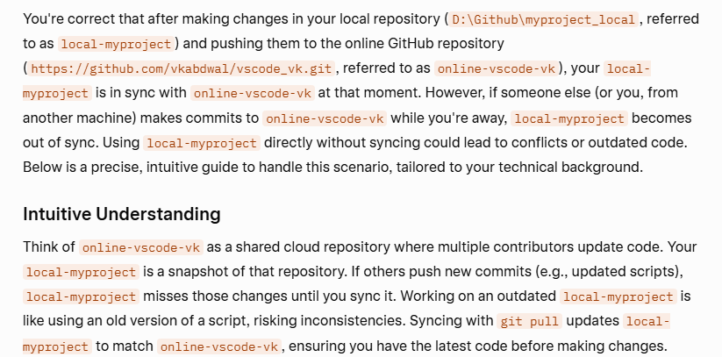
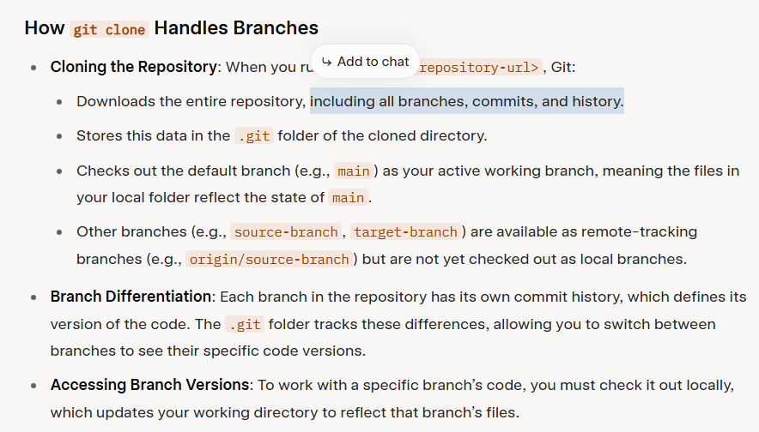
git pull origin branch_name
Fetches the latest changes from the remote repository (origin) for the specified branch (branch_name) and merges them into your current local branch.
In short:
It updates your local branch with any new commits from the same branch on GitHub. Cloning copies the entire repository, including all branches, to your local machine.
- You want to merge changes from the revision_questions branch into the main branch in your online GitHub repository (https://github.com/vkabdwal/vscode_vk.git, referred to as online-vscode-vk), using your local repository (D:\Github\myproject_local, referred to as local-myproject). This can be done by creating a pull request (PR) on GitHub to merge revision_questions into main, or by performing the merge locally and pushing the updated main branch.
Intuitive Understanding
Think of revision_questions as a working draft of your project (e.g., updated readme.docx or other files) and main as the stable version. Merging revision_questions into main is like incorporating your draft changes into the final document. A pull request on GitHub is the preferred method for reviewing and merging changes, especially in collaborative projects, as it allows you to verify diffs and handle conflicts. Alternatively, merging locally gives you more control but requires pushing the updated main branch.
- Deleting a branch
