The First Year Plan 1953-1957

**Key Issues:**

The Reasons for the Five Year Plans

The Success or otherwise of the first Five Year Plan

Did Economic Planning achieve rapid economic growth

What lessons can be drawn from the first Five Year Plan

**Understanding of:**

* Industry and the first 5 year plan
* Mao’s economic aims for China
* Social reforms and ideology
* Role of the USSR
* Political control of CCP
* Plans for the second Five Year Plan

A five year plan is a detailed plan as to how to manage the economy over that period. They exist today.

The original plan was taken directly from the Soviet model, where Five Year Plans had been in action since 1928. In fact, Russian advisers poured into China at this time. Their advice was based on a command-style economic model characterized by state ownership and centralized economic planning. Heavy industry (iron, steel, construction) was the focus in the early years, paid for by peasants, hence the need to collectivise farming.

China already had a history of state dominated initiatives & enterprises. With this background and the strong influence of the USSR at this time, it is logical that China would be happy to follow this model.

Importantly, in the 1950’s, when China first adopted the model, it was still a model that was working in the USSR and centralisation was part of the system that had helped defeat the Nazis and modernise Russia. It became clear in Russia that it has many deficiencies only in the 1960s and onwards.

USSR-China relations:

What was the Treaty of Friendship and Mutual Alliance with USSR of early 1950?

When was the Korean War? Oct 1950 - July 1953

Why did the USSR help China with their Central Planning?

Economic success outside the Five Year Plans: Inflation had been brought under control from 1949-51 by:

* Slashing public expenditure
* Raising taxes on urban dwellers
* Replacing the Chinese dollar with the renminbi or yuan (人民币 OR 元）

**The First Five Year Plan (中国五年计划） 1953-57**

The goal of China’s First Five-Year Plan (1953-57) was to strive for a high rate of economic growth and emphasize development in heavy industry (mining, iron manufacturing, and steel manufacturing) and technology (like machine construction).

Focus on Industrialisation:

This had started under the GMD with the National Resources Committee which had managed industrial policy. Many NRC managers and 200,000 of its workforce stayed in China after 1949 so there was a base of skill.

Also, urban migration had started early under the CCP with the urban population being 57 million in 1949 and 100 million in 1957.

Agriculture was not a focus, in fact, agricultural policy was dealt with separately and was aimed at being a means to supply/support/pay for industrialisation.

Areas targeted for increased production were:

Coal

Steel   
Petrochems

Plus the development of the auto industry

Plus some major civil engineering works eg road and rail bridge across the Yangzi at Nanjing.

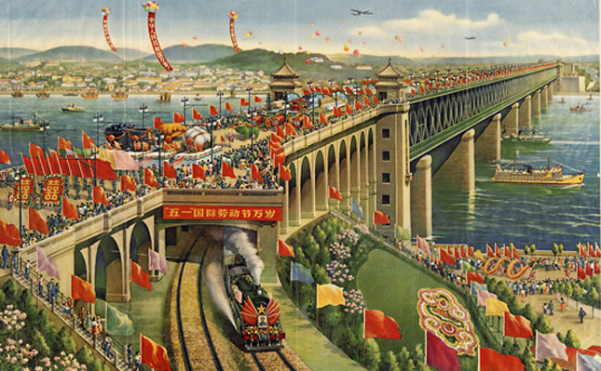

In order for the First Five-Year Plan to be successful, the Chinese government needed to nationalize industry in order to concentrate capital into heavy industry projects. Some projects were co-funded with Russia, although the funding needed to be repaid.

Private business owners were pressured to sell their companies or convert them into joint public-private companies. By 1956, there were no privately owned companies in China.

**Why the shift of focus from agriculture to industrialisation:**

Mao’s wanted to transform China into a modern industrialised nation.

In 1953 the *People’s Daily* quoted the Chairman, telling its readers that “only with industrialisation of the state may we guarantee our economic independence and non-reliance on imperialism”.

**Success?**

In terms of expenditure, the plan was successful in that spending as a % of national budget increased notably in areas economic and industrial importance and decreased in defence and administration, indicating a slimming of the bloated and corrupt administration of the GMD era.

Source: Lynch p67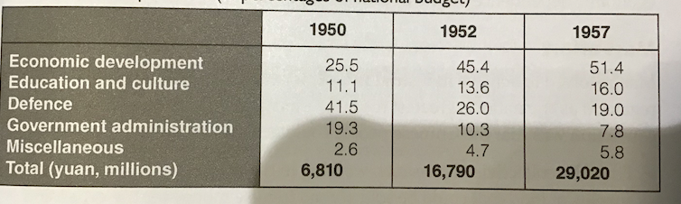

Growth in workers income, from 1953 to 1957, was 9% per annum and industrial production grew by 19% YoY.

Production in these major target areas increased:

Eg 16.56 million tonnes of steel was produced between 1953-57 which was double China’s combined steel production between 1900 and 1948.

Eg Coal production increased by 98%

Urban populations benefitted. There was major growth. Workplaces were organised on socialist principles; urban and industrial workers subsidised housing, medical care and educational facilities. Life expectancy rose from 36 to 57 years, city housing standards improved and urban incomes increased by 40 per cent. Mao saw the political benefits of such improvements, saying in 1957 that “If China becomes prosperous, just like the standard of living in the Western world then [people] will not want revolution”.

**(Negative) Effects:**

The state continued to expand its influence over citizens. Life for urban Chinese was tightly regimented by way of *danwei* or work units. The *danwei* provided the basic structure for labour and controlled many aspects of everyday life, including accommodation, education and social services. People even had to consult their *danwei* in matters regarding to marriage, having children or travel.

Centralised state control increased, private ownership became virtually impossible. By 1956, approximately two-thirds of industrial enterprises were state-owned; the remainder were jointly owned.

Rigid central planning and national demands often resulted in local needs being neglected, especially in the countryside. While 84 per cent of the population lived in rural areas, 88 per cent of government investment was pumped into heavy industry in towns and cities. The state monopoly on grain and the impact of collectivisation also caused disruption and dissatisfaction in rural areas in the mid-1950s.

**Plans for the Second Five Year Plan 1958-1962 or The Great Leap Forward**

Mao wanted to turn the PRC into a modern industrialised nation in the shortest possible. He believed that the dedicated efforts of the Chinese people, guided by the Communist government, could go straight from rural economy to urban industrial economy in one ‘leap’

He also wanted to start to dissolve the relationship with Russia, to become truly independent. The reliance on Russian funding was irksome and Mao did not believe China had to slavishly follow the Russian model.

Mao talked of quantities of steel and iron being important but the people’s hearts and minds being more important.

He believed China’s massive population could achieve ‘lift off’ industrial growth. They would produce excess food to fund the expansion and then sell externally; industrial growth would come at the ‘hands’ of the people.

Manual labour became key although the scale of projects undertaken were enormous - Mao liked the grand projects! Propaganda talked of armies of ‘blue ants’, mechanical diggers were shunned for people power.

However, the second five year plan was not based on sound economic analysis, more grandiose aims with little planning.