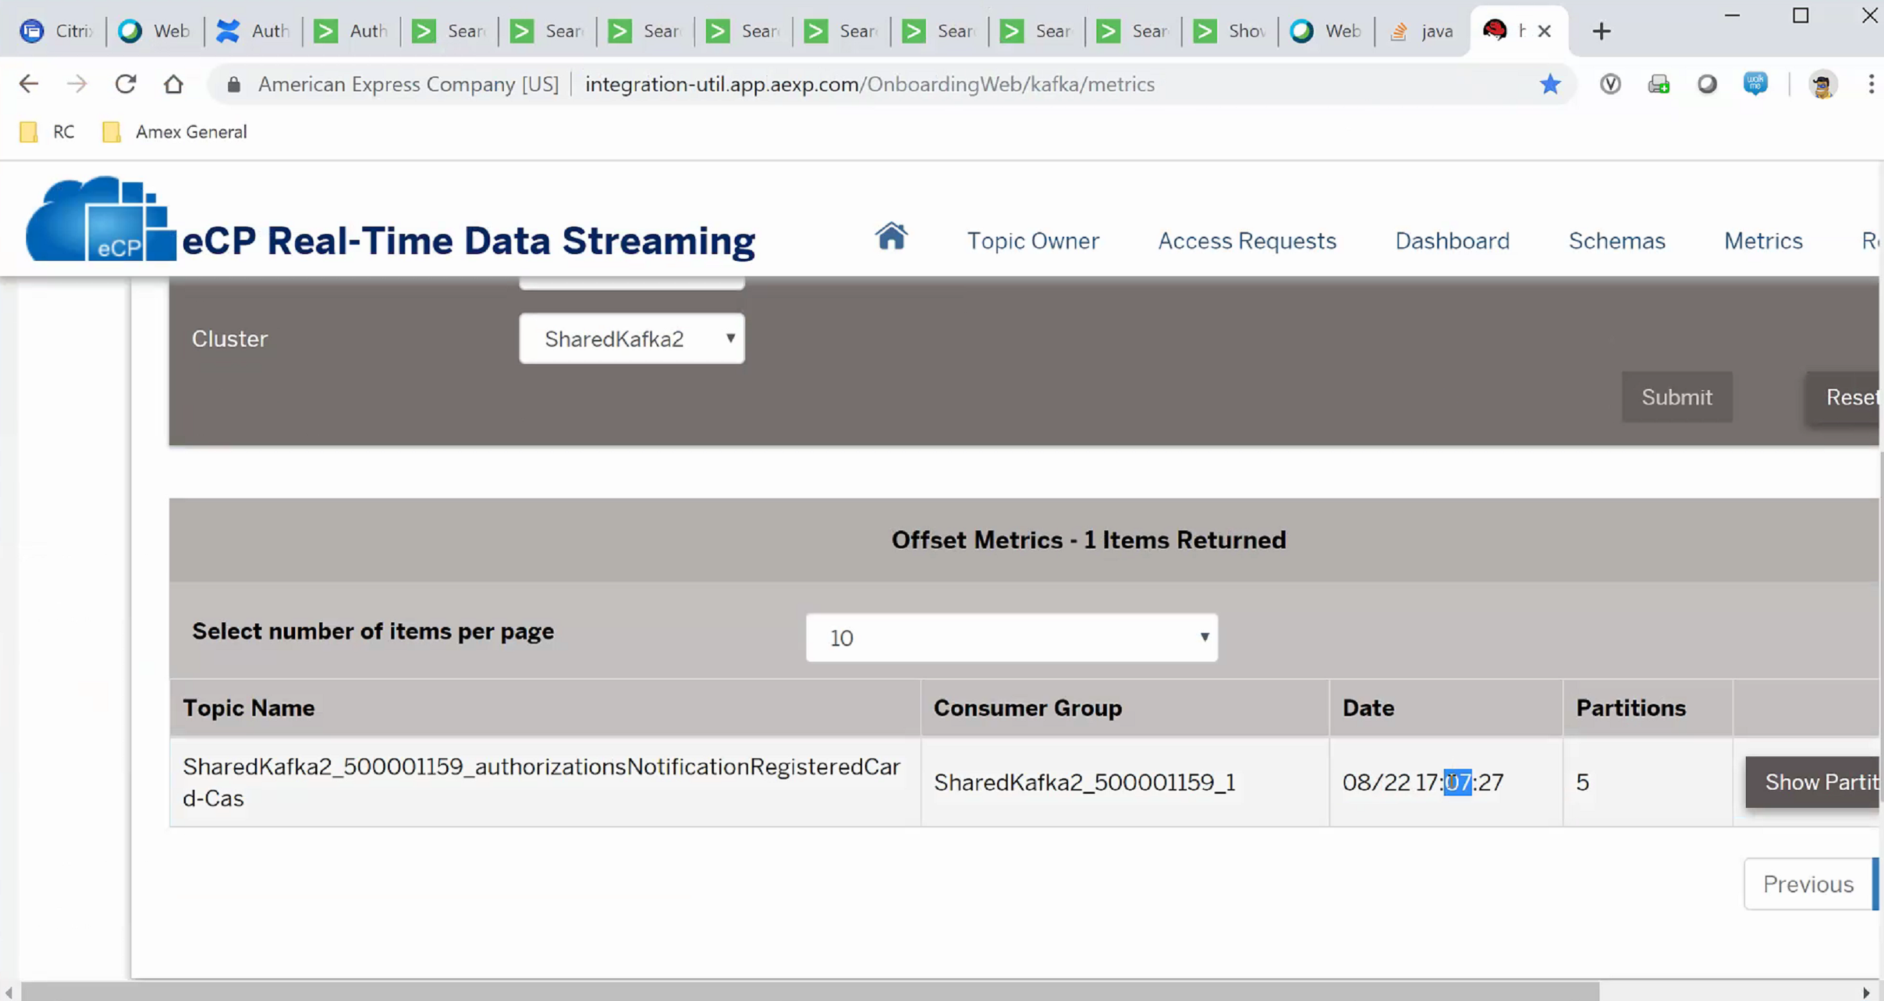

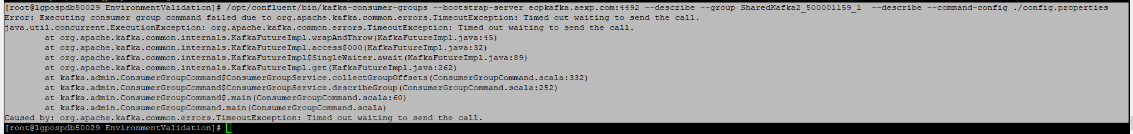

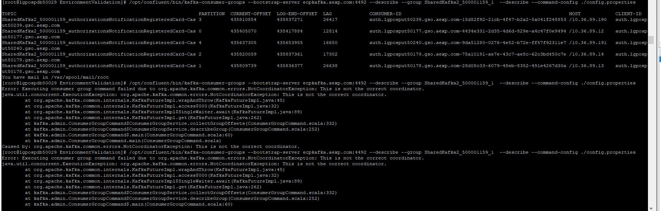

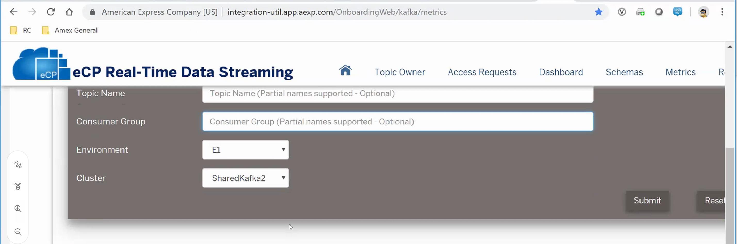

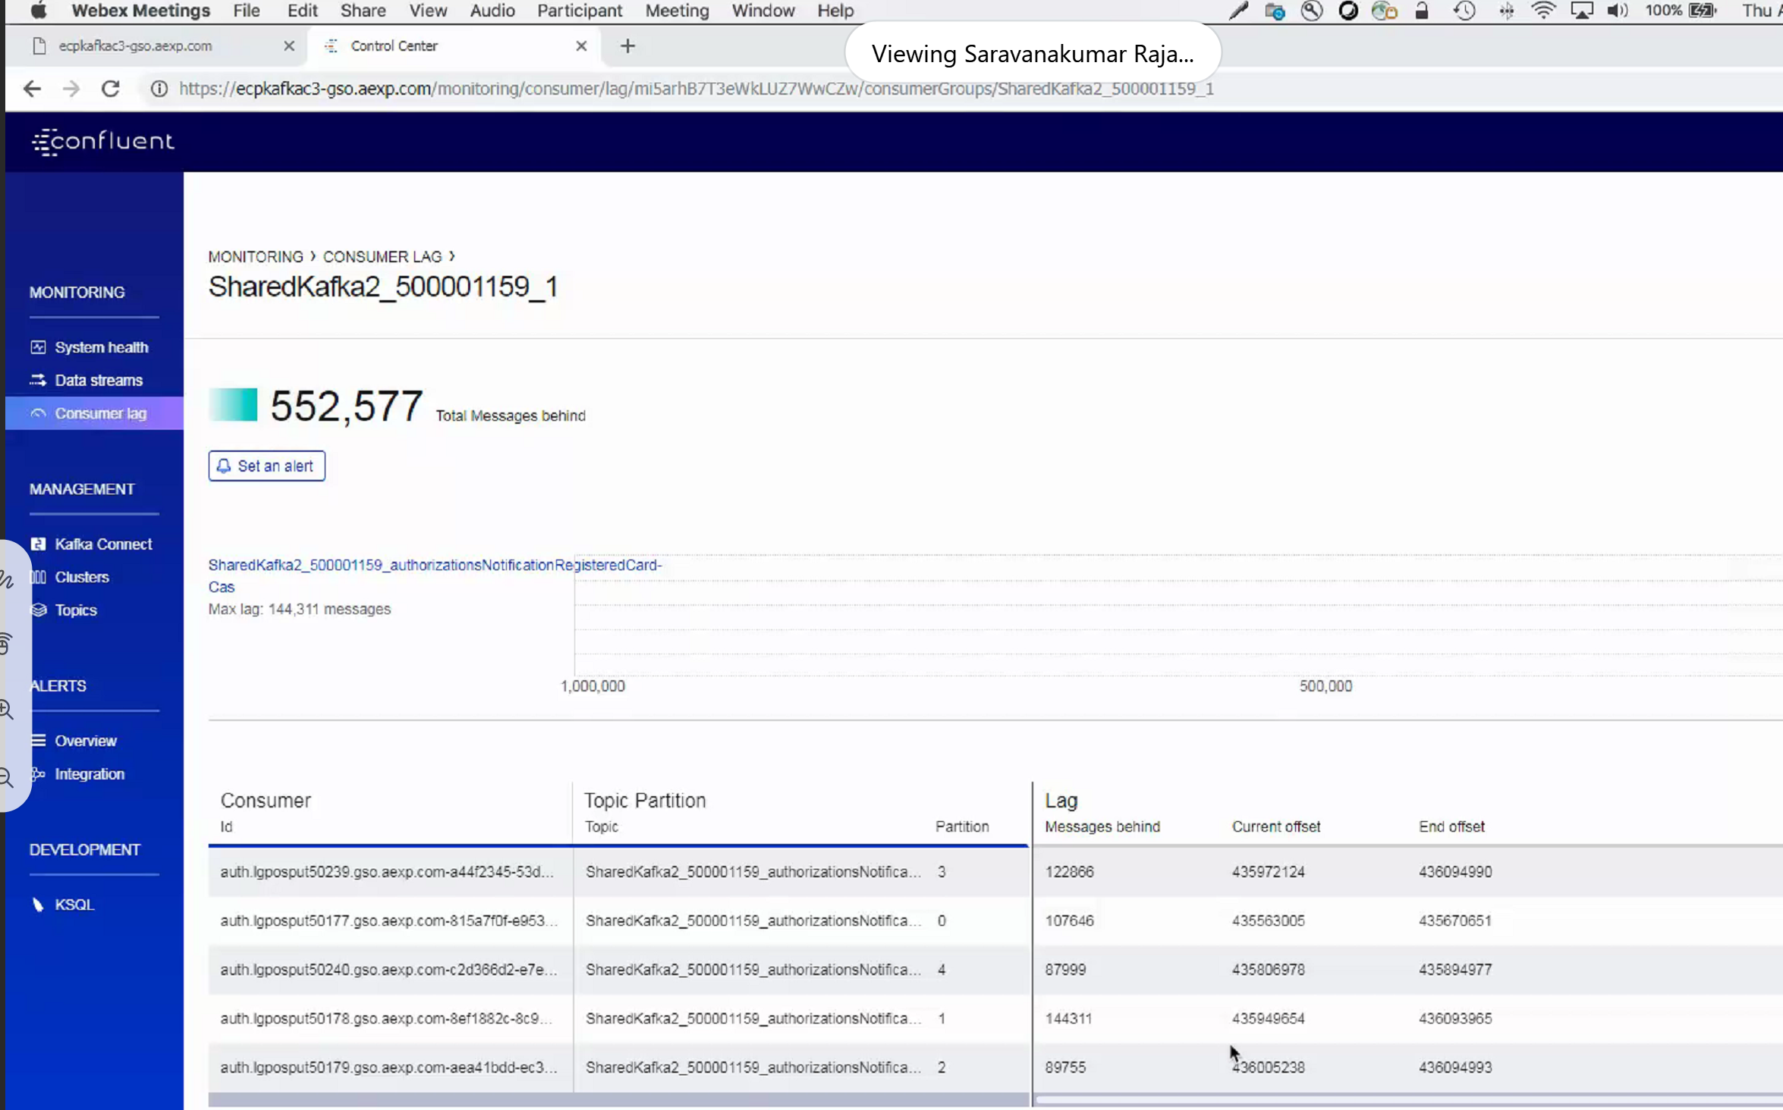

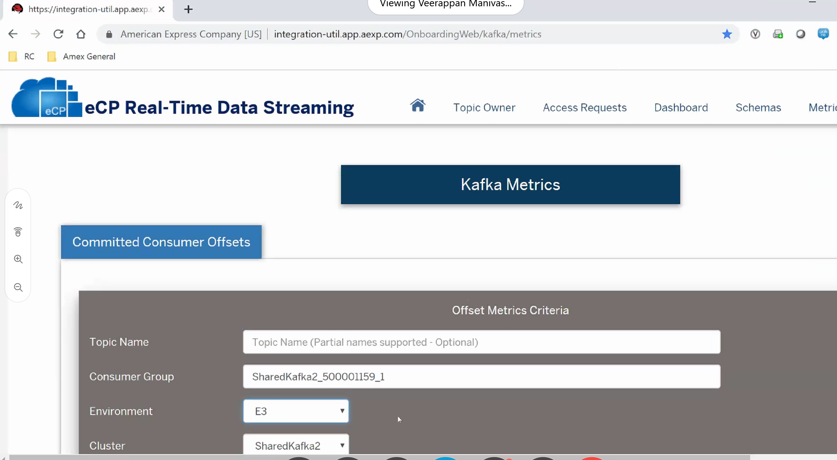

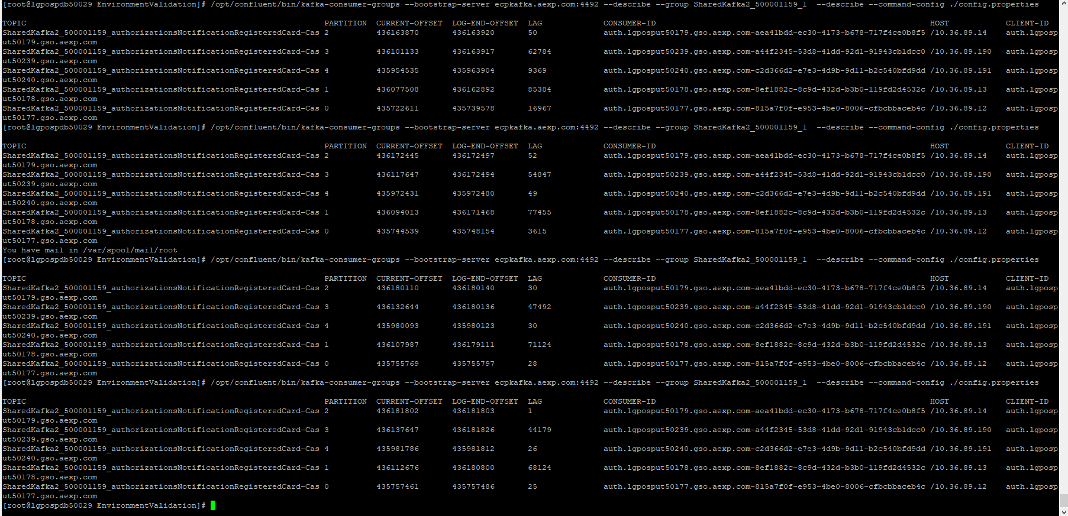

Partitions can be increase in E3 upto 15 same time increase consumer-ID

Auto commit is not request . Manually commit is recommended.

If it was not consumed it will reprocess from kafka

We restarted the consumer