Calibration

1. Fof2 was determined from EISCAT Dynasonde data from Svalbard until mid-2015 **[]**.
2. Expected maximum of electron number density in the F region was calculated using the following formula.

$$f_{o}F2 \left(MHz\right)= f_{P}\left(F2\right)= \frac{ω_{P}}{2π} =\frac{1}{2π}\sqrt{\frac{N_{e} e^{2}}{ε_{o}m_{e}}}$$

From above equation, we calculated $N_{e}= 8.16* {10}^{11} m^{-3}$

1. We calculate the Magic constant using equation below:

$$Magic_const=\frac{N_{e}^{Peak}\left(Calculated from f_{o}F2\right)}{N_{e}^{max}(Obtained from GUIDAP)}$$

After calculation we got Magic_const = 5.801. We repeated the simulation using Magic_const value and we got

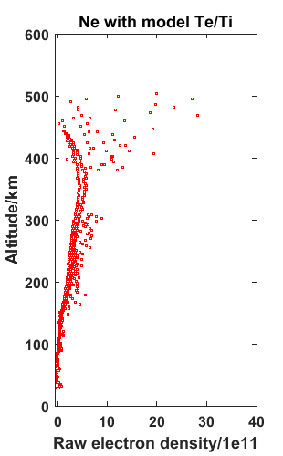

Data Analysis:

2. Solar proton fluxes – 7.7eV

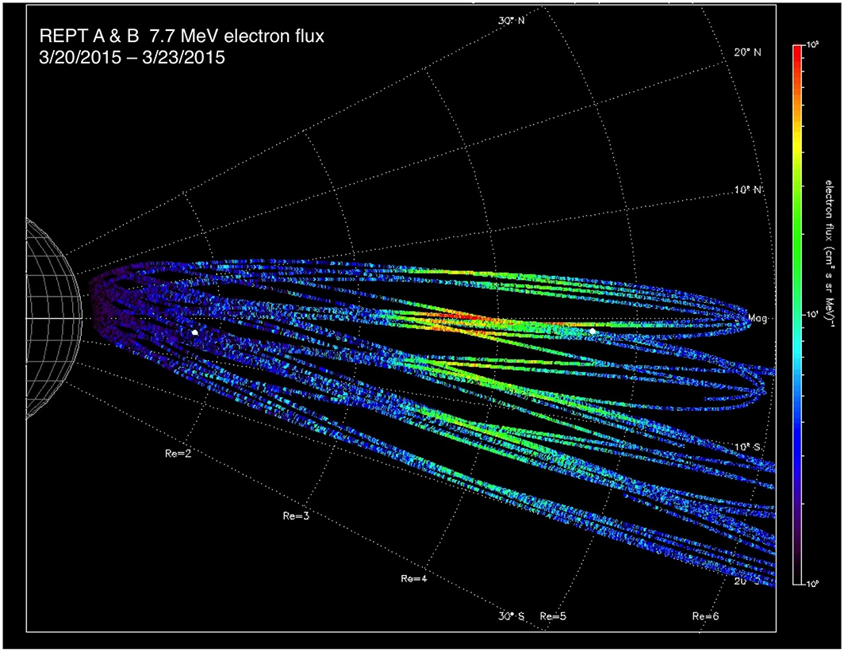

Magnetic latitude versus radial distance portrayal of flux build up from 20 March through 23 March 2015 at 7.7 MeV energies measured by REPT-A and REPT-B sensors.

Link: <http://onlinelibrary.wiley.com/doi/10.1002/2016JA022502/full>

Magnetometer value-

ftp://sohoftp.nascom.nasa.gov/sdb/goes/ace/daily/

Link:

( https://www.eiscat.se/wp-content/uploads/2016/06/Calibration-of-EISCAT-incoherent-scatter-radar-electron-densities-and-the-anomaly-of-23-25-October-2003.pdf)