

Vasudha Kapre
Engineering Portfolio

Introduction
I am a postdoctoral researcher specializing in thermo-mechanical modeling and simulation of polymer composite manufacturing, with a focus on connecting physics-based process models to measurable print outcomes. My work integrates finite-element, discrete-element, and analytical approaches to understand melting, flow, fiber orientation, and deformation in extrusion-based additive manufacturing. I build predictive tools that reduce trial-and-error, accelerate process optimization, and bridge simulation with experiment at both the material and part scale.
This portfolio presents three representative projects demonstrating my ability to model complex process physics, design experiments, extract material behavior, and develop validated simulation frameworks relevant to high-performance 3D-printed polymer systems.
Contents
1. Single Screw Extrusion of Fiber-Reinforced Polymer Pellets (Ph.D. Dissertation)
2. Process Optimization for Additive Manufacturing (Lockheed Martin Collaboration)
3. Developing Material Cards for 3D Printing Simulations (Industry-Academia Collab)
4. Current Project (Postdoc in Mechanical Engineering, Purdue University)
5. Closing Statement
6. Contact Information

1. Single Screw Extrusion of Fiber-Reinforced Polymer Pellets (Ph.D. Dissertation)
Problem
Long discontinuous fiber-reinforced polymer pellets melt, deform, and break inside an extruder, but most models ignore the solid to melt transition where fiber attrition starts. This limits screw-design and process decisions that affect final composite performance.
My Role
Built a unified DEM–FEM–analytical framework during my Ph.D. to predict pellet motion, melting, deformation, and fiber breakage along the screw.
Approach
- Discrete element method (DEM-LIGGGHTS) for pellet motion and kinematics.
- Finite element method (FEM-ABAQUS) for individual pellet heat-transfer and melting.
- Beam-theory + Weibull strength model for pellet deformation, fiber separation and breakage.
- Developed a framework to track melt progression and fiber-length evolution.
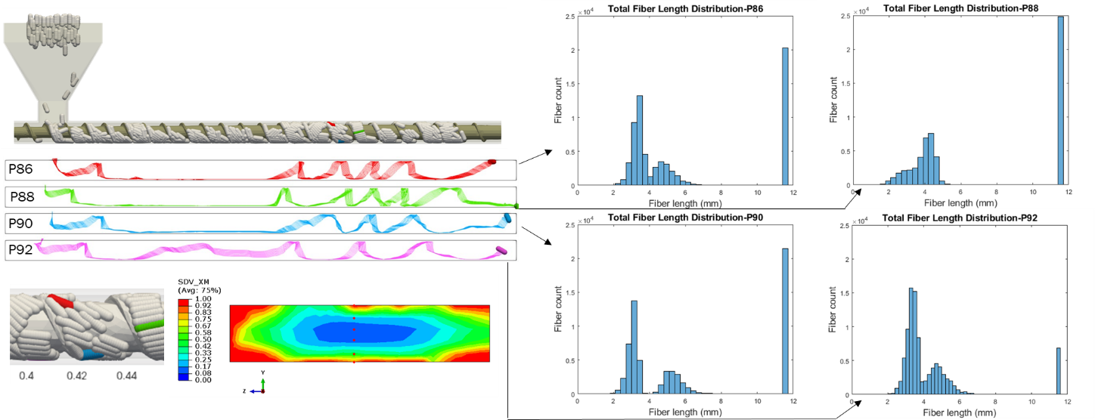
Figure 1: DEM pellet trajectories, fiber-length distribution at screw exit, and melting profile of a partially molten pellet.
Key Results
- Pellets circulate in the second half of screw; this coincides with rapid outside-in melting.
- Fiber breakage starts as soon as the outermost layer of pellet melts.
- Starve-feeding reduces residence time and fiber attrition; high RPM leads to incomplete melting.
- Resulting fiber-length distribution is bimodal and matches experimental trends.
Impact
Provides a quantitative framework to tune screw geometry, feeding mode, and process settings to preserve fiber length and improve composite performance; extensible to other thermoplastics and extrusion-based AM feedstocks.
Tools
LIGGGHTS, ABAQUS, MATLAB, Python, HPC environment, Material: 40% CF-PPS

2. Process Optimization for Additive Manufacturing (Lockheed Martin Collaboration)
Problem
Print quality and part deformation in extrusion deposition AM dependent strongly on bead geometry and microstructure, yet the link between printing parameters → fiber orientation → effective properties → part scale deformation is poorly quantified for carbon-fiber-reinforced polymers.
My Role
Designed the experiment matrix, performed tensile testing, processed all mechanical data, and prepared technical reports and figures for journal and conference publications.
Approach
- Selected three dominant parameters (nozzle size, bead aspect ratio, bead/nozzle area ratio).
- Designed 12 printing conditions: prepared and tested coupons (tensile modulus & strength).
- Extracted elastic properties and inferred fiber orientation (A₁₁) using micromechanics models.
- Performed virtual printing simulations using ADDITIVE-3D for the two extreme material cards.
Figure 2: Average elastic modulus in the printing direction for varying deposition parameters.
Key Results
- Elastic modulus ranged from 9.53 to 15.65 GPa; tensile strength 92–145 MPa across the 12 sets.
- Inferred fiber orientation A₁₁ was 0.60 and 0.77 for extreme cases, capturing strong microstructure sensitivity.
- Virtual printed parts showed 8.6% and 9.5% deformation for low vs high orientation cases.
- Demonstrated that print parameters directly tune microstructure and part deformation.
Impact
Establishes a clear process–structure–property–performance link for fiber-reinforced AM, enabling systematic tuning of print parameters to achieve target stiffness, strength, and dimensional accuracy, reducing trial-and-error and improving predictability for large or load-bearing parts.
Tools
CAMRI printer, tensile testing (MTS), MATLAB, ADDITIVE-3D (FEM-based), Material: 25% CF-PESU

3. Developing Material Cards for 3D Printing Simulations (Industry-Academia Collab)
Problem
Accurate simulation of extrusion-based additive manufacturing requires complete, orthotropic material cards capturing microstructure, thermal behavior, viscoelasticity, and directional mechanical properties. Most composite feedstocks lack validated, simulation-ready datasets.
My Role
Led major portions of the characterization effort for three carbon-fiber-reinforced thermoplastics (50% CF-PPS, 20% CF-PEI, 25% CF-PESU) in collaboration with Techmer and Lockheed Martin. Generated mechanical, microstructural, and viscoelastic data used to build the final material cards.
Approach
- Printed and tested tensile coupons to obtain modulus and strength in printing, transverse and stacking directions.
- Quantified microstructure (fiber-orientation tensor) at bead level using microscopy and X-ray CT.
- Performed DMA to extract temperature-dependent viscoelastic behavior and fit Prony-series coefficients and DSC to characterize crystallization and melting kinetics.
- Consolidated all tests into a complete, simulation-ready card for each material system.
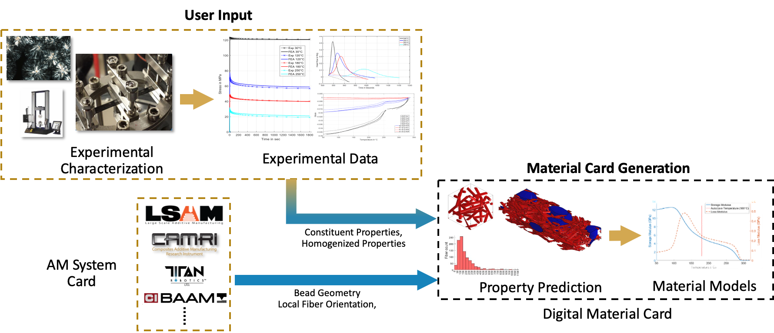
Figure 3: Flowchart explaining the process of generating a material card for a given additive manufacturing system.
Results
- Wrote detailed technical report with complete characterization and validation efforts as part of the project deliverables for all three material systems.
- Implemented material cards in ADDITIVE-3D simulations and validated part deformation.
Impact
Delivered validated, physics-based material inputs that significantly reduce trial-and-error in virtual printing, improve deformation prediction, and enable parametric studies for design and process optimization.
Tools
DSC, DMA, TGA, X-ray CT, optical microscopy, MTS tensile frames, MATLAB, Python, ADDITIVE-3D

4. Current Project (Postdoc in Mechanical Engineering, Purdue University)
- I am leading an industry project with Juggerbot3D to characterize the cure kinetics of the carbon fiber-reinforced vinyl ester resin system
- The goal is to develop physics-based simulations for additive manufacturing of thermosets

5. Closing Statement
My work centers on building predictive, physics-based models that connect process parameters, material behavior, and final part performance. I combine simulation, controlled experiments, and analytical methods to extract mechanisms, quantify uncertainty, and translate results into actionable engineering decisions. Across extrusion modeling, process optimization, and material-card development, my focus has been the same: reduce trial-and-error, expose the underlying process physics, and deliver validated tools that improve printing quality and reliability.
I see strong alignment between this approach and the engineering challenges at Formlabs. I would welcome the opportunity to contribute to simulation-driven process tuning, material behavior modeling, and print-quality optimization for advanced polymer and composite systems.

6. Contact Information
Vasudha Kapre,
Postdoctoral Research Assistant
School of Mechanical Engineering
Composites Manufacturing & Simulation Center (CMSC)
Purdue University, West Lafayette, IN 47906
Ph: +1 786-327-2727
Email: vkapre@purdue.edu
LinkedIn: https://www.linkedin.com/in/vasudhakapre/
Website: https://vkapre.github.io/

