Assignment 5 : Quicksort Algorithm: Implementation, Analysis, and Randomization

Venkata Navya Lakshmi Katta

MSCS-532 Algorithms and Data Structures
Michael Solomon

University of the Cumberlands

July 25, 2026

Implementation

Deterministic Quicksort
In Quicksort, the pivot is always the last element of the subarray. The algorithm partitions the array by moving the elements which are less than the pivot to the left-hand side and the elements which are greater than the pivot to the right-hand side. Then it will be applied to each of the two subarrays of length 1 on the left and right until the entire array is sorted.
This implementation is efficiently implementable for randomly distributed data. The pivot selection is fixed, though, so it is strongly dependent on the initial ordering of the data input.

Randomized Quicksort
The randomised version follows the same recursive sorting procedure but picks a pivot at random before using partitions to sort the array. The final step is to select a pivot at random and swap it with the last element; the standard partition algorithm is then performed.
Randomised pivot selection ensures the algorithm is more stable when pivoting across different input distributions, as it is less likely to produce highly imbalanced partitions.

Design Choices
A few design choices had to be made in the implementation to make it correct, readable and make it properly comparable.
The last one is used as the pivot for the deterministic algorithm: this is the standard implementation of Quicksort, and it shows a good example of what can happen if the pivot is not chosen wisely. The random component contains a function that selects the pivot for the current subarray before partitioning using Python's random.randint() function.
The algorithm performance was assessed with 3 different types of datasets:
- Random arrays
- Sorted arrays
- Reverse-sorted arrays
To make it fair, for every experiment, duplicate regular datasets were given to both algorithms. For measurement of execution time, Python's time.perf_counter() function was employed, which gives high-resolution timing for benchmarking algorithms.

Performance Analysis

Best Case
The best-case scenario occurs when the pivot divides the array into two nearly equal halves during every recursive call. Each recursion level processes all $n$elements, while the recursion depth remains approximately$\log_{2}{n}$.
The recurrence relation is
$$T\left(n\right)=2T\left(\frac{n}{2}\right)+O\left(n\right)$$
Using the Master Theorem,
$$T\left(n\right)=O\left(n\log{n}\right)$$
Therefore, the best-case time complexity is
$$O\left(n\log{n}\right)$$

Average Case
In practice, Quicksort usually partitions the array reasonably evenly, although not perfectly. Consequently, the recursion depth remains logarithmic, while each level processes all elements.
The average-case complexity is
$$T\left(n\right)=O\left(n\log{n}\right)$$
This is the primary reason why Quicksort performs efficiently for most real-world applications.

Worst Case
The worst-case scenario occurs when the pivot is always selected as either the smallest or the largest element. This commonly happens when the input is already sorted or reverse sorted while using the last element as the pivot.
The recurrence becomes
$$T\left(n\right)=T\left(n-1\right)+O\left(n\right)$$
Expanding the recurrence gives
$$T\left(n\right)=n+\left(n-1\right)+\left(n-2\right)+⋯+1$$
which simplifies to
$$T\left(n\right)=O\left(n^{2}\right)$$
As a result, the recursion depth becomes linear, significantly increasing the execution time.

Space Complexity
Quicksort is an in-place sorting algorithm because it does not require an additional array for sorting. The primary memory overhead comes from recursive function calls.
Case | Space Complexity
Best Case | $$O\left(\log{n}\right)$$
Average Case | $$O\left(\log{n}\right)$$
Worst Case | $$O\left(n\right)$$
In the best and average cases, recursion remains balanced, resulting in logarithmic memory usage. In the worst case, recursion becomes completely unbalanced, causing linear space complexity.

Randomized Quicksort Analysis
Randomized Quicksort improves pivot selection by choosing the pivot randomly from the current subarray before partitioning.
Unlike deterministic Quicksort, randomization greatly reduces the probability of repeatedly selecting poor pivots. Consequently, balanced partitions occur more frequently, producing a much more stable recursion tree.
Although the theoretical worst-case complexity remains
$$O\left(n^{2}\right)$$
its probability becomes extremely small. Therefore, the expected running time of Randomized Quicksort is
$$O\left(n\log{n}\right)$$
making it a preferred implementation for practical applications.

Empirical Analysis
The three different input arrays used for testing the algorithms which are Random arrays, Sorted arrays and Reverse-sorted arrays. The sizes for the array were 1000, 5000, and 10000 elements. The actual running times are reported in the table below.
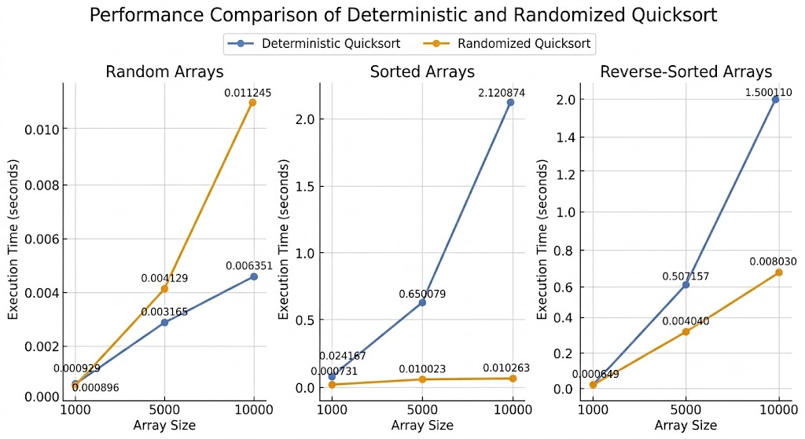
Figure 1 : Performance Comparison of Deterministic and Randomized Quicksort
The experimental results are in good agreement with the theoretical analysis. On random data sets, the two implementations are comparable, as partitions were mostly uniform. But when Quicksort is used to sort already sorted and reverse-sorted arrays, it starts slowing quite a bit; this is the place where deterministic becomes its disadvantage. Each partition was very unbalanced, with the last element always being chosen as the key; hence the running time was quadratic.
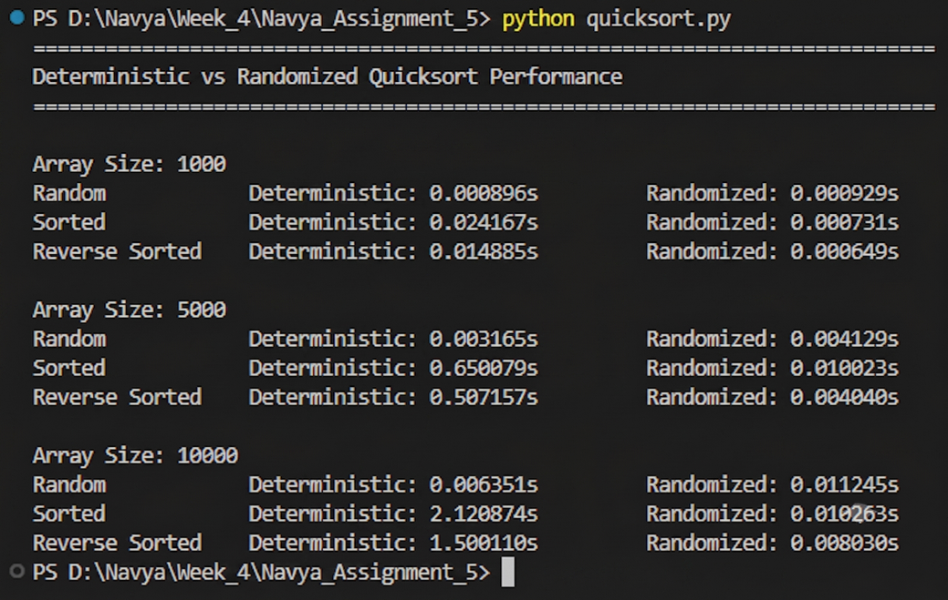
Figure 2 : Program Execution Results
On the other hand, the performance of Randomised Quicksort was not affected by any type of input distribution. The partitions were both well-balanced and well-balanced on average, due to random pivot selection, so that the execution times were near the expected $O\left(n\log{n}\right)$ value as the number of input elements grew.

