Below is the network diagram for question 2 part 2 of assignment 4.

Texxon Oil Distribution Problem.

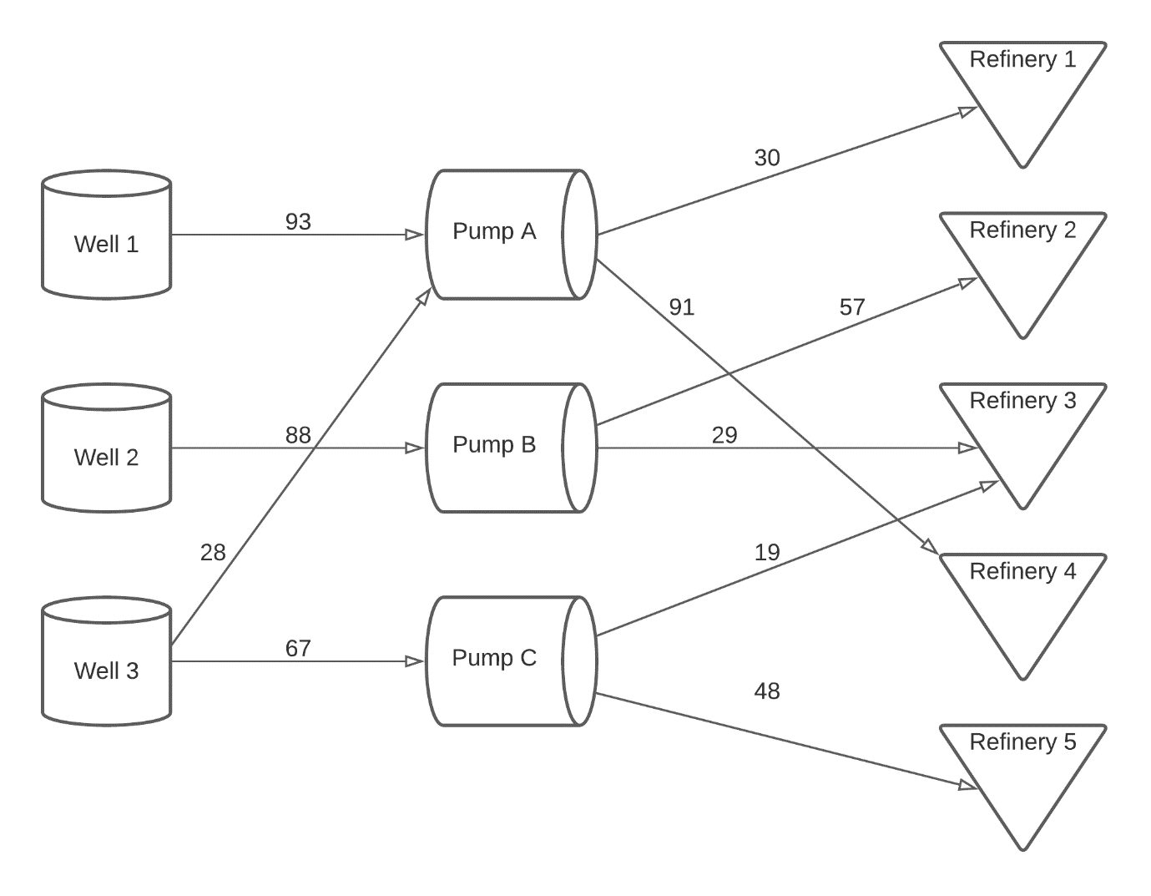

The above diagram depicts the distribution of oil from wells to pumps and then to refineries.