Name: Von Kaukeano EE3612 Assignment name: HW ch4 Date: 10/11/19

Place the problem statement here.

Attach 8 switches on PORTB and 8 LED’s attached to PORTA.

Write assembly code so that when switch on PB0 is closed LED on PA0 is on, switch on PB1 is closed LED on PA1 is on, and repeat for all rest of the switches and LED’s.

Describe your problem solution here using a few sentences to describe your flowchart below.

Activate pull up resistors and make portb an input and porta an output. Check if bit in portb is high or low. If high set porta pin high, if low set port a pin low.

Place Flowchart from IO.DRAW here. You may have to use a screenshot.

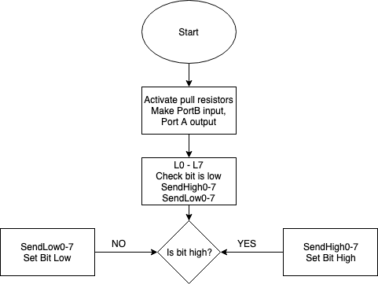

Code for your solution here.

LDI R16,$FF

OUT PORTB,R16 ; ACTIVATE PULLUPS

LDI R17,$00

OUT DDRB,R17; Set Direction as inputs. PORT B INPUT

OUT DDRA, R16 ; PORT A OUTPUT

L0:

SBIC PINB,0

RJMP SENDHIGH0

RJMP SENDLOW0

L1:

SBIC PINB,1

RJMP SENDHIGH1

RJMP SENDLOW1

L2:

SBIC PINB,2

RJMP SENDHIGH2

RJMP SENDLOW2

L3:

SBIC PINB,3

RJMP SENDHIGH3

RJMP SENDLOW3

L4:

SBIC PINB,4

RJMP SENDHIGH4

RJMP SENDLOW4

L5:

SBIC PINB,5

RJMP SENDHIGH5

RJMP SENDLOW5

L6:

SBIC PINB,6

RJMP SENDHIGH6

RJMP SENDLOW6

L7:

SBIC PINB,7

RJMP SENDHIGH7

RJMP SENDLOW7

SENDHIGH0:

SBI PORTA, 0

RJMP L1

SENDHIGH1:

SBI PORTA,1

RJMP L2

SENDHIGH2:

SBI PORTA,2

RJMP L3

SENDHIGH3:

SBI PORTA,3

RJMP L4

SENDHIGH4:

SBI PORTA,4

RJMP L5

SENDHIGH5:

SBI PORTA,5

RJMP L6

SENDHIGH6:

SBI PORTA,6

RJMP L7

SENDHIGH7:

SBI PORTA,7

RJMP L0

SENDLOW0:

CBI PORTA, 0

RJMP L1

SENDLOW1:

CBI PORTA,1

RJMP L2

SENDLOW2:

CBI PORTA,2

RJMP L3

SENDLOW3:

CBI PORTA,3

RJMP L4

SENDLOW4:

CBI PORTA,4

RJMP L5

SENDLOW5:

CBI PORTA,5

RJMP L6

SENDLOW6:

CBI PORTA,6

RJMP L7

SENDLOW7:

CBI PORTA,7

RJMP L0

Discuss results and verification here.

Screenshot of results here that are described above

<https://drive.google.com/open?id=1RgWRxErp2cE8D_PF4odeXiETQW6WVZ5h>