Name: Von Kaukeano EE3612 Assignment name: HW ch4 Date: 10/11/19

Place the problem statement here.

Use the 8 switches on PORTB and 8 LED’s attached to PORTA.

Write code so that when switch PB0 is closed a binary 0 is sent to LEDs and no LEDs are on, when  LEDs switch PB1 is closed a binary 1 is displayed on LEDs, when  LEDs switch PB2 is closed a binary 2 is displayed on  LEDs, when  switch PB3 is closed a binary 3 is displayed on  LEDs, keep doing all the way up to when PB7 is closed a binary 7 is displayed on the LEDs

Describe your problem solution here using a few sentences to describe your flowchart below.

Activate pull up resistors and make portb an input and porta an output. Check if bit in portb is high or low. If high set porta binary 0-7, if low set port a low.

Place Flowchart from IO.DRAW here. You may have to use a screenshot.

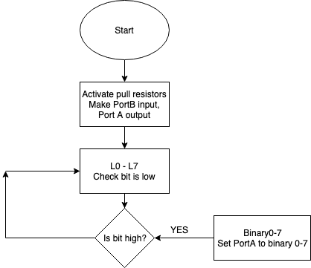

Code for your solution here.

LDI R16,$FF

OUT PORTB,R16 ; ACTIVATE PULLUPS

LDI R17,$00

OUT DDRB,R17; Set Direction as inputs. PORT B INPUT

OUT DDRA, R16 ; PORT A OUTPUT

L0:

SBIC PINB,0

RJMP BINARY0

L1:

SBIC PINB,1

RJMP BINARY1

L2:

SBIC PINB,2

RJMP BINARY2

L3:

SBIC PINB,3

RJMP BINARY3

L4:

SBIC PINB,4

RJMP BINARY4

L5:

SBIC PINB,5

RJMP BINARY5

L6:

SBIC PINB,6

RJMP BINARY6

L7:

SBIC PINB,7

RJMP BINARY7

RJMP L0

BINARY0:

LDI R16,0

OUT PORTA, R16

RJMP L1

BINARY1:

LDI R16,1

OUT PORTA, R16

RJMP L2

BINARY2:

LDI R16,2

OUT PORTA, R16

RJMP L3

BINARY3:

LDI R16,3

OUT PORTA, R16

RJMP L4

BINARY4:

LDI R16,4

OUT PORTA, R16

RJMP L5

BINARY5:

LDI R16,5

OUT PORTA, R16

RJMP L6

BINARY6:

LDI R16,6

OUT PORTA, R16

RJMP L7

BINARY7:

LDI R16,7

OUT PORTA, R16

RJMP L0

Discuss results and verification here.

I noticed that you cannot have two switches set at once or else it will bug. A clear port may fix that issue. Also the lights stay on after the switch is off and do not do the next number until the next switch is thrown.

Screenshot of results here that are described above

<https://drive.google.com/open?id=1y_MTCAI_5rjJozNhsG1oF6FjmtOK-jyh>