Name: Von Kaukeano EE3612 Assignment name: HW ch4 Date: 10/11/19

Place the problem statement here.

Write assembly code so that when switch on PB0 is closed the LEDs sequentially light up starting at PA0 through PA7. In the same code when switch on PB1 is closed the LEDs sequentially light up starting at PA7 through PA0.

Describe your problem solution here using a few sentences to describe your flowchart below.

Activate pull up resistors and make portb an input and porta an output. Check if bit in portb is high or low. If high set porta binary 0-7, if low set port a low.

Place Flowchart from IO.DRAW here. You may have to use a screenshot.

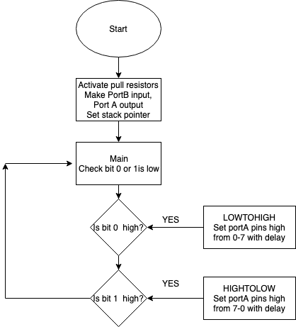

Code for your solution here.

.include <m324pbdef.inc>

LDI R16,HIGH(RAMEND)

OUT SPH,R16

LDI R16,LOW(RAMEND)

OUT SPL,R16

LDI R20, 0xFF

OUT DDRA, R20;make PORTA an output port

OUT PORTB,R16 ; ACTIVATE PULLUPS

LDI R17,$00

OUT DDRB,R17; Set Direction as inputs. PORT B INPUT

Main:

SBIC PINB,0

CALL LOWTOHIGH

SBIC PINB,1

CALL HIGHTOLOW

rjmp Main

LOWTOHIGH:

ldi r16, 0

out porta,r16

SBI PORTA,0;set bit PA0

CALL DELAY;DELAY before next one

SBI PORTA,1;turn on PA1

CALL DELAY;DELAY before next one

SBI PORTA,2;turn on PA2

CALL DELAY

SBI PORTA,3

CALL DELAY

SBI PORTA,4

CALL DELAY

SBI PORTA,5

CALL DELAY

SBI PORTA,6

CALL DELAY

SBI PORTA,7

CALL DELAY

RET

HIGHTOLOW:

ldi r16, 0

out porta,r16

SBI PORTA,7;set bit PA0

CALL DELAY;DELAY before next one

SBI PORTA,6;turn on PA1

CALL DELAY;DELAY before next one

SBI PORTA,5;turn on PA2

CALL DELAY

SBI PORTA,4

CALL DELAY

SBI PORTA,3

CALL DELAY

SBI PORTA,2

CALL DELAY

SBI PORTA,1

CALL DELAY

SBI PORTA,0

CALL DELAY

RET

DELAY: ldi r20,32

L1: LDI R21, 200

L2: LDI R22, 250

L3: NOP

NOP

DEC R22

BRNE L3

DEC R21

BRNE L2

DEC R20

BRNE L1

RET

Discuss results and verification here.

Screenshot of results here that are described above

<https://drive.google.com/open?id=1_dZ-eBSznBEr3NJtogaKbZm8BV-ERBaA>