Name: Von Kaukeano EE3612 Assignment name: HW ch7 Date: 11/11/19

Place the problem statement here.

Write a C program so that when pin 0 on PORTB is LOW then count up from 0 to 9 on the 7 segment display with a delay between each number of 500 msec. Also when when pin 0 on PORTB is HIGH then count Down from 9 to 0 on the 7 segment display with a delay between each number of 1000 msec.

Put a Youtube link of a video showing your results.

Place Flowchart from IO.DRAW here. You may have to use a screenshot.

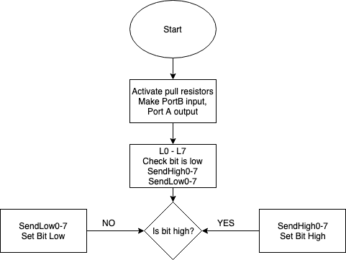

Code for your solution here.

#define F_CPU 16000000UL

#include <util/delay.h>

#include <avr/io.h>

int main(void)

{

DDRA = 0Xff; // PORTA OUTPUT

DDRB = 0x00; // PORTB INPUT

PORTB = 0Xff; // ACTIVATE PULLUP RESISTORS

unsigned char zero = 0X3F;

unsigned char one = 0X06;

unsigned char two = 0X5B;

unsigned char three = 0X4F;

unsigned char four = 0X66;

unsigned char five = 0X6D;

unsigned char six = 0X7D;

unsigned char seven = 0X07;

unsigned char eight = 0X7F;

unsigned char nine = 0X67;

unsigned char z;

z = 0x01;

unsigned char input;

while (1) {

input = PINB & z;

if(input == 0){

PORTA = zero;

_delay_ms(500);

PORTA = one;

_delay_ms(500);

PORTA = two;

_delay_ms(500);

PORTA = three;

_delay_ms(500);

PORTA = four;

_delay_ms(500);

PORTA = five;

_delay_ms(500);

PORTA = six;

_delay_ms(500);

PORTA = seven;

_delay_ms(500);

PORTA = eight;

_delay_ms(500);

PORTA = nine;

_delay_ms(500);

}

else {

PORTA = nine;

_delay_ms(1000);

PORTA = eight;

_delay_ms(1000);

PORTA = seven;

_delay_ms(1000);

PORTA = six;

_delay_ms(1000);

PORTA = five;

_delay_ms(1000);

PORTA = four;

_delay_ms(1000);

PORTA = three;

_delay_ms(1000);

PORTA = two;

_delay_ms(1000);

PORTA = one;

_delay_ms(1000);

PORTA = zero;

_delay_ms(1000);

}

}

return 0;

}

Discuss results and verification here.

Screenshot of results here that are described above

<https://drive.google.com/open?id=1SmSa0j4gzNj5CNJfUTTc9fHxy9B5lI7l>