Name: Von Kaukeano EE3612 Assignment name: HW ch7 Date: 11/11/19

Place the problem statement here.

Use the lower four bits of PORTB that are connected  to four switches.

Write a C program to send the following ASCII characters to a PORTA, based on the status of the switches:

Switches        PORTA

0000                 '0'

0001                '1'

0010                '2'

0011                 '3'

0100                 '4'

0101                '5'

0110                '6'

0111                '7'

1000                '8'

1001                 '9'

1010                'A'

1011               'B'

1100               'C'

1101                 'D'

1110                'E'

1111               'F'

Put a Youtube link of a video showing your results.

Place Flowchart from IO.DRAW here. You may have to use a screenshot.

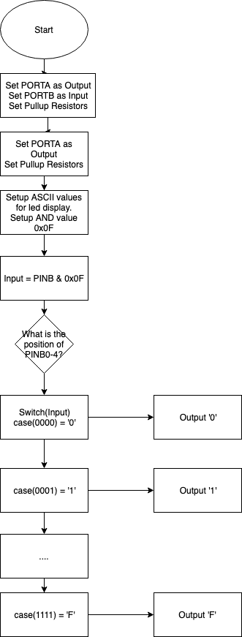

Code for your solution here.

#define F_CPU 16000000UL

#include <util/delay.h>

#include <avr/io.h>

int main(void)

{

DDRA = 0Xff; // PORTA OUTPUT

DDRB = 0x00; // PORTB INPUT

PORTB = 0Xff; // ACTIVATE PULLUP RESISTORS

unsigned char zero = '0';

unsigned char one = '1';

unsigned char two = '2';

unsigned char three = '3';

unsigned char four = '4';

unsigned char five = '5';

unsigned char six = '6';

unsigned char seven = '7';

unsigned char eight = '8';

unsigned char nine = '9';

unsigned char ten = 'A';

unsigned char eleven = 'B';

unsigned char twelve = 'C';

unsigned char thirteen = 'D';

unsigned char fourteen = 'E';

unsigned char fifteen = 'F';

unsigned char z;

z = 0x0F;

unsigned char input;

while (1) {

input = PINB & z;

switch(input){

case(0b00000000):

PORTA = zero;

break;

case(0b00000001):

PORTA = one;

break;

case(0b00000010):

PORTA = two;

break;

case(0b00000011):

PORTA = three;

break;

case(0b00000100):

PORTA = four;

break;

case(0b00000101):

PORTA = five;

break;

case(0b00000110):

PORTA = six;

break;

case(0b00000111):

PORTA = seven;

break;

case(0b00001000):

PORTA = eight;

break;

case(0b00001001):

PORTA = nine;

break;

case(0b00001010):

PORTA = ten;

break;

case(0b00001011):

PORTA = eleven;

break;

case(0b00001100):

PORTA = twelve;

break;

case(0b00001101):

PORTA = thirteen;

break;

case(0b00001110):

PORTA = fourteen;

break;

case(0b00001111):

PORTA = fifteen;

break;

default:

PORTA = '0';

}

}

return 0;

}

Discuss results and verification here.

Screenshot of results here that are described above

<https://drive.google.com/open?id=1pY7QKys4mdB-fqoSsHbBoAM0TZCP6zM5>