Name: Von Kaukeano EE3612 Assignment name: HW ch7 Date: 11/11/19

Place the problem statement here.

Write a C program to find the number of 1's in an 8-bit number.

Place Flowchart from IO.DRAW here. You may have to use a screenshot.

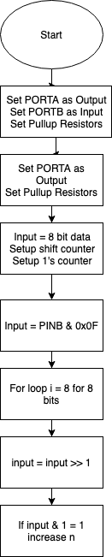

Code for your solution here.

#define F_CPU 16000000UL

#include <util/delay.h>

#include <avr/io.h>

int main(void)

{

DDRA = 0XFF;

derby = 0xFF;

unsigned int n; // counter

unsigned int i; //increment

unsigned char input;

input = 0b10101011;

for(i=0;i<=8;i++){

if((input & 1) == 1){

n++;

}

input = input >> 1;

}

PORTA = n;

}

Discuss results and verification here.

Video shows 5 ones in the input data and output 5 in binary on the LED’s.

Screenshot of results here that are described above

<https://drive.google.com/open?id=1eJy4f2zzE4Afw5a-Tx6xt0pBHjhr_08e>