AWS LAMP Stack Design

Technical Design

Varun Kaushik

2019

Table of Contents

Background 2

AWS Services used in solution 2

Git Repo details 4

# Background

This Document provides detailed solution is to create an AWS environment with LAMP stack

* Redundant
* Secure
* Cost Effective

|  |
| --- |
| Challenge:  Provide a Cloud formation template defining a redundant, secure and cost-effective LAMP stack within AWS.  Response:  -         Provide documentation describing your environment  -         Provide a link to a public git repository hosting the template (committing frequently so we can see how your solution progressed)  Stretch Goal:  -         Provide a small application that will run on the infrastructure (written in PHP that connects to the MySQL database)  Notes: Apache, PHP or MySQL not your thing? Feel free to swap any of these out for an alternate technology. |

# AWS Services used in solution

* Amazon Cloudfront:

Deliver static and dynamic content, Cache for improving performance of site

* WAF:

Secure the communication channel by applying policy on traffic

* EC2:

Manage the web server and application code

* ALB:

Manage and distribute the traffic between autoscaling group of EC2 instances in multiple Availability zones within same region

* S3:

Store static content (media/downloadable files) of website

* Route53:

DNS management and ensure that the traffic from internet reaches WAF

* VPC:

Use subnets to isolate network and enhance security to database. Implement FW rules.

* + Internet Gateway to communicate with Internet
* Autoscaling:

For making system scale out and in according to load and make solution highly available and cost effective.

* AmazonElastiCache:

Helps in making system highly available and improved performance.

* Amazon File System:

shared filesystem among the servers to save configuration files

* NAT Gateway:

Communication from restricted zone to Internet

* Amazon RDS:

MySQL/Aurora instances Read Replica and Master Replica

* Amazon Certificate Manager:

Manage SSL certificates to encrypt the communication related to data in transit

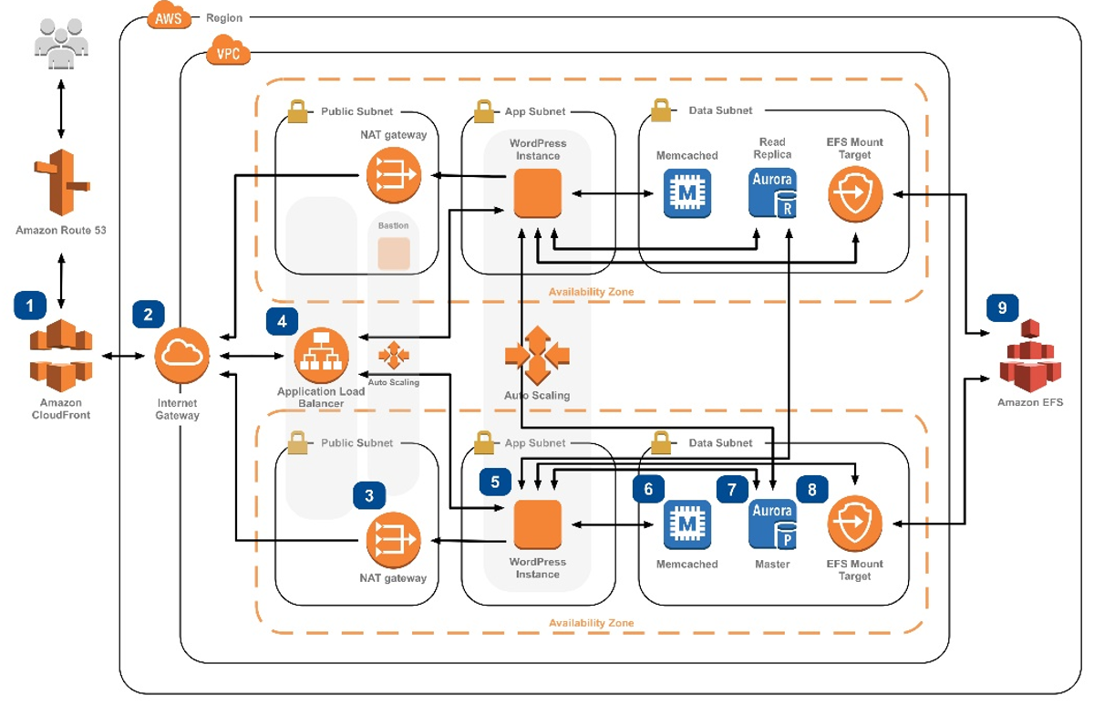

Figure 1: Overall design for the LAMP stack

# Git Repo details

<https://github.com/vkaushik13/aws-lamp-stack-cf>

* 01-newvpc.yaml

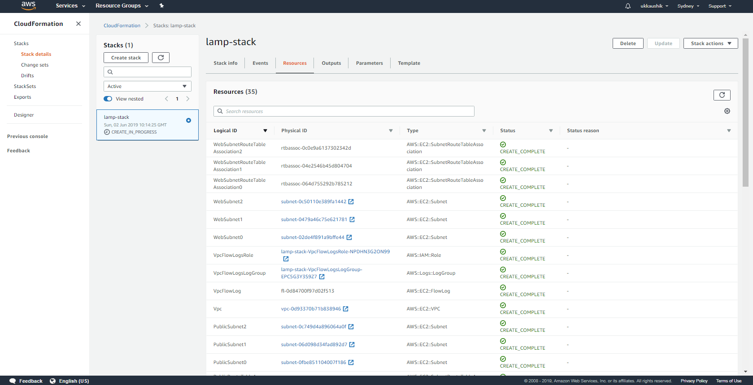

* 02-securitygroups.yaml
* 03-bastion.yaml
* 04-web.yaml