**DAY – 2**

**Ce1.**

Create a Windows EC2 instance with t2.micro Instance and show the remote connection of that EC2 Instance.

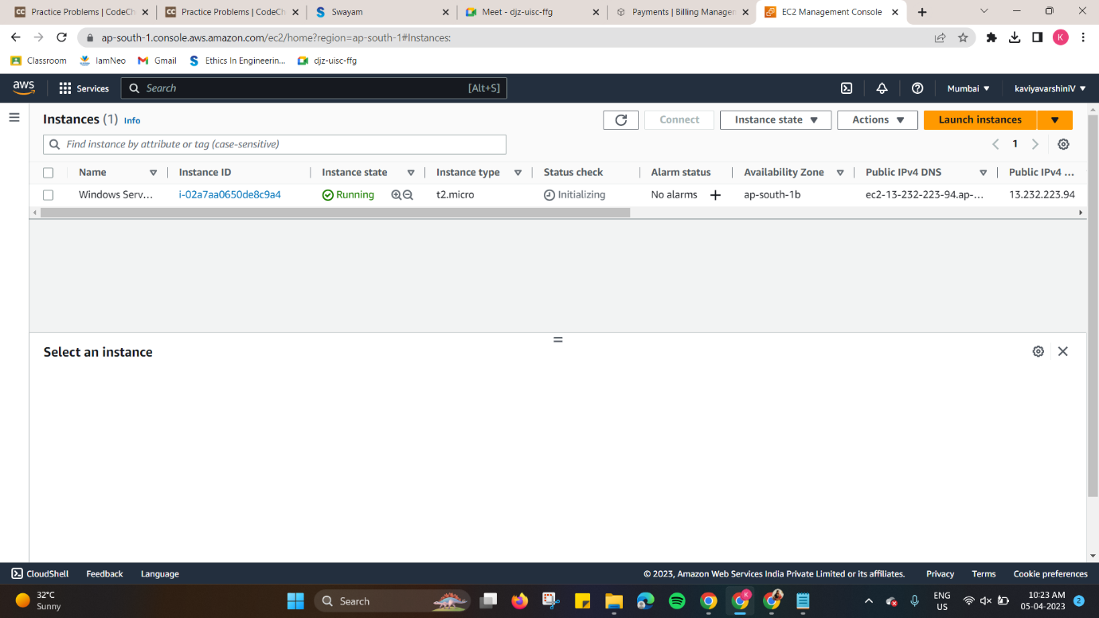

**Ce2.**

Create an EBS volume of 5 GB and attach to a windows EC2 instance and make partition of that EBS volume.

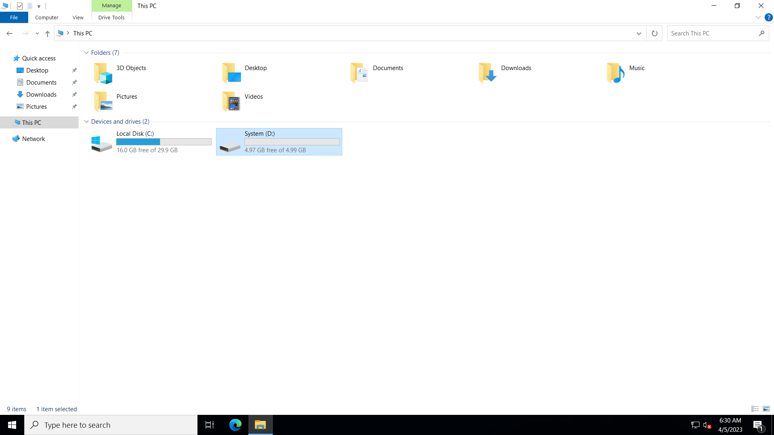

**Ce3.**

Create some files and folders into 5 GB EBS volume of the previous exercise and take a snapshot of that EBS volume.

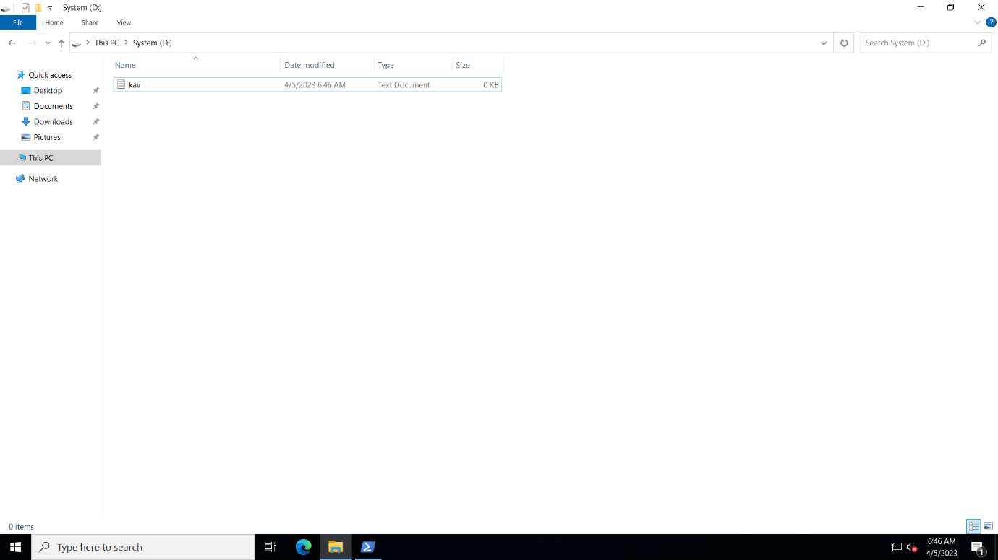

**Ce4.**

Create a Linux EC2 instance with t2.micro Instance and show the remote connection of that EC2 Instance. 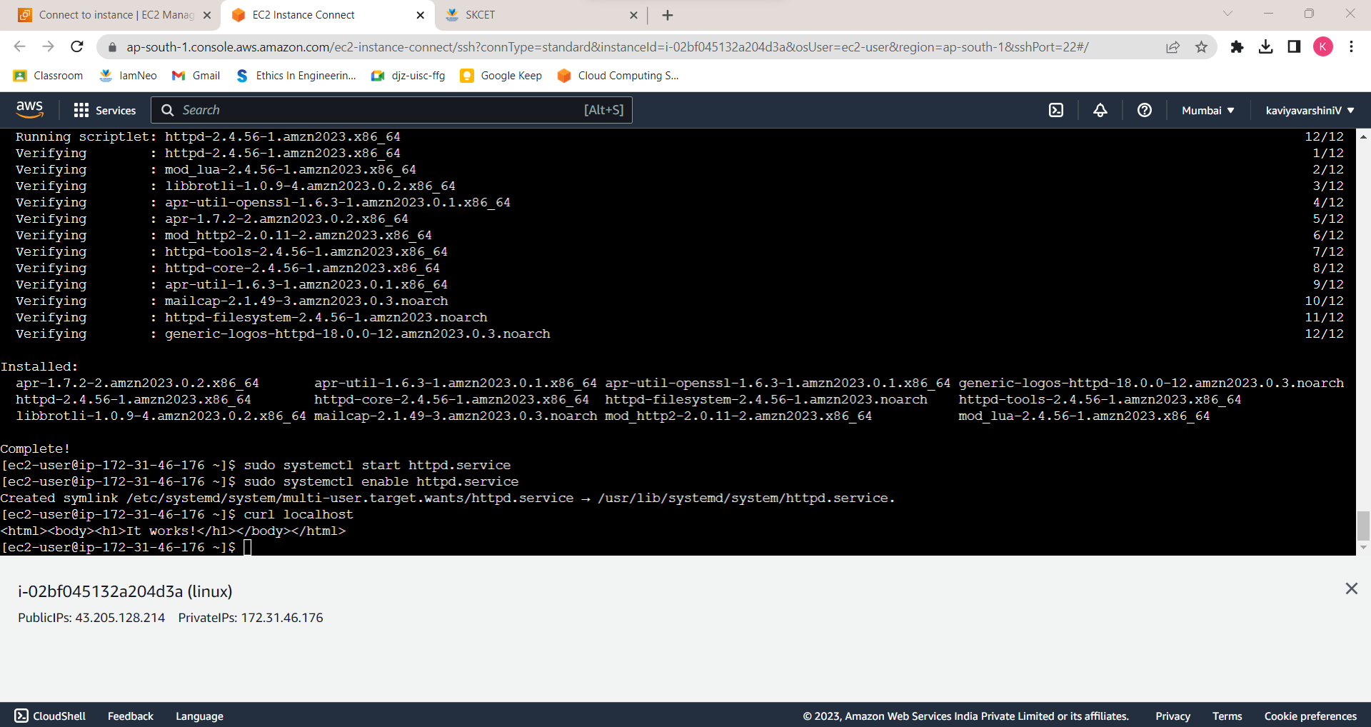

**Ce5.**

Install, Start and Enable the httpd webservice in that Linux EC2 Instance, then host a static website in EC2.

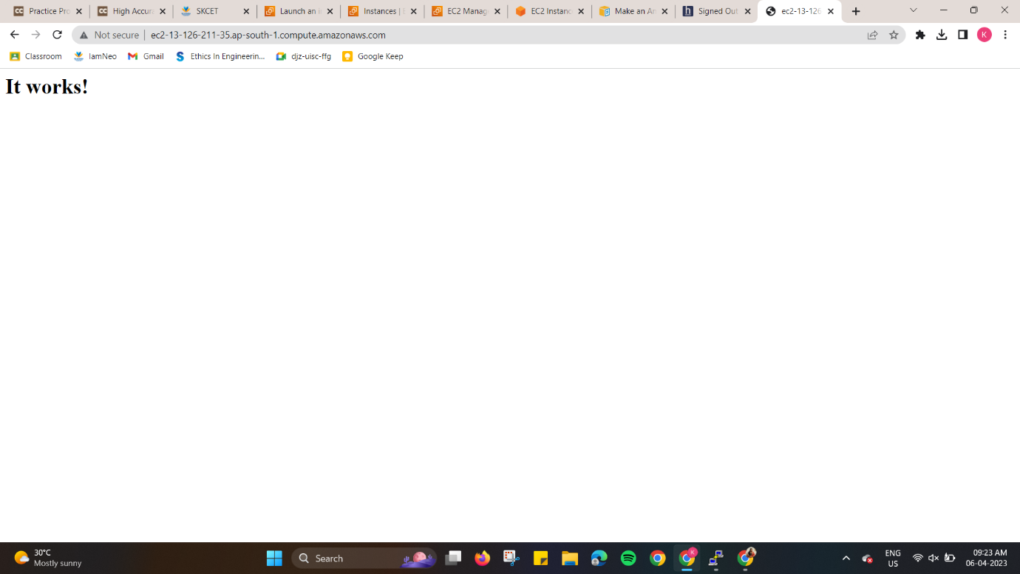

**Ce6.**

Create Image (MyAMI) of the linux Webserver (from the previous exercise) and launch new EC2 instance from the created Image (MyAMI)

