**DAY – 3**

**Ce1.**

Create a S3 Bucket and create a folder in the bucket and upload a file in the folder.

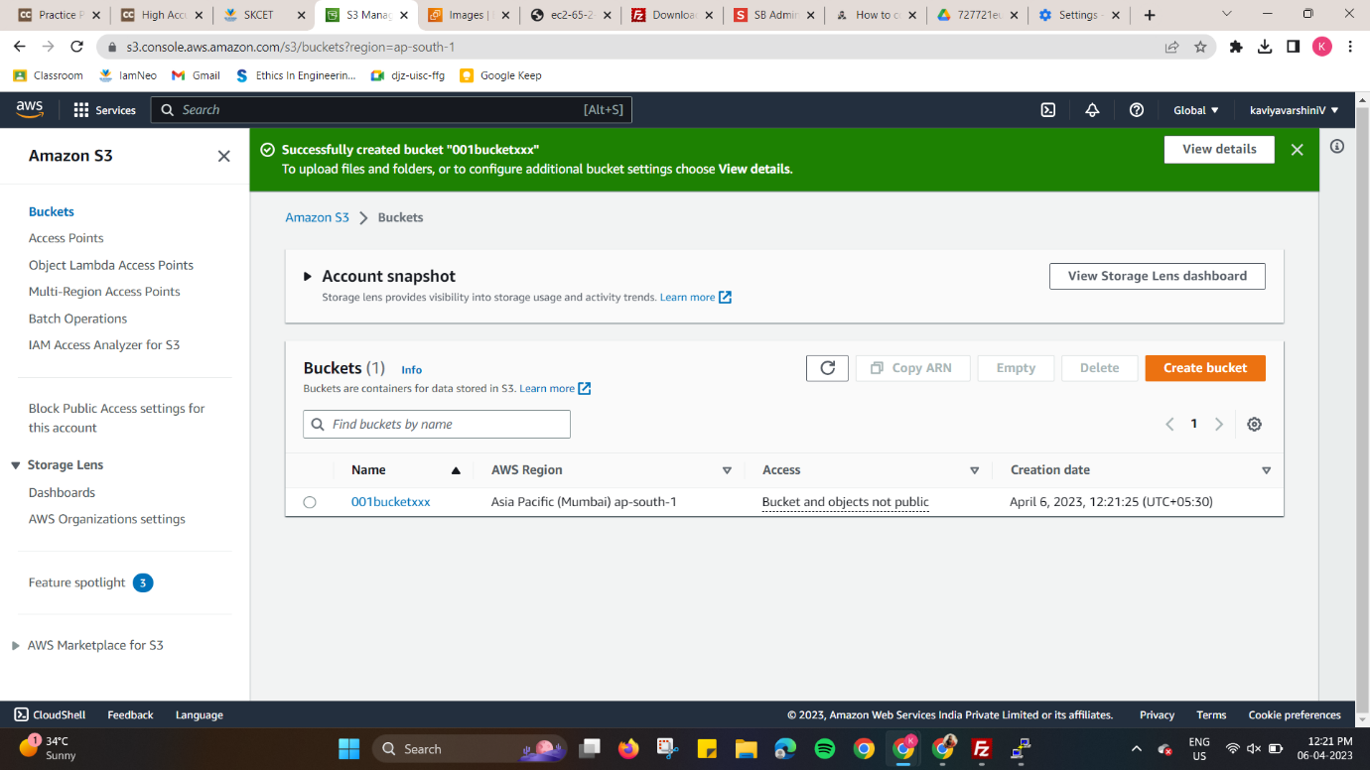

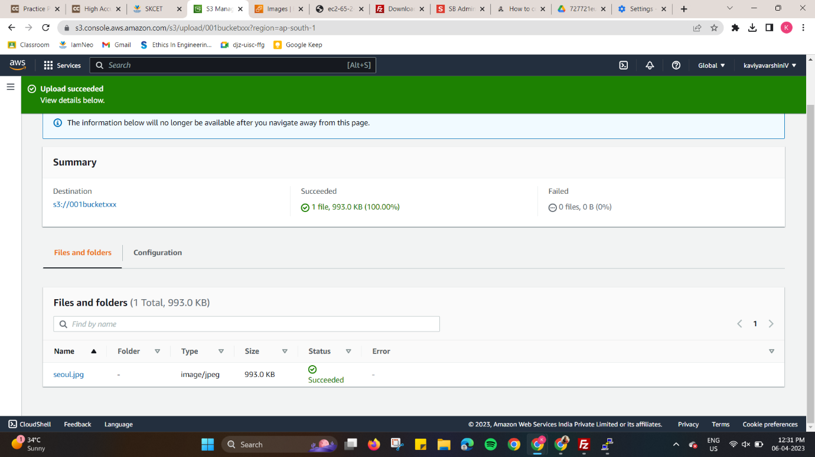

**Ce2.**

Disable "Block Public Access" for the bucket and enable public read access for a file.

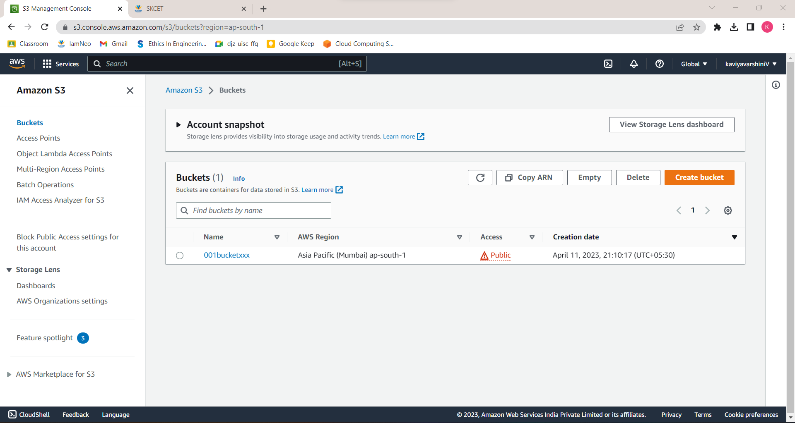

**Ce3.**

Create a bucket policy which should deny to read objects under a folder of a bucket.

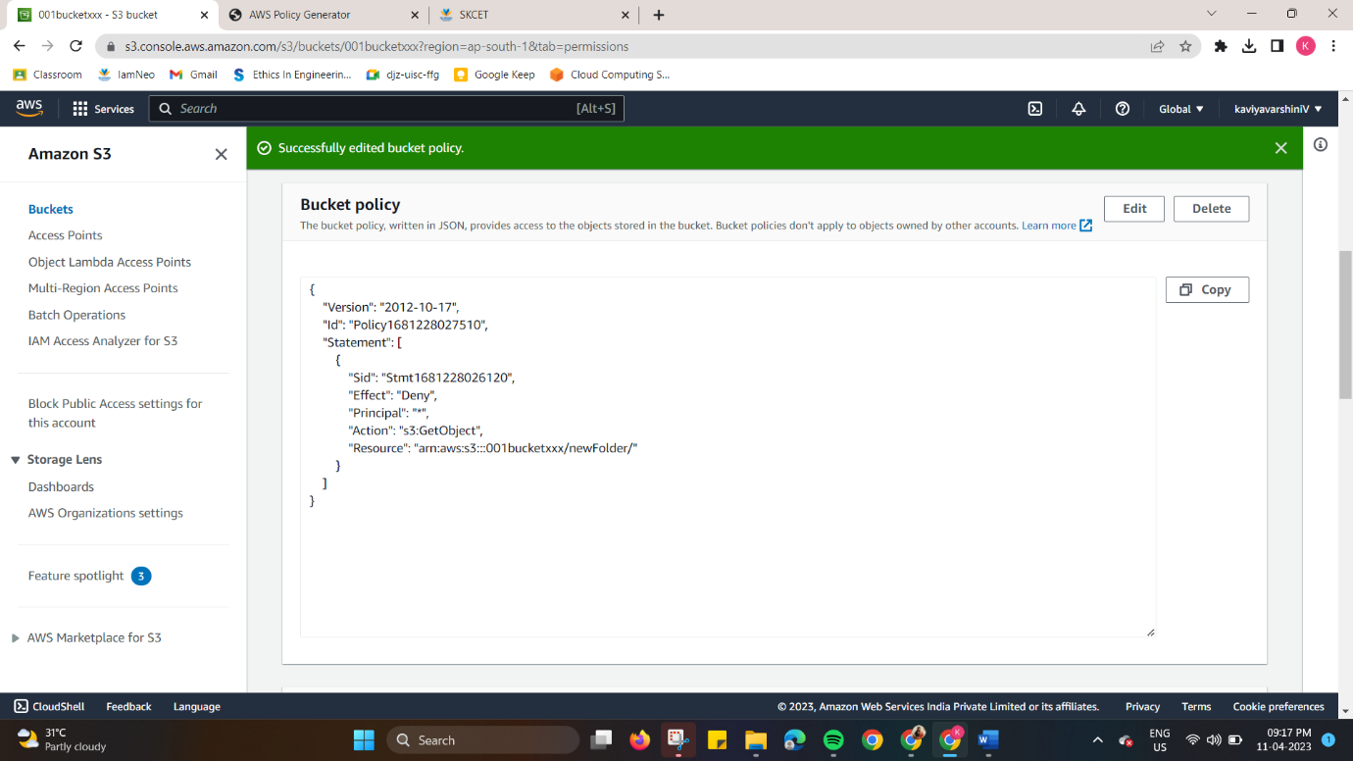

**Ce4.**

Enable versioning objects for a bucket and upload objects with multiple versions of it.

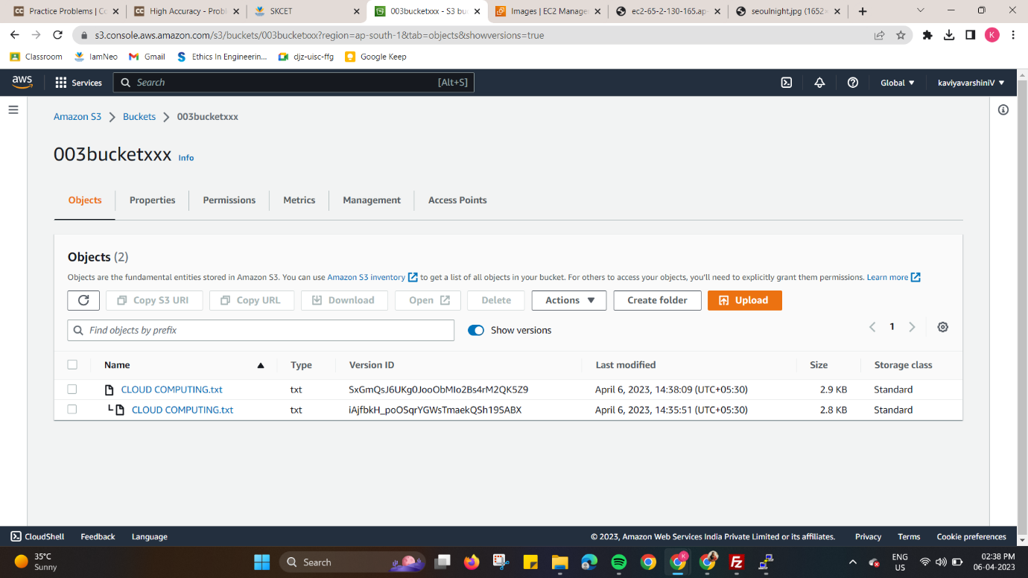

**Ce5.**

Host a static webpage in a bucket itself by using static website hosting feature of it.

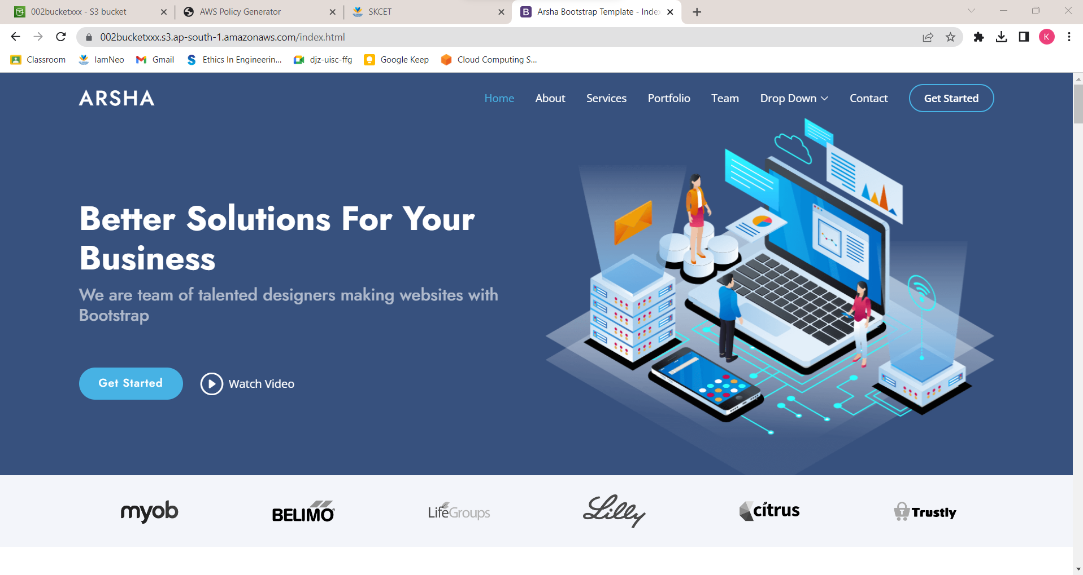

**Ce6.**

Enable a lifecycle management rule between various storage classes for a S3 bucket.

