**DAY-4**

**Ce1.**

Create an IAM group called as ‘S3-Admins’ with ‘AmazonS3FullAccess’.

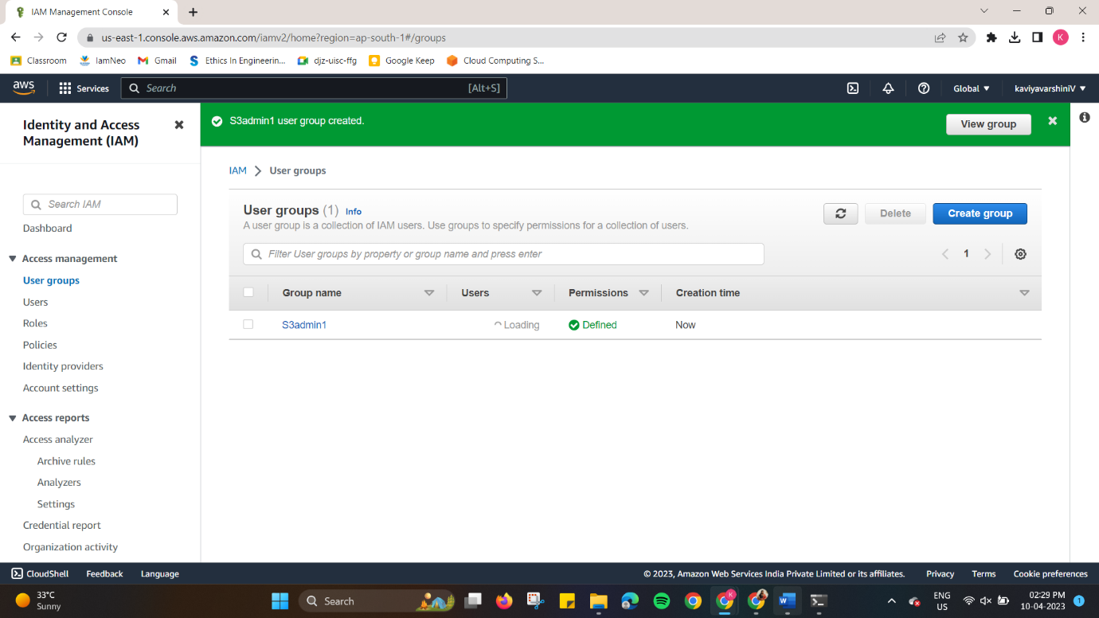

**Ce2.**

Create an IAM user called as ‘S3Admin1’ and add it to the ‘S3-Admins’ group.

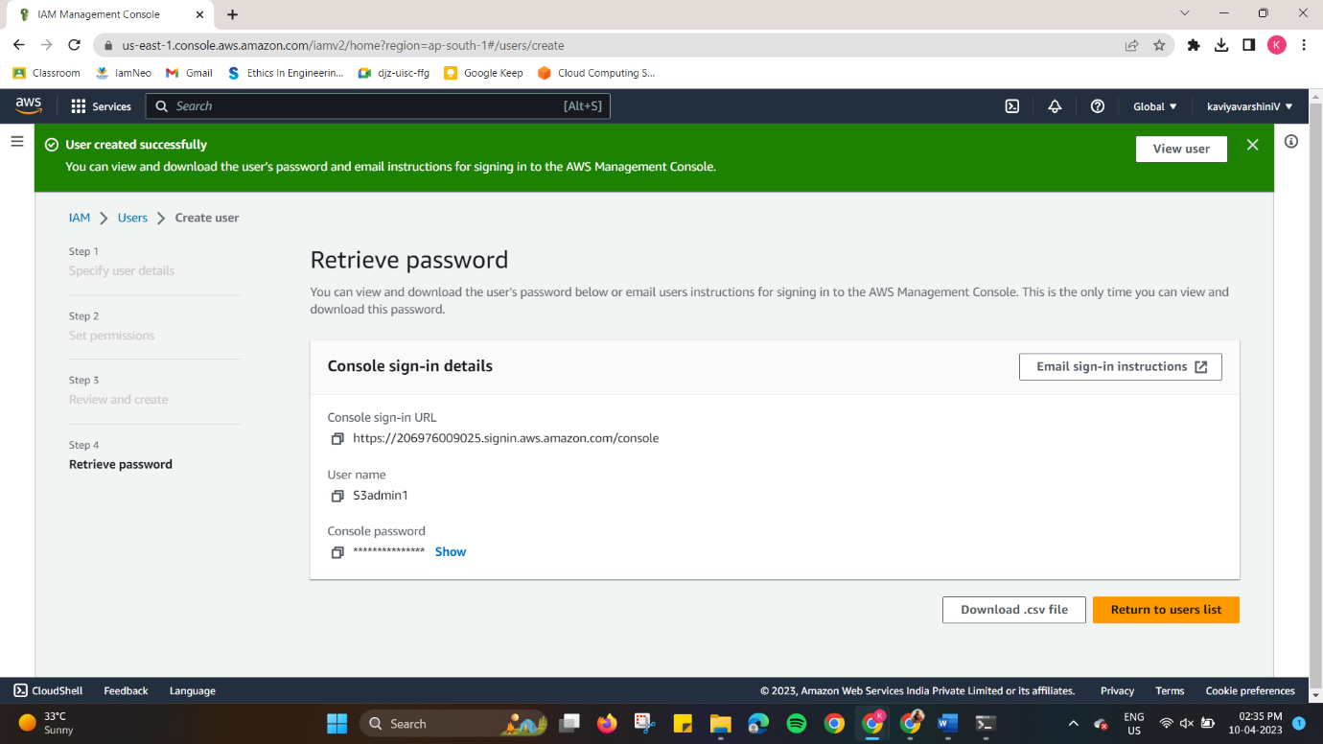

**Ce3.**

Attach an IAM custom policy to the ‘S3-Admins’ group which should deny to delete objects.

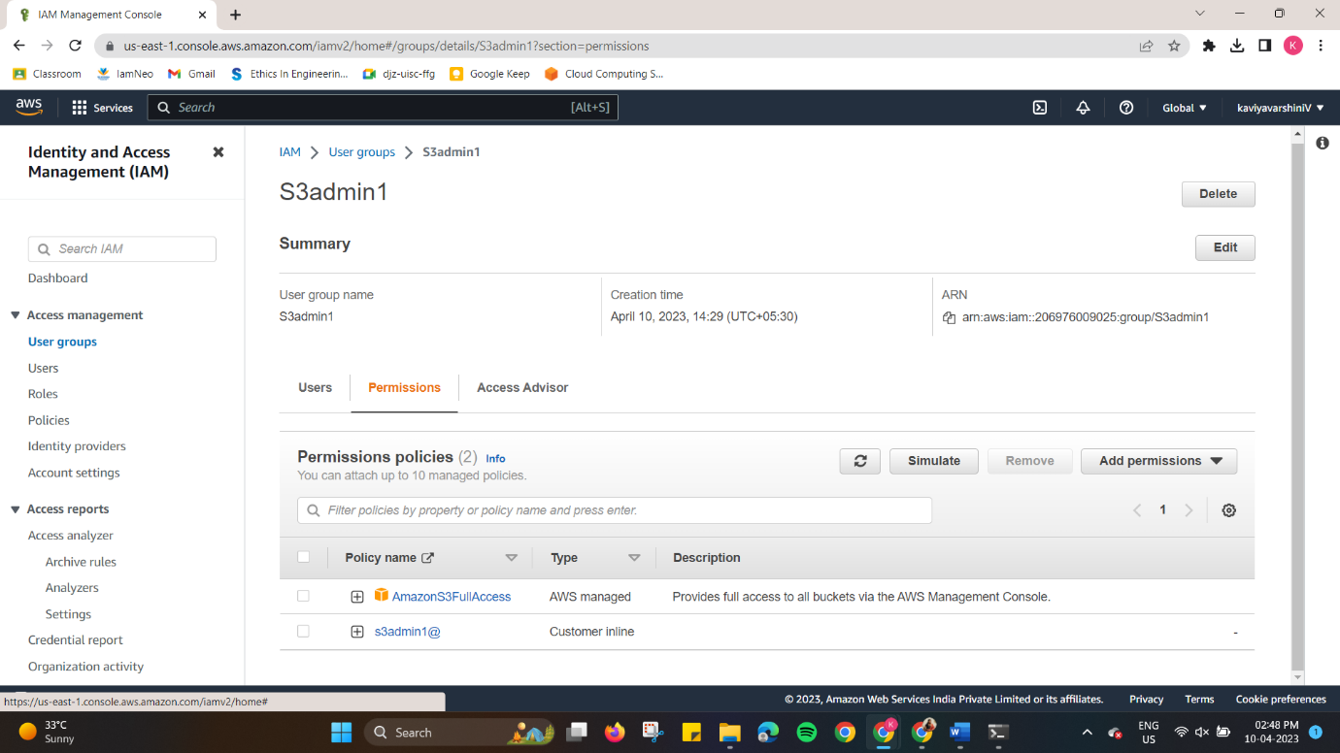

**Ce4.**

Create an Inline policy for an IAM user and set some permission boundary for that user.

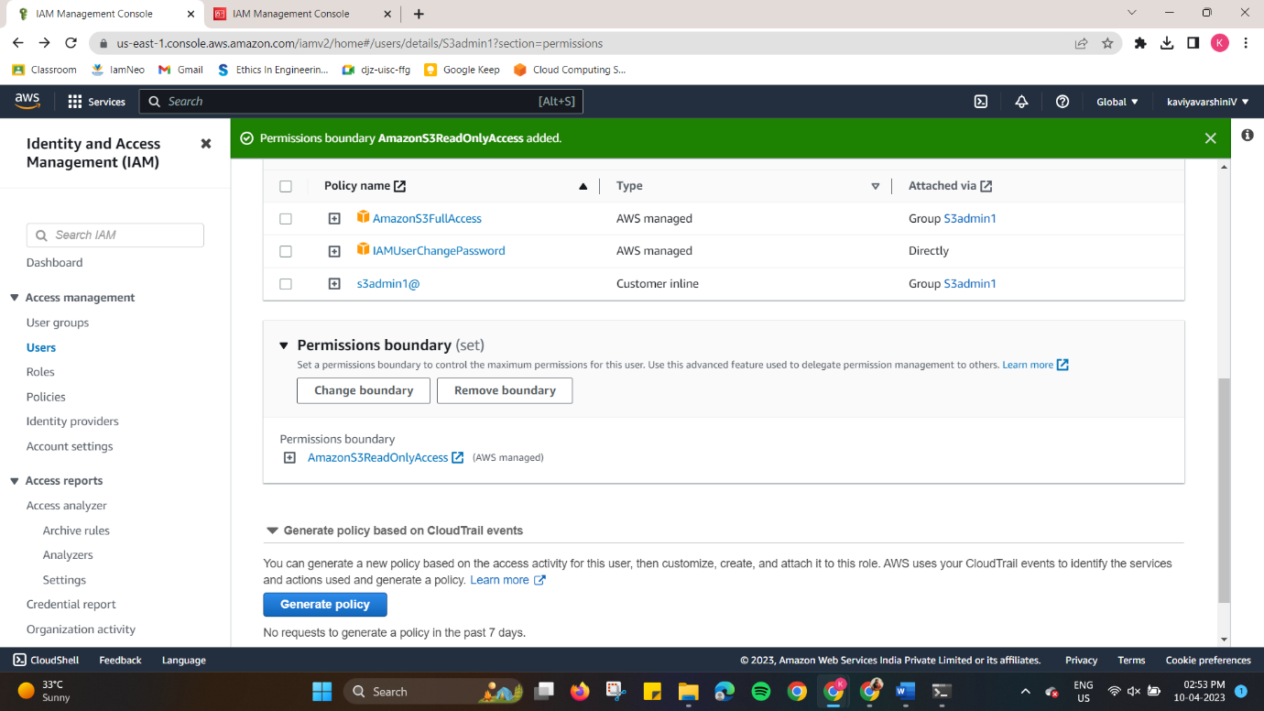

**Ce5.**

Create an IAM role with ‘AmazonS3FullAccess’ and attach the role to an EC2 instance.

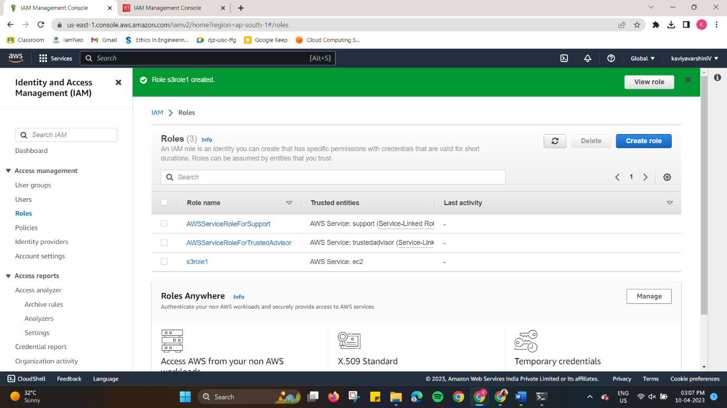

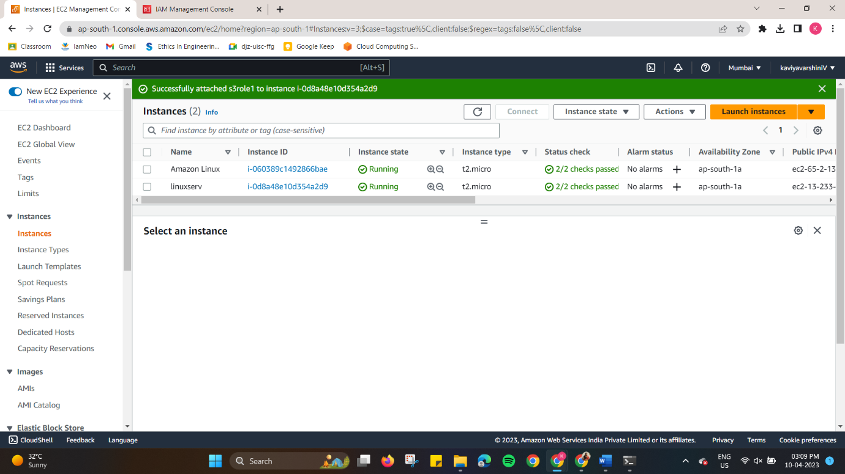

**Ce6.**

Activate MFA for an IAM user and Set some Password Policies such as 1 uppercase, 1 lowercase etc

