**DAY – 5**

**Ce1.**

Create a launch template with a custom AMI and t2.micro instance type

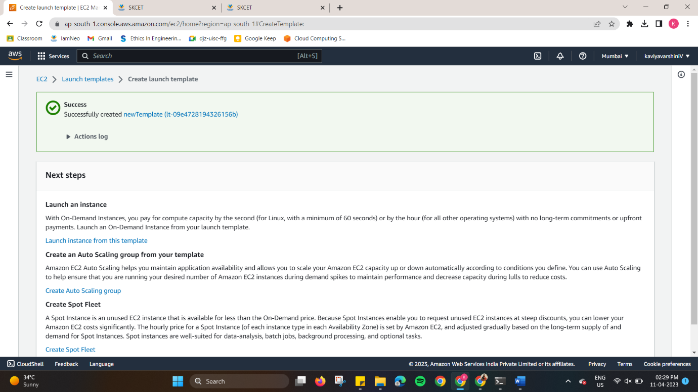

**Ce2.**

Create an autoscaling group with the above-created launch template

